UNITED STATES

SECURITIES AND EXCHANGE COMMISSION

Washington, D.C. 20549

SCHEDULE 14A INFORMATION

Proxy Statement Pursuant to Section 14(a) of the

Securities Exchange Act of 1934 (Amendment No. )

Filed by the Registrant ☒

Filed by a Party other than the Registrant ☐

Check the appropriate box:

- Preliminary Proxy Statement

- Confidential, for Use of the Commission Only (as permitted by Rule 14a-6(e)(2))

- Definitive Proxy Statement

- Definitive Additional Materials

- Soliciting Material Pursuant § 240.14a-12

TECHNIPFMC PLC

(Name of Registrant as Specified In Its Charter)

(Name of Person(s) Filing Proxy Statement, if Other Than the Registrant)

Payment of Filing Fee (Check the appropriate box):

- No fee required

- Fee computed on table below per Exchange Act Rules 14a-6(i)(1) and 0-11.

  - Title of each class of securities to which transaction applies:

  - Aggregate number of securities to which transaction applies:

  - Per unit price or other underlying value of transaction computed pursuant to Exchange Act Rule 0-11 (set forth the amount on which the filing fee is calculated and state how it was determined):

  - Proposed maximum aggregate value of transaction:

  - Total fee paid:

- Fee paid previously with preliminary materials.

- Check box if any part of the fee is offset as provided by Exchange Act Rule 0-11(a)(2) and identify the filing for which the offsetting fee was paid previously. Identify the previous filing by registration statement number, or the Form or Schedule and the date of its filing.

  - Amount Previously Paid:

  - Form, Schedule or Registration Statement No.:

  - Filing Party:

  - Date Filed:



2020
Notice of Annual General

Meeting of Shareholders and Proxy Statement

TechnipFMC Proxy Statement 2020


Notice of 2020 Annual General Meeting of Shareholders

TechnipFMC plc

(a public limited company having its registered office at One St. Paul’s Churchyard, London EC4M 8AP, United Kingdom and incorporated in England and Wales with company number 09909709)

April 24, 2020

10:00 a.m., London time

One St. Paul’s Churchyard, London EC4M 8AP, United Kingdom


Proposal | Description
1(a) – 1(n) | Election of Directors: To re-elect each of our 14 director nominees for a term expiring at the Company’s 2021 Annual General Meeting of Shareholders:
 | a. Douglas J. Pferdehirt | e. Marie-Ange Debon | i. John O’Leary | m. James M. Ringler
 | b. Eleazar de Carvalho Filho | f. Claire S. Farley | j. Olivier Piou | n. John Yearwood
 | c. Arnaud Caudoux | g. Didier Houssin | k. Kay G. Priestly
 | d. Pascal Colombani | h. Peter Mellbye | k. Kay G. Priestly
 | d. Pascal Colombani | h. Peter Mellbye | l. Joseph Rinaldi
2 | 2019 U.S. Say-on-Pay for Named Executive Officers: To approve, as a non-binding advisory resolution, the Company’s named executive officer compensation for the year ended December 31, 2019,
 | as reported in the Company’s Proxy Statement
3 | 2019 U.K. Directors’ Remuneration Report: To approve, as a non-binding advisory resolution, the Company’s directors’ remuneration report for the year ended December 31, 2019, as reported in the
 | Company’s U.K. Annual Report and Accounts
4 | Receipt of U.K. Annual Report and Accounts: To receive the Company’s audited U.K. accounts for the year ended December 31, 2019, including the reports of the directors and the auditor thereon
5 | Ratification of PwC as U.S. Auditor: To ratify the appointment of PricewaterhouseCoopers LLP (“PwC”) as the Company’s U.S. independent registered public accounting firm for the year ending
 | December 31, 2020
6 | Reappointment of PwC as U.K. Statutory Auditor: To reappoint PwC as the Company’s U.K. statutory auditor under the U.K. Companies Act 2006, to hold office from the conclusion of the 2020
 | Annual General Meeting of Shareholders until the next annual general meeting of shareholders at which accounts are laid
7 | Approval of U.K. Statutory Auditor Fees: To authorize the Board and/or the Audit Committee to determine the remuneration of PwC, in its capacity as the Company’s U.K. statutory auditor for the year
 | ending December 31, 2020

These items are more fully described in the Proxy Statement attached, which forms a part of this Notice of Annual Meeting. As of the date of the Proxy Statement, TechnipFMC does not know of any other matters to be raised at the 2020 Annual General Meeting of Shareholders.

Your vote is very important. Whether or not you plan to attend the 2020 Annual General Meeting of Shareholders in person, please (i) promptly return the enclosed proxy card in the enclosed envelope, or (ii) grant a proxy and give voting instructions by telephone or internet, so that you may be represented at the meeting. Voting instructions are provided on your proxy card or on the voting instruction form provided by your broker.


March 13, 2020

On behalf of the Board of Directors,

Dianne B. Ralston

Executive Vice President, Chief Legal Officer, and Secretary

- TechnipFMC

TechnipFMC Proxy Statement 2020

Proxy Statement for the 2020 Annual General Meeting of Shareholders

This Proxy Statement relates to the solicitation of votes or proxies by the Board of Directors (the “Board”) of TechnipFMC plc (the “Company,” “TechnipFMC,” “us,” or “we”) for use at our 2020 Annual General Meeting of Shareholders and at any adjournment or postponement of such meeting (the “Annual Meeting”).

The Notice of Internet Availability of Proxy Materials (the “Notice of Materials”) and related Proxy Materials (as defined below) were first made available to shareholders on or about March 13, 2020 at www.proxyvote.com. You may also request a printed copy of this Proxy Statement and the form of proxy by any of the following methods:


- Internet at www.proxyvote.com;

(b) | Telephone at 1-800-579-1639; or

- Email at sendmaterial@proxyvote.com.

Our Annual Report on Form 10-K, including consolidated financial statements, for the year ended December 31, 2019 (our “Form 10-K”) and our U.K. Annual Report and Accounts are being made available at the same time and by the same methods.

Our registered office is located at One St. Paul’s Churchyard, London EC4M 8AP, United Kingdom. Our telephone number in our London office is +44 20 3429 3950. Information regarding the Annual Meeting, including the information required by Section 311A of the U.K. Companies Act 2006 (the “Companies Act”), can be found at www.TechnipFMC.com. Information contained on our website is not to be considered as part of the proxy solicitation material and is not incorporated into this Proxy Statement.

TechnipFMC is a public limited company incorporated under the laws of England and Wales, and our ordinary shares (the “Ordinary Shares”) trade on the New York Stock Exchange in the United States (the “NYSE”) and the Euronext Paris exchange (“Euronext”) under the symbol “FTI.” As a result, the Company is governed by the
Companies Act, U.S. securities laws and regulations, E.U. securities regulations, and the listing standards of the NYSE and Euronext.

IMPORTANT NOTICE REGARDING THE AVAILABILITY OF PROXY MATERIALS FOR THE 2020 ANNUAL GENERAL MEETING OF SHAREHOLDERS TO BE HELD ON APRIL 24, 2020 The Notice of Annual Meeting and Proxy Statement, Annual Report on Form 10-K, and our U.K.

Annual Report and Accounts are available at www.proxyvote.com.

- TechnipFMC

TechnipFMC Proxy Statement 2020

Contents

2020 Proxy Summary | 7
Annual Meeting Information | 7
Voting Matters and Board Recommendations | 8
Core Values and Foundational Beliefs | 9
Governance Highlights | 10
2019-2020 Shareholder Engagement Program | 11
Director Nominees | 12
2019 At-a-Glance | 13
Executive Compensation | 14
Corporate Responsibility and Sustainability | 16
Core Values and Foundational Beliefs | 16
Code of Business Conduct | 17
Sustainability | 18
Supporting Communities | 20
Advancing Gender Diversity | 24
Respecting the Environment | 27
Corporate Governance | 33
Governance Guidelines and Key Board Practices | 33
Shareholder Engagement | 34
Leadership Structure of the Board | 37
Board Composition and Criteria for Board Membership | 39
Enterprise Risk Management | 44
Committees of the Board of Directors | 45
Board Meetings and Attendance | 47
Director Independence | 48
Compensation Committee Interlocks and Insider Participation in Compensation Decisions | 49
Communications with Directors | 49
Director Compensation | 50
Non-executive Director Compensation | 50

- TechnipFMC

TechnipFMC Proxy Statement 2020
Executive Compensation Discussion and Analysis | 54
Named Executive Officers | 55
Business Overview | 55
Executive Compensation Highlights | 56
Compensation Governance | 67
Elements of 2019 Executive Compensation | 72
Other Compensation, Benefits, and Considerations | 87
Summary Compensation Table for the Year Ended December 31, 2019 | 91
Grants of Plan-Based Awards Table | 93
Outstanding Equity Awards at Fiscal Year-End Table | 94
Option Exercises and Stock Vested Table | 95
Pension Benefits Table | 96
Non-Qualified Deferred Compensation Table | 98
Potential Payments upon Termination | 99
CEO Pay Ratio | 102
Compensation of Former Executive Chairman | 103
Compensation Committee Report | 107
Audit Committee Report | 108
Proposals 1(a) – 1(n) – Election of Directors | 109
Director Nominees | 111
Proposal 2 – 2019 Say-on-Pay for NEOs | 125
Proposal 3 – 2019 Directors’ Remuneration Report | 126
Proposal 4 – Receipt of U.K. Annual Report and Accounts | 127
Proposal 5 – Ratification of U.S. Auditor | 128
Proposal 6 – Reappointment of U.K. Statutory Auditor | 129
Proposal 7 – Approval of U.K. Statutory Auditor Fees | 130
Transactions with Related Persons | 131
Security Ownership of Our Management and Holders of More Than 5% of Our Outstanding Ordinary Shares | 132
Section 16(a) Beneficial Ownership Reporting Compliance | 134
Proposals for the 2021 Annual General Meeting of Shareholders | 135
Shareholders Sharing an Address | 136

- TechnipFMC

TechnipFMC Proxy Statement 2020
General Information about the Annual Meeting | 137
What is the location of the Annual Meeting? | 137
What is a proxy statement? | 137
What is a proxy? | 137
How will the Company distribute Proxy Materials? | 137
Where can I find governance documents related to the Company? | 138
Who is entitled to vote at the Annual Meeting? | 138
What is the difference between holding Ordinary Shares as a shareholder of record and as a beneficial owner? | 139
Do I have to attend the Annual Meeting to vote? | 139
Who can attend the Annual Meeting? | 139
How do I vote? | 140
Can I change my vote? | 142
What should I do if I receive more than one proxy card? | 142
How many votes must be present to hold the Annual Meeting? | 142
What if I have been nominated by a shareholder of record to have information rights under the Companies Act? | 142
What is a broker non-vote? | 143
What are the voting requirements to approve the resolutions? | 143
Who will pay the costs of this proxy solicitation? | 143
Who will count the votes? | 144
Where can I find the voting results of the Annual Meeting? | 144

- TechnipFMC

TechnipFMC Proxy Statement 2020

2020 Proxy Summary


Along with the Notice of Annual Meeting, we are providing this Proxy Statement, the U.K. Annual Report and Accounts, and our Form 10-K in connection with the Annual Meeting (collectively, the “Proxy Materials”).

This summary highlights information contained elsewhere in this Proxy Statement. This summary does not contain all the information that you should consider regarding each of the proposals to be voted on at the Annual Meeting. Please read the entire Proxy Statement carefully before voting. For further information regarding our 2019 financial performance, please review our Form 10-K and our U.K. Annual Report and Accounts.

Annual Meeting Information

Time and Date

April 24, 2020 at 10:00 a.m.,

London time

Place

One St. Paul’s Churchyard,

London EC4M 8AP, United Kingdom

Record Date

February 27, 2020, 5:00 p.m.,

New York time

Admission

Admission ticket and valid photo identification required. Please see “General Information about the Annual Meeting—Who can attend the Annual Meeting?” for more information.

Voting

Each Ordinary Share is

entitled to one vote for

each of the proposals

to be voted on.

Voting Deadlines

New York Stock Exchange shares:

11:59 PM, New York time, on April 23, 2020

Euronext Paris Exchange shares: Direct or indirect nominative form (au nominatif pur ou administré):

11:59 PM, New York time, on April 23, 2020

Anonymous/bearer form (au porteur): Return

voting card to your bank, broker, or financial

intermediary before April 21, 2020

Please follow the voting instructions on your proxy card and/or your voting instruction form as diﬀerent voting deadlines may be applicable across markets. Please also review “How do I vote?” in the section entitled “General Information about the Annual Meeting.”

- TechnipFMC

TechnipFMC Proxy Statement 2020


Voting Matters and Board Recommendations

The full text of each resolution to be voted on at the Annual Meeting is set out in the Notice of Annual Meeting.

Proposal to be Voted Upon | Board Recommendation | Where You Can Find
Proposal to be Voted Upon | Board Recommendation | More Information
1(a) – 1(n): Election of Directors | FOR | Page 109
1(a) – 1(n): Election of Directors | Each Director Nominee | Page 109
2: 2019 U.S. Say-on-Pay Proposal for Named Executive Officers | FOR | Page 125
3: 2019 U.K. Directors’ Remuneration Report | FOR | Page 126
4: Receipt of U.K. Annual Report and Accounts | FOR | Page 127
5: Ratification of PwC as U.S. Auditor | FOR | Page 128
6: Reappointment of PwC as U.K. Statutory Auditor | FOR | Page 129
7: Approval of U.K. Statutory Auditor Fees | FOR | Page 130

- TechnipFMC

TechnipFMC Proxy Statement 2020

Core Values and Foundational Beliefs
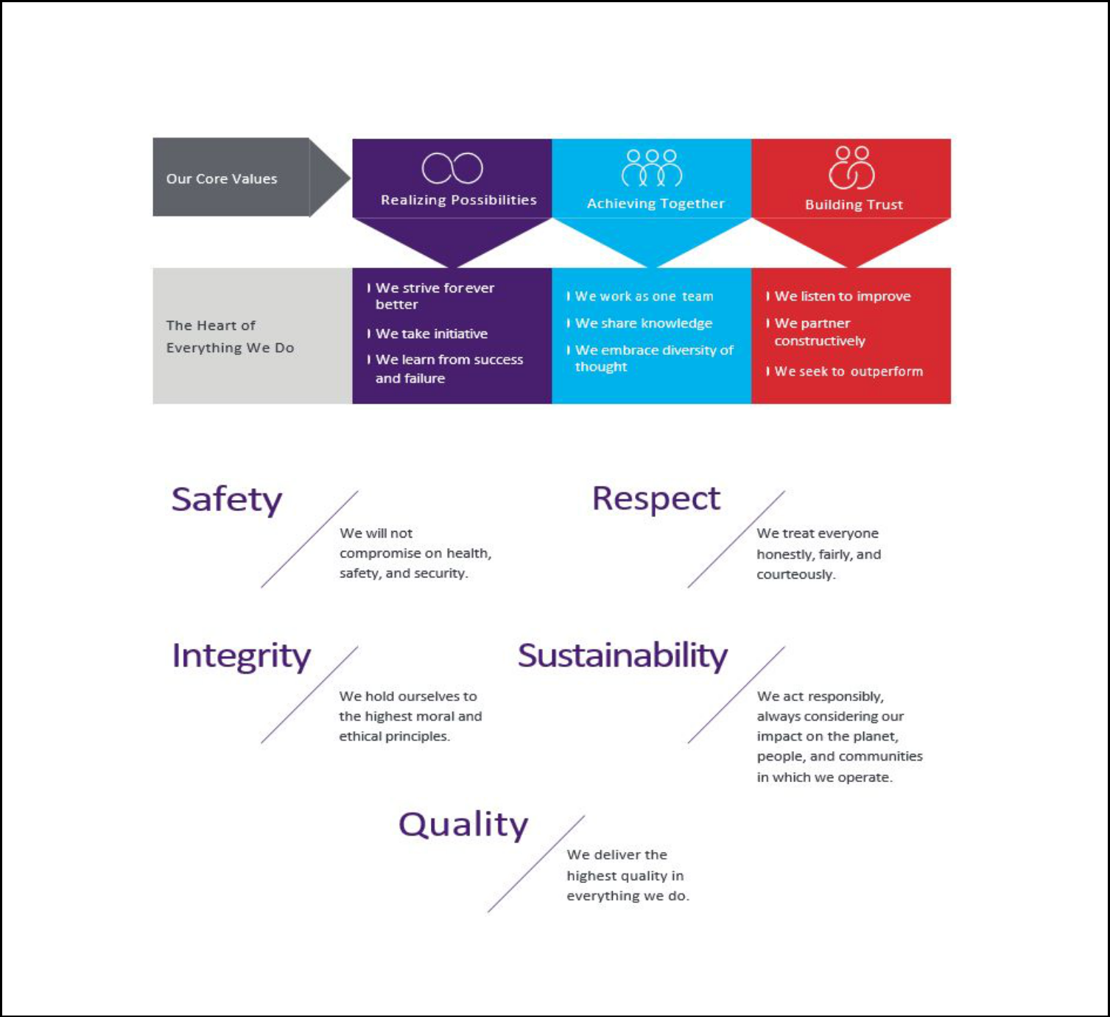

Our decisions regarding corporate responsibility, governance, and sustainability are founded on the principles that guide our Company. Our core values provide the framework for all of our decision making and are based on our foundational beliefs (“Foundational Beliefs”).

Our Foundational Beliefs are the cornerstone of our values that describe how we fundamentally do business and what we never compromise on, no matter the circumstances.

For additional details on the Company’s core values, Foundational Beliefs, and our sustainability program, please see the section entitled “Corporate Responsibility and Sustainability.”

- TechnipFMC

TechnipFMC Proxy Statement 2020

Governance Highlights
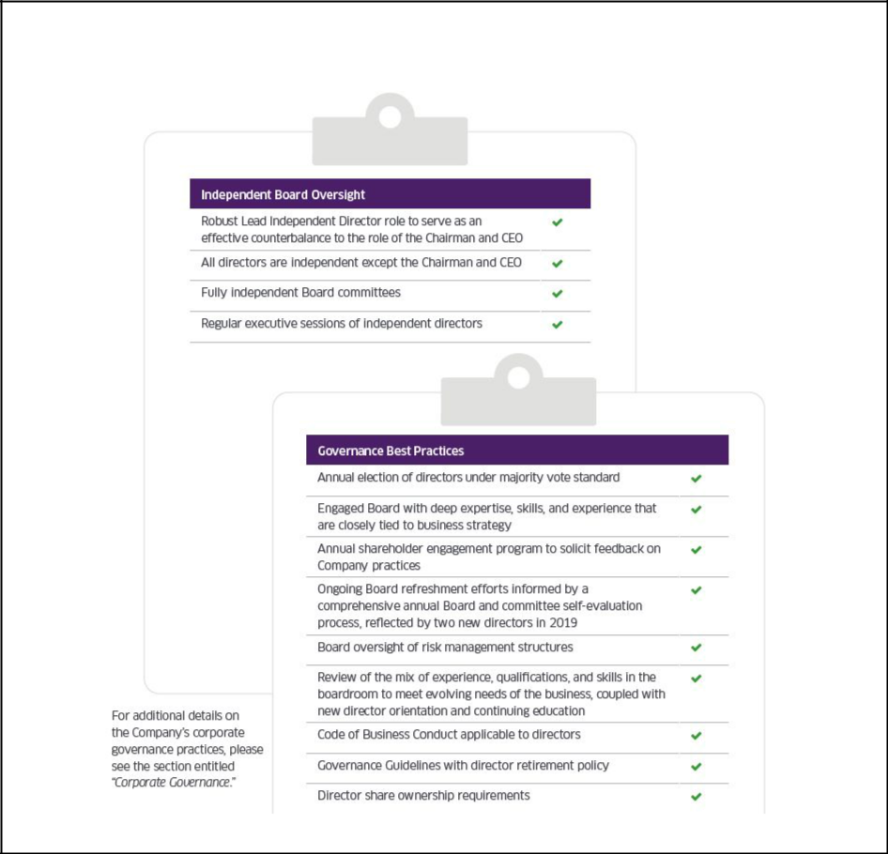

Board and Governance Best Practices

- TechnipFMC

TechnipFMC Proxy Statement 2020

2019-2020 Shareholder Engagement Program


Our relationship and ongoing dialogue with our shareholders is an important part of our Board’s corporate governance commitment. Our Lead Independent Director and Compensation Committee Chair, or our executives and management from our Legal, People and Culture, and Investor Relations groups, meet with shareholders regularly on a variety of topics.

Management provides reports to the Board and its committees regarding the feedback received.

For our 2019-2020 engagement, we contacted proxy advisory firms and our top shareholders representing approximately 50% of our Ordinary Shares outstanding. Management, and in some instances, our Lead Independent Director or our Compensation Committee Chair, held meetings with proxy advisory firms and shareholders representing approximately 13% of our Ordinary Shares outstanding. Some shareholders did not require a meeting as they either indicated their support for our compensation and governance practices or did not have questions regarding our compensation or governance practices.

Our 2019-2020 shareholder engagement program allowed us to understand our shareholders’ priorities and perspectives, which prompted us to make several changes to our compensation program and to our disclosure philosophy.

For detailed descriptions of key shareholder feedback received, and our responses to such feedback, please see the section entitled “Corporate Governance—Shareholder Engagement.”

- TechnipFMC

TechnipFMC Proxy Statement 2020

Director Nominees
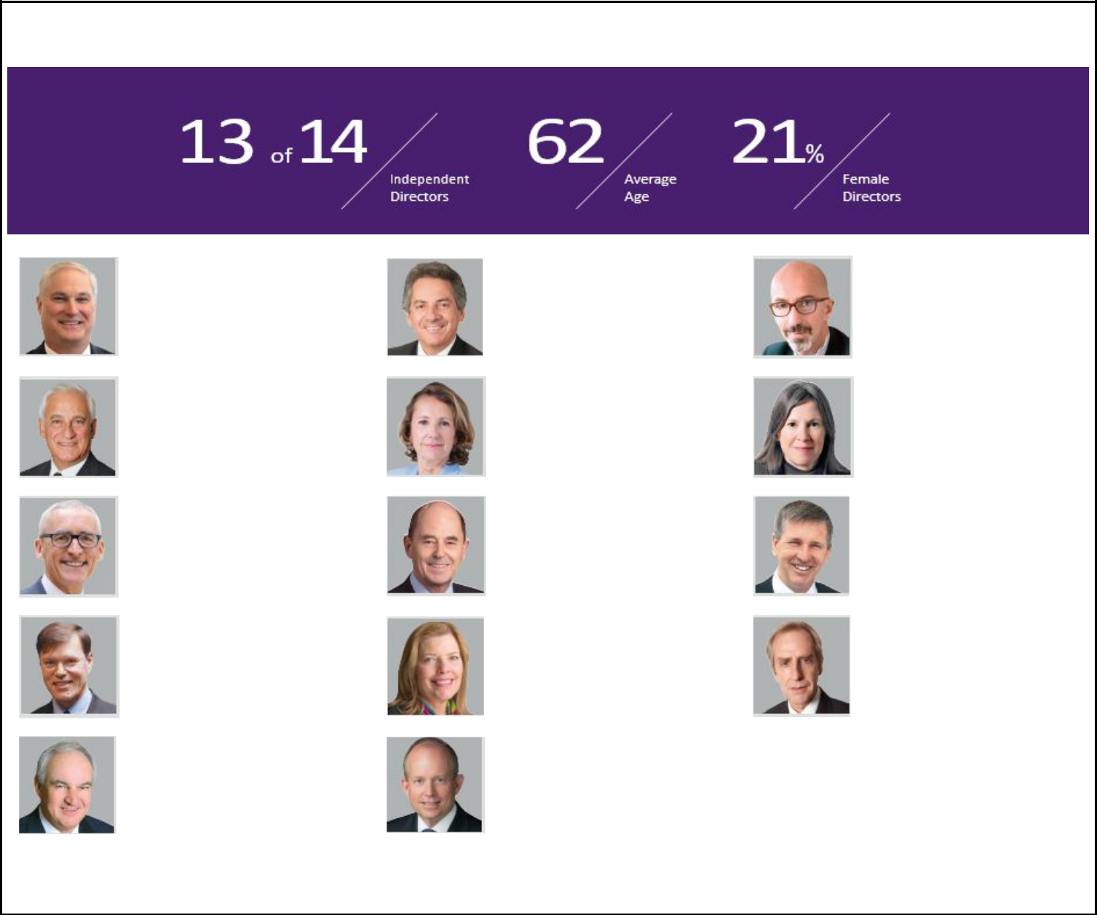

Key Board Statistics after Annual Meeting

Douglas J. Pferdehirt
Chairman and CEO | Eleazar de Carvalho Filho | Arnaud Caudoux
Age: 56 | Independent | Independent
Committees: Strategy | Age: 62 | Age: 49
Committee (Chair) | Committees: Audit | Committees: Audit
Pascal Colombani
Lead Independent Director |  | Claire S. Farley
Age: 74 | Marie-Ange Debon | Independent
Committees: Nominating | Independent | Age: 61
and Corporate Governance, | Age: 54 | Committees:
Strategy | Committees: Audit (Chair) | Compensation, Strategy
Didier Houssin | Peter Mellbye
Independent | Independent | John O’Leary
Age: 63 | Age: 70 | Independent
Committees: Nominating | Committees: Nominating | Age: 64
and Corporate Governance, | and Corporate Governance | Committees:
Strategy | (Chair), Strategy | Compensation
Olivier Piou
Independent |  | Joseph Rinaldi
Age: 61 | Kay G. Priestly | Independent
Committees: Nominating | Independent | Age: 62
and Corporate Governance, | Age: 64 | Committees: Audit,
Strategy | Committees: Audit | Compensation
 | John Yearwood
James M. Ringler | Independent
Independent | Age: 60
Age: 74 | Committees:
Committees: Compensation | Compensation, Nominating
(Chair) | and Corporate Governance

Detailed biographies for each of our director nominees are disclosed in the section “Proposals 1(a) – 1(n)—Election of Directors— Director Nominees.”

- TechnipFMC

TechnipFMC Proxy Statement 2020

2019 At-a-Glance
Governance
 | Olivier Piou and John Yearwood were appointed | Enhanced disclosures regarding
Combined the roles of | Olivier Piou and John Yearwood were appointed | shareholder feedback and our
Chairman and CEO | as directors to replace two retired directors | response
 |  | Improved disclosures regarding
 |  | director service commitments and
 |  | director independence
 |  | determinations
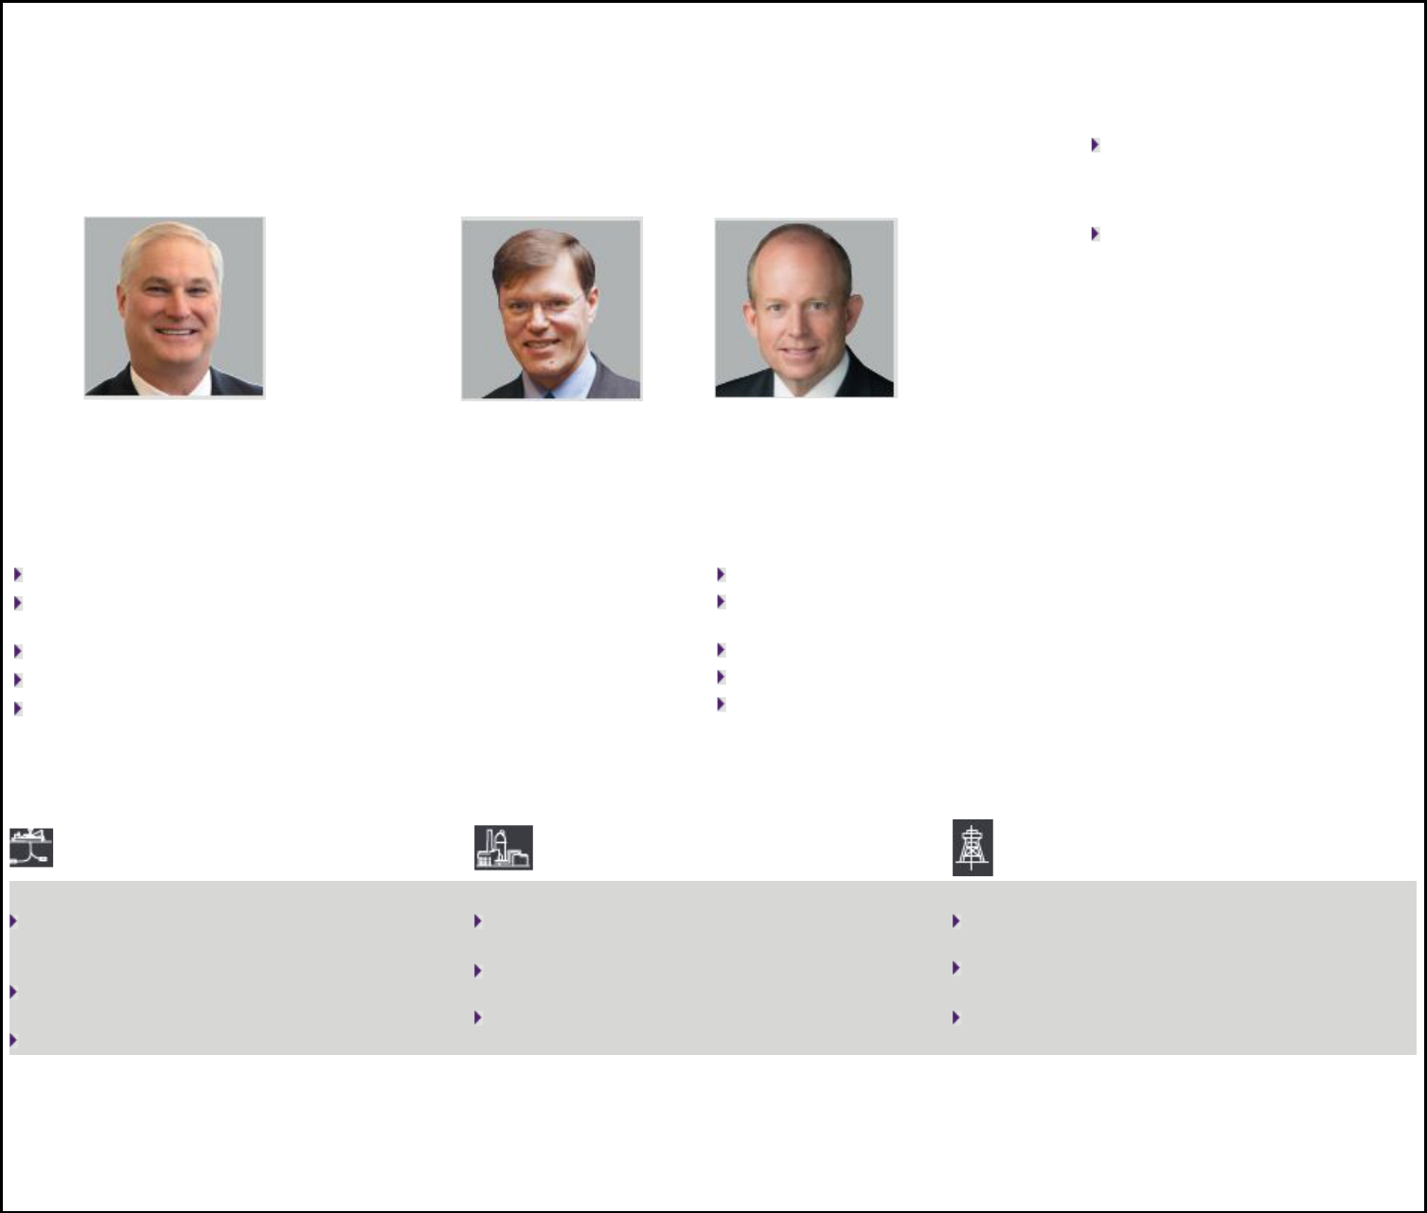

 | Strategic Transaction
 | Announced spin-oﬀ of Technip Energies creating two industry-leading publicly traded companies
 | TechnipFMC (RemainCo) |  |  |  | TechnipFMC (SpinCo)
 | Unlocking value, realizing potential |  |  |  | Capitalizing on structural growth trends
 | TechnipFMC will retain Subsea and Surface Technologies segments (noted |  |  |  | Spin-off will include Onshore/Offshore segment (including Genesis), Loading
 | exceptions to SpinCo) |  |  |  | Systems (Surface Technologies), and Cybernetix (Subsea)
 | Listings: NYSE, Euronext Paris |  |  |  | Listing: Euronext Paris
 | HQ: Houston; Domicile: United Kingdom |  |  |  | HQ: Paris; Domicile: Netherlands
 | Employees: ~22,000 |  |  |  | Employees: ~15,000
 | Financials1
 | Subsea |  | Onshore/Offshore |  |  | Surface Technologies
 | Results |  | Results |  |  | Results
 | Revenue growth of 14% versus the prior year, driven |  | Three quarters of sequential revenue growth, as |  |  | Revenue growth of more than 15% in markets
 | by double-digit growth in both project and service |  | segment revenue has inflected above the 2018 trough |  |  | outside of North America versus the prior year
 | activities |  | Revenue growth, excluding the Yamal LNG project, |  |  | Surface international revenues account for more
 | Integrated project activity a higher mix of business |  | exceeded 25% versus the prior year |  |  | than 50% of total segment
 | portfolio |  | Backlog of $15.3 billion |  |  | Backlog of $0.5 billion

Backlog of $8.5 billion

- Reported financial results for the twelve months ended December 31, 2019 and inbound and backlog as of December 31, 2019 are as reported in our Form 10-K.

For additional details regarding the Company’s 2019 financial performance, please see the section entitled “Executive Compensation Discussion and Analysis—Business Overview.”

- TechnipFMC

TechnipFMC Proxy Statement 2020

Executive Compensation
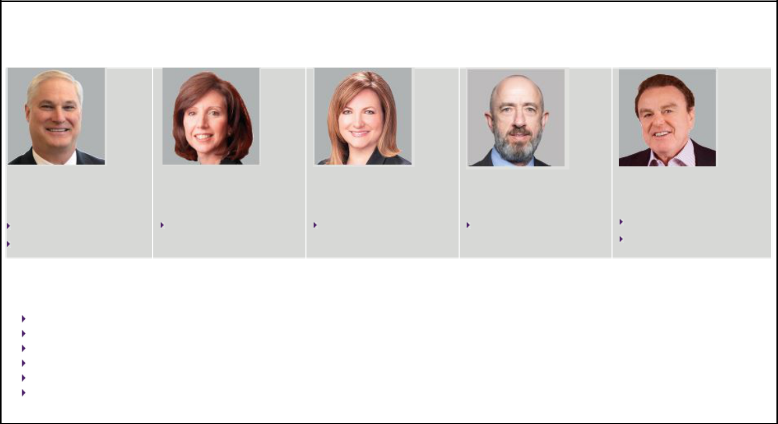

Our named executive officers (“NEOs”) for 2019 are:

Douglas J. Pferdehirt | Maryann T. Mannen | Dianne B. Ralston | Justin Rounce
Age: 56 | Age: 57 | Age: 53 | Age: 53
Positions Held in 2019: | Position Held in 2019: | Position Held in 2019: | Position Held in 2019:
Chief Executive Officer and Chairman, | Executive Vice President and Chief | Executive Vice President, Chief Legal | Executive Vice President and Chief
from May 1, 2019 | Financial Officer | Officer, and Secretary | Technology Officer
Chief Executive Officer from January
1, 2019 through April 30, 2019

Nello Uccelletti

Age: 66

Positions Held in 2019:

President and Advisor to the CEO from November 1 through December 31, 2019

President Onshore/ Offshore from January 1 through October 31, 2019

Our compensation practices are designed to align with shareholder interests and incorporate strong governance practices that support the guiding principles of our executive compensation program, which include the following:

Attract talented individuals by providing market competitive levels of compensation

Retain our leaders by incentivizing them to deliver on our vision

Link the interests of our executive officers with the interests of the Company and shareholders

Align executive officers’ interests with our long-term financial and strategic objectives

Maintain flexibility to better respond to the cyclical energy industry

Encourage prudent risk-taking by our executives

- TechnipFMC

TechnipFMC Proxy Statement 2020


Executive Compensation Practices

What We Do: |  | What We Don’t Do:
Pay for performance by aligning performance measures with our strategy and |  | No single-trigger vesting upon a change-in-control
shareholder interests |  | No guaranteed bonuses
Provide the majority of NEO compensation as performance-based, “at-risk” |  | No uncapped incentives
compensation |  | No uncapped incentives
compensation |  | No tax gross-ups on any severance payments
Maintain a clawback policy in the event of malfeasance or fraud |  | No tax gross-ups on any severance payments
 |  | No excessive perquisites, benefits, or pension payments
Require robust executive and director share ownership requirements |  | No discounting, reloading, or repricing of stock options
Engage an independent, external compensation consultant |  | No hedging and pledging of Company securities

Benchmark compensation against relevant global and industry peer groups

Cap performance stock unit (“PSU”) payout at target when relative Total

Shareholder Return (“TSR”) exceeds peers’ but absolute TSR is negative

In response to shareholder feedback provided in 2019, we have taken the following actions:

Eliminated the role of Executive Chairman following completion of post-Merger (as defined below) integration and reduced to a single, CEO-level compensation structure.

Discontinued the use of stock options so that performance-based equity will represent 70% of all annual equity awards beginning in 2020, and annual equity awards will comprise only PSUs (70%) and time-based restricted stock units (“RSUs”) (30%).

Retained the metric, EBITDA as a Percentage of Revenue, under our annual incentive plan to reinforce the link between annual incentive metrics and business strategy.

Continued the use of Return on Invested Capital (“ROIC”) in our long-term equity incentive plan, in addition to relative TSR. ROIC is an absolute financial metric that measures management’s ability to efficiently allocate capital, and performance for ROIC is measured against an internal target. The relative TSR metric is based on share price performance relative to an external peer group. Due to the cyclical nature of the oil and gas industry, shareholders have supported inclusion of both internal and external metrics in long-term equity incentive plans.

Based a portion of our CEO’s annual cash incentive bonus on certain sustainability measures to further reinforce the Company’s commitment to our Foundational Beliefs.

Updated our compensation and performance peer groups to reflect changes in our business environment.

Simplified disclosures in our Compensation Discussion and Analysis to provide additional details and calculations, including enhanced descriptions of the individual performance component of our annual cash incentive bonus plan, as well as our target-setting process and our peer group selection rationale.

For additional details regarding our executive compensation program, please see the section entitled “Executive Compensation Discussion and Analysis.”

- TechnipFMC

TechnipFMC Proxy Statement 2020

Corporate Responsibility and Sustainability

We are a global leader in oil and gas projects, technologies, systems, and services and provide our clients deep expertise across subsea, onshore/offshore, and surface projects. Our vision to enhance the performance of the world’s energy industry is supported by a relentless drive of every individual at TechnipFMC.

Our decisions regarding corporate responsibility, governance, and sustainability are founded on the principles that guide our Company. Our core values provide the framework for all of our decision making and are based on our Foundational Beliefs.

Core Values and Foundational Beliefs

Our core values are the drivers that guide how we act in a distinctly TechnipFMC way, so we can deliver on our purpose and achieve our vision. We bring our values to life through our behaviors—specific, observable, and measurable actions.
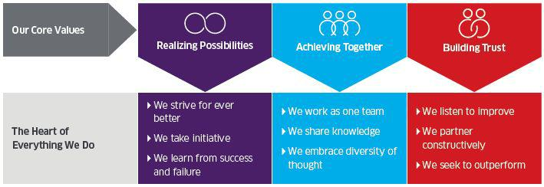

- TechnipFMC

TechnipFMC Proxy Statement 2020

Our Foundational Beliefs are the cornerstone of our values that describe how we fundamentally do business and what we never compromise on, no matter the circumstances.
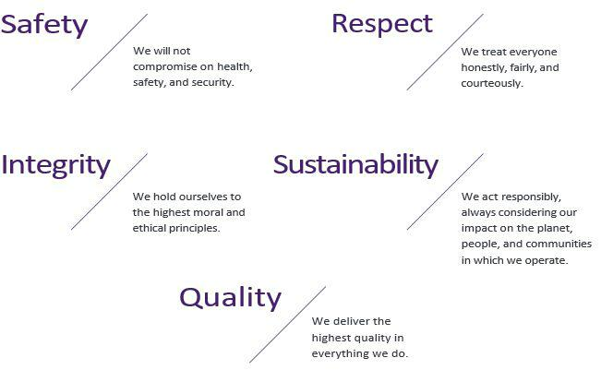

Code of Business Conduct

Our Code of Business Conduct is built on our Foundational Beliefs and gives our directors, officers, and employees a common language and playbook for decisions and actions that help us live our core values. We are committed to

establishing and maintaining an effective compliance program that is intended to increase the likelihood of preventing, detecting, and correcting violations of Company policy and the law. Moreover, we have a hotline in place for employees, officers, directors, and external parties to anonymously report violations of our Code of Business Conduct or complaints regarding accounting and auditing practices. Reports of possible violations of financial or accounting policies are reported to our Audit Committee.

We will disclose amendments to, or waivers of, our Code of Business Conduct that are required to be disclosed under the U.S. Securities and Exchange Commission (“SEC”) and NYSE rules or any other applicable laws, rules, and regulations. Any waiver of our Code of Business Conduct for our officers and directors must be approved by the Board or a relevant Board committee. We have not made any such waivers, and do not anticipate making any such waiver.

- TechnipFMC

TechnipFMC Proxy Statement 2020

Sustainability

We believe corporate responsibility and sustainability is a key element of our Company’s long-term success and is, therefore, one of our Foundational Beliefs. To ensure that the Company is collectively focused on making meaningful and tangible changes, we have focused our sustainability efforts under three pillars.
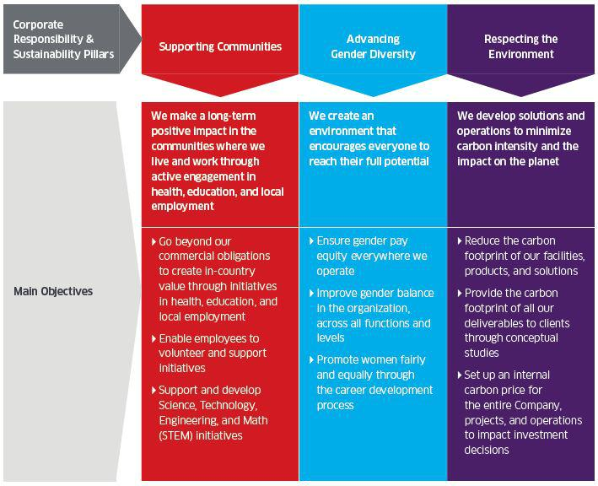

Each year, we set key performance targets for each of these pillars and report our performance against these targets to our Board and other stakeholders. In addition to these annual objectives, the Company demonstrates its commitment in other ways.

For instance, in 2019, TechnipFMC reaffirmed its support of the Ten Principles of the United Nations (UN) Global Compact in the areas of Human Rights, Labor, Environment, and Anti-Corruption. The UN Global Compact requires an annual Communication on Progress, which is submitted and made publicly available on the UN Global Compact website.

- TechnipFMC

TechnipFMC Proxy Statement 2020

Additionally, our Code of Business Conduct requires that we, among other things:

Design sustainable development initiatives with a focus on long-term added value

Engage with local communities impacted by our activities in close coordination with our clients and contribute to social and economic self-sustainability

Anticipate and minimize potential disruptions to the community

Mitigate any negative impacts to local communities from our activities

Contribute to local employment growth by fostering training and transfer of skills and technology

Respect local cultures and be aware of local practices and traditions, legislation, and cultural factors that may impact behaviors and decisions

Our Code of Business Conduct also covers many sustainability issues, from fair employment practices and equal opportunity to Health, Safety, and Environment (“HSE”), human rights, and community involvement. We also have a Quality, Health, Safety, Environment, and Security (“QHSES”) program aimed at preventing accidents and incidents, ensuring personal and corporate accountability, and simplifying practices and processes across our Company. Backed by our Foundational Beliefs, our HSE and QHSES teams create a culture of engagement to develop the leadership behaviors that deliver enhanced performance and business results. For example, the Company is a proud member of Building Responsibly – an industry-led collaborative initiative enabling construction and engineering companies to collaborate around their shared values, advance their compliance programs, and agree on common approaches regarding worker welfare and human rights. We are specifically advancing compliance in recruitment, working conditions, and supply chain practices. In addition, we have a specific Environmental Working Group (“EWG”) that reports to the Company’s Corporate HSE team and coordinates a network of environmental specialists from all of our business units. The EWG sets environmental programs, supports the enhancement of environmental performance, and develops global environmental initiatives involving all of our assets and projects.

- TechnipFMC

TechnipFMC Proxy Statement 2020

Supporting Communities


Supporting Communities is our first sustainability pillar. Our Code of Business Conduct encourages employees to engage with local communities where we live and work, to contribute to their social and economic self-sustainability, and to ensure that TechnipFMC is a responsible corporate citizen in our communities. It is the foundation of that responsibility that forges our commitment to local communities.

Supporting Communities – Objectives

TechnipFMC supports and encourages its employees to volunteer and support their community development programs in line with our Code of Business Conduct and our Supporting Communities pillar, whose objectives include the following:

Go beyond our commercial obligations to create in-country value through initiatives in health, education, and local employment

Support and develop initiatives related to Science, Technology, Engineering, and Mathematics (STEM)

Enable employees to volunteer and support initiatives

- TechnipFMC

TechnipFMC Proxy Statement 2020

Go beyond our commercial obligations to create in-country value

Overall, in 2019, 346 initiatives were organized in 33 countries where TechnipFMC operates, which is a significant increase from 245 initiatives in 27 countries in 2018. Employees spent approximately 26,500 volunteer hours in 2019 creating in-country value through actions in health, education, STEM, local employment, environment, gender diversity, and other relevant and impactful local issues.

Examples of initiatives launched or continued in 2019 in several countries are described below.

Increasing the number

of community initiatives
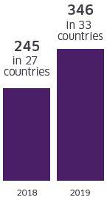

Support and develop STEM initiatives
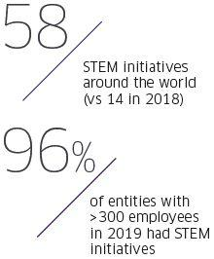

In 2019, we focused on topics related to STEM and 58 initiatives were organized in 17 countries, which was a significant increase from 14 initiatives in eight countries in 2018.

Our target of having at least one STEM initiative in each Company entity with more than 300 employees will be achieved by the end of the first quarter 2020. Initiatives developed in 2019 could be grouped in three main areas: working with schools and/or organizations to promote STEM for children, promoting STEM careers for students and young professionals, and promoting STEM for employees’ children.
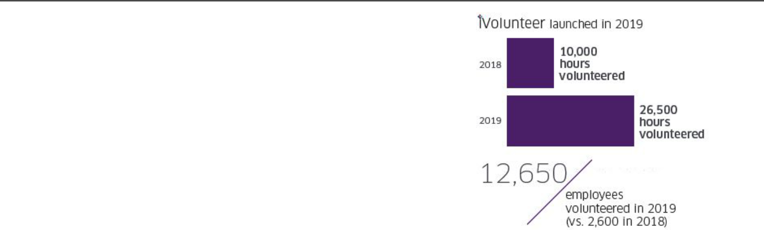

Enable employees to volunteer and support initiatives

In 2019, we launched our global volunteering program, iVolunteer, that enables employees to support initiatives in the communities where they live and work. The key purpose is to have a positive, tangible, and collective impact on these communities.

iVolunteer allows entities and countries to develop volunteering initiatives to further engage employees. Globally, approximately 12,650 of our employees participated in local initiatives and spent approximately 26,500 hours volunteering in 2019, which is over double the 10,000 hours volunteered in 2018.

- TechnipFMC

TechnipFMC Proxy Statement 2020

Below are some examples of our outreach in our communities in 2019:
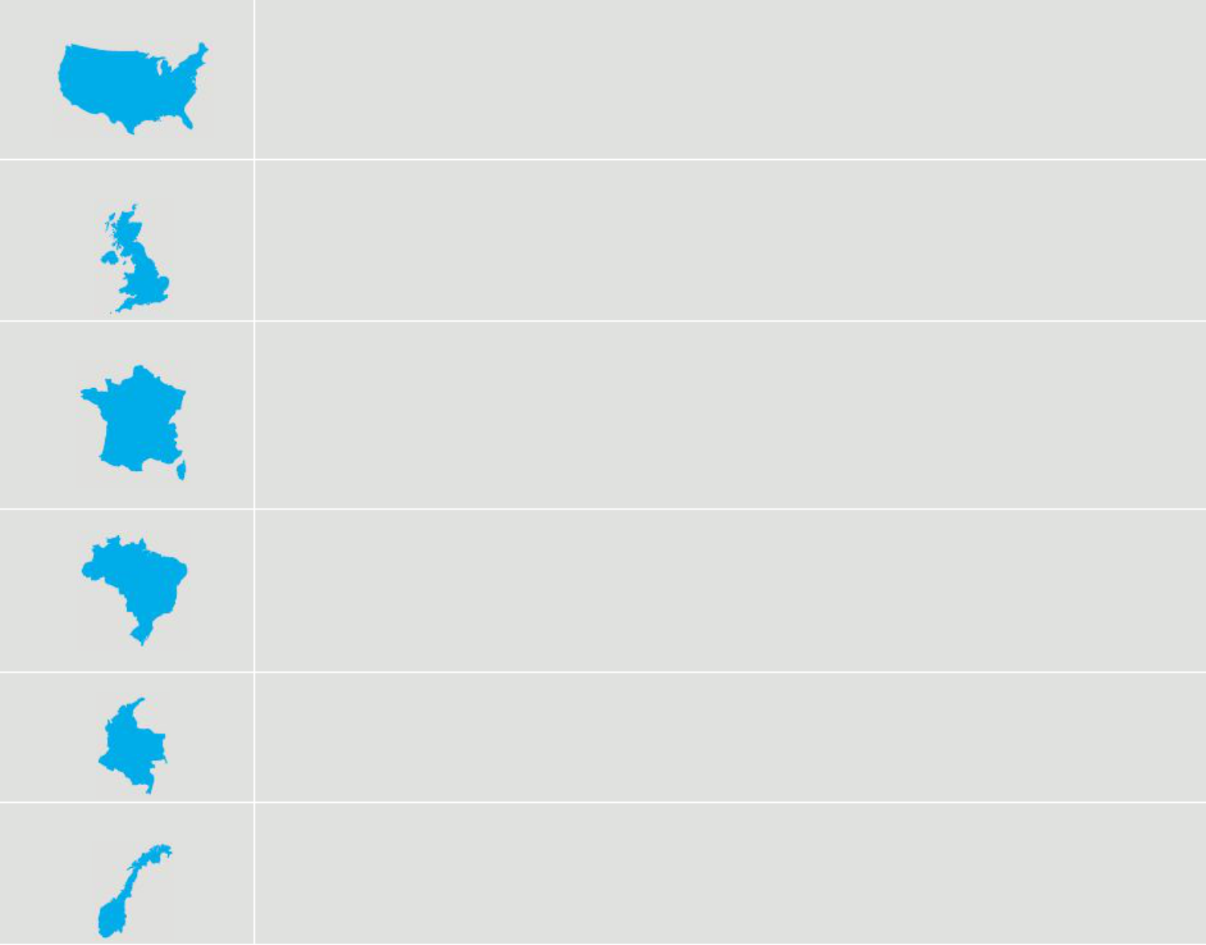

United States

We participate regularly in numerous events, including Women’s Initiative Day of Caring, Target Hunger Day of Caring, and the Veterans Program. Other initiatives include being part of the Houston Heart Walk, an annual fundraising event dedicated to spreading awareness about health, and being a sponsor for the Energy Day Festival to promote the STEM fields for thousands of local schoolchildren.

United Kingdom

Our volunteers have raised funds for, and partner with, local and national charities chosen by employees, including the Scotland Animal Welfare Charity, Chest, Heart and Stroke Scotland, Charlie House, Kayleighs Wee Stars, and Alzheimer Scotland. We also support events and network with other organizations that promote health, welfare, education, and diversity.

France

TechnipFMC in France supports the non-profit organization, Elles Bougent (Girls on the Move). Elles Bougent promotes gender diversity in STEM, as well as more accessibility to young female students in technical and industrial careers. We also arrange for the collection of clothes, books, and toys in Paris for donation to local charities for children, the homeless, and vulnerable families. TechnipFMC also makes donations to schools and associations in France to finance educational programs. Moreover, since 2018, our employees participated in the Enfants sans Cancer (Children without Cancer) city race to raise funds and awareness for this cause.

Brazil

In Brazil, we engage in a series of social and environmental programs involving underprivileged children and young students from neighboring communities to help them become better citizens and have equal opportunities. Also, in 2019, our volunteers organized a beach cleaning activity in Rio de Janeiro where half a ton of garbage was collected.

Colombia

In Colombia, we promote the respect of human rights of vulnerable populations through workshops, donations, and assistance, particularly the recyclers, street vendors, and homeless communities near our Bogota office.

Norway

Since 2018, our employees in Norway have participated in city walks, as part of our iVolunteer program, to raise money for local charities of employees’ choice, including children’s support charities, mental health charities, local hospitals, and charitable sports organizations.

- TechnipFMC

TechnipFMC Proxy Statement 2020
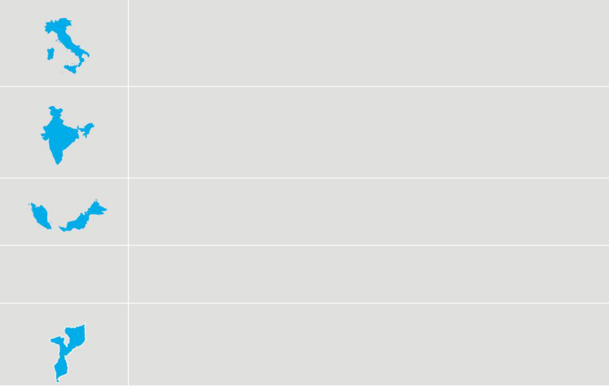

Italy

TechnipFMC in Italy, in collaboration with Technical School Enrico Fermi based in Rome, is involved in the Alternanza Scuola-Lavoro (Education-Work Rotation) project. Our Rome Operating Center is committed to deliver 400 individual hours of on-the-job training to 11 students on our premises. This collaboration enriches school programs with energy sector experience focused on oil and gas, enabling students to better understand the added value offered by working in our industry and at TechnipFMC.

India

In India, our impact-driven sustainable initiative, Seed of Hope, benefitted more than 10,000 lives by enabling STEM education for girls, skill development workshops for youth, and sponsoring school fees for underprivileged children. We have also installed 100 biogas units in a rural area and plastic recycling units to minimize our carbon footprint. Our commitment towards community well-being and UN Sustainable Development Goals has been recognized by the Ministry of Corporate Affairs with a National CSR Award 2019, conferred by the Honorable, President of India.

Malaysia

In Malaysia, we adopted four schools under the PINTAR School Adoption program, targeted at underprivileged schools with poor academic performance and students of lower socioeconomic status. Our TechnipFMC school adoption initiative dates back to 2011, and the initiative has helped approximately 500 students, equipping them with the necessary knowledge and skills through creative, innovative, and mentally stimulating teaching methods.

Indonesia

Our “Share to Care” campaign in Indonesia included the adoption of a home that houses farmers’ children and abandoned kids. This long-term program aims to provide the program’s children with education, training, and internships to sustain themselves. Currently, one child is interning in our Jakarta office, while another is interning in our Cakung manufacturing plant.

Mozambique

In March 2019, tropical cyclone Idai devastated Mozambique. Large parts of the country’s second largest city, Beira, were damaged, and entire villages and towns completely flooded. TechnipFMC donated $100,000 to assist disaster relief and recovery efforts. The funds helped with ongoing rescue efforts by the Red Cross and helped provide shelter and basic commodities for victims. Our employees also volunteered to work at the Maputo Bay to pack emergency relief kits that were sent to the communities impacted by the cyclone.

- TechnipFMC

TechnipFMC Proxy Statement 2020

Advancing Gender Diversity


Advancing Gender Diversity is our second sustainability pillar, and we believe it is not only a matter of responsibility, but also a business imperative for our success. We do not tolerate unlawful discrimination related to employment, and our Code of Business Conduct requires that employment decisions related to recruitment, selection, evaluation, compensation, and development, among others, are not influenced by race, color, religion, gender, age, ethnic origin, nationality, sexual orientation, marital status, or disability. We also ensure that our suppliers, customers, and business partners are aware of our goal of creating a diverse and tolerant workforce.

In the first quarter of 2018, we developed a global framework and key performance indicators for 2018 and beyond to promote and accelerate the development of women in all functions of our global organization.

Advancing Gender Diversity – Objectives

Our Advancing Gender Diversity objectives include the following :

 | Ensure gender pay equity | Improve gender balance in the | Promote women fairly and equally through
 | everywhere we operate and review all jobs to ensure | organization, across all functions | the career development process
 | gender pay equity and monitor them through a full | and levels
 | review every three years

- TechnipFMC

TechnipFMC Proxy Statement 2020

Ensure gender pay equity
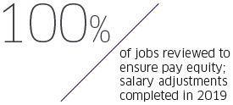

In 2018, we reviewed 100% of our Company job functions to ensure pay equity. We identified areas for improvement and completed all necessary salary adjustments in 2019 to ensure fair compensation for all of our employees. A job review and any necessary adjustments will be performed every three years to ensure that no pay gaps arise.

Improve gender balance

In 2019, to foster a diverse and inclusive culture, the Company launched its “Diversity & Inclusion — it Matters!” e-learning module with an aim to raise awareness of our differences and help our employees improve as people and professionals.

Our Company also fosters Employee Resource Groups (“ERGs”), which are voluntary, employee-led focus groups dedicated to a diverse and inclusive work environment. We currently have seven active ERGs with approximately 1,800 members in the United States, the United Kingdom, and Brazil, covering Diversity in STEM, Mothers Network, Black Organization for Leadership & Development, Young Professionals Group, Military Veterans & Friends Network, and Handicap Inclusion.

Our ambition is to encourage participation in ERGs throughout the whole Company. ERGs discuss and promote topics related to diversity and inclusion, develop and organize workshops internally and externally, support local initiatives, and propose actions to improve accessibility and inclusivity for all at the workplace.

Top 2019 initiatives:

The launch of “Diversity

- Inclusion – it Matters!” learning module

Diversity in STEM:

7 employee resource groups

(ERG) with ~1,800 members
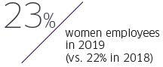

As of December 31, 2019, TechnipFMC had the following number of employees:

 | Male Employees |  | Female |  | Total |  | % of Female
 |  |  | Employees |  |  |  | Employees
 | 2018 | 2019 | 2018 | 2019 | 2018 | 2019 | 2018 | 2019
Executive officers | 8 | 7 | 3 | 4 | 11 | 11 | 27% | 36%
Senior managers | 98 | 84 | 17 | 24 | 115 | 108 | 15% | 22%
Employees on payroll (overall) | 28,987 | 28,760 | 8,157 | 8,407 | 37,144 | 37,167 | 22% | 23%

- TechnipFMC

TechnipFMC Proxy Statement 2020

Promote women fairly and equally
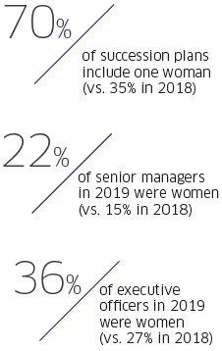

Continuous discussions around improving representation of women in the organization helps us promote women fairly and equally throughout their career development process within our Company. In 2019, our People and Culture team reviewed all senior management succession plans to ensure that female candidates were considered and included. As a result, 70% of our succession plans in 2019 include at least one woman, which is a significant increase from 35% in 2018.

- TechnipFMC

TechnipFMC Proxy Statement 2020

Respecting the Environment


Respecting the Environment is the third of our three sustainability pillars. We believe our environmental responsibility requires us to operate in a manner that minimizes the impact of our operations on the environment, develop sustainable solutions

to reduce carbon emissions within our overall environmental footprint, and avoid any environmental incidents in our operations and activities.

Respecting the Environment – Objectives

Our Respecting the Environment objectives include the following:

 | Reduce the carbon footprint of our facilities, | Provide the carbon footprint of | Establish an internal carbon price for the
 | products, and solutions and reduce our greenhouse | all our deliverables to clients | entire Company, including projects and
 | gas emissions |  | operations, to inform and impact investment
 | gas emissions |  | decisions

- TechnipFMC

TechnipFMC Proxy Statement 2020

Reduce our carbon footprint

TechnipFMC is committed to reducing carbon emissions and its overall environmental footprint by developing new, innovative, and sustainable solutions in the oil and gas market. In 2019, the Company adopted a Global Greenhouse Gas Management standard to enhance the Company’s capabilities in greenhouse gas (“GHG”) reduction in the Company’s business. In 2019, total GHG emissions decreased by 27% from 643,469 tons of CO2 equivalent in 2018 to 469,955 tons of CO2 equivalent in 2019. The reduction is mainly linked to the closure of important engineering, procurement, and construction (“EPC”) projects that completed the energy consuming phases in the first quarter of 2019.

In addition to our eﬀorts in reducing our carbon emissions within our operations, TechnipFMC is also working to ensure our next generation of products are less carbon intensive. For example, our Subsea 2.0TM design included a lifecycle GHG analysis that demonstrated how our innovations for the production of trees may allow up to a 46% reduction in our carbon footprint as compared to the previous design.

Moreover, a comprehensive Carbon Footprint Training Program was also launched by the Company’s HSE department for all business levels and projects. As of December 31, 2019, over 30 training sessions for engineers and managers had been delivered in key Company locations. This program is focusing on extended knowledge transfer, from the lifecycle perspective, and carbon footprint concepts to empower engineers in the implementation of a complete GHG analysis for all business lines and to increase managers’ competencies on the reduction of our carbon footprint at any company level.

- TechnipFMC

Greenhouse Gas Emissions
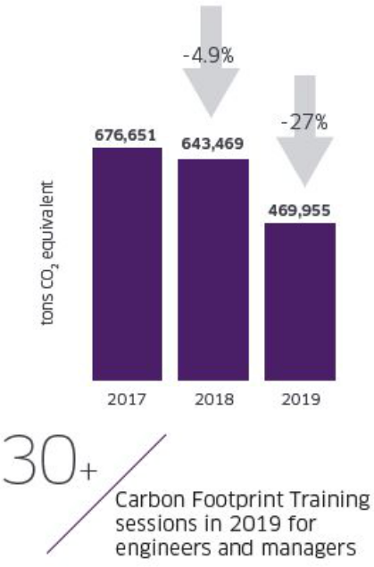

TechnipFMC Proxy Statement 2020

The annual quantity of GHG emissions measured in tons of CO2 equivalent resulting from activities for which the Company is responsible and has operational control, is described in the table below:

 | 2018 |  | 2019
Total GHG Emissions | Direct emissions | Indirect emissions | Direct emissions | Indirect emissions
(in metric tons CO2 equivalent) | Scope 1 | Scope 2 | Scope 1 | Scope 2
Our Assets | 254,535 | 60,401 | 283,545 | 39,932
Industrial sites | 10,968 | 40,778 | 9,701 | 21,375
Fleet | 242,117 | 21 | 272,292 | 0
Offices | 1,450 | 19,602 | 1,551 | 18,558
Our Projects | 319,523 | 9,010 | 132,572 | 13,906
including Construction sites and Yards/Bases:
Onshore/Offshore | 284,055 | 3,898 | 51,780 | 9,128
Subsea | 29,658 | 2,840 | 76,023 | 2,873
Other | 5,810 | 2,272 | 4,769 | 1,905
GHG Emissions by Scope | 574,058 | 69,411 | 416,117 | 53,838
Total GHG Emissions | 643,469 |  | 469,955

To ease yearly comparison and trend analysis, industrial sites, offices, and fleet are presented under Our Assets, being TechnipFMC’s permanent sites fully owned and operationally managed. Construction sites and Yards/Bases are aggregated under Our Projects and presented separately as they are usually temporary sites that are not owned by TechnipFMC but operationally managed during the construction phase. They are subject to important variations from one year to another, depending on the number and type of ongoing projects and the type of construction activities (e.g., early site work, civil work, construction, pre-commissioning, commissioning, or start-up).

Within our Assets, Scope 1, direct emissions (“Scope 1”), increased minimally, due to fleet activities compared to the same period in 2018, while Scope 2, indirect emissions (“Scope 2”), decreased by 34% compared to the same period in 2018. This reduction is associated with the Company’s asset energy transition in place in different countries where businesses are shifting towards certified renewables in offices and manufacturing plants. As part of the transition, 4,210 tons of CO₂ equivalent have been saved by renewable energy in use in offices and manufacturing areas.

With respect to TechnipFMC projects, a 59% reduction of Scope 1 emissions was registered in 2019 compared to the same period in 2018 due to the closure of several EPC projects in the first part of 2019. Scope 2 emissions increased slightly due to the restart of activities in several yards for new projects starting in the second part of 2019.

- TechnipFMC

TechnipFMC Proxy Statement 2020

The annual quantity of emissions from the purchase of electricity, heat, steam, or cooling by the Company is described in the table below:

Total GHG Emissions from purchase of | 2018 | 2019
(in metric tons CO2 equivalent)
Electricity | 69,304 | 53,725
Heat | 87 | 0
Steam | 0 | 0
Cooling | 20 | 113
Total Emissions | 69,411 | 53,838

GHG Emissions Intensity

The Company’s GHG emissions’ intensity factor is calculated using both direct and indirect emissions (Scope 1 and Scope 2 emissions) as a numerator and the environmental hours worked (corresponding to sites that contributed to environmental data reporting)1 as a denominator. Hours worked has been acknowledged as being the information that is the most representative of the Company’s overall activity and is frequently used in HSE standards in the industry.

(in kg eq. CO2/hours worked) | 2018 | 2019
Total GHG Emissions Intensity | 4.07 | 2.99

Methodology

Environmental data is collected through our HSE reporting system, Synergi, a global, integrated software solution. Each of the Company’s reporting entities is required to consolidate and record its environmental data in Synergi on a monthly basis. This data reflects the environmental performance of entities involved in the offices, construction sites, yards and spoolbases, manufacturing, and fleet operations when we own or manage the site in question and when we are responsible for managing the work.

Environmental data is aggregated for the analysis in Asset and Projects categories: industrial sites, fleet, and offices are consolidated as Our Assets since these three categories represent TechnipFMC’s permanent sites (owned or leased) under full operational control, while the EPC Construction sites and Yards/Bases are not all owned sites but are all under the operational control and responsibility of the Company for short- to medium-term periods (less than five years of activities). These definitions are set out in the Company’s guidelines on environmental reporting and are in line with our HSE principles and standards.

The reporting period is the 2019 calendar year. Figures for environmental indicators have been extracted from the Company reporting tool for the period from January 1, 2019 to December 31, 2019.

To calculate Scope 1 and Scope 2 GHG emissions, energy data registered by sites for electricity consumption and fuel consumption are converted using emission factors from the IPCC Guidelines for National Greenhouse Gas Inventories, 2006, and from CAIT v8.0, 2011. Emission factors are different depending on the type of fuel, method of generating electricity, and country. They are then integrated into the reporting tool that calculates the resulting CO2 emissions.

- Environmental Coverage is defined as the ratio between Environmental Worked Hours in locations reporting environmental data and HSE worked hours in all Company locations. Environmental Coverage in 2019 was 93.8%, which was stable compared to 93.6% in 2018. In 2019, approximately 234 locations, projects, and vessels reported environmental data compared to 213 locations, projects, and vessels in 2018.

- TechnipFMC

TechnipFMC Proxy Statement 2020

Provide the carbon footprint to our clients
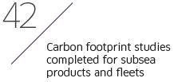

Our second Respecting the Environment objective aims to provide the carbon footprint of all our deliverables to clients through conceptual studies to help introduce our clients to new, low-carbon options in early stages of projects and highlight the carbon footprint differences between concepts as early as possible. In 2019, carbon footprint calculation modules were developed and are under implementation in both Onshore/Offshore and Subsea conceptual studies.

Internal carbon price
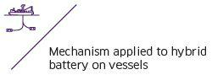

Since 2019, TechnipFMC has been developing a mechanism to establish an internal carbon price for the Company, focused on our assets, which should be implemented as part of the future Company’s investment decisions for capital expenditures. We followed the highest international standards on this topic, and, in 2019, we formed a business integrated Internal Carbon Price Workgroup with the participation of our HSE, EWG, Strategy, Finance, and Sustainability experts. The purpose of the workgroup was to assess the potential impact of an internal carbon price on TechnipFMC’s capital expenditures. A case study was performed and several internal carbon price methodologies were applied. The case study emphasized the improvement of the Company’s cumulative cash flow, internal rate of return, and the reduction of the payback period, and valorized the most sustainable solutions in terms of carbon emissions reduction.

As a result of the case study, we are further progressing the development of a global internal carbon price standard and guiding principles that will be implemented in the future.

- TechnipFMC

TechnipFMC Proxy Statement 2020

Environmental Certifications

Despite operating in a complex industry, we are committed to successfully managing our environmental impacts by eﬀectively measuring our environmental performance. The Company is operated in a manner that minimizes the environmental impact of, and risks associated with, our activities through eﬀective environmental management standards that are implemented in an extended lifecycle perspective.
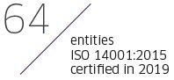
The Company maintains a policy of seeking to implement environmental certification ISO 14001 where practicable. To meet this commitment, TechnipFMC has implemented an environmental management framework. As of December 31, 2019, 64 entities have completed the transition to the new ISO 14001:2015 standard, including all head oﬃces and managed projects, industrial sites, and fleet. For each of these entities, the environmental management system was verified and certified by an independent third party.

2019 Environmental Initiatives

TechnipFMC has also joined global initiatives for the protection of the oceans from plastic pollution. Plastic is a valuable resource that needs to be responsibly used. The Company is committed to reducing its use of single-use plastic in day-to- day working activities. A Single-Use Plastic Elimination (“SUPE”) project was launched in 2018 in 52 locations, comprising 28% of Company locations, and in the fleet with the aim of eliminating single-use plastic or substituting it with more sustainable and reusable items. In 2018, the SUPE project saved approximately 167,000 plastic bottles and 2.3 million plastic cups.

In 2019, the SUPE project has been extended to over 40 countries. Approximately 139 locations, comprising 76% of Company locations, and over 30 vessels and projects have completed the elimination of single-use plastic bottles and cups.
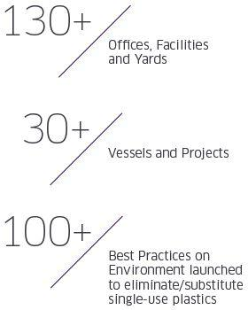

Single-Use Plastic Elimination Project
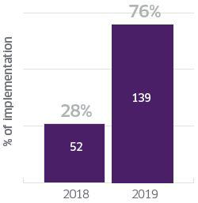

No. of Locations

- TechnipFMC

TechnipFMC Proxy Statement 2020

Corporate Governance

The Board believes that the purpose of corporate governance is to facilitate effective oversight and management of the Company to maximize shareholder value in a manner consistent with our vision statement, purpose, core values, Foundational Beliefs, Code of Business Conduct, and all applicable legal requirements.

The Board provides accountability, objectivity, perspective, judgment, and, in some cases, specific industry or technical knowledge or experience. In carrying out its responsibilities to our shareholders, the fundamental role of the Board is to ensure continuity of leadership; the implementation, understanding, and pursuit of a sound strategy for the success of our Company; and the availability of financial and management resources and the implementation of control systems to carry out that strategy.

Governance Guidelines and Key Board Practices

Our Corporate Governance Guidelines (“Governance Guidelines”) contain general principles and practices regarding the function of the Board and the Board committees. The Governance Guidelines establish a framework to guide the Board in its oversight responsibilities in a manner that is independent of management and aligned with the interests of our shareholders. The Board reviews these governance practices, the laws of England and Wales under which we are incorporated, the U.K. Disclosure Guidance and Transparency Rules, the regulations, directives, and decisions of the European Union, the rules and listing standards of the NYSE and Euronext, and the regulations of the SEC, as well as best practices recognized by governance authorities, to benchmark the standards under which it operates.

Key Elements and Practices

Composition of the Board. Our Board seeks to attract professionals who are not only qualified under the governance rules pertinent to our Company but also bring diversity of thought and experience. Our Nominating and Corporate Governance Committee considers multiple factors when determining whether a candidate is qualified to serve on our Board in order to achieve a balance between fresh perspectives and the deep knowledge and experience of our more tenured directors. As such, our Nominating and Corporate Governance Committee often considers a candidate’s:

- Experience in corporate management, as a board member of another publicly held company, and in finance and accounting and/or compensation practices

- Professional and academic experience relevant to our industry

- Leadership skills

- Cultural perspective and diversity of thought

- Ability to commit the time required for service on our Board

Board and Committee Evaluations. Each year, our directors complete a self-evaluation to determine whether the Board and its committees are functioning effectively. Additionally, each of the Audit, Compensation, Nominating and Corporate Governance, and Strategy Committees conducts a separate evaluation of its own performance and the adequacy of its charter. These evaluations include an assessment of the diversity of talents, expertise, and occupational and personal backgrounds of the Board members. The Nominating and Corporate Governance Committee receives comments from all directors and reports the results of the evaluations annually to the Board, as well as recommendations for improvements in the overall performance of the Board and its committees.

New Director Orientation and Continuing Education. An orientation program has been developed for new non-executive directors, which includes written materials and meetings with our executive officers. The orientation program is designed to provide general information about our Board and its committees; a review of director duties and

- TechnipFMC

TechnipFMC Proxy Statement 2020

responsibilities; and comprehensive information about our industry, operations, strategies, and challenges. The Board believes that ongoing education is important for maintaining an effective Board. Accordingly, our Board encourages directors to participate in ongoing education and reimburses directors for expenses incurred in connection with such education programs.

Retirement Policy. As further described in our Governance Guidelines, a non-executive director whose birth date occurs prior to July 1st must retire at the annual general meeting of shareholders of the Company during the year of such director’s 72nd birthday, and a non-executive director whose birth date occurs on or after July 1st must retire at the annual general meeting of shareholders of the Company the year following such director’s 72nd birthday. Our Board may waive this policy on a case-by-case basis on the recommendation of the Nominating and Corporate Governance Committee if it deems a waiver to be in the best interests of the Company and its shareholders.

Director Share Ownership Requirements. Within five years following initial election to the Board, directors are required to own Ordinary Shares with a value equal to or more than five times the Company’s annual cash retainer paid to directors.

Shareholder Engagement

Our relationship and ongoing dialogue with our shareholders is an important part of our Board’s corporate governance commitment. Our Lead Independent Director and Compensation Committee Chair, or our executives and management from our Legal, People and Culture, and Investor Relations groups, meet with shareholders regularly on a variety of topics. Management provides reports to the Board and its committees regarding the key themes and results of these conversations, including typical investor concerns and questions, and emerging issues related to governance, compensation, safety, and sustainability.

Although we were pleased that our shareholders voted in favor of all of our 2019 proposals, the approval threshold of 70% for our 2018 executive compensation program was below our preferred threshold of 75% for our proposals. This vote outcome prompted us to engage with shareholders and proxy advisory firms earlier than usual to connect and understand the reasons behind the support.

As such, we contacted shareholders and proxy advisory firms after our 2019 Annual Meeting to seek their views specifically on our executive compensation program and any governance-related feedback, including those related to negative votes for some of our directors. These transparent and productive discussions allowed us to better understand potential disconnects between our disclosure and how our compensation program actually operates.

Furthermore, in early 2020, we further engaged our shareholders in order to discuss more broadly our announced spin- off transaction, our Board leadership structure, our general Board practices, our executive compensation program, and our sustainability efforts. We welcomed our shareholders’ feedback and suggestions in maintaining the balance between strengthening the link between pay and performance, retaining and motivating our executives, and appropriately compensating our executives for outperformance, while increasing long-term shareholder value.

Overall, for our 2019-2020 engagement, we contacted proxy advisory firms and our top shareholders representing approximately 50% of our Ordinary Shares outstanding. Management, and in some instances, our Lead Independent Director or our Compensation Committee Chair, held meetings with proxy advisory firms and shareholders representing approximately 13% of our Ordinary Shares outstanding. Some shareholders did not require a meeting as they either indicated their support for our compensation and governance practices or did not have questions regarding our compensation or governance practices.

- TechnipFMC

TechnipFMC Proxy Statement 2020

Board Responsiveness to Shareholder Feedback

In 2019, we adjusted certain features of our compensation program and updated certain governance disclosures based on insightful feedback from our shareholders.


What We Heard |  | What We Did
Reinforce the link between annual |  |  | EBITDA as a Percentage of Revenue, which reflects the performance and sustainability of our business,
incentive metrics and business |  |  | was introduced as a metric under our 2018 annual incentive plan and continued as a metric in 2019, as
strategy |  |  | many shareholders confirmed that this metric, in addition to EBITDA ($) and Working Capital Days, is an
 |  |  | appropriate measure and aligned with shareholder interests.
 |  |  | Continued the use of ROIC in our long-term equity incentive plan, in addition to relative TSR. ROIC is an
 |  |  | absolute financial metric that measures management’s ability to eﬃciently allocate capital, and
 |  |  | performance for ROIC is measured against an internal target. The relative TSR metric is based on share
 |  |  | price performance relative to an external peer group. Due to the cyclical nature of the oil and gas
 |  |  | industry, shareholders have supported inclusion of both internal and external metrics in long-term equity
 |  |  | incentive plans.
 |  |  | Our CEO’s annual cash incentive bonus in 2019 was based on Company performance measures and
 |  |  | individual performance, the latter of which was based on specific objectives, including certain
 |  |  | sustainability objectives to further reinforce the Company’s commitment to our Foundational Beliefs.
Consider increasing the at-risk |  |  | For 2020, we will discontinue use of stock options, and performance- based equity will represent 70% of annual equity
portion |  |  | awards.
of executive compensation
 | Some shareholders do not consider
 | stock options as at-risk as they believe
 | time-based stock options do not include
 | performance conditions despite their
 | intrinsic performance threshold
Improve transparency on outcomes |  |  | This Proxy Statement provides details of performance and vesting for the 2017 PSU grant, our first PSU grant to vest
under annual incentive plan and |  |  | since the merger of Technip S.A. and FMC Technologies, Inc. (the “Merger”) was completed in 2017.
vesting of PSUs
 | Some shareholders requested clarity |  | All other incentive goals, performance, and payout outcomes were previously disclosed.
 | regarding PSU payouts during periods
 | of declining performance
Concern over the duration of two |  |  | We eliminated the role of Executive Chairman following completion of post-Merger integration and reduced to a single,
CEO-level compensation packages |  |  | CEO-level compensation structure. Mr. Pferdehirt’s compensation package was not materially increased with the
(for |  |  | assumption of additional Chairman duties.
separate Executive Chairman and
CEO)

- TechnipFMC

TechnipFMC Proxy Statement 2020
 | What We Heard |  | What We Did
 | Disclosing shareholder feedback from |  | We have added additional disclosure of our shareholder engagement program, including this list of feedback received,
 | shareholder engagement program |  | and our response to shareholder concerns.
 | and
 | Company response
 | Additional transparency regarding our |  | The Nominating and Corporate Governance Committee monitors the other board commitments of directors to ensure
 | directors’ other board commitments |  | their ability to diligently serve on the Board and our shareholders.
 | Some shareholders expressed possible |  | We have provided more detailed disclosures regarding how we evaluate our directors’ performance and commitment to
 | concern with overboarding |  | our Company, including other board commitments.
 | Additional disclosures regarding the |  | Sustainability is one of the Company’s Foundational Beliefs, and we have provided additional disclosures regarding our
 | Company’s sustainability focus |  | three sustainability pillars and our 2018 and 2019 sustainability efforts and achievements.
 | Concern regarding the independence |  | We clarified our disclosure related to the Company’s commercial agreement with Bpifrance Participations to explain the
 | of one of our directors, Arnaud |  | limited nature of the scope and duration of this agreement.
 | Caudoux, due to a commercial
 | agreement between an aﬃliate of
 | Banque publique d’investissement
 | (“Bpifrance”) and the Company
 | Concern regarding our director, |  | We have provided additional disclosure clarifying that Ms. Debon’s directorship with Lydec S.A. was related to her duties
 | Concern regarding our director, |  | and responsibilities as an executive officer of the Suez Group.
 | Marie-Ange Debon’s, service on other
 | public company boards when she also
 | served as an executive of the Suez
 | Group
 | Cautionary support for our Audit |  | We disclosed via our Form 10-K that our prior material weaknesses have been remediated and that our internal control
 | Committee due to previously
 | Committee due to previously |  | over financial reporting was effective as of December 31, 2019.
 | disclosed
 | material weaknesses in the
 | Company’s
 | internal control over financial
 | reporting


- TechnipFMC

TechnipFMC Proxy Statement 2020

Leadership Structure of the Board

Following the retirement of our former Executive Chairman, Thierry Pilenko, in May 2019, the independent members of our Board gave thoughtful consideration to the Board’s leadership structure. The Board believes that our shareholders are best served by a Board that has the flexibility to adjust our leadership structure to the evolving needs of the Company. With the completion of the post-Merger integration, the Board determined that combining the roles of Chairman and CEO, paired with a strong Lead Independent Director, would be in the best interests of our shareholders.

Each of their specific responsibilities are listed below:

Executive and Board Leadership


Key Responsibilities

All strategic and operational aspects of the Company

Serving as the principal external spokesperson for the Company with analysts, investors, media, and clients

Managing all executives of the Company

Leading the Board

High-level government and client engagement

Douglas J. Pferdehirt

Chairman of the Board and CEO

Independent Leadership

Pascal Colombani

Lead Independent Director

- TechnipFMC

Key Responsibilities


Approving Board meeting schedules and agendas

Presiding over all meetings of the Board at which the Chairman and CEO is not present

Presiding over executive sessions of the independent directors

Acting as the liaison between the independent directors and the Chairman and CEO Monitoring and reporting to the Board any conflicts of interests of directors

Participating in the Company’s shareholder engagement program

TechnipFMC Proxy Statement 2020

The determination to combine the Chairman and CEO role was based on the Board’s strong belief that a combined Chairman and CEO role leads to a more effective Board that remains balanced and independent due to the presence of a strong Lead Independent Director, while also creating a unified approach on corporate strategy development and execution and streamlining accountability for our performance. In making this determination, the Board also evaluated Mr. Pferdehirt’s performance as CEO and director, his positive relationships with other directors and senior management, and the strategic perspective, comprehension, and knowledge of day-to-day operations he would bring to the role of Chairman.

Balanced, Independent, and Effective Board – The Board believes that a combined Chairman and CEO leadership structure is balanced by the oversight of the remaining 13 members of our Board, each of whom is an independent director, and ensures that the Board functions independently. Moreover, only independent directors serve on our Audit Committee, Compensation Committee, and Nominating and Corporate Governance Committee. In addition, the Board nominated Mr. Colombani to serve as Lead Independent Director, who has the ability to call meetings of the Board and presides over executive sessions of the Board. For transparency and alignment, our Compensation Committee consults all independent directors in setting our CEO’s compensation, but the authority to approve our CEO’s compensation remains with the fully independent Compensation Committee. In addition, our CEO’s annual performance objectives are reported and evaluated by both the Compensation Committee and the Nominating and Corporate Governance Committee to ensure a comprehensive, inclusive, and diverse analysis and evaluation of our CEO’s annual performance. Finally, the Board believes that the Company’s Governance Guidelines, and the quality, stature, and substantive business knowledge of the Board, as well as the Board’s culture of open communication and transparency with the CEO and senior management are conducive to Board effectiveness with a combined Chairman and CEO position.

Unified Approach on Corporate Strategy Development and Execution – Mr. Pferdehirt is the individual with primary responsibility for managing the Company’s day-to-day operations and is best positioned to chair regular Board meetings as the Board discusses key business and strategic issues and to focus the Board’s attention on strategies and opportunities of greatest importance to the Company and its shareholders. This has proven to be particularly important given the Company’s announced spin-off of Technip Energies. This leadership structure also allows the Board to benefit from Mr. Pferdehirt’s knowledge of the Company’s business, market opportunities, and risks, and facilitates communications and relations with other members of senior management.

Streamline Accountability – Combining the roles of Chairman and CEO creates a clear line of authority that promotes decisive and effective leadership, both within and outside the Company.

As our Company evolves, the Board will regularly evaluate the Board leadership structure to ensure it continues to meet the needs of the Company, and to ensure that it provides strong, independent oversight for our shareholders.

In particular, as part of this evaluation, the Board will take under consideration the outcomes of the annual Board and committee self-evaluation process as well as feedback received from shareholders, in addition to other factors, including the current state of the Company’s strategy and operations, recent Company performance, market and industry factors, and peer company practices.

- TechnipFMC

TechnipFMC Proxy Statement 2020

Board Composition and Criteria for Board Membership

Our Board seeks directors whose complementary and diverse knowledge, experience, and skills provide a broad range of perspectives and leadership expertise in the energy and engineering industry, strategic planning and business development, business operations, sustainability and emerging technologies, finance and audit, corporate governance, and other areas important to the Company’s strategy and oversight. Our Board also assesses director age and tenure and Board continuity and strives to achieve a balance between the perspectives of new directors and those of longer-serving directors with industry and institutional insights.

Criteria for Board Membership in Governance Guidelines

Our Governance Guidelines state that candidates for our Board, in order to be nominated by our Nominating and Corporate Governance Committee (or a subcommittee thereof), must be qualified and eligible to serve under applicable law, our articles of association (“Articles”), and the NYSE and Euronext rules, and should have:

A high level of personal and professional integrity

Strong ethics and values

The ability to make mature business judgments

In addition, the Governance Guidelines provide that the Nominating and Corporate Governance Committee, or relevant subcommittee, may consider additional factors when determining whether a candidate is qualified to serve on our Board, including the candidate’s:

Experience in corporate management, as a board member of another publicly held company, and in finance and accounting and/or compensation practices

Professional and academic experience relevant to our industry

Leadership skills

Cultural perspective and diversity of thought

Ability to commit the time required for service on our Board

Board Composition, Refreshment, and Succession Planning

The Nominating and Corporate Governance Committee regularly evaluates the composition of our Board and considers whether the Board has the right set of backgrounds, experience, skills, diversity, and qualifications to effectively oversee our Company’s strategy and our executives’ execution of that strategy. One of the key goals of our Board composition is to ensure we have the right skills and experience on our Board to execute our strategic goals successfully and efficiently. Our current directors possess a diversity of skills, experience, and expertise that are relevant to our business, such as experience in the following:

Executive leadership

Industry experience

Corporate governance and legal

Strategy and risk management

Cultural and gender diversity

Sustainability and emerging technologies

Outside public company board service

- TechnipFMC

TechnipFMC Proxy Statement 2020

Finance and audit

Acquisition, divestment, and investment portfolio management

In 2019, two of our directors, Messrs. Thierry Pilenko and Richard Pattarozzi, retired at our 2019 Annual Meeting. Our Nominating and Corporate Governance Committee, with the assistance of Spencer Stuart, a nationally recognized director search firm, identified, screened, and assessed the capabilities of potential new director candidates. This rigor assisted the Company in identifying and retaining two new Board members in 2019, Messrs. Olivier Piou and John Yearwood, as part of our ongoing Board refreshment focus.

In addition to evaluating directors’ skills and experience that tie directly to our business strategy, the Nominating and Corporate Governance Committee also regularly considers any changes in the professional status, independence, outside commitments, and other public company directorships of our directors to assess the potential impact of these changes on the Board’s effectiveness.

As further described in our Governance Guidelines, a non-executive director whose birth date occurs prior to July 1st must retire at the annual general meeting of shareholders of the Company during the year of such director’s 72nd birthday, and a non-executive director whose birth date occurs on or after July 1st must retire at the annual general meeting of shareholders of the Company the year following such director’s 72nd birthday. Our Board may waive this policy on a case-by-case basis on the recommendation of the Nominating and Corporate Governance Committee if it deems a waiver to be in the best interests of the Company and its shareholders.

- TechnipFMC

TechnipFMC Proxy Statement 2020

Board and Committee Evaluations

The Board believes that a rigorous evaluation process is an essential component of strong corporate governance practices. The Nominating and Corporate Governance Committee reviews regularly the Board’s composition, including the key skills and experience represented on the Board, to ensure it meets the changing needs of the business, also taking into consideration the outcomes of the annual Board and committee self-evaluation process, feedback received from shareholders, and evolving market best practices with respect to governance.

The Nominating and Corporate Governance Committee’s annual evaluation process to evaluate Board effectiveness includes a full Board evaluation and committee evaluations.

Process is Initiated |  | Evaluation Distributed | Analysis | Presentation of
 |  | Evaluation Distributed | Analysis | Results
The Nominating and Corporate Governance |  | Questionnaires are distributed through a third-party web-based | Completed questionnaires are | The Nominating and Corporate
Committee reviews and approves the |  | platform. The process encourages candid responses from our | analyzed and summarized by Company | Governance Committee Chair reviews
process to evaluate the performance of the |  | directors and promotes productive discussions. | management and reported to the | the results of the evaluations with the
Board of Directors and its four committees. |  | Questionnaires solicit feedback on issues, including: | Nominating and | full Board and each committee to
 |  | Questionnaires solicit feedback on issues, including: | Corporate Governance Committee | determine areas of opportunity.
 |  | Board/Committee operations | Chair.
 |  | Succession planning
 |  | Committee composition, processes and effectiveness
 |  | Board dynamics
 |  | Director preparation, participation, and contribution
 |  | Management preparation and communications
41 | TechnipFMC

TechnipFMC Proxy Statement 2020

Board Commitments

In conjunction with our Board and committee evaluations, our Nominating and Corporate Governance Committee is responsible for ensuring that our directors possess and demonstrate a willingness to devote the required time and attention to Board duties and to otherwise fulfill the responsibilities required of directors. During our 2019-2020 shareholder engagement, certain institutional investors and proxy advisory firms raised concerns about potential overboarding.
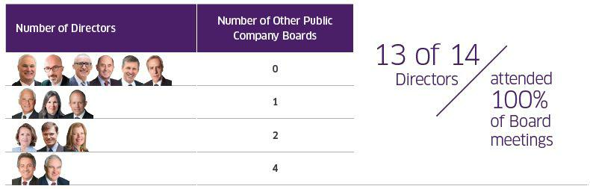

As noted above, a majority of our directors serve on just one or no other public company board of directors. Our Nominating and Corporate Governance Committee and our Board believe that each of our directors has demonstrated, and will continue to demonstrate, her or his expertise and ability to dedicate sufficient time to carry out Board duties effectively and diligently. Our directors’ outside board service or other commitments did not limit their ability to devote the required time and attention to their duties as directors of the Company as evidenced by the 100% attendance rate at our Board meetings for all but one director.

In assessing our directors’ ability to devote the required time to his or her Board duties, the Nominating and Corporate Governance Committee reviews the nature of the other companies on which they serve, including whether any board service is with a company that is either affiliated with their employer or affiliated with one of their other directorships. The committee also discusses with each director the time commitments and expectations of his or her other board duties to ensure that he or she can continue to serve the Company and its shareholders effectively. Noted below are examples of the relationships the Nominating and Corporate Governance Committee considered when confirming a director’s ability to serve on our Board.

Mr. Carvalho Filho’s duties as a director of Companhia Brasileira de Distribuicão (Grupo Pão de Açúcar) (“GPA”) include serving on the board of Cnova N.V., an affiliate of GPA. GPA has a 34% ownership interest in Cnova N.V. and three out of nine directors on Cnova N.V.’s board of directors are appointed by GPA. As such, Mr. Carvalho Filho’s role and time commitment at these two companies differs from serving on two traditional, unrelated publicly-traded companies.

During 2019, Ms. Debon’s duties as Senior Vice President of Suez Group included serving as a director of Suez Group’s subsidiary, Lydec S.A., which is a closely-held corporation of Suez Group. Lydec S.A.’s financials are fully consolidated with those of Suez Group, and as such, Ms. Debon’s role at Lydec S.A. differed from a traditional, publicly-traded company since her directorship was related to her position and responsibilities as Senior Vice President of Suez Group.

- TechnipFMC

TechnipFMC Proxy Statement 2020

Shareholder Recommendations for Future Candidates

Shareholders may submit recommendations for future candidates for election to the Board for consideration by the Nominating and Corporate Governance Committee by writing to us at One St. Paul’s Churchyard, London EC4M 8AP, United Kingdom, Attention: Corporate Secretary. We may move our principal headquarters after our spin-off transaction is completed. If and when this happens, please visit our website at www.TechnipFMC.com for our new address. All recommendations from shareholders will be reviewed by the Nominating and Corporate Governance Committee. The Nominating and Corporate Governance Committee evaluates nominees recommended by shareholders in the same manner in which it evaluates other nominees. Please see “Criteria for Board Membership in Governance Guidelines” above.

- TechnipFMC

TechnipFMC Proxy Statement 2020

Enterprise Risk Management

Executive management is responsible for the day-to-day management of the risks the Company faces, while our Board, as a whole and through its various committees, has responsibility for the oversight of risk management for the Company. The Company has an Enterprise Risk Management (“ERM”) process and framework to identify and evaluate varying levels of risk and their potential impact on the Company, as well as steps to further mitigate those risks. As part of the ERM framework, our senior management, led by our CEO, undertakes a process that identifies, categorizes, and analyzes the relative severity and likelihood of the various risks to which the Company is or may be subject. In addition, our Board and its committees receive periodic reports from senior management that identify and assess significant enterprise- related risks and address mitigation strategies and plans implemented or proposed for each key risk. In 2019, the Company retained external consultants to review our ERM program and benchmark our risk identification and mitigation processes against best practices within the industry.

In addition, while the Board has ultimate responsibility for overall risk management oversight, it has designated each of its four Board committees with oversight of certain risks within their own areas of responsibility, as indicated in the table below.


Audit

Financial reporting

Liquidity

Contract management

Cybersecurity

Legal and regulatory compliance related to financial statements and disclosures

Information-related risks, such as cybersecurity, taxes, and foreign exchange

Insurance

Compensation

Compensation policies and practices (including employee benefit plans and administration of equity plans)

Nominating and Corporate Governance

Legal and regulatory corporate governance compliance

Director succession

Crisis management preparedness

Emergency procedures for management succession

Environmental, sustainability, and governance

Strategy

Global strategy related to emerging or evolving competitive activity, governmental or legislative developments, and global economic conditions

- TechnipFMC

TechnipFMC Proxy Statement 2020

Committees of the Board of Directors

Our Board has an Audit Committee, a Compensation Committee, a Nominating and Corporate Governance Committee, and a Strategy Committee, each of which comprises at least four directors, selected by the Board upon the recommendation of the Nominating and Corporate Governance Committee. Each member of our Audit Committee, Compensation Committee, and Nominating and Corporate Governance Committee meets the heightened independence standards

as defined under the NYSE’s listing standards and SEC rules, as applicable. Additionally, each member of our Audit Committee qualifies as an “audit committee financial expert,” as defined by SEC rules.

Following our announced spin-off transaction, TechnipFMC and Technip Energies will each have an Environmental, Sustainability, and Governance Committee to better reflect our focus on these critical areas. For TechnipFMC, this committee will replace its current Nominating and Corporate Governance Committee.

The Board receives regular updates from its committees on individual categories of risk, including strategy, financial/ operations, cybersecurity, people, technology, investment, legal/compliance, political/legislative/regulatory, and corporate responsibility and sustainability. Each of these committees operates pursuant to a written charter setting out the functions and responsibilities of the committee, which is reviewed annually, and may be viewed on our website at www.TechnipFMC.com under the heading “About us > Governance.”

Audit Committee

2019 Meetings: 5

Members | Primary Responsibilities
Marie-Ange Debon | Oversight of the financial management and control of the Company, as well as oversight of the Company’s independent registered
(Chair) | public accounting firm
Eleazar de Carvalho | Monitoring the Company’s financial reporting process
Filho | Reviewing the Company’s consolidated financial statements and internal controls with management and the independent auditor
Arnaud Caudoux
Arnaud Caudoux | Monitoring the Company’s compliance with its internal accounting and control policies, as well as legal and regulatory requirements to
Kay G. Priestly
Kay G. Priestly | the extent such compliance relates to the consolidated financial statements and financial disclosures
Joseph Rinaldi | Selecting, subject to shareholder approval, the Company’s independent auditor, and reviewing the qualifications, independence,
 | performance, and remuneration of such independent auditor
 | Reviewing the effectiveness and performance of the Company’s internal audit function
 | Considers risks relating to cybersecurity and receives regular reports on the Company’s cyber readiness, adversary assessment, risk
 | profile status, and any countermeasures being undertaken or considered by the Company
 | Reviewing the effectiveness of processes for reviewing and escalating financial-related allegations reported through the Company’s
 | allegation hotline

- TechnipFMC

TechnipFMC Proxy Statement 2020

Compensation Committee

2019 Meetings: 5

Members | Primary Responsibilities
James M. Ringler | Reviewing, evaluating, and approving the agreements, plans, policies, and programs of the Company to compensate its independent
(Chair) | directors, the Chairman and CEO, and other officers
Claire S. Farley | Consistent with equity plans approved by the Company’s shareholders, reviewing, evaluating, and approving all equity awards by the
John O’Leary | Company to executive officers and approving the number of equity securities or equity derivatives that the CEO is authorized to allocate
John O’Leary | to all other employees at his discretion
Joseph Rinaldi | to all other employees at his discretion
Joseph Rinaldi | Reviewing the compensation disclosures in the Company’s U.K. annual report and proxy statement for the Company’s annual general
John Yearwood
John Yearwood | meeting of shareholders
 | Producing the Compensation Committee Report to be included in the Company’s proxy statement
 | Reviewing, evaluating, and approving the directors’ remuneration policy and the directors’ remuneration report
 | Otherwise discharging the Board’s responsibilities related to compensation of the Company’s executive officers and directors

Nominating and Corporate Governance Committee

2019 Meetings: 6

Members | Primary Responsibilities
Peter Mellbye (Chair) | Advising and making recommendations to the Board regarding appropriate corporate governance practices and assisting the Board in
Pascal Colombani | implementing those practices
Didier Houssin | Monitoring the development and implementation of the Company’s compliance program (including procedures for allegation reporting,
Didier Houssin | investigation, and remediation) to ensure that the Company operates in compliance with the principles of ethical conduct and good
Olivier Piou
Olivier Piou | governance
John Yearwood | Reviewing the Company’s corporate responsibility and sustainability program and key performance indicators
 | Reviewing the Company’s succession plans for the Executive Chairman, CEO, and other executive officers
 | Identifying individuals qualified to become members of the Board and recommending director nominees for election at
 | the annual general meeting of shareholders or for appointment to fill vacancies on the Board
 | Recommending directors to serve on each committee of the Board and recommending the Lead Independent Director
 | Leading the Board in the annual performance evaluation of the Board and its committees

- TechnipFMC

TechnipFMC Proxy Statement 2020

Strategy Committee

2019 Meetings: 5

Members

Douglas J. Pferdehirt (Chair)

Pascal Colombani

Claire S. Farley

Didier Houssin

Peter Mellbye

Olivier Piou

Primary Responsibilities


Reviewing the development and implementation of the Company’s long-term global strategy, risks, and opportunities relating to such strategy

Reviewing strategic decisions regarding major asset acquisitions, divestitures, joint ventures, and strategic alliances by the Company

Board Meetings and Attendance

Our Board met in person or by telephone conference seven times in 2019.
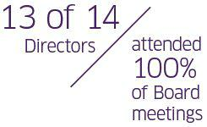

All directors except one attended 100% of our Board meetings in 2019. Mr. Ringler missed one Board meeting due to a family member’s illness, resulting in an 86% attendance rate.

All directors except two attended 100% of their committee meetings. Mr. Ringler missed a Compensation Committee meeting for the same reasons noted above, resulting in an 80% attendance rate, and Mr. Piou missed one Nominating and Corporate Governance Committee meeting due to a previous commitment that was made known to our Board prior to his on-boarding in June 2019, resulting in a 67% attendance rate.

We encourage our directors to attend the annual general meeting of shareholders. Five of our directors attended our 2019 Annual Meeting.

- TechnipFMC

TechnipFMC Proxy Statement 2020

Director Independence

Annual Review of Independence

The Nominating and Corporate Governance Committee conducts an annual review of the independence of Board members and reports its findings to the full Board, which then makes a determination as to the independence of each director, as defined under the standards adopted by the NYSE. These standards specify certain relationships that are prohibited in order for a director to be deemed independent. In addition to these objective standards, our Board makes a subjective determination of independence by evaluating all relevant facts and circumstances. In particular, when assessing the materiality of a director’s relationship with the Company, the Board considers the issue not merely from the standpoint of the director, but also from the standpoint of persons or organizations with whom the director has an affiliation.

The Board has not adopted a policy that deems a director to be non-independent after a certain tenure on the Board as we believe our retirement policy and natural turnover will achieve the appropriate balance between long-term directors with deep institutional knowledge and new directors who bring fresh perspectives and diversity to our Board. Our Board reviews director tenure in connection with its director independence determinations. If all of our director nominees are elected at the Annual Meeting, the average tenure of our independent directors will be three years as the Board believes prior service on our legacy companies differed in breadth and scope from current service on our Board.

The Board’s independence determinations included a review of all 2019 commercial transactions, relationships, and arrangements between us and our subsidiaries, aﬃliates, and executive oﬃcers with entities associated with our directors or members of their immediate family. Such transactions, relationships, and arrangements are summarized below.

The Board considered that Mses. Debon, Farley, and Priestly and Messrs. Houssin, Mellbye, O’Leary, and Ringler each served as directors or executive officers at companies that have had commercial business relationships with the Company in 2019, all of which were ordinary course commercial transactions

Arnaud Caudoux – The Company’s prior commercial agreement with Bpifrance Participations, a subsidiary of Bpifrance, was erroneously described as a “consulting agreement” instead of a subscription agreement in our 2019 Proxy Statement. Bpifrance, which owns Bpifrance Participations, is a Company shareholder and Arnaud Caudoux is Deputy Chief Executive Officer and an executive director. Under the subscription agreement, Bpifrance Participations provided access and introductions to start-up companies registered with Bpifrance Participations’ Le Hub that matched our Company’s investment criteria. Mr. Caudoux had no involvement related to this subscription agreement, and he did not receive any direct compensation or direct financial benefit from this agreement. The agreement terminated on April 1, 2019, and has not been extended or renewed. In addition, due to Bpifrance’s policies, Mr. Caudoux has waived his annual cash and equity remuneration for his services as a director, and asserts that he is able to act in the best interests of all TechnipFMC shareholders.

Pascal Colombani – Mr. Colombani is a member of the Europe, Middle East, and Asia (“EMEA”) advisory board of JPMorgan Chase Bank, N.A., which is a lender under the Company’s revolving credit facility and may be party to other ordinary course banking transactions with the Company. Mr. Colombani’s role as a member of the EMEA advisory board of JPMorgan Chase Bank, N.A. did not involve any discussion or deliberations regarding the Company’s revolving credit facility.
Claire S. Farley – In 2019, after a robust due diligence and evaluation process, the Company selected KKR & Co. (“KKR”) to be its recommended provider for our Subsea clients seeking alternative financing arrangements. Ms. Farley is a Senior Advisor of KKR and was not involved in the preparation of KKR’s presentation to the Company, which was submitted by a separate group at KKR than the group managed by Ms. Farley. When providing these financing

- TechnipFMC

TechnipFMC Proxy Statement 2020

arrangements, KKR would contract directly with the Company’s clients with no direct involvement of the Company, and Ms. Farley, in her role at KKR, has no involvement with any such contracts. Ms. Farley will not receive any direct compensation or direct financial benefit from the selection of KKR by the Company.
Didier Houssin – The Company is party to a technology development agreement with IFP Énergies Nouvelles (“IFPEN”), which is a shareholder, where Mr. Houssin is Chairman and Chief Executive Officer. The agreement was established in 2004 between Technip and IFPEN, which was prior to Mr. Houssin joining IFPEN as director in 2015. The agreement was amended in 2017, and Mr. Houssin recused himself from Board deliberations regarding the approval of the amendment. Mr. Houssin does not receive any direct compensation or direct financial benefit from this technology development agreement.

James M. Ringler – FMC Technologies and John Bean Technologies Corporation (“JBT”) are parties to a separation and distribution agreement and a tax sharing agreement that relate to the spin-off of FMC Technologies’ FoodTech and Airport Systems businesses (acquired by JBT) that occurred in July 2008.

Independence Determination

In determining that none of the relationships noted above affected the independence of any of the interested directors, the Nominating and Corporate Governance Committee considered the nature of the transactions, the dollar amounts involved, and the respective director’s role, if any, in the transaction.

Based on the report and recommendation of the Nominating and Corporate Governance Committee, the Board has affirmatively determined that each of our non-executive directors is “independent” as defined under the NYSE listing standards. As such, following our Annual Meeting, 13 of our 14 directors will be non-executive, independent directors. In addition, the Board has affirmatively determined that all of the members of the Audit Committee and Compensation

Committee satisfy the enhanced independence criteria required for such members under regulations adopted by the SEC and NYSE listing standards.

Compensation Committee Interlocks and Insider Participation in Compensation Decisions

In 2019, the members of the Compensation Committee of the Board were Claire S. Farley, John O’Leary, Richard A. Pattarozzi (member through May 1, 2019), Joseph Rinaldi, James M. Ringler, and John Yearwood (member since June 1, 2019), none of whom has ever been an officer or employee of the Company or any of our subsidiaries or had any relationships requiring disclosure with us or any of our subsidiaries. None of our executive officers has ever served on the board of directors or the compensation committee of any other entity that has had any executive officer serving as a member of our Board or Compensation Committee.

Communications with Directors

To provide our shareholders and other interested parties with a direct and open line of communication to our Board, a process has been established for communications with any member of the Board, including our Lead Independent Director, the Chair of any of our committees, or with our non-employee directors as a group, by sending such written communication to c/o Lead Director, TechnipFMC plc, One St. Paul’s Churchyard, London EC4M 8AP, United Kingdom. We may move our principal headquarters after our spin-off transaction is completed. If and when this happens, please visit our website at www.TechnipFMC.com for our new address. All communications will be received, processed, and then directed to the appropriate member(s) of our Board, other than, at the Board’s request, certain items unrelated to the Board’s duties, such as spam, junk mail, solicitations, employment inquires, and similar items.

- TechnipFMC

TechnipFMC Proxy Statement 2020

Director Compensation

This section describes the Company’s compensation programs that apply to our non-executive directors. The compensation of our Chairman and CEO, Douglas Pferdehirt, is included in the “Executive Compensation Discussion and Analysis” section below because he is an NEO under SEC rules.

Non-executive Director Compensation

Compensation for our non-executive directors was developed by the Compensation Committee with the assistance of its compensation consultant, Willis Towers Watson, and approved by the Board. The program, which comprises cash compensation and RSU awards, is designed to reflect the practices of both U.S. and European companies as determined by reference to the peer groups discussed in “Executive Compensation Discussion and Analysis.”

The directors’ compensation program is intended to provide a competitive package that enables the Company to attract and retain highly skilled individuals with relevant experience and the necessary time and ability to serve on the board of a company of our size, complexity, and geographical breadth. The program balances the practices within our market norms in our core geographies, and the varied expectations of our diverse shareholder base. Given the global talent pool that our directors represent, the program is also designed to provide sufficient flexibility in the form of compensation delivered to meet the needs of individuals who are located in different countries and the travel that is often required to attend meetings, while ensuring that a substantial portion of directors’ compensation is linked to the long-term success of the Company.

Key Non-executive Director Compensation Practices


- TechnipFMC uses an independent consulting firm, Willis Towers Watson, to recommend changes in compensation for non-executive directors.

- Any changes to our director compensation program are reviewed and approved by our Compensation Committee, comprising independent directors.

- Any changes to our director compensation program recommended by our Compensation Committee must be ratified by a vote of our full Board.

- Our Directors’ Remuneration Policy reflects sector and geographic (U.S. and European) peer groups to reflect the global nature of the Company, and both U.S. and European compensation practices given the global nature of the Company, our dual NYSE and Euronext Paris listings, and our U.K. incorporation.

- Our Directors’ Remuneration Policy provides for an annual cap on total remuneration (i.e., cash and equity awards) of $500,000.

- Each non-executive director is subject to a share ownership requirement of 5x the annual cash retainer.

- TechnipFMC

TechnipFMC Proxy Statement 2020

Components of Non-executive Director Compensation

The following table describes the components of the Company’s non-executive director compensation program for 2019 pursuant to our Directors’ Remuneration Policy, which was approved at our 2018 Annual Meeting.


Compensation Element | Compensation
Annual Cash Retainer | $100,000
Annual Equity Grant | $175,000 in RSUs, vesting after one year of service and settled upon leaving the Board
 | Starting with the 2020 award, non-executive directors will have the opportunity to elect the year in which they
 | will take receipt of the equity grants from either (a) a period of 1 to 10 years from
 | the grant date or (b) upon their separation from Board service. The elections are made prior to
 | the beginning of the grant year and are irrevocable after December 31st of the year prior to
 | grant.
Annual Chair Fee | $20,000 for Audit Committee
 | $15,000 for Compensation Committee
 | $10,000 for Nominating and Corporate Governance Committee
 | $10,000 for Strategy Committee
Annual Lead Independent Director Fee | $50,000
Committee Meeting Fee | $2,500 per committee meeting
Other Benefits | Reimbursement of travel and other related expenses incurred in connection with attending Board and
 | committee meetings
 | Assistance for the annual individual U.K. tax return
 | Participation in our matching charitable contribution program on the same terms as employees

- TechnipFMC

TechnipFMC Proxy Statement 2020

Non-executive Director Compensation Table

The following table details the total compensation for our non-executive directors for the year ended December 31, 2019. Our former Executive Chairman, Mr. Pilenko, and current Chairman and CEO, Mr. Pferdehirt, are not included in the table below as they were employees during 2019 and did not receive any additional compensation for their service as a director.

Name | Annual Cash | Additional Fees | Stock Awards ($)2 | All Other | Total ($)
 | Retainer ($) | ($)1 |  | Compensation ($)
Arnaud Caudoux³ | 0 | 0 | 0 | 0 | 0
Eleazar de | 100,000 | 12,500 | 174,994 | 1,104 | 288,598
Carvalho Filho
Pascal Colombani | 100,000 | 50,000 | 174,994 | 1,104 | 326,098
Marie-Ange Debon | 100,000 | 32,500 | 174,994 | 1,104 | 308,598
Claire S. Farley | 100,000 | 22,500 | 174,994 | 1,104 | 298,598
Didier Houssin | 100,000 | 25,000 | 174,994 | 1,104 | 301,098
Peter Mellbye | 100,000 | 35,000 | 174,994 | 1,104 | 311,098
John O’Leary | 100,000 | 12,500 | 174,994 | 1,104 | 288,598
Richard A. Pattarozzi⁴ | 50,000 | 35,000 | 174,994 | 1,448 | 261,442
Olivier Piou⁵ | 58,333 | 12,500 | 0 | 0 | 70,833
Kay G. Priestly | 100,000 | 12,500 | 174,994 | 1,104 | 288,598
Joseph Rinaldi | 100,000 | 25,000 | 174,994 | 2,668 | 302,662
James M. Ringler | 100,000 | 25,000 | 174,994 | 2,159 | 302,153
John Yearwood⁵ | 58,333 | 15,000 | 0 | 0 | 73,333

- Includes the amount of the fees paid for attendance at committee meetings, and additional fees paid to the Chair of each Board committee and to the Lead Independent Director.
- RSU grants were made on March 8, 2019, valued at $20.98 per share, the closing price on the NYSE of the Company’s Ordinary Shares on that date. The aggregate value for all of the Company’s non-executive directors was $1,924,936 as of the grant date and was computed in accordance with the SEC proxy disclosure rules and Financial Accounting Standards Board (“FASB”) Accounting Standards Codification (“ASC”) Topic 718. The annual RSU grant vests after one year of service but is settled in Ordinary Shares only when the director leaves the Board. The RSUs are forfeited if a director ceases service on the Board prior to the vesting date of the RSUs,

except in the event of death or disability. Unvested RSUs will be settled and are payable in Ordinary Shares upon the death or disability of a director or in the event of a change-in-control of the Company. Except for Messrs. Piou and Yearwood, who joined the Board in June 2019, the aggregate outstanding RSUs held by each of the Company’s non-executive directors on December 31, 2019 was 19,196 RSUs (10,855 of which are vested but not yet settled in Ordinary Shares). Dividend equivalents will accumulate on the RSUs to the extent the Company pays dividends on its Ordinary Shares and are payable only if and when the RSUs are settled in Ordinary Shares.
- Mr. Caudoux waived his cash and equity remuneration because of the policies of his employer, Bpifrance.
- Mr. Pattarozzi was not nominated for reelection at the 2019 Annual Meeting, so his service on the Board of Directors terminated immediately following the 2019 Annual Meeting.
- Mr. Piou and Mr. Yearwood joined the Board of Directors of the Company on June 1, 2019. They will each receive a pro-rated grant of RSUs for their service in 2019 on the annual grant date in 2020.

- TechnipFMC

TechnipFMC Proxy Statement 2020

Other Benefits

Each non-executive director receives reimbursement for travel and other related expenses incurred in connection with attending Board and committee meetings.

In addition, to reflect the Company’s corporate responsibility and sustainability strategy of supporting communities, directors are eligible to participate in our matching charitable contribution program on the same terms as employees. Pursuant to this program, the Company matches 100% of the charitable contributions of its employees and directors up to an aggregate of $10,000 in any year, although the Company exercises discretion to approve matching contributions in excess of that amount from time to time. Directors who are not Company employees do not participate in any employee benefit plans other than the Company’s matching program for charitable contributions. The Company has not made any charitable contribution to an organization in which a director serves as an employee or an immediate family member of the director serves as an executive officer.

Share Ownership Requirements


To further align the interests of non-executive directors with the interests of the Company’s shareholders, each non- executive director is subject to a share ownership requirement.

Ownership Requirement | Directors: 5x the annual cash retainer
Covered Share Interests | Ordinary Shares and RSUs that the Director owns and/or has a beneficial interest in
Time for Achievement | Five years from initial appointment

All directors met our ownership guidelines in 2019, with the exception of John Yearwood, who joined the Board in June 2019. Given Mr. Caudoux waived his annual cash and equity remuneration because of the policies of his employer, Bpifrance, he is not subject to any share ownership requirements.

- TechnipFMC

TechnipFMC Proxy Statement 2020

Executive Compensation Discussion and Analysis

2019 Compensation Program Updates

Our Compensation Committee takes shareholder input seriously, carefully reflecting on the results of shareholder advisory votes and feedback received during shareholder engagement. At our 2019 Annual Meeting, 70% of votes cast approved our 2018 executive compensation program as disclosed in our 2019 Proxy Statement. While this represented majority support, the Compensation Committee wanted to better understand the reasons some shareholders voted against our 2018 executive compensation.

Through our shareholder engagement efforts, our Board and executive leadership team solicited feedback specifically on our 2018 executive compensation program and considered shareholders’ input within the context of our pay-for- performance philosophy, business, and strategies.

As a result, in 2019, our Compensation Committee made the following changes to our executive compensation program:

Eliminated the role of Executive Chairman following completion of post-Merger integration and reduced to a single, CEO-level compensation structure.

Discontinued the use of stock options so that performance-based equity will represent 70% of all annual equity awards beginning in 2020, and annual equity awards will comprise only PSUs (70%) and RSUs (30%).

Retained the metric, EBITDA as a Percentage of Revenue, under our annual incentive plan to reinforce the link between annual incentive metrics and business strategy.

Continued the use of ROIC in our long-term equity incentive plan, in addition to relative TSR. ROIC is an absolute financial metric that measures management’s ability to efficiently allocate capital, and performance for ROIC is measured against an internal target. The relative TSR metric is based on share price performance relative to an external peer group. Due to the cyclical nature of the oil and gas industry, shareholders have supported inclusion of both internal and external metrics in long-term equity incentive plans.

Based a portion of our CEO’s annual cash incentive bonus on certain sustainability measures to further reinforce the Company’s commitment to our Foundational Beliefs.

Updated our compensation and performance peer groups to reflect changes in our business environment.

Simplified disclosures in our Compensation Discussion and Analysis to provide additional details and calculations, including enhanced descriptions of the individual performance component of our annual cash incentive bonus plan, as well as our target-setting process and our peer group selection rationale.

- TechnipFMC

TechnipFMC Proxy Statement 2020

Named Executive Oﬃcers

Named Executive Oﬃcers and Position(s) Held in 2019

 | Douglas J. Pferdehirt |  | Dianne B. Ralston | Justin Rounce | Nello Uccelletti
 |  | Maryann T. Mannen
 | Chief Executive | Executive Vice | Executive Vice | Executive Vice | President and
 | Officer and | President and Chief | President, Chief | President and Chief | Advisor to the CEO
 | Chairman, from | Financial Officer | Legal Officer, and | Technology Officer | from November 1
 | May 1, 2019 |  | Secretary |  | through December
 | Chief Executive |  |  |  | 31, 2019
 | Officer from |  |  |  | President Onshore/
 | January 1 through |  |  |  | Offshore from
 | April 30, 2019 |  |  |  | January 1 through
 |  |  |  |  | October 31, 2019



Business Overview

TechnipFMC plc is a global energy service company with a portfolio of solutions for the production and transformation of hydrocarbons and other renewable energy sources. These solutions range from discrete products and services to fully integrated solutions based on proprietary technologies, with a clear focus to deliver greater efficiency across project lifecycles from concept to delivery and beyond.

We have operational headquarters in Paris, France and Houston, Texas, United States. We operate across three business segments: Subsea, Onshore/Offshore, and Surface Technologies. Through these segments, we are levered to the three energy growth areas of unconventional reserves, liquefied natural gas, and deepwater developments.

Enhancement of our performance and competitiveness is a key component of our strategy, especially in a cyclical industry, and this is achieved through technology innovation and differentiation, seamless execution, and simplification that drives cost efficiency. We are targeting profitable and sustainable growth, seizing market growth opportunities, expanding our range of services, and managing our assets efficiently to ensure that we are well prepared to benefit from the opportunities we see in many of the segments we serve.

Each of our more than 37,000 employees is driven by a steadfast commitment to clients and a culture of purposeful innovation, challenging industry conventions, and finding new and better ways of working to unlock possibilities. This leads to fresh thinking, streamlined decisions, and smarter results, enabling us to achieve our vision of enhancing the performance of the world’s energy industry.

- TechnipFMC

TechnipFMC Proxy Statement 2020

Executive Compensation Highlights

We are a global leader in oil and gas projects, technologies, systems, and services and provide our clients deep expertise across subsea, onshore/offshore, and surface projects. Our vision to enhance the performance of the world’s energy industry is supported by the relentless drive of every individual at TechnipFMC. We are united by one single purpose:

to bring together the scope, knowledge, and determination to transform our clients’ project economics. Our executive compensation is designed to help us achieve our vision by:

Motivating our executive officers to achieve and exceed our short-term and long-term goals and objectives
Aligning the interest of our executive officers with the interests of our shareholders by focusing our executive compensation program on drivers of sustainable shareholder value and by ensuring a majority of executive compensation is at-risk

Providing market competitive levels of compensation to help us retain and attract exceptionally talented individuals who can deliver on our vision

What We Do:


Pay for performance by aligning performance measures with our strategy and shareholder interests

Majority of NEO compensation is performance- based, “at-risk” long-term compensation

Maintain a clawback policy in the event of malfeasance or fraud

Require robust executive and director share ownership requirements Engage an independent, external compensation consultant

Benchmark compensation against relevant global and industry peer groups

Cap PSU payout at target when relative TSR exceeds peers’ but absolute TSR is negative

What We Don’t Do:


No single-trigger vesting upon a change-in-control

No guaranteed bonuses

No uncapped incentives

No tax gross-ups on any severance payments

No excessive perquisites, benefits, or pension payments

No discounting, reloading, or repricing of stock options

No hedging and pledging of Company securities

As intended by our pay-for-performance program, and as outlined in the sections below, our 2019 executive compensation was directly impacted by our performance against key financial, operational, and individual metrics.

- TechnipFMC

TechnipFMC Proxy Statement 2020

Emphasize Pay-for-Performance
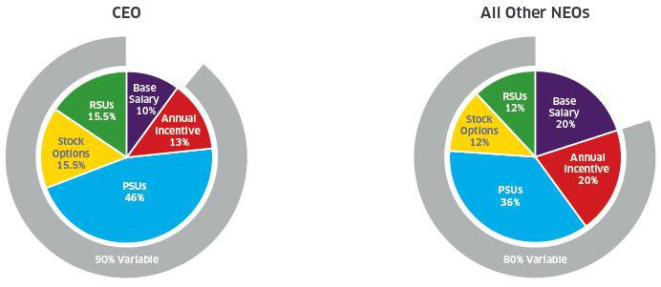

Fixed | 10% | Fixed | 20%
Variable | 90% | Variable | 80%
Cash | 23% | Cash | 40%
Cash | 77% | Equity | 60%
Equity | 77% | Equity | 60%
Short-Term Performance | 15% | Short-Term Performance | 25%
Short-Term Performance | 85% | Short-Term Performance | 75%
Long-Term Performance | 85% | Long-Term Performance | 75%


Stock options are considered variable as they require the stock price to increase before they yield any value. The delivered value of RSUs is variable based on share price at vesting.

Total target compensation is made up of salary, an annual cash incentive, and long-term equity incentives.

Our compensation program is strongly linked to performance, and a majority of our NEOs’ pay is variable, at-risk compensation.

Total target compensation is benchmarked relative to appropriate peer groups by our independent compensation consultant and is targeted at market median.

Annual cash incentive bonus is based on financial performance (75%) and individual performance in areas of strategic significance (25%).

Payouts for the financial portion are based on quantifiable performance. There is no payout if Company performance is below a minimum level of performance due to our emphasis on paying for performance. Payouts increase with increasing levels of performance and there is a cap on payout at maximum performance. Performance targets and goals are predetermined, communicated in advance, and included in our disclosures.
Payout for the individual performance indicators are based on rigorous, individual goal setting and year-end evaluation of performance.

PSUs comprise the majority of long-term equity incentives (60%) with vesting contingent on ROIC performance and relative TSR performance, each measured over three years.

- TechnipFMC

TechnipFMC Proxy Statement 2020

Payouts for the PSU plan are based on performance. There is no payout if Company performance is below a minimum level of performance, and there is a cap on payout at maximum performance. In addition, in the case of negative absolute TSR performance, payouts are capped at target, even if our TSR performance relative to our Relative TSR Peer Group (as defined below) is above target. Performance targets and goals are pre-determined, communicated in advance, and disclosed publicly.

The remainder of the long-term equity incentives are delivered in the form of stock options and RSUs. The delivered value of stock options and RSUs to NEOs is also based on share price performance.

Starting in 2020, we will eliminate stock options from our executive compensation program, based on feedback from shareholders that stock options are not performance-based, at-risk compensation.

All long-term equity incentive awards vest at the end of three years, providing a significant retention incentive to NEOs.

Alignment of pay and performance

The chart below presents the relative alignment of CEO pay to TSR performance over a two-year period compared to our 2019 Industry Peer Group. For more details on our 2019 Industry Peer Group, please see the section “—Compensation Governance—Compensation Decisions—Compensation Peer Groups.”

TechnipFMC’s position in the central corridor illustrates that our pay is in alignment with our performance.

Our two-year TSR performance for 2017-2018 is at the 57th percentile versus our peers, while our two-year CEO pay rank is at the 47th percentile of our peers.

TechnipFMC plc: Pay for Performance*

Two-Year CEO Pay Rank vs. Two-Year TSR Percentile Rank
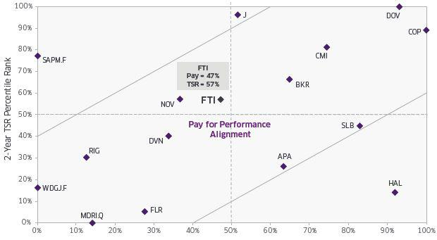

Two-Year CEO Pay Rank

- Two-year performance and pay data was used (instead of a three-year analysis) since the Merger was completed in 2017, and peer group data for 2019 was not available at the time of this Proxy Statement.

In addition, the table above excludes the following companies from our Industry Peer Group: (i) Anadarko Petroleum Corporation and Chicago Bridge & Iron due to merger/acquisition activity; (ii) Weatherford International plc due to Chapter 11 bankruptcy filing; and (iii) Subsea 7 S.A. due to insufficient disclosure.

- TechnipFMC

TechnipFMC Proxy Statement 2020

TechnipFMC 2019 Performance

TechnipFMC operates a sophisticated, global business in a highly competitive industry that has been negatively impacted by an extended period of low commodity prices. Our solutions add value to some of the largest capital investments in the world. We identified an opportunity to change the way projects are conceived and executed in the industry with the introduction of our subsea integrated engineering, procurement, construction, and installation (“iEPCI”) business model aimed at lowering project costs and accelerating the delivery of initial hydrocarbon production.

In 2019, the value of these integrated subsea awards to TechnipFMC more than doubled versus the prior year, representing more than 40% of all Subsea inbound orders. The increase was driven by further adoption of the integrated business model, particularly with those clients where we have unique alliances. With the industry’s most comprehensive and only truly integrated market offering, we have continued to expand the deepwater opportunity set for our customers.

TechnipFMC’s expertise does not end with the development of hydrocarbons. Because of its best-in-class project design and execution capabilities, enabled by a portfolio of proprietary technologies, TechnipFMC continues to secure and deliver projects that further enable our clients to monetize resources — from liquefaction of gas, both onshore and on floating vessels, to refining and production facilities, through new energy solutions and applications for the world’s energy transition.
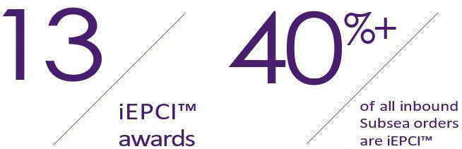

- TechnipFMC

TechnipFMC Proxy Statement 2020

On August 26, 2019, the Company announced that it will separate into two diversified, pure-play market leaders — TechnipFMC, focused on subsea and surface hydrocarbon production, and Technip Energies, focused on downstream EPC project execution. The separation will enable both companies to benefit from distinct and compelling market opportunities across the energy value chain; dedicated focus of management, resources, and capital; and unique value propositions with differentiated investment appeal.

TechnipFMC (RemainCo) | Technip Energies (SpinCo)
TechnipFMC will be a fully integrated technology and services provider, | Technip Energies will be a leading engineering and construction provider,
driving energy development across deepwater, conventional, and | with a robust project delivery model, strong technical capabilities, and proven
unconventional resources. | track record as demonstrated by the successful execution of some of the
The Company will continue to demonstrate leadership in integrated subsea | world’s most iconic EPC projects.
project delivery and will focus on replicating this success through the | The new company will continue to leverage its industry-leading process
development of integrated production models for the surface production | technology portfolio, particularly in the areas of ethylene and hydrogen, while
market. | pursuing further opportunities to enhance and differentiate this portfolio.
TechnipFMC is also poised to benefit from service opportunities
resulting from the world’s largest installed base of subsea
production equipment, umbilicals, risers, and flowlines.
Creating Two Industry Leaders
Distinct and compelling | Unique business profiles with
market opportunities | differentiated investment appeal


Strong balance sheets and

tailored capital structures

Focus, agility, and

strategic flexibility

Continuing to reshape the energy industry and create value for all stakeholders

We expect that the executive compensation programs for these two companies will continue to emphasize performance and will be tailored to each company’s business and strategy.

- TechnipFMC

TechnipFMC Proxy Statement 2020

Key Strategic Achievements in 2019

We have summarized some of our key 2019 results and achievements below.
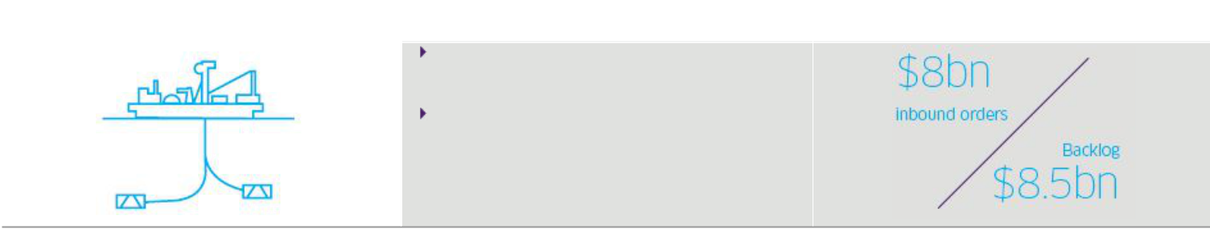

Subsea | Financials1

Revenue growth of 14% versus the prior year, driven by double-digit growth in both project and service activities

Integrated project activity a higher mix of business portfolio
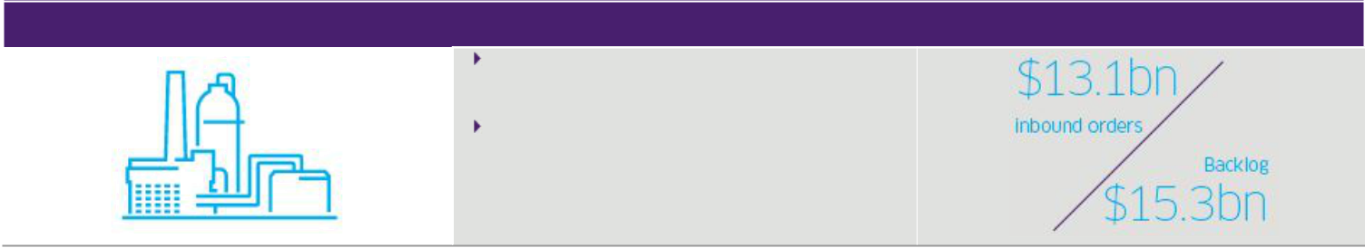

Onshore/Oﬀshore

Three quarters of sequential revenue growth, as segment revenue has inflected above the 2018 trough

Revenue growth excluding the Yamal LNG project exceeded 25% versus the prior year
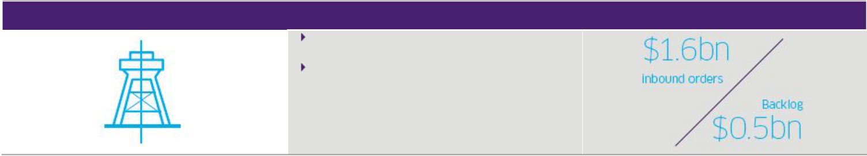

Surface Technologies

Revenue growth of more than 15% in markets outside of North America versus the prior year

Surface international revenues account for more than 50% of total segment

- Reported financial results for the twelve months ended December 31, 2019 and inbound and backlog as of December 31, 2019 are as reported in our Form 10-K.

- TechnipFMC

TechnipFMC Proxy Statement 2020

Market Leadership

Subsea


Inbound order growth exceeded 50% versus the prior year, driven by integrated (iEPCI™) awards, subsea services, and new technologies

Continued growth in adoption of the integrated model across multiple clients and regions including the Mozambique LNG Subsea project, our largest integrated subsea award to date

Awarded industry’s first 20,000 psi high-pressure, high-temperature system for LLOG’s Shenandoah project in the U.S. Gulf of Mexico

Further enhanced our competitive position through newly formed strategic partnerships, with particular focus on expanding the number of clients engaged in iEPCI alliances

Entered into a strategic collaboration agreement with Allseas to jointly pursue deepwater projects where the assets, products, and capabilities of both companies are complementary and support the execution of our differentiated iEPCI business model

Onshore/Offshore


Inbound order growth exceeded 75% versus the prior year driven by EPC contract awards for LNG projects including:

Novatek Arctic LNG 2 project which leverages our proven track record in delivering harsh environment mega projects

ExxonMobil Rovuma LNG project which builds upon our local content and expands our capabilities in Africa; the full value of the EPC contract will be included in backlog upon issuance of full notice to proceed, most likely in conjunction with project FID

Strong order activity also supported by project awards in the downstream and gas monetization sectors:

MIDOR Refinery modernization and expansion in Egypt

ExxonMobil Refinery crude expansion project in the U.S. Gulf of Mexico BP Greater Tortue Ahmeyim gas FPSO offshore Africa

Entered into EPICEROL® strategic license agreement with Meghmani Finechem, marking our first “green” epichlorohydrin (ECH) technology license in India

- TechnipFMC

TechnipFMC Proxy Statement 2020

Surface Technologies


Capitalized on our high degree of vertical integration and technology differentiation outside North America where revenue increased more than 20% versus the prior year

Successful introduction of several new product development items from our Frac 2.0 suite

Successful introduction of our first Automated Well Testing Unit in the Bakken

Applying our subsea integrated model to the U.S. land production market to further transform our North American business Awarded loading arms for an LNG project in Asia Pacific, one of our largest orders to date

Disciplined Capital Allocation


Total shareholder distributions of $326 million:

Dividend payments of $233 million Repurchase of Ordinary Shares of $93 million

Capital expenditures* of $378 million:

Continued to fund targeted growth initiatives

Capital expenditures were below depreciation

- Excludes $80 million associated with dive support vessel acquisition

Further optimization of Subsea fleet:

Disposal of a pipelay vessel while retaining predetermined operational access

Consolidation of pipelay support vessel joint venture to maximize fleet optionality

While 2019 presented a competitive and challenging environment, our relentless focus on strong project execution and cost reduction drove solid operational performance. Our integrated business models have further reinforced our market leadership. We achieved robust year-over-year growth in inbound orders and backlog in both Subsea and Onshore/ Offshore, providing improved revenue visibility for 2020 and beyond. We are capitalizing on the offshore recovery and current LNG cycle through early customer engagement, demonstrated engineering capabilities, and multicenter execution. Additionally, in Surface Technologies, we are taking aggressive restructuring actions in North America to further realign our product and service offering to the changing markets, while leveraging our strong international franchise for the growth we see in markets outside of the United States. In support of the overall strategy, we continue to focus on quality, health, safety, and environment with the implementation of our quality and safety program.

- TechnipFMC

TechnipFMC Proxy Statement 2020

2017-2019 TSR Performance

30% of our long-term equity incentive plan is based on relative TSR performance versus the relative TSR peer group for the year of grant. As such, the figures below indicate the Company’s TSR performance against our 2017 Performance Peer Group as defined in our 2018 Proxy Statement (“2017 Performance Peer Group”) and against the Philadelphia Oil Service Sector (OSX) index. Note that the OSX index is not used for plan payout, but provided as a reference point to demonstrate TSR performance for the oil service industry as a whole during this period.

Although our absolute TSR for this period was negative, our relative TSR was above the median for our 2017 Performance Peer Group, demonstrating superior relative performance during a period of downturn for the industry.

Note: Our executive compensation plan rules capped the payout of the relative TSR component of the 2017-2019 PSU award at target, despite above target performance. For more details on this, please see the section “—Elements of 2019 Executive Compensation—Long-Term Equity Incentives—Vesting of 2017 PSU Awards.”
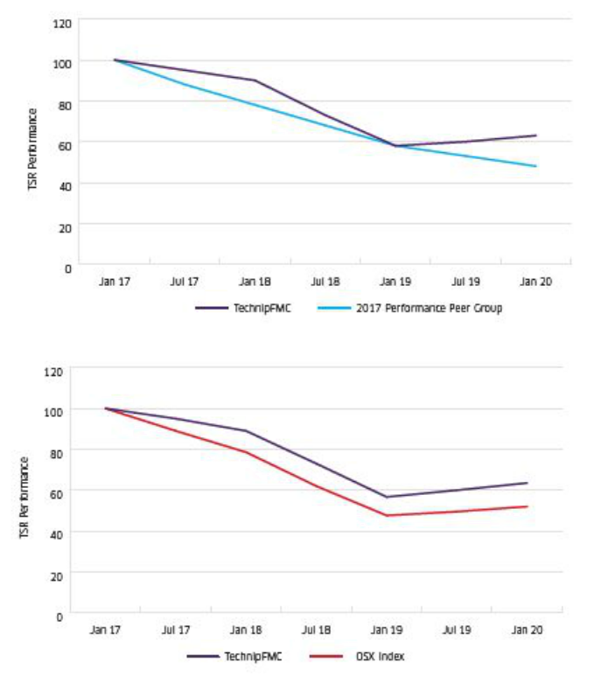

For detailed information regarding our 2019 results, please see our Form 10-K, which reports our results using U.S. generally accepted accounting principles, and our U.K. Annual Reports and Accounts, which reports our results using international financial reporting standards (as adopted by the European Union).

- TechnipFMC

TechnipFMC Proxy Statement 2020

2019 Performance Impact on Compensation

The table below outlines the elements of our compensation program that are directly tied to Company performance, along with 2019 performance and resulting payouts. For additional details, including calculations and payout scales, please see the sections “—Elements of 2019 Executive Compensation—Annual Cash Incentive Bonus” and “—Elements of 2019 Executive Compensation—Long-Term Equity Incentives—Vesting of 2017 PSU Awards.”


Compensation | Objective | 2019 | Performance |  | 2019 Performance |  | 2019 Payout
Element | Objective | Measures |  |  | 2019 Performance |  | 2019 Payout
Long-Term | To drive and reward the achievement of long-term | 30% PSUs |  | > | 2017-2019 | > | 0% of target¹
Long-Term | To drive and reward the achievement of long-term | 3-year ROIC |  | > | performance of 6.9%¹ | > | 0% of target¹
Equity | results and align interests of NEOs with shareholder |  |  |  | 2017-2019
 | interests | 30% PSUs |  | > | 2017-2019 | > | 100% of target¹
 |  | 3-year relative TSR |  | > | performance | > | 100% of target¹
 |  |  |  |  | of 5th rank¹
 | The remaining 40% of the long-term equity incentive was delivered in the form of stock options (20%) and RSUs (20%), the delivered value of which will also depend on share price
 | appreciation, and thus is aligned with shareholder interests.
Annual Cash | To drive and reward the achievement of short-term | 25% EBITDA |  | > | $1,667 million - 162% | > | 162% of target
 |  |  |  |  | performance rating | > | 162% of target
Incentive | Company strategic goals and individual contributions | 25% EBITDA
Bonus |  |  |  | > | 12.4% - 155% | > | 155% of target
 |  | as a Percentage |  | > | performance rating | > | 155% of target
 |  | of Revenue |  |  | performance rating
 |  | 25% Working |  | > | 74 days - 200% | > | 200% of target
 |  | Capital Days |  | > | performance rating | > | 200% of target
 |  | 25% Annual |  | > | Ranging from 140% | > | 140% to 180%
 |  | Individual |  | > | to 180% performance | > | 140% to 180%
 |  |  |  |  |  |  | of target
 |  | Performance |  |  | rating |  | of target

(1) Payout for the 2017-2019 grant has been provided instead of payout for the 2019-2021 grant, since payout for the latter will only be determined at the end of 2021.

Our pay-for-performance program aims to motivate our executive officers to achieve and exceed both our short-term and long-term goals and objectives by including an appropriate mix of long-term equity compensation and annual cash incentive bonus compensation. As intended by our program, our NEO compensation was directly impacted by our performance.

Long-Term Equity

The majority of our executives’ variable compensation is in the form of long-term equity compensation, comprising 85% and 75% of 2019 total target variable compensation for our CEO and other NEOs, respectively. Our NEOs achieved a payout of 50% of target on their 2017 performance-based, long-term equity incentive awards, based on the following:

For the ROIC measure, we did not meet the threshold performance for the 2017-2019 performance period, and as a result, the ROIC component of the 2017 PSU awards paid out at 0%.
For the three-year relative TSR measure, we achieved above-target performance for relative TSR for the 2017-2019 performance period based on our performance relative to our 2017 Performance Peer Group. However, our absolute TSR performance was negative given the overall oil and gas market conditions during the same period. Therefore, our payout under our incentive plan was capped at target (100%) given the absolute TSR performance.

- TechnipFMC

TechnipFMC Proxy Statement 2020

Annual Cash Incentive Bonus

For 2019, our annual cash incentive comprised 15% and 25% of total target variable compensation for our CEO and other NEOs, respectively. Performance targets related to our annual cash incentive are set at “stretch” targets that are difficult and challenging but achievable with superior execution based on our long-range plans. Given the cyclical nature of our sectors, as well as the variability in some of our metrics caused by the lifecycle progression of a few very large projects, our targets will not always increase, in absolute terms, over prior year targets but are set to ensure that achievement will require the same or increased execution to achieve the targets.

In setting performance goals, the Compensation Committee considers the Company’s annual financial plans, strategic initiatives, and projections, which are impacted by the following factors:

The overall business climate and the cyclical nature of our business

Underlying market conditions for our products and services

Volatility in commodity prices

Our competitors’ performance

Anticipated changes in customer activity

Our prior-year performance

These inputs inform discussions regarding both the targets and the ranges around the target to ensure the goals are sufficiently difficult without incentivizing inappropriate risk taking.

In setting our 2019 targets, the Compensation Committee considered the market outlook for each of our business segments and for the Company as a whole. In particular, we considered the projected decline for our Subsea segment due to the volatile, and generally low, crude oil price environment over the last several years that led many of our customers to reduce their capital spending plans or defer new deepwater projects. This led to the winding down of certain projects, and an expected decline in operating margins due to the competitive environment in 2019. During this time, we focused on growing our order backlog.

As a result, in 2019, our performance exceeded the targets for the EBITDA, EBITDA as a Percentage of Revenue, and Working Capital Days measures due to accelerated market adoption of our new subsea technologies, our strong execution and disciplined capital spending, and achieving an unprecedented level of backlog. As a result, our annual cash incentive bonus plan paid out in a range of 164%-174%, including the impact of annual individual performance indicator results.

- TechnipFMC

TechnipFMC Proxy Statement 2020

Compensation Governance

Role of the Compensation Committee

Our Compensation Committee of five independent non-executive directors oversees our executive compensation program and determines the compensation for our executive officers on behalf of the Board. The Compensation Committee is responsible for, among other things, reviewing, evaluating, and approving:

The agreements, plans, policies, and programs of the Company to compensate its independent directors, Chairman and CEO, and other officers, as applicable; and

All awards of equity securities or equity derivatives to executive officers of the Company, as well as the total number of equity securities or equity derivatives to be allocated to all other employees at the discretion of the CEO, consistent with equity plans approved by the Company’s shareholders.

The Compensation Committee also reviews the Company’s incentive compensation arrangements to ensure that they do not incentivize excessive risk-taking and evaluates compensation policies and practices that could mitigate any such risk.

Additional information on the roles and responsibilities of the Compensation Committee is provided in the section “Corporate Governance—Committees of the Board of Directors—Compensation Committee” and the charter of the Compensation Committee may be viewed on our website at www.TechnipFMC.com under the heading “Who we are > Governance.”

Role of the Compensation Committee’s Independent Consultant

Under its charter, the Compensation Committee has the sole authority to retain and terminate any compensation consultant, outside counsel, or any other advisors engaged to assist in the evaluation of compensation of directors or executive officers, including the sole authority to approve the consultant’s fees and its terms. The Compensation Committee considers appropriate standards in selecting its compensation consultants consistent with NYSE rules, SEC rules, and requirements under the Dodd-Frank Wall Street Reform and Consumer Protection Act (the “Dodd-Frank Act”).

In 2019, the Compensation Committee retained Willis Towers Watson as its principal compensation consultant to provide information and advice to the Compensation Committee on executive and director compensation and related governance matters. This included evaluating our director and executive compensation programs against general market and peer data and providing updates on current executive compensation trends and applicable legislative and governance activity. In addition, Willis Towers Watson provided retirement benefit consultant services, health and group benefits consulting services, and corporate risk and broking services to management. In 2019, Willis Towers Watson was paid approximately $358,000 in fees related to executive compensation services and $1,960,000 related to non-executive compensation services.

In February 2020, the Compensation Committee considered the independence of Willis Towers Watson pursuant to SEC rules and NYSE listing standards. At the request of the Compensation Committee, Willis Towers Watson prepared a letter providing data on the following factors relevant to assessing independence: (a) other services provided to the Company by Willis Towers Watson; (b) fees paid by the Company as a percentage of Willis Towers Watson’s total revenue; (c) policies and procedures maintained by Willis Towers Watson that are designed to prevent a conflict of interest; (d) any business or personal relationships between the individual consultants involved in the engagement and a member of the Compensation Committee; (e) any Ordinary Shares owned by the individual consultants involved in the engagement or their immediate family members; and (f) any business or personal relationships between our executive officers and Willis Towers Watson or the individual consultants involved in the engagement. The Compensation Committee also considered that the Willis Towers Watson consultants advising the Compensation Committee derived no economic benefit from the fees paid for the non-executive compensation services. The Compensation Committee discussed these considerations and concluded that the work of Willis Towers Watson and the consultants involved in the engagement did not raise any conflict of interest.

- TechnipFMC

TechnipFMC Proxy Statement 2020

The Annual Process

Each year the Compensation Committee approves an annual calendar which sets out the key activities in accordance with its charter. The key activities of the committee in 2019 were as follows:


 | Q1 |  | Q2–Q3 |  | Q4
 | Approve compensation decisions and equity awards |  | Review executive officer share ownership guidelines |  | Review internal governance policies (e.g., clawback,
 | Approve compensation decisions and equity awards |  | Review executive officer share ownership guidelines |  | insider trading policy, anti-hedging, pledging) and
 | for directors and officers |  | and compliance |  | insider trading policy, anti-hedging, pledging) and
 | for directors and officers |  | and compliance |  | compliance
 | Approve Company performance achievements for |  | Discuss shareholder engagement outcomes and review |  | Approve equity programs, annual equity budget for
 | prior year in relation to annual and long-term |  | Discuss shareholder engagement outcomes and review |  | Approve equity programs, annual equity budget for
 | prior year in relation to annual and long-term |  | proxy voting results |  | non-executives, and impact on shareholder dilution
 | incentive plans |  | proxy voting results |  | non-executives, and impact on shareholder dilution
 | Review and discuss executive compensation strategy |  |  |  | Review of peer compensation practices
 | structure and programs |  |  |  | Review of peer compensation practices
 | Approve annual compensation disclosures in
 | Company Proxy Statement and U.K. Annual Report

Compensation Decisions

Compensation Peer Groups

In making decisions about target compensation levels, the Compensation Committee references data from two distinct peer groups. We believe that it is important to look at both global companies of similar size, complexity, and capital- intensive nature, as well as companies within the same industry with significant U.S. operations in order to get a comprehensive view of who we compete with for talent.

These two peer groups are combined to provide a holistic view for compensation benchmarking. In addition, the Compensation Committee also looks at each peer group separately in order to gain insight into variations between the two groups.

The Global Peer Group comprises a broadly equal weighting of U.S. and European headquartered companies, of similar size to the Company (in terms of revenue) who compete for executive talent in capital intensive industries similar to the Company including the oil and gas industry, construction and engineering, and industrial manufacturing.

The Industry Peer Group is focused more closely on our sub-industry and is drawn from companies in the oilfield services and oil exploration and production sectors, as well as heavy engineering organizations with greater (but not exclusive) focus on North America.

The Compensation Committee does not place a specific weight on the data from either peer group, but considers the data in light of all the circumstances relevant to each executive under review, as well as the Company’s compensation philosophy.

For both sets of peers, we use a range of selection criteria that include, among other factors, financial indicators such as revenue and market capitalization, number of employees, company size, industry, end markets, complexity, geographic footprint, and headquarters location.

- TechnipFMC

TechnipFMC Proxy Statement 2020
Peer Group | Purpose
Global Peer Group | Similarly sized, complex, and capital-intensive global companies, including those
Global Peer Group | based outside the United States.
Industry Peer Group | Companies with significant U.S. operations, reflecting competitors for critical U.S.
Industry Peer Group | executive talent.


Below are the companies that comprised the 2019 Compensation Peer Group. The companies below include both global peers and industry peers.

2019 Combined Compensation Peer Group Constituents

Air Liquide S.A | Ingersoll-Rand plc
Alstom S.A. | Jacobs Engineering Group Inc.
Anadarko Petroleum Corporation | John Wood Group plc
Apache Corporation | McDermott International, Inc.
Baker Hughes Company | National Oilwell Varco, Inc.
Caterpillar Inc. | Petrofac Limited
Chicago Bridge & Iron | Repsol, S.A.
Cummins Inc. | Saipem S.p.A.
ConocoPhillips | Schlumberger Limited
Devon Energy Corporation | Subsea 7 S.A.
Dover Corporation | Transocean Ltd.
Enbridge, Inc. | VINCI S.A.
Fluor Corporation | Weatherford International plc
Halliburton Company

Companies in blue bold comprise the Industry Peer Group.

The Compensation Committee reviews the composition of the Company’s peer groups on a periodic basis. For 2019 compensation decisions, the companies noted below were included; however, we anticipate these companies will be removed from our peer groups for 2020 compensation decisions.

Chicago Bridge & Iron merged with McDermott International, Inc. in May 2018.

Anadarko Petroleum Corporation was acquired by Occidental Petroleum Corporation in August 2019.

Weatherford International plc filed for bankruptcy under Chapter 11 in July 2019.

McDermott International, Inc. filed for bankruptcy under Chapter 11 in January 2020.

- TechnipFMC

TechnipFMC Proxy Statement 2020

When 2019 compensation decisions were made, the median revenue and median market capitalization for each of the peer groups used and the Company’s relative ranking are provided below:

Peer Group | Median Revenue | TechnipFMC | Median Market | TechnipFMC Market
 |  | Revenue Ranking | Capitalization | Capitalization Ranking
Global Peer Group | $15.7 billion | 46th percentile | $17.7 billion | 48th percentile
Industry Peer Group | $9.5 billion | 67th percentile | $13.6 billion | 57th percentile
Combined Peer Group | $15.1 billion | 57th percentile | $15.1 billion | 46th percentile

Accordingly, the Compensation Committee agreed that this group of companies was reasonable in terms of size for market median comparisons. Where possible, the Compensation Committee’s consultant size-adjusts data to account for differences in size between the Company and the Compensation Peer Group.

Setting Target Executive Compensation

In determining the target compensation package for each NEO, the Compensation Committee compares each element and combined total of an NEO’s compensation to data for relevant roles within the Compensation Peer Group. To provide additional perspectives, the Compensation Committee also considers internal relativities between the CEO and the NEOs.

In setting target compensation, the Compensation Committee also considers market median data, as well as other factors including the experience, tenure, role criticality, and performance of the incumbent NEOs. In addition, any changes to Mr. Pferdehirt’s target compensation are in accordance with the shareholder-approved Director Remuneration Policy.

No executive participates in any discussion that relates to his or her own compensation.

The Compensation Committee, in partnership with its independent advisor, determines and approves any changes to compensation for the Chairman and CEO, who is not present during these discussions.

The CEO recommends changes to compensation for the other NEOs without them present, which are approved by the Compensation Committee with input from its independent advisor.

Use of Compensation Tally Sheets

The Compensation Committee uses tally sheets to ensure they receive the information necessary to evaluate the total compensation of an NEO. Tally sheets list each component of an executive’s compensation throughout a range of alternative scenarios (e.g., termination, change-in-control transaction, etc.). The compensatory amounts include cash compensation, accumulated deferred compensation balances, outstanding equity awards, benefits, perquisites, and any other item, as well as projected values of equity awards under various performance and termination scenarios, realized stock option and stock gains, and total wealth accumulation.

- TechnipFMC

TechnipFMC Proxy Statement 2020

Establishing Performance Metrics and Goals

In setting performance goals, the Compensation Committee considers the Company’s annual financial plans, strategic initiatives, and projections, which are impacted by the following factors:

The overall business climate and the cyclical nature of our business

Underlying market conditions for our products and services

Volatility in commodity prices

Our competitors’ performance

Anticipated changes in customer activity

Our prior-year performance

These inputs inform discussions regarding both the targets, and the ranges around the target to ensure the goals are sufficiently difficult without incentivizing inappropriate risk taking.

Individual strategic goals are established at the start of the year. The Compensation Committee establishes and approves the objectives for the CEO, who is not present when these are being discussed. The CEO recommends and the Compensation Committee approves the objectives for the other NEOs.

- TechnipFMC

TechnipFMC Proxy Statement 2020

Elements of 2019 Executive Compensation

Our executive compensation program comprises three primary elements of base salary, annual cash incentive bonus, and long-term equity awards, along with the provision of market competitive benefits and perquisites. The table below summarizes these elements, along with their purpose and key characteristics. However, a more detailed explanation is available in further sections.


Element | Purpose | Key Characteristics
Base Salary | To provide market competitive compensation for the role | Fixed cash compensation
 |  | Reflects major responsibilities of an NEO’s role
 |  | Set with reference to market median, based on
 |  | responsibility, experience, and performance
 |  | Variable cash compensation
Annual Cash | To drive and reward the achievement of short-term Company | Target value based on role, set with reference to market
Incentive Bonus | strategic goals and individual contributions | median
 |  | Actual payout can range from 0% to 200% of target
 |  | Paid based on achievement of business performance
 |  | targets (75%) and achievement of individual performance
 |  | targets (25%)
 |  | 2019 shared business performance targets were:
 |  | 25% - EBITDA
 |  | 25% - EBITDA as a Percentage of Revenue
 |  | 25% - Working Capital Days

- TechnipFMC

TechnipFMC Proxy Statement 2020
Element | Purpose | Key Characteristics
Long-Term Equity | To drive and reward the achievement of long-term results and | Granted as combination of three vehicles: PSUs (60%),
Incentives | shareholder value creation while encouraging retention | stock options (20%)1, and RSUs (20%)
 |  | Target value based on role, set with reference to market
 |  | median
 |  | PSUs (60% of total long-term equity grant) subject to two
 |  | performance conditions measured over three years: ROIC
 |  | (30% of total long-term equity grant) and relative TSR
 |  | (30% of total long-term equity grant)
 |  | 50% of after-tax RSUs must be retained for at least one
 |  | year following vesting
 |  | All long-term incentive awards are subject to three-year
 |  | cliff vesting
Health and Welfare | To facilitate the performance of the role and ensure a market | Health and welfare benefits, similar to what is offered to other
Benefits, Retirement | competitive total compensation package | employees of the Company in the respective countries
Benefits and |  | Retirement savings offered through participation in our
Perquisites |  | 401(k) and non- qualified defined contribution plans for
 |  | eligible U.S. NEOs, similar to plans offered to other U.S.
 |  | employees
 |  | Limited perquisites including financial planning, tax
 |  | assistance, use of company cars, club memberships,
 |  | executive physicals, and security services where necessary
 |  | Limited participation in other programs dependent on
 |  | geography and tenure (non- U.S.-based NEO)


- In 2019, the Board decided to remove stock options; beginning in 2020, equity awards will be a combination of only PSUs (70%) and RSUs (30%).

73TechnipFMC

TechnipFMC Proxy Statement 2020

Base Salary

We provide our NEOs with a market competitive base salary to compensate them for services performed during the year. We set base salary by referencing market median total target compensation. When setting an individual NEO’s base salary, we consider factors such as individual performance, experience, and contributions to the business, while staying within an appropriate range of the market median for the role.

The Compensation Committee reviews base salary for NEOs on an annual basis. For the CEO, the Compensation Committee determines and approves any changes, with input from the committee’s independent compensation consultant. For the other NEOs, the CEO recommends changes to the Compensation Committee with the support of the committee’s compensation consultant, and the Compensation Committee approves the changes. The NEOs do not participate in discussions or decisions relating to their own or the other NEOs’ compensation.

In 2019, the Compensation Committee approved base salary increases for Ms. Mannen, Ms. Ralston, and Mr. Uccelletti as provided below, based on a review of market median total target compensation data for the Global Peer Group as well as the Industry Peer Group. There was no increase in 2019 for Mr. Pferdehirt and Mr. Rounce — the market median total target compensation for each of them was assessed to be within the desired range. In addition, Mr. Rounce was recently hired in September 2018.

Named Executive Officer | Base Salary | Base Salary | Increase
Named Executive Officer | (December 31, 2018) | (December 31, 2019) | Increase
Douglas J. Pferdehirt | $1,236,000 | $1,236,000 | 0%
Maryann T. Mannen | $772,500 | $803,000 | 4%
Dianne B. Ralston | $618,000 | $643,000 | 4%
Justin Rounce | $600,000 | $600,000 | 0%
Nello Uccelletti | $543,513 | $565,693 | 4%

Annual Cash Incentive Bonus

2019 Annual Cash Incentive Bonus Targets

We provide our NEOs with an annual cash incentive bonus, in order to drive and reward the achievement of short-term Company strategic goals and individual contributions. Each NEO has an annual cash incentive bonus target, set as a percentage of base salary. The NEO can earn from 0%-200% of their annual cash incentive bonus target, depending on performance.

The Compensation Committee reviews and approves target annual cash incentive bonus percentages for the NEOs on an annual basis, based on a review of market median total compensation data for our peers. The targets are set at appropriate levels to incentivize executive officers to achieve the short-term financial and operational goals for the Company, as well as to provide executive officers with market-competitive levels of total compensation.

The following were the 2019 annual cash incentive bonus targets for the NEOs:

Named Executive Officer | 2018 | 2019 | Increase
Douglas J. Pferdehirt | 135% | 135% | 0%
Maryann T. Mannen | 100% | 100% | 0%
Dianne B. Ralston | 100% | 100% | 0%
Justin Rounce | 100% | 100% | 0%
Nello Uccelletti | 100% | 100% | 0%

- TechnipFMC

TechnipFMC Proxy Statement 2020

2019 Annual Cash Incentive Bonus Performance Indicators

75% of the annual cash incentive bonus is based on business performance indicators (“BPI”), and 25% is based on individual annual performance indicators (“API”).

75% BPI | + | 25% API
Assessment of overall Company performance | + | Assessment of individual performance based
based on EBITDA. EBITDA as a Percentage of | + | on qualitative factors reflected in each NEO’s
Revenue, and Working Capital Days |  | annual performance objectives

The payout under both the BPI and API components may range from 0% to 200% of target depending on performance.

BPI Component – 75% of Annual Cash Incentive Bonus

The Compensation Committee annually establishes BPI targets and reviews the performance measures at its February meeting. In 2019, the Compensation Committee selected three equally weighted measures, which reflected the Company’s strategic priorities: EBITDA, EBITDA as a Percentage of Revenue, and Working Capital Days.


BPI Measure | Weighting | 2019 Goal |  | Definition | Why It Matters
(Weight) | Weighting | 2019 Goal |  | Definition | Why It Matters
EBITDA ($M) | 25% | $1,531 |  | Earnings before interest, | Indicative of our operating
 |  |  |  | taxes, depreciation, and | profitability and a driver of
 |  |  |  | amortization | shareholder value creation; facilitates
 |  |  |  |  | comparisons with peer companies
 |  |  |  |  | by excluding the effect of different
 |  |  |  |  | capital structures and financing
 |  |  |  |  | decisions
EBITDA as a | 25% | 11.4% |  | Earnings before interest, | Reflects the performance and
Percentage of |  |  |  | taxes, depreciation, and | sustainability of the business,
Revenue |  |  |  | amortization, calculated | leveraging cost efficiencies and
 |  |  |  | as a percentage of | driving profitability improvement
 |  |  |  | revenue
Working Capital | 25% | 55 days |  | Average number of days | Measures our efficiency of using
Days |  |  |  | to convert working capital | operating capital to operate the
 |  |  |  | into revenue | business; our contract arrangements
 |  |  |  |  | typically result in negative working
 |  |  |  |  | capital due to advance payments
 |  |  |  |  | and milestone payments
The payout scale for 2019 is as follows:
Performance Level |  |  |  |  | Payout Percentage
Threshold |  |  |  |  | 0%
Target |  |  |  |  | 100%
Maximum |  |  |  |  | 200%

Note: Payout for performance between the threshold, target, and maximum payouts are interpolated on a straight-line basis.

- TechnipFMC

TechnipFMC Proxy Statement 2020

The 2019 performance goals and the 2019 results achieved (for NEOs on enterprise-wide incentive targets) are outlined below:


 |  |  | 2019 Goals |  | 2019 Outcome
 |  | Threshold | Target | Maximum | Actual | Payout |  | Weighted
 | BPI Measure |  |  |  |  |  | Weighting | Payout
 | BPI Measure | Performance | Performance | Performance | Percentage | Performance | Weighting | Payout
 |  |  |  |  |  |  |  | Percentage
 | EBITDA ($M) | $1,246 | $1,531 | $1,751 | $1,667 | 162% | 1/3 | 54%
 | EBITDA as a Percentage | 9% | 11.4% | 13.3% | 12.4% | 155% | 1/3 | 512/3%
 | of Revenue
 | Working Capital Days | 48 days | 55 days | 61 days | 74 days | 200% | 1/3 | 662/3%
 | Payout Percentage | 0% | 100% | 200%
 | Final Weighted Payout Percentage (BPI) |  |  |  |  |  |  | 172%

Note: Payout for performance between the threshold, target, and maximum payouts are interpolated on a straight-line basis. The final weighted payout percentage for BPI is rounded to the nearest whole percent for calculating the annual cash incentive payout.

In accordance with established guidelines, the goals are adjusted for the cumulative effect of changes in accounting principles, significant acquisitions and divestitures, and foreign exchange movements. These changes are intended to ensure that performance is measured on a like-for-like basis relative to the goals that were set. Financial targets and actual performance based on EBITDA exclude non-recurring charges and credits, such as impairments, restructuring costs, integration costs, as well as other items identified in TechnipFMC’s quarterly and annual financial statements.

API Component – 25% of Annual Cash Incentive Bonus

Each February the individual performance goals are established for each NEO.

These objectives are set at “stretch” levels (i.e., objectives that are difficult and challenging, but should be achievable with superior execution), and are set using a rigorous evaluation process. If an NEO failed to achieve any of his or her objectives, the API multiple would likely be 0%, absent any mitigating factors. If the NEO met some, but not all of the objectives, the API multiple would fall between the range of 0% to 200%, depending upon the number of objectives accomplished, their relative importance and difficulty as determined by the Compensation Committee, and any factors that may have prevented achievement of certain objectives. An NEO achieving all objectives could potentially receive an API of 200%, although it is intended that this ranking reflects outstanding performance given the inherent degree of difficulty factored into both the objective setting and evaluation processes.

For 2019, the NEOs received API ratings ranging from 140% to 180% for the year, with an average rating of 150%.

In determining the 2019 API rating for our CEO, the Compensation Committee took into account a comprehensive view of his performance and contributions, including performance on key objectives and results. In addition to individual goals related to Company strategy, profitable growth, and safety, his objectives also included the three pillars of our corporate responsibility and sustainability efforts to ensure that the Company makes meaningful and tangible changes in this

area. The Compensation Committee considers the CEO’s overall performance relative to the accomplishment of his key objectives, the importance of each accomplishment, as well as the market conditions that impacted performance.

- TechnipFMC

TechnipFMC Proxy Statement 2020

Objectives |  | Key Achievements |  |  |  | Performance Assessment
 |  | Key Achievements | Below |  |  |  | Meets | Exceeds
 |  |  | Expectations |  |  |  | Expectations | Expectations
Mr. Pferdehirt
Strategy |  |  |  |  |  |  |  |  | ✓
 | Unlock long-term shareholder value | Spin-off of Technip Energies was announced.
 | Unlock long-term shareholder value | Spin-off of Technip Energies was announced. |  |  |  |  | ✓
 |  | Preparations for spin-off are currently ongoing. |  |  |  |  | ✓
Profitable Growth |  | Over 40% of inbound as iEPCI |  |  |  |  |  |  | ✓
 | iEPCI – 35% subsea inbound orders as iEPCI
 | iEPCI – 35% subsea inbound orders as iEPCI |  |  |  |  |  |  |  | ✓
 | LNG market – secure $3 billion of LNG awards | Over $8 billion of LNG inbound
Corporate Responsibility and Sustainability |  | Please see section “Corporate Responsibility and
 | Focus and advance sustainability efforts under three | Sustainability – Sustainability” for a detailed |  |  |  |  |  |  |  | ✓
 | pillars – Supporting Communities, Advancing Gender | description of 2019 objectives and results. |  |  |  |  |  |  |  | ✓
 | Diversity, and Respecting the Environment
Health & Safety |  | Zero serious injury goal not achieved. |  | ✓
 | Zero serious injuries in 2019 | Zero serious injury goal not achieved. |  | ✓
 | Overall Rating for Mr. Pferdehirt |  |  |  |  | 180%
77 | TechnipFMC


TechnipFMC Proxy Statement 2020

Individual performance assessments for the other NEO are summarized below:


NEO | Summary of 2019 Objectives and Key Achievements
Maryann T. Mannen | Ms. Mannen’s 2019 individual performance objectives reflected her wide range of responsibilities as our Chief Financial
Executive Vice President and Chief | Officer in leading our finance, tax, risk management, internal audit, internal controls, and investor relationship functions. Ms.
Financial Officer | Mannen’s 2019 objectives and achievements included implementing a global treasury management system, achieving key
 | advancements in the tax and reporting functions, improving financial results through discipline and management of the finance
 | function to deliver improved working capital efficiency, improving investor communications and outreach, and leading the
 | financial and due diligence aspects of strategic projects, including the announced spin-off of Technip Energies.
Dianne B. Ralston | Ms. Ralston’s 2019 individual performance objectives reflected her wide range of responsibilities as our Chief Legal Officer in
Executive Vice President, Chief Legal | leading our legal, compliance, and global facilities functions. Ms. Ralston’s 2019 objectives and achievements included
Officer and Secretary | resolving a complex compliance matter, introducing workflow management tools and high-value insourcing to the legal and
 | compliance functions, implementing inclusion and unconscious bias awareness training throughout our Company, and leading
 | the legal and due diligence aspects of strategic projects, including the announced spin-off of Technip Energies.
Justin Rounce | Mr. Rounce’s 2019 individual performance objectives reflected his wide range of responsibilities as our Executive Vice
Executive Vice President and Chief | President and Chief Technology Officer in leading our research and innovation, product engineering, procurement and sourcing,
Technology Officer | manufacturing, quality, safety, security, IT, digital corporate development, mergers and acquisitions, and external technology
 | engagement functions. Mr. Rounce’s 2019 objectives and achievements included advancing our technology and digital strategy,
 | establishing a product management organization, developing a product development framework, improving our external
 | technology engagement, and playing a key role in strategic projects, including the announced spin-off of Technip Energies.
Nello Uccelletti | Mr. Uccelletti’s 2019 individual performance objectives reflected his wide range of responsibilities in his role as President of
President and Advisor to the CEO | Onshore/Offshore from January to October 2019 and as President and Advisor to the CEO from November to December 2019.
(November 1 | Mr. Uccelletti’s 2019 objectives and achievements included achieving superior execution of Onshore/Offshore projects and
to December 31, 2019) | exceeding financial targets for the Onshore/Offshore business, exceeding targets for Onshore/Offshore order intake, improving
President Onshore/Offshore | safety indicators, managing customer relationships, particularly with strategic partners, and playing a key role in strategic
(January 1 to October 31, 2019 | projects for both the Onshore/ Offshore business as well as the Company as a whole, including the announced spin-off of
 | Technip Energies.

- TechnipFMC

TechnipFMC Proxy Statement 2020

Determination of 2019 Payouts under the Annual Cash Incentive Compensation Plan

Each executive’s target annual cash bonus is a percentage of his or her base salary for the year. For example, assuming an NEO has a base salary of $600,000, a 100% target bonus, a BPI rating of 172%, and an API rating of 100%, the executive’s annual cash bonus would be calculated as follows:

Component | Base Salary | Weighting | Target | Rating | Payout
Component | Base Salary | Weighting | Bonus % | Rating | Payout
BPI: | $600,000 | x 75% | x 100% | x 172% | = $774,000
API: | $600,000 | x 25% | x 100% | x 100% | = $150,000
Total Cash Incentive | Compensation |  |  |  | $924,000

Long-Term Equity Incentives

Long-term equity incentive awards, granted in the form of TechnipFMC equity, represent the largest component of each NEO’s annual target compensation opportunity, grounded in our compensation philosophy of paying for performance and aligning executives’ interests with those of our shareholders. Awards are made in the form of three complementary vehicles, providing a balanced focus on performance, sustainable long-term value creation, and retention.
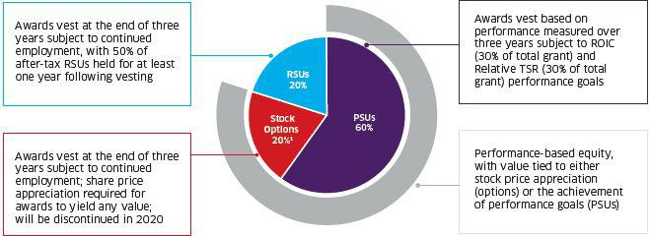

(1) In 2020, we will discontinue the use of stock options, and annual equity awards will comprise only PSUs (70%) and RSUs (30%).

The Compensation Committee reviews and approves annual awards for the NEOs on an annual basis. The awards are based on market competitiveness on total target compensation and aim at providing appropriate levels of retention and incentives for achieving the Company’s long-term goals.

- TechnipFMC

TechnipFMC Proxy Statement 2020

For 2019, the Compensation Committee set the target value of equity awards for each NEO with reference to market median total compensation data.

Named Executive Officer | 2019 Long-Term Incentive Target Award
Douglas J. Pferdehirt | $9,700,000
Maryann T. Mannen | $3,100,000
Dianne B. Ralston | $2,100,000
Justin Rounce | $1,800,000
Nello Uccelletti | $1,300,000

2019 Performance Stock Unit Awards (60% of Equity Award)

The Compensation Committee sets the performance targets associated with PSU awards prior to the beginning of each three-year performance period. For awards in 2019, PSU awards comprised 60% of the total long-term equity award and included the following two equally weighted measures:


PSU Measure | Weighting | Definition | Why It Matters
ROIC | 30% of total long- | Annual net income divided by equity plus | Assesses our profitability and how effectively the Company
 | term equity | long-term debt | is using capital over the three-year period to generate income.
 |  |  | Given the capital-intensive nature of our business, it is
 |  |  | critical that we effectively use our investments and assets.
Relative TSR | 30% of total long- | Cumulative three-year increase in volume- | Assesses our overall performance in the eyes of our
 | term equity | weighted average price and reinvested | shareholders and the broader stock market, relative to
 |  | dividends relative to peers | companies with whom we compete for customers and
 |  |  | investors that are subject to similar macro- economic factors.

The relative TSR performance for our 2019 PSU awards will be measured against a group of 13 companies (“Relative TSR Peer Group”) that the Compensation Committee believes best reflect the companies that we compete with for both investments and customers. The financial and operational performance of these companies is therefore most directly relevant to TechnipFMC, and we are all subject to similar macro-economic factors.

We use relative TSR to motivate our NEOs to achieve superior share price compared to our key competitors, thus aligning their interests with shareholder interests. We further reinforce this by requiring a minimum threshold of relative performance for payout, and by capping payout in the case of negative shareholder return.

- TechnipFMC

TechnipFMC Proxy Statement 2020

The Compensation Committee reviewed our 2018 Performance Peer Group as defined in our 2019 Proxy Statement, and no changes were made for 2019 since they were deemed appropriate based on the factors stated above. For awards made in 2019, the Performance Peer Group (now referred to as our Relative TSR Peer Group) comprised the following:

2019 Relative TSR Peer Group

Baker Hughes Company | McDermott International Inc. | Saipem S.p.A.
Chicago Bridge & Iron Company N.V. | National Oilwell Varco, Inc. | Subsea 7 S.A.
Fluor Corporation | Oceaneering International, Inc. | Weatherford International plc
Halliburton Company | Oil States International, Inc.
John Wood Group plc | Schlumberger Limited

The vesting date for these PSU awards is March 8, 2022, with a performance period of January 1, 2019 through December 31, 2021.

The Compensation Committee approved the following targets in relation to the 2019 PSU awards:

Performance Achievement | ROIC Performance | Relative TSR Ranking | Payout
 |  |  | (% of earned PSUs)
Below Threshold | Below Plan | Below 25th percentile | 0%
Threshold | 6% | 25th percentile | 50%
Target | 7% | 42nd percentile | 100%
Maximum or above | 8% | 75th percentile or greater | 200%

Note: If the Company’s TSR is negative for the performance period, the payout in respect of the TSR element will be capped at target, regardless of our relative performance.

For performance achievement between the levels identified above, payout percentage will be interpolated on a straight- line basis.

2019 Stock Options (20% of Equity Award)

In addition to PSUs, NEOs received an annual grant of stock options in 2019. This award aimed at aligning pay with the performance of our stock, aligning NEOs’ interests with our shareholders’ interests, as well as retaining NEOs over the long-term.

Based on feedback received from shareholders, we plan to eliminate stock options in 2020, thereby increasing the share of PSUs to further align pay with performance.

NEOs’ 2019 stock option awards are subject to a three-year cliff vesting, with no phased vesting, meaning the NEO must remain employed through the vesting date of March 8, 2022 for any of the options to become exercisable, with exceptions for retirement, death, and disability in line with market norms. Options are exercisable for a period of 10 years from the date of grant and have an exercise price equal to the closing price of the Company’s Ordinary Shares as reported by the NYSE on the grant date.

The number of stock options granted to each of the NEOs is determined by dividing the approved target award value by the expected value of each option (calculated using the Black-Scholes option pricing model) on the grant date.

- TechnipFMC

TechnipFMC Proxy Statement 2020

2019 Time-Based RSU Awards (20% of Equity Award)

The final component of the long-term incentive mix is RSU awards. These awards further align NEOs’ interests with the interests of our shareholders by incentivizing them to increase share price, while reinforcing the retention impact of our compensation program.

RSUs are subject to three-year cliff vesting terms, with no phased vesting, meaning the NEO must remain employed through the vesting date of March 8, 2022, with exceptions only for retirement, death, and disability. Once vested, the executive receives ownership and the voting rights of the underlying Ordinary Shares. The number of RSUs granted to each of the NEOs was determined by dividing the target value set for each executive officer by the closing price of the Company’s Ordinary Shares on the NYSE on the grant date.

On vesting, 50% of the after-tax number of RSUs must be held for a period of at least one year to incentivize NEOs to retain the shares and increase share price, further aligning NEOs’ interests with those of our shareholders.

Vesting of 2017 PSU Awards

Following the Merger in 2017, the Compensation Committee approved PSU awards subject to a three-year performance period. As with the awards made in 2018 and 2019, vesting was contingent on performance delivered in two areas: ROIC and relative TSR. The Compensation Committee believes that the continued use of these metrics remains relevant for the long-term since they focus executives on the achievement of specific financial long-term goals directly aligned with our operating and strategic plans.

As a result of our 2017-2019 performance, our NEOs achieved a payout of 50% of target on their 2017 PSUs.

Performance Goals:
Goal/Weightings | Performance Measure | Threshold | Target | Maximum
 |  | Performance | Performance | Performance
ROIC | Achievement of stated target | 0% | 100% | 200%
(30% of total long-term equity)
Relative TSR | Ranking against the 2017 | 0% | 100% | 200%
(30% of total long-term equity) | Performance Peer Group

For the ROIC measure, the Performance Targets and earned PSUs are as noted below. For performance achievement between the levels identified below, the payout percentage is interpolated on a straight-line basis.

Achieved Performance | Performance Target | Earned PSUs
Below Threshold | Below 10% | 0%
Threshold Performance | 10% | 50%
Target Performance | 11% | 100%
Maximum Performance or above | 12% | 200%

- TechnipFMC

TechnipFMC Proxy Statement 2020

For the relative TSR measure, the earned PSUs were based on a percentile ranking of the Company’s TSR against the constituents of the 2017 Performance Peer Group.

Ranking | Earned PSUs1
13th or Lower | 0%
11th or 12th | 50%
9th or 10th | 75%
8th | 100%
7th | 120%
6th | 140%
5th | 160%
4th | 180%
3rd or higher | 200%

(1) If the Company’s TSR is negative for the performance period, the payout in respect of the TSR element will be capped at target, regardless of our relative performance.

The overall achievement for the performance element of our 2017 PSU awards was 50% based on the following:

Three-year ROIC performance for 2017-2019 was 6.9%. This ROIC performance was below the threshold for payout on the payout scale provided above, and therefore, the ROIC component of the 2017 PSU awards paid out at 0%.

Three-year relative TSR performance for the Company for 2017-2019 was –37.8%, which placed the Company at a ranking of 5th relative to the 2017 Performance Peer Group. This resulted in a payout for the relative TSR metric of 100%, based on the payout scale above.

We achieved above-target performance for the relative TSR measure for our 2017-2019 performance period based on our performance relative to the Performance Peer Group. However, our absolute relative TSR performance was negative given the overall oil and gas market conditions during the same period. Therefore, our payout under our incentive plan was capped at target (100%) given the absolute TSR performance.

2017 Long-Term Incentive (Equity Award) Plan (as of December 31, 2019)
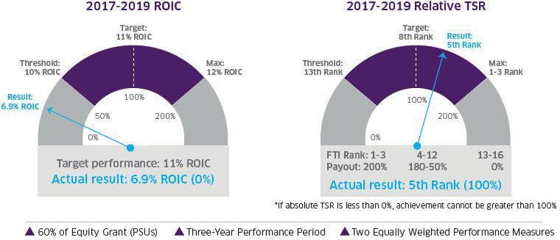

- TechnipFMC

TechnipFMC Proxy Statement 2020

2020 Long-Term Incentive Plan Grants

The Compensation Committee granted long-term equity incentives to our NEOs on March 9, 2020, consisting of the following:

Based on feedback from shareholders in 2019, we eliminated the use of stock options in the 2020 long-term equity incentive awards.

30% of awards granted are time-based RSUs.

70% of awards granted are PSUs. The performance period was set from January 1, 2020 to December 31, 2022. Due to the announced spin-off of Technip Energies, the performance metrics for the PSUs will be pro-rated based on two separate periods: January 1, 2020 to the closing date of the spin-off (“Pre-spin Period”) and from the closing date of the spin-off to December 31, 2022 (“Post-spin Period”).

For the Pre-spin Period, the PSU performance metric will be based on relative TSR performance versus our Relative TSR Peer Group, using the payout scale below:

Relative TSR Ranking | Payout (% of earned PSUs)
Below 25th percentile | 0%
25th percentile | 50%
75th percentile or greater | 200%

Note: If the Company’s TSR is negative for the performance period, the payout in respect of the TSR element will be capped at target, regardless of our relative performance.

For the Post-spin Period, each of TechnipFMC and Technip Energies will set its performance metrics and targets related to the Post-spin Period as soon as practicable after the closing of the spin-off.

Each company will include TechnipFMC’s Pre-spin Period performance in a weighted calculation of its performance for the 2020-2022 performance period.

Indirect Compensation

The final element of our compensation comprises market-aligned benefits and perquisites. These are intended to both facilitate the performance of our NEOs in their roles while ensuring we are market competitive in what we provide.

Retirement Benefits

Eligibility for retirement savings plan participation depends on an NEO’s tenure and the country in which he or she is based. The majority of our NEOs participate in the U.S.

Qualified and Non-Qualified Savings Plans on the same terms as other eligible employees.

- TechnipFMC

TechnipFMC Proxy Statement 2020
Plan | Eligibility | Features
U.S. Qualified Savings Plan | U.S. employees working more than | Employees can contribute between 1% and 75% of eligible compensation (salary and
 | 30 hours a week | eligible incentives) on a pre-and after- tax basis up to statutory limits for tax qualified plans
 | All NEOs other than Mr. Uccelletti | Company matches 100% of the first 5% of eligible contributions
 | All NEOs other than Mr. Uccelletti | Participants are 100% vested in their contributions and matching contributions
 | are eligible
 | are eligible | Employees receive an additional 2% non-elective Company contribution that vests after
 |  | three years of service
 |  | For annual compensation that exceeds the limit required for the plan to be qualified, the
 |  | Company contributes 5% of such excess to the employee’s non-qualified savings plan (see
 |  | below)
U.S. Non- Qualified Savings | U.S. executives and other eligible | The Company contributes an amount equal to any missed Company contribution under the
Plan | senior employees | U.S. Qualified Savings Plan on annual compensation that exceeds the maximum limit
 | All NEOs other than Mr. Uccelletti | required for the plan to be qualified
 | All NEOs other than Mr. Uccelletti | Intent of the plan is to ensure eligible employees receive the same contribution as a
 | are eligible
 | are eligible | percentage of eligible earnings from the Company regardless of their compensation level
 |  | Terms mirror those of the U.S. Qualified Savings Plan
 |  | Participants can contribute up to 75% of their eligible compensation (salary and eligible
 |  | incentives) on a pre-tax basis
 |  | Company matches 100% of the first 5% of eligible contributions
 |  | Participants are 100% vested in their contributions and matching contributions
 |  | Employees receive an additional 2% non-elective Company contribution that vests after
 |  | three years of service
 |  | All vested funds must be distributed upon an employee’s separation from service with the
 |  | Company; provided, however, that there is a six-month delay for key employees
U.S. Pension Plan | U.S. employees of FMC | A tax-qualified defined benefit plan
 | Technologies with five years of | Pension based on final average pay, calculated as the highest 60 consecutive months of pay
 | service prior to January 1, 2010 | (base salary and annual cash incentive bonus) in the final 120 months of service
 | Ms. Mannen is the only eligible | Benefit accruals frozen for non-union employees effective December 31, 2017
 | NEO


- TechnipFMC

TechnipFMC Proxy Statement 2020
Plan | Eligibility | Features
U.S. Non- Qualified Pension | U.S. executives and other |  | A non-qualified defined benefit pension plan
Plan | eligible senior employees of |  | A non-qualified defined benefit pension plan
 | FMC Technologies with five |  | Pension based on final average pay, calculated as the highest 60 consecutive
 | years of service prior to | months of pay (base salary, annual cash incentive bonus, and employee contributions
 | January 1, 2010 | made to the U.S. Non-Qualified Savings Plan) in the final 120 months of service up to
 | Ms. Mannen is the only eligible | statutory limits for tax qualified plans
 | Ms. Mannen is the only eligible |  | Benefit accruals frozen for non-union employees effective December 31, 2017
 | NEO
Italian Statutory Pension | All employees of Technip Italy |  | The TFR (Trattamento di fine rapport) is paid in any case of termination of employment
Plan
Plan | Mr. Uccelletti is the only eligible | (including retirement)
 | NEO |  | Annual accrual is salary divided by 13.5
 |  |  | At the employee’s request, this amount can be transferred to a private pension fund


Perquisites

The Company also provides limited perquisites to NEOs, facilitating the performance of their roles and to ensure a competitive total compensation package. The perquisites we provide to our executives may include financial planning and personal tax assistance, personal use of Company automobiles, dining club memberships and country club memberships, executive physicals, 100% match of charitable contributions up to an aggregate of $10,000 per year, and other minor expenses associated with their business responsibilities. The value of perquisites deemed to be personal is imputed as income to an executive officer, and we do not gross up for the taxes due on such imputed income. Additional allowances or benefits may be granted to NEOs, if considered appropriate and reasonable.

Reflecting the safety concerns associated with their roles, the Company provides a security program for our executive officers. The Compensation Committee believes this is in the best interests of shareholders as the personal safety and security of our executive officers is critical to the stability of the Company. The security program was developed based on a risk assessment determined to be appropriate by our security team and an outside consultant. We do not consider the security measures provided to our executive officers to be a personal benefit, but rather reasonable and necessary expenses for the benefit of the Company. However, in accordance with SEC disclosure rules, the aggregate incremental cost of these services is reported in the Summary Compensation Table.

- TechnipFMC

TechnipFMC Proxy Statement 2020

Other Compensation, Benefits, and Considerations

Executive Severance Benefits

It is our policy to offer severance benefits to our executive officers because we believe that severance benefits provide important financial protection to executive officers in the event of involuntary job loss, are consistent with the practices of peer companies, and are appropriate for the retention of executive talent.

Our executive officers, including our NEOs, are entitled to severance benefits outside of a change-in-control context pursuant to our executive severance plan or individual employment agreements, the material terms of which are described in the chart below. Our general executive severance arrangements are consistent with the market practice of large public companies surveyed by Willis Towers Watson. Change-in-control severance benefits, as described below, and general severance benefits are exclusive of one another, and in no circumstance would any NEO receive benefits under both a change-in-control severance agreement and our general executive severance plan.

Each of our NEOs is party to an Executive Severance Agreement, pursuant to which he or she is entitled to enhanced severance in the event of a qualifying termination in connection with a change-in-control. We entered into the Executive Severance Agreements to ensure executives are incentivized to continue to work in the Company’s best interests during the period of time when a change-in-control transaction is taking place and in order to ensure we have the ability to maintain continuity of management. The Compensation Committee believes it is appropriate to provide executives with the assurance they will not be adversely affected by a change-in-control transaction without fair compensation, except in the case of termination for cause. The material terms of the Executive Severance Agreements are described in the chart below.


Separation | Provisions under TechnipFMC Executive Severance Plan, Executive Severance Agreement,
Scenario | or Relevant Equity Award Agreements
Termination without | Cash severance equal to 18 months of base salary and target annual cash incentive bonus
cause | Pro-rated target annual cash incentive bonus for the year of termination
 | 18 months of medical and dental benefits continuation
 | Outplacement assistance as appropriate
 | Financial planning and tax preparation assistance for the final calendar year of employment
 | Severance benefits subject to compliance with non-disclosure, non-compete, and non-solicitation covenants
 | Equity treated pursuant to the terms of the applicable plan
 | No tax gross-ups on any payments
Retirement | Outstanding equity settled on the originally scheduled date
 | Outstanding PSUs will remain subject to the original performance conditions, measured at the originally scheduled date
Death or disability | Accelerated vesting of all granted and outstanding equity awards, with outstanding PSUs vesting at target

- TechnipFMC

TechnipFMC Proxy Statement 2020
Separation | Provisions under TechnipFMC Executive Severance Plan, Executive Severance Agreement,
Scenario | or Relevant Equity Award Agreements
Qualifying termination |  | Double trigger requirements, meaning a change-in-control event must occur, followed by a qualifying termination within
Qualifying termination |  | 24 months
without cause or resignation |  | 24 months
for good reason following a | “Qualifying termination” defined as termination by the Company without cause, or if the executive terminates
change-in-control event |  | employment for good reason (e.g., material change in responsibilities, material reduction in salary and/or benefits,
 |  | significant change in location of employment)
 |  | Cash severance equal to two to three times the greater of the executive’s annual base salary on the date of the
 |  | agreement or the date of termination and two to three times the greater of his or her average actual annual cash
 |  | incentive bonuses paid in the three years prior to termination or his or her target annual cash incentive bonus for |  | the
 |  | year the executive is terminated
 |  | Pro-rated target annual cash incentive bonus for the year of termination
 |  | Amount equal to the premiums payable for health and welfare coverage for 24 to 36 months
 | Up to $50,000 in outplacement assistance
 |  | Accelerated vesting of all granted and outstanding equity awards, with outstanding PSUs vesting at target
 | No tax gross-ups on any payments
 | 280G best after-tax cutback


- TechnipFMC

TechnipFMC Proxy Statement 2020

Compensation Risk

As part of a robust approach to risk mitigation, the Company operates a number of policies that apply to our NEOs, and in many instances to broader employee populations. These policies are intended to align our NEOs with the long-term interests of our shareholders and encourage them to make decisions that expose the Company to an appropriate level of risk within our agreed framework.

Clawback Policy

The Company has adopted a compensation recovery clawback policy that enables us to recoup and/or cancel previously awarded compensation in defined situations.

Covered Employees | Executive officers subject to the reporting requirements of Section 16 of the U.S. Securities Exchange Act of 1934, as amended (the
 | “Exchange Act”)
 | By definition, this includes all NEOs
Covered Compensation | Cash incentive compensation
 | Equity awards
Triggering Events | Illegal acts including fraud, material theft of Company assets, bribery and corruption
 | Gross negligence
 | Willful misconduct, including conduct that requires the Company to materially restate its quarterly or annual financial or operating results
Compensation | Determine whether a triggering event has occurred
Committee Authority | Cancel previously granted compensation in part or in whole, whether vested or deferred
 | Clawback previously earned compensation by requiring the executive officer to repay the Company any gain realized or payment received
 | Reduce or offset future incentive compensation

- TechnipFMC

TechnipFMC Proxy Statement 2020

Share Ownership and Retention Requirements

The Compensation Committee oversees the operation of share ownership guidelines that apply to our executive officers. All executive officers, including all NEOs, met their pro rata ownership and retention requirements under the Company’s policy in 2019.

Share Ownership | ◗ | CEO: 6x base salary
Requirements | ◗ | CFO: 5x base salary
 | ◗ Other executive officers: 3x base salary
Qualifying Share | ◗ | Ordinary shares owned outright
Interests | ◗ PSU awards where the performance period is final and approved
 | ◗ | Unvested RSUs
Time for | ◗ | Five years from the effective date of appointment
Achievement | ◗ Pro rata requirement of 20% per year applies within the first five years
Consequences for Non- | ◗ | At the discretion of the Board of Directors
Achievement
Retention Requirement | ◗ | 50% of the after-tax RSUs must be retained for at least one year following vesting
 | ◗ Applies regardless of whether an executive has met the ownership requirement

Insider Trading and Speculation in Company Stock

Our officers, directors, and employees are prohibited from engaging in discretionary transactions involving our securities while in possession of material, non-public information or otherwise using such information in any manner that would violate applicable laws and regulations. All such individuals are also prohibited from directly or indirectly

speculating in Ordinary Shares, including derivative transactions, hedging and pledging activities, short selling, the sale or purchase of options in Ordinary Shares, and borrowing against Ordinary Shares. Our Insider Trading Policy aims to align management’s economic ownership risk with those of shareholders.

Tax Considerations

Section 162(m) of the U.S. tax code limits the deductibility of compensation in excess of $ 1 million paid to U.S.-based NEOs in any calendar year. Under the U.S. tax rules in effect before 2018, compensation that qualified as “performance- based” under Section 162(m) was deductible without regard to this $1 million limit. However, the U.S. Tax Cuts and Jobs Act of 2017 (the “TCJA”) eliminated this performance-based compensation exception effective January 1, 2018, such that any compensation awarded on or after January 1, 2018 in excess of $1 million to our U.S.-based NEOs generally is not deductible. While the TCJA limits the deductibility of compensation paid to our U.S.-based NEOs, such limitations have not had and will not have a material impact on the Company’s executive compensation program. Our Compensation Committee will continue to structure our compensation program in the best long-term interests of our shareholders.

- TechnipFMC

TechnipFMC Proxy Statement 2020

Summary Compensation Table for the Year Ended December 31, 2019

The following table summarizes the compensation earned by each of the NEOs from all sources for services rendered in all of their capacities to the Company during the fiscal year ended December 31, 2019.

 |  |  |  |  |  |  | Change in
 |  |  |  |  |  |  | Pension
 |  |  |  |  |  |  | Value and
 |  |  |  |  |  | Non-Equity | Nonqualified
Name and Principal |  |  |  |  |  | Incentive Plan | Deferred | All Other
Position as of |  | Salary | Bonus | Stock Awards | Option Awards | Compensation | Compensation | Compensation | Total
12/31/2019 | Year | ($) | ($) | ($)1 | ($)2 | ($) | Earnings ($)3 | ($)4 | ($)
Douglas J. Pferdehirt | 2019 | 1,236,000 | — | 8,877,924 | 1,939,995 | 2,903,364 | — | 393,923 | 15,351,206
Chairman and CEO | 2018 | 1,230,000 | — | 7,965,213 | 1,739,994 | 2,154,499 | — | 313,794 | 13,403,500
 | 2017 | 1,116,667 | — | 7,317,853 | 1,739,998 | 2,272,556 | — | 241,026 | 12,688,100
Maryann T. Mannen | 2019 | 797,917 | — | 2,837,216 | 619,999 | 1,308,583 | 1,058,285 | 218,713 | 6,840,713
Executive Vice President and Chief | 2018 | 768,750 | — | 2,838,182 | 619,998 | 968,625 | — | 148,977 | 5,344,532
Financial Officer | 2017 | 718,284 | — | 2,698,086 | 623,048 | 1,028,942 | 2,162,942 | 86,423 | 7,317,725
Dianne B. Ralston | 2019 | 638,833 | — | 1,921,999 | 419,998 | 1,047,687 | — | 128,601 | 4,157,118
Executive Vice | 2018 | 615,000 | — | 1,922,626 | 420,000 | 797,963 | — | 114,120 | 3,869,709
President, Chief | 2017 | 591,667 | — | 1,827,750 | 422,065 | 891,938 | — | 121,734 | 3,855,154
Legal Officer and
Secretary
Justin Rounce | 2019 | 600,000 | — | 1,647,411 | 359,997 | 999,000 | — | 37,436 | 3,643,844
Executive Vice President and Chief | 2018 | 200,000 | 1,225,500⁵ | 2,099,986 | — | 244,500 | — | 10,325 | 3,780,311
Technology Officer
Nello Uccelletti6 | 2019 | 561,997 | — | 1,189,806 | 259,997 | 921,674 | — | 459,497 | 3,392,971
President and

Advisor to the CEO

- Amounts disclosed in the Stock Awards column represent the sum of the aggregate grant date fair value of time-based RSUs and PSUs subject to either performance (ROIC) or market-based (TSR) vesting conditions. Determination of fair value was made in accordance with FASB ASC Topic 718. With respect to PSUs subject to performance-based (ROIC) vesting conditions and time-based RSUs, the aggregate grant date fair value of such awards was based on the Company’s share price on the grant date of the awards at target performance. With respect to PSUs subject to TSR market-based vesting conditions, the grant date fair value of such award was determined utilizing a Monte Carlo simulation as disclosed in our Form 10-K.

The maximum award value of PSUs subject to both performance conditions and market-based conditions are shown in the table below. The methodology used in this table is the same as in the Summary Compensation Table for the PSUs.

 | Pferdehirt | Mannen | Ralston | Rounce | Uccelletti
2019 | $13,875,848 | $4,434,472 | $3,004,000 | $2,574,830 | $1,859,644
2018 | $12,450,470 | $4,436,366 | $3,005,276 | N/A | N/A
2017 | $11,155,726 | $4,156,182 | $2,815,504 | N/A | N/A

- Represents the grant date fair value of stock options determined in accordance with FASB ASC Topic 718 using the Black-Scholes method as disclosed in our Form 10-K.
- The amounts shown in the Change in Pension Value column reflect the actuarial increase in the present value of the NEO’s benefits at the first retirement date with unreduced benefits (age 62 for U.S. pension programs) under all of our pension plans. These amounts are determined using interest rates and mortality rate assumptions consistent with those disclosed in our Form 10-K.
In 2018, the discount rate used to value the actuarial liability increased 70 basis points from 3.7% to 4.4%, resulting in a decrease in the pension value for Ms. Mannen by $299,788 and therefore, no increase is shown.
- The amounts reflected in the All Other Compensation column for the fiscal year ended December 31, 2019 represent:
Mr. Pferdehirt — contributions to the U.S. Qualified Savings Plan and U.S. Non-Qualified Savings Plan of $241,779, Company-provided apartment in Paris, France of $66,384, spouse travel for Company business functions of $42,699, financial planning and personal tax assistance of $20,935, security services of $16,378, personal use of Company automobile of $4,977, and Company-paid life insurance premium of $771.
Ms. Mannen — contributions to the U.S. Qualified Savings Plan and U.S. Non-Qualified Savings Plan of $124,740, Company-provided apartment in Paris, France of $46,955, spouse travel for Company business functions of $459, club membership of $21,459, financial planning and personal tax assistance of $20,935, security services of $3,667, and Company-paid life insurance premium of $498.
Ms. Ralston — contributions to the U.S. Qualified Savings Plan and U.S. Non-Qualified Savings Plan of $98,272, club membership of $6,930, financial planning and personal tax assistance of $20,935, security services of $2,066, and Company-paid life insurance premium of $399. Mr. Rounce — contributions to the U.S. Qualified Savings Plan and U.S. Non-Qualified Savings Plan of $21,252, club membership of $10,018, personal tax assistance of $2,935, security services of $2,857, and Company-paid life insurance premium of $374.

Mr. Uccelletti — contributions to the Italian Statutory Pension Plan of $372,521, Company-provided apartment in Paris, France of $60,787, compensation for national holidays worked of $10,824, personal tax assistance of $2,935, personal use of Company automobile of $2,052, and Company-paid life insurance premium of $10,379.

- TechnipFMC

TechnipFMC Proxy Statement 2020

- Mr. Rounce commenced employment on September 14, 2018. In order to attract Mr. Rounce to join the Company and to make him whole for forfeited compensation at his prior company, he received a cash bonus totaling $750,000 in one-third increments over three years, subject to him not being terminated for cause. This amount is reflected in the Bonus column. In addition, Mr. Rounce was guaranteed a bonus of $720,000 that included a pro-rated annual cash incentive for 2018. The difference between the guaranteed amount of $720,000 and his actual annual cash incentive earned in 2018 is reflected in the Bonus column, and the actual annual cash incentive earned in 2018 is reflected in the Non-Equity Incentive Plan Compensation column.

- The amounts reported as salary, non-equity incentive compensation, bonus, and all other compensation for Mr. Uccelletti were paid in Euros. These amounts were converted to U.S. dollars utilizing an average of the Euro to U.S. dollar exchange rates on the last day of each month during 2019.

- TechnipFMC

TechnipFMC Proxy Statement 2020

Grants of Plan-Based Awards Table

Shown below is information with respect to plan-based awards made in 2019 to each NEO.

 |  |  | Estimated Possible Payouts Under |  |  | Estimated Possible Payouts Under Stock Option
 |  |  | Non-Equity Incentive Plan Awards |  |  | Equity Incentive Plan Awards |  |  | All Other | All Other
 |  |  |  |  |  |  |  |  | Stock | Option
 |  |  |  |  |  |  |  |  | Awards: | Awards: |  | Grant Date
 |  |  |  |  |  |  |  |  | Number of | Number of | Exercise or | Fair Value
 |  |  |  |  |  |  |  |  | Shares of | Securities | Base Price | of Stock
 |  |  |  |  |  |  |  |  | Stock or | Underlying | of Option | and Option
 |  |  | Threshold | Target | Maximum | Threshold | Target | Maximum | Units | Options | Awards | Awards
Name | Award Type1 | Grant Date | ($) | ($)² | ($) | (#) | (#) | (#) | (#) | (#) | ($/Sh) | ($)³
Douglas J. | Annual Incentive | 2019 | — | 1,668,600 | 3,337,200
Pferdehirt
 | RSU | 3/8/2019 |  |  |  |  |  |  | 92,469 |  |  | 1,940,000
 | PSU-ROIC | 3/8/2019 |  |  |  | — | 138,703 | 277,406 |  |  |  | 2,909,989
 | PSU-TSR | 3/8/2019 |  |  |  | — | 138,703 | 277,406 |  |  |  | 4,027,935
 | Stock Options | 3/8/2019 |  |  |  |  |  |  |  | 343,727 | 20.98 | 1,939,995
Maryann T. Mannen | Annual Incentive | 2019 | — | 797,917 | 1,595,833
 | RSU | 3/8/2019 |  |  |  |  |  |  | 29,551 |  |  | 619,980
 | PSU-ROIC | 3/8/2019 |  |  |  | — | 44,327 | 88,654 |  |  |  | 929,980
 | PSU-TSR | 3/8/2019 |  |  |  | — | 44,327 | 88,654 |  |  |  | 1,287,256
 | Stock Options | 3/8/2019 |  |  |  |  |  |  |  | 109,851 | 20.98 | 619,999
Dianne B. Ralston | Annual Incentive | 2019 | — | 638,833 | 1,277,666
 | RSU | 3/8/2019 |  |  |  |  |  |  | 20,019 |  |  | 419,999
 | PSU-ROIC | 3/8/2019 |  |  |  | — | 30,028 | 60,056 |  |  |  | 629,987
 | PSU-TSR | 3/8/2019 |  |  |  | — | 30,028 | 60,056 |  |  |  | 872,013
 | Stock Options | 3/8/2019 |  |  |  |  |  |  |  | 74,415 | 20.98 | 419,998
Justin Rounce | Annual Incentive | 2019 | — | 600,000 | 1,200,000
 | RSU | 3/8/2019 |  |  |  |  |  |  | 17,159 |  |  | 359,996
 | PSU-ROIC | 3/8/2019 |  |  |  | — | 25,738 | 51,476 |  |  |  | 539,983
 | PSU-TSR | 3/8/2019 |  |  |  | — | 25,738 | 51,476 |  |  |  | 747,432
 | Stock Options | 3/8/2019 |  |  |  |  |  |  |  | 63,784 | 20.98 | 359,997
Nello Uccelletti | Annual Incentive | 2019 | — | 561,997 | 1,123,993
 | RSU | 3/8/2019 |  |  |  |  |  |  | 12,392 |  |  | 259,984
 | PSU-ROIC | 3/8/2019 |  |  |  | — | 18,589 | 37,178 |  |  |  | 389,997
 | PSU-TSR | 3/8/2019 |  |  |  | — | 18,589 | 37,178 |  |  |  | 539,825
 | Stock Options | 3/8/2019 |  |  |  |  |  |  |  | 46,066 | 20.98 | 259,997

- “RSU” awards are time-based restricted stock unit awards, “PSU-ROIC” awards are performance-based restricted stock unit awards based on the ROIC performance measure, and “PSU-TSR” awards are market-based restricted stock unit awards based on the TSR performance measure.
- Each target award as a percentage of base salary: Mr. Pferdehirt – 135%; Ms. Mannen – 100%; Ms. Ralston – 100%; Mr. Rounce – 100%, and Mr. Uccelletti – 100%.
- Grant date fair values were determined in accordance with FASB ASC Topic 718. With respect to time-based RSUs and PSUs that are subject to performance (ROIC) vesting conditions, the aggregate grant date fair value of such awards was based on the Company’s share price on the grant date of the awards, assuming target performance. With respect to PSUs subject to market-based (TSR) vesting conditions, the grant date fair value of such award was determined utilizing a Monte Carlo simulation as disclosed in our Form 10-K. With respect to stock options, the grant date fair value was determined using the Black-Scholes method as disclosed in our Form 10-K.

For a description of the material terms of the RSU awards, including the vesting schedules and a description of the performance targets and potential award amounts for those restricted shares subject to performance-based conditions, and the time-vesting stock options, see the descriptions set forth in “Executive Compensation Discussion and Analysis.” Dividend equivalents, where allowed, are accumulated on RSU and PSU awards and are payable only if and when the RSUs and PSUs vest.

- TechnipFMC

TechnipFMC Proxy Statement 2020

Outstanding Equity Awards at Fiscal Year-End Table

Shown below is information for each of the NEOs with respect to outstanding equity awards at December 31, 2019.

 |  |  |  |  |  |  |  |  |  | Incentive
 |  |  |  |  |  |  |  |  | Incentive | Award Plan
 |  |  |  | Incentive |  |  |  |  | Award Plan | Awards:
 |  |  |  | Award Plan |  |  |  |  | Awards: | Market or
 |  |  |  | Awards: |  |  |  |  | Number of | Payout Value
 |  | Number of | Number of | Number of |  |  | Number | Market Value | Unearned | of Unearned
 |  | Securities | Securities | Securities |  |  | of Shares | of Shares | Shares, Units, | Shares, Units,
 |  | Underlying | Underlying | Underlying |  |  | or Units of | or Units of | or Other | or Other
 |  | Unexercised | Unexercised | Unexercised | Option | Option | Stock that | Stock that | Rights that | Rights that
Name | Grant Date | Options (#) | Options (#) | Unearned | Exercise | Expiration | have Not | have Not | have Not | have Not
Name | Grant Date | Exercisable | Unexercisable | Options (#) | Price ($/€) | Date | Vested (#) | Vested ($)1 | Vested (#) | Vested ($)1
Douglas J. | 6/20/2017 |  | 224,8352 |  | $26.62 | 6/20/2027 | 65,364² | 1,401,404 | 196,093³ | 4,204,234
Pferdehirt
Pferdehirt | 2/26/2018 |  | 193,0114 |  | $30.30 | 2/26/2028 | 57,425⁴ | 1,231,192 | 172,277⁵ | 3,693,619
 | 3/8/2019 |  | 343,727⁶ |  | $20.98 | 3/8/2029 | 92,469⁶ | 1,982,535 | 277,407⁷ | 5,947,606
Maryann T. | 2/28/2017 |  | 66,148² |  | $32.32 | 2/28/2027 | 19,183² | 411,284 | 57,549³ | 1,233,851
Mannen | 2/26/2018 |  | 68,774⁴ |  | $30.30 | 2/26/2028 | 20,462⁴ | 438,705 | 61,386⁵ | 1,316,116
 | 3/8/2019 |  | 109,851⁶ |  | $20.98 | 3/8/2029 | 29,551⁶ | 633,573 | 88,655⁷ | 1,900,763
Dianne B. Ralston | 2/28/2017 |  | 44,810² |  | $32.32 | 2/28/2027 | 12,995² | 278,613 | 38,985³ | 835,838
 | 2/26/2018 |  | 46,589⁴ |  | $30.30 | 2/26/2028 | 13,861⁴ | 297,180 | 41,584⁵ | 891,561
 | 3/8/2019 |  | 74,415⁶ |  | $20.98 | 3/8/2029 | 20,019⁶ | 429,207 | 60,057⁷ | 1,287,622
Justin Rounce | 11/1/2018 |  |  |  |  |  | 26,3958 | 565,909
 | 3/8/2019 |  | 63,784⁶ |  | $20.98 | 3/8/2029 | 17,1596 | 367,889 | 51,477⁷ | 1,103,667
Nello Uccelletti | 6/14/2013 | 18,552 |  |  | €42.87 | 6/14/2021
 | 9/7/2015 | 50,000 |  |  | €23.92 | 9/7/2023
 | 7/1/2016 |  | 50,000⁹ |  | €24.17 | 7/1/2024 | 30,000⁹ | 643,200
 | 2/28/2017 |  | 26,672² |  | $32.32 | 2/28/2027 | 7,735² | 165,838 | 23,205³ | 497,515
 | 2/26/2018 |  | 27,731⁴ |  | $30.30 | 2/26/2028 | 8,250⁴ | 176,880 | 24,752⁵ | 530,683
 | 3/8/2019 |  | 46,066⁶ |  | $20.98 | 3/8/2029 | 12,392⁶ | 265,684 | 37,178⁷ | 797,096

- The market value of RSUs that have not vested is calculated using the closing price of the Company’s Ordinary Shares on the NYSE of $21.44 on December 31, 2019.
- Reflects grant of stock options and RSUs, as applicable, that vest on February 28, 2020.
- Reflects the target number of PSUs that vest on February 28, 2020.
- Reflects grant of stock options and RSUs, as applicable, that vest on February 26, 2021.
- Reflects the target number of PSUs that vest on February 26, 2021.
- Reflects grant of stock options and RSUs, as applicable, that vest on March 8, 2022.
- Reflects the target number of PSUs that vest on March 8, 2022.
- Reflects grant of RSUs that vest on September 14, 2020.

- Reflects grant of legacy Technip stock options and PSUs, as applicable, that were earned based on the satisfaction of performance criteria at target, and that vest on July 1, 2020.

- TechnipFMC

TechnipFMC Proxy Statement 2020

Option Exercises and Stock Vested Table

Shown below is information for each of the NEOs with respect to options to purchase Ordinary Shares exercised in 2019 and RSU and PSU awards that vested in 2019.


 | Option Awards |  | Stock Awards
Named Executive Officer | Number of | Value Realized on | Number of Shares | Value Realized on
 | Shares Acquired | Exercise ($) | Acquired on | Vesting1
 | on Exercise |  | Vesting | ($)
 | (#) |  | (#)
Douglas J. Pferdehirt | — | — | 54,132 | 1,324,069
Maryann T. Mannen | — | — | — | —
Dianne B. Ralston | — | — | — | —
Justin Rounce | — | — | 26,395 | 679,935
Nello Uccelletti | — | — | 11,200 | 287,989

(1) The value of the vested shares does not include dividends earned.

- TechnipFMC

TechnipFMC Proxy Statement 2020

Pension Benefits Table

The table below shows the present value of accumulated benefits payable to Ms. Mannen, who is the only NEO who participates in a Company pension plan. The table includes the number of years of service credited to Ms. Mannen using interest rate and mortality rate assumptions consistent with those used in our financial statements. Credited years of service for Ms. Mannen includes years of service with FMC Technologies and its former parent company. The U.S.

Pension Plan values are the present value of accrued benefits at the first retirement date for unreduced benefits. The U.S. Non- Qualified Pension Plan value is the present value at December 31, 2019 of the lump sum payable at the first retirement date for unreduced benefits.

Name | Plan Name1 | Number of Years of | Present Value of | Payments During
 |  | Credited Service as | Accumulated | Last Fiscal Year
 |  | of 12/31/2019 | Benefit as of
 |  |  | 12/31/2019 ($)2
Maryann T. Mannen | U.S. Pension Plan | 31.7 | 1,512,141 | 0
 | U.S. Non-Qualified Pension Plan | 31.7 | 6,483,931 | 0

- Effective January 1, 2010, the U.S. Pension Plan and the U.S. Non-Qualified Pension Plan were closed to new entrants and frozen for employees, including executive officers, with less than five years of vesting service as of December 31, 2009. Accordingly, only Ms. Mannen participates in the
U.S. Pension Plan and the U.S. Non-Qualified Pension Plan. Effective December 31, 2017, future benefit accruals were frozen under the U.S. Pension Plan and the U.S. Non-Qualified Pension Plan.
- The following assumptions were used to calculate the present value of Ms. Mannen’s accumulated benefits as of December 31, 2019:

– Present value of U.S. Pension Plan benefit calculated as amount payable at first unreduced age using December 31, 2019 FASB ASC Topic 715 disclosure assumptions (3.40%, RP-2014 adjusted with modified MP-2014 projection scale with long-term rate plan improvement of 0% in 2027) and reflecting discounting of present value back to December 31, 2018 using FASB ASC Topic 715 interest only (3.40%);
– Present value of U.S. Non-Qualified Pension Plan benefit calculated as amount payable at first unreduced age using December 31, 2019 FASB ASC Topic 715 assumptions (2.30%, 417(e) mortality table for lump sum distributions payable in 2019 and 3.40% for five-year certain annuity) and reflecting discounting of present value back to December 31, 2019 using FASB ASC Topic 715 interest only (3.40%); and
– Unreduced benefits are first available at age 62 (or current age, if later) under the U.S. Pension Plan and the U.S. Non-Qualified Pension Plan.

- TechnipFMC

TechnipFMC Proxy Statement 2020

U.S. Pension Plan

Benefit Formula

Our U.S. Pension Plan is a defined benefit plan that provides eligible employees having five or more years of service a pension benefit for retirement. Years of credited service and final average yearly earnings are used to calculate the pension benefit. The final average yearly earnings are based on the highest 60 consecutive months out of the final 120 months of compensation through the date on which benefit accruals were frozen, December 31, 2017. The normal annual retirement benefit is the product of (a) and (b) below:

- the sum of:

  - 1% of the participant’s final average yearly earnings up to the Social Security Covered Compensation Base (defined as the average of the maximum Social Security taxable wages bases for the 35-year period ending in the year in which Social Security retirement age is reached), plus 1.5% of the participant’s final average yearly earnings in excess of the Social Security covered compensation base, multiplied by the participant’s expected years of credited service at age 65 up to 35 years of credited service; and

  - 1.5% of the participant’s final average yearly earnings multiplied by the participant’s expected years of credited service at age 65 in excess of 35 years of credited service; and

- the ratio of actual years of credited service to expected years of credited service at age 65.

Eligible Earnings

Eligible earnings under the U.S. Pension Plan include the base salary and annual cash incentive bonus paid by the Company to the executives for each plan year, subject to certain IRS limits. Equity compensation, such as RSU, PSU, and stock option awards, and deferrals to the U.S. Non-Qualified Savings Plan, are not included. Eligible earnings were frozen as of December 31, 2017.

Early Retirement

The U.S. Pension Plan’s “early retirement” eligibility is on or after the participant’s 55th birthday with 10 years of service. A participant in the U.S. Pension Plan who retires on or after their “early retirement date” is entitled to receive the early retirement benefit, which is equal to the normal retirement benefit reduced by one-third of 1% for each month by which the commencement of the participant’s early retirement benefit precedes the participant’s 62nd birthday. A participant in the U.S. Pension Plan whose employment terminates prior to their early retirement date is entitled to receive an early retirement benefit payable after the attainment of age 55, which is equal to the normal retirement benefit reduced by one-half of 1% for each month by which the commencement of the participant’s early retirement benefit precedes the participant’s 65th birthday.

Payment of Pension Benefit

The normal retirement benefit is an individual life annuity for single retirees and 50% joint and survivor annuity for married retirees. The U.S. Pension Plan also provides for a variety of other methods for receiving pension benefits, such as 75% and 100% joint and survivor annuities, level income, and lump sum for benefits with lump sum values of $1,000 or less. The levels of annuities are actuarially determined based on the age of the participant and the age of the participant’s spouse for joint and survivor annuities. The actuarial reduction for a participant and spouse who are both age 62 is 7.9% from the normal retirement benefit for the 50% joint and survivor annuity, 11.4% from the normal retirement benefit for the 75% joint and survivor annuity, and 14.7% from the normal retirement benefit for the 100% joint and survivor annuity. The level income annuity pays increased benefits to the retiree until Social Security benefits begin at age 62 and reduces the benefit after age 62 so that the total of the retirement benefit and Social Security benefits is approximately equal before and after age 62.

- TechnipFMC

TechnipFMC Proxy Statement 2020

U.S. Non-Qualified Pension Plan

The normal form of payment for the U.S. Non-Qualified Pension Plan is a lump sum distribution. In addition, a participant may elect to receive his benefit in monthly installments payable over five years. The actuarial equivalence assumption for interest rates is based on the lesser of the 30-year Treasury Rate in effect for October of the year prior to termination and 6%. Distributions will be made to Ms. Mannen six months after her separation from service because she is a “key employee” as defined by the Code.

Italian Statutory Pension Plan

The TFR (Trattamento di fine rapporto) is an end-of-employment contract indemnity constituted by a certain amount of salary set aside each month to be paid to each employee upon termination of the employment contract. It is calculated according to the formula of a year’s overall salary divided by 13.5. The TFR may be transferred (if the employee requests) to either a state pension fund or private complementary pension funds. Mr. Uccelletti has decided to transfer 100% of his TFR to a supplementary pension fund.

Non-Qualified Deferred Compensation Table

Pursuant to the Company’s U.S. Non-Qualified Savings Plan, certain of our U.S.-based employees, including our NEOs, may defer up to 75% of base salary and annual cash incentive bonuses. For the U.S. Non-Qualified Savings Plan, deferral elections are made by eligible employees in November or December of each year for amounts earned (or granted with regard to incentive compensation awards) in the following year. The investment options are publicly available mutual funds. The Company’s matching contribution will be made in the same investment allocations that the participant selects for his or her contributions to the plan. In addition, the NEOs who participate in the U.S. Non-Qualified Savings Plan may

elect to defer all or any portion of their base salary and annual cash incentive bonus payments for the current year under the U.S. Non-Qualified Savings Plan, and the deferred amounts will be deemed as being invested in any funds available under the U.S. Non-Qualified Savings Plan.

Name | Executive | Registrant | Aggregate | Aggregate | Aggregate
 | Contributions in | Contributions in | Earnings in Last | Withdrawals/ | Balance at Last
 | Last Fiscal Year | Last | Fiscal Year | Distributions | Fiscal Year End
 | ($)1 | Fiscal Year | ($) | ($) | ($)4
 |  | ($)2, 3
Douglas J. Pferdehirt | 339,050 | 225,104 | 453,901 | 0 | 2,825,852
Maryann T. Mannen | 7,973 | 106,580 | 106,967 | 0 | 566,483
Dianne B. Ralston | 63,829 | 80,135 | 122,616 | 0 | 692,598
Justin Rounce | 29,365 | 2,056 | 2,670 | 0 | 34,091
Nello Uccelletti | 0 | 0 | 0 | 0 | 0

- All amounts are included in Salary and Non-Equity Incentive Plan Compensation reported for the NEOs in the Summary Compensation Table.
- All contributions made by the Company for the NEOs are included in All Other Compensation for the NEOs in the Summary Compensation Table.
- The total amount includes a contribution made on March 15, 2019 attributable to the 2018 plan year and excludes a contribution to be made by March 15, 2020 attributable to the 2019 plan year.
- The following amounts have been reported in the Summary Compensation Table in previous years: Mr. Pferdehirt $829,346; Ms. Mannen $93,293; and Ms. Ralston $372,313. Mr. Rounce did not participate in the U.S. Non-Qualified Savings Plan in previous years, and Mr. Uccelletti does not participate in the U.S. Non-Qualified Savings Plan.

- TechnipFMC

TechnipFMC Proxy Statement 2020

Potential Payments upon Termination

The compensation and benefits payable to each of the NEOs in the event of a voluntary termination are the same as those available to all other salaried employees in those situations. Our NEOs receive additional compensation benefits either in the event of their death or disability, retirement, or involuntary not-for-cause termination as discussed in this section, or, alternatively, in the event of a change-in-control. Termination payments and change-in-control payments are mutually exclusive, and our NEOs are not entitled to receive both forms of payment.

Payments in the Event of Death, Disability, or Retirement

In the event of the death or disability of an NEO during active employment with the Company, all outstanding equity awards vest on the first business day following death or disability. This death or disability benefit exists for any of our employees who hold an unvested equity award at the time of their death or disability. In the event of an NEO’s
retirement after reaching the age of 62, all outstanding equity awards are retained and vest in accordance with their pre- retirement, normal vesting schedule.
Nello Uccelletti was the only NEO eligible for retirement as of December 31, 2019.

The following table shows the value to each of the NEOs if death or disability had occurred on December 31, 2019.

Executive Benefits and Payments in the Event of Death or Disability on December 31, 2019 Long-Term Incentive Compensation

Name | Performance- | Stock Options/ | Time Vested | Total ($)
 | Based Restricted | SARs ($)1, 2 | Restricted Stock
 | Stock Units ($)1 |  | Units Unvested and
 |  |  | Accelerated ($)1
Douglas J. Pferdehirt | 13,845,459 | 158,114 | 4,615,132 | 18,618,705
Maryann T. Mannen | 4,450,730 | 50,531 | 1,483,562 | 5,984,823
Dianne B. Ralston | 3,015,021 | 34,231 | 1,005,000 | 4,054,252
Justin Rounce | 1,103,667 | 29,341 | 933,798 | 2,066,806
Nello Uccelletti | 1,825,294 | 21,190 | 1,251,603 | 3,098,087

- Assumes PSUs are paid at target (100%).
- Unvested stock options vest and become exercisable in the event of death or disability. No value is included for stock options that have an exercise price that is greater than the Company’s stock price on December 31, 2019.

- TechnipFMC

TechnipFMC Proxy Statement 2020

Payments Made in an Involuntary Termination

The amounts shown in the table below are calculated using the assumption that an involuntary not-for-cause termination was effective as of December 31, 2019, and, as a result, are based on amounts earned through such time and are only estimates of amounts that would be paid out to the NEOs in the event of such a termination. The actual amounts that would be paid out if such a termination were to occur can only be determined at the time of such executive officer’s actual termination.

Executive Benefits and Payments for Involuntary Termination Not in Connection with a Change-in-Control Occurring on December 31, 2019


 |  | Compensation |  |  | Benefits and Perquisites
 |  | Pro-rated Target Annual
 |  | Cash | Equity Award | Medical, Dental, | Financial
 |  | Bonus or Agreed | and Long-Term | Life Insurance and | Planning and | Outplacement
 | Severance | Bonus | Incentive | Disability Benefits | Tax Preparation | Services | Total
Name | Payment ($)1 | ($) | Acceleration ($)2 | ($)2 | Assistance ($) | ($) | ($)
Douglas J. Pferdehirt | 3,522,600 | 1,668,600 | — | 36,181 | 20,935 | 50,000 | 5,298,316
Maryann T. Mannen | 2,002,417 | 797,917 | — | 17,119 | 20,935 | 50,000 | 2,888,388
Dianne B. Ralston | 1,603,333 | 638,833 | — | 0 | 20,935 | 50,000 | 2,313,101
Justin Rounce | 1,500,000 | 600,000 | — | 28,316 | 2,935 | 50,000 | 2,181,251
Nello Uccelletti3 | 1,921,458 | 561,997 | — | 8,100 | 2,935 | 50,000 | 2,544,490

- The amount represents 18 months of base salary plus target annual cash incentive bonus. For Mr. Uccelletti, the amount represents 18 months’ salary and bonus paid during the prior 12 months, plus an additional amount equal to 40% of his base salary and annual bonus paid during the prior 12 months, payable in monthly installments for up to 12 months, as payment for a non-compete pursuant to the terms of his employment agreement. The Company may waive the non-compete, in which case no additional non-compete payments would be due.

- Assumes no change in the coverage by such NEO for their medical and dental benefits coverage as in effect on December 31, 2019.
- All amounts for Mr. Uccelletti were converted to U.S. dollars utilizing an average of the Euro to U.S. dollar exchange rates on the last day of each month during 2019.

- TechnipFMC

TechnipFMC Proxy Statement 2020

Payments Made in the Event of a Qualifying Termination upon a Change-in-Control

Under the terms of our NEOs’ executive severance agreements, our NEOs are entitled to receive severance benefits if they experience a Qualifying Termination within 24 months following a change-in-control. A “Qualifying Termination” is an involuntary termination of the NEO’s employment by the Company for reasons other than cause, disability, or death or a voluntary resignation for good reason, in each case during the 24-month period following a change-in-control.

The amounts shown in the table below are calculated using the assumption that each NEO incurred a Qualifying Termination upon a change-in-control that was effective as of December 31, 2019. As a result, such amounts are based on amounts earned through such time and are only estimates of amounts that would be paid out to the NEOs in the event of such a termination. The actual amounts that would be paid if such a termination were to occur can only be determined at the time of such NEO’s actual termination.

Executive Benefits and Payments for a Qualifying Termination upon Change-in-Control Occurring on December 31, 2019


 |  |  | Compensation |  |  | Benefits and Perquisites
 |  | Pro-rated Target
 |  | Annual | Equity Award |  | Medical, | Financial |  | Value of
 |  | Cash Incentive | and Long- |  | Dental, Life | Planning |  | Additional
 |  | Bonus or | Term Incentive |  | Insurance | and Tax | Outplacement | Pension
 | Severance | Agreed Bonus | Acceleration | Non-Compete | and Disability | Preparation | Services | Service | Total
Name | Payment ($)1 | ($) | ($)2 | Payments ($) | Benefits ($)3 | Assistance ($) | ($) | ($)4 | ($)
Douglas J. Pferdehirt | 6,277,644 | 2,569,644 | 25,830,098 | — | 74,676 | 20,935 | 50,000 | — | 27,611,604
Maryann T. Mannen | 3,637,792 | 1,228,792 | 8,289,497 | — | 35,731 | 20,935 | 50,000 | 1,793,614 | 12,751,687
Dianne B. Ralston | 2,912,803 | 983,803 | 5,615,479 | — | 797 | 20,935 | 50,000 | — | 8,022,590
Justin Rounce | 2,124,000 | 924,000 | 3,404,994 | — | 38,503 | 2,935 | 50,000 | — | 5,206,244
Nello Uccelletti5 | 1,996,865 | 865,475 | 4,064,552 | — | 31,558 | 2,935 | 50,000 | — | 6,044,917

- The amount represents base salary and an annual cash incentive bonus based on a BPI rating of 172%, as determined by the Board at its February 2020 meeting.
- Assumes PSUs are paid at target (100%).
- Assumes no change in the coverage by such NEO for their medical and dental benefits coverage as in effect on December 31, 2019.
- For Ms. Mannen, the amount represents the value of three additional years of age and service credits under the U.S. Non-Qualified Pension Plan provided by the terms of her executive severence agreement.
- All amounts for Mr. Uccelletti were converted to U.S. dollars utilizing an average of the Euro to U.S. dollar exchange rates on the last day of each month during 2019.

- TechnipFMC

TechnipFMC Proxy Statement 2020

CEO Pay Ratio

Pursuant to Section 953(b) of the Dodd-Frank Act and Item 402(u) of Regulation S-K as promulgated by the SEC, we are providing the following information about the ratio of the total annual compensation of our CEO to the total annual compensation of our median employee for our last completed fiscal year, 2019.

For 2019, the annual total compensation of our CEO for purposes of determining the pay ratio was $15,351,206, and the annual total compensation of our median employee was $63,294. As a result, for 2019, the ratio of the annual total compensation of our CEO to the total annual compensation of our median employee was approximately 243:1. We identified the median employee in 2018, pursuant to the SEC guidelines referenced above. There were no significant changes to our employee population in 2019 and no significant changes to our pay policies and practices. As such, we kept the same median employee for the second year of three as permitted under Item 402(u) of Regulation S-K.

In 2018, we identified our median employee from our employee population as of December 31, 2018, which consisted of approximately 36,720 individuals globally, with 6,107 employees being in the United States. As permitted under the SEC’s 5% “de minimis exemption,” we excluded employees in Algeria (44), Cameroon (11), China (251), Ghana (83), Kazakhstan (46), Mozambique (9), Poland (197), Saudi Arabia (65), Tunisia (6), Venezuela (96), Vietnam (71), and United Arab Emirates (2). After these exclusions, our employee population used in determining our median employee was 35,839 employees. In identifying the median employee, we first identified a median base salary using full-year 2018 salaries actually earned. This population was further refined into the most represented job classifications. We then excluded certain employees who, based on our employee population and compensation practices, we assumed would not be representative of our median employee. From this subset we computed the total annual compensation of each employee and the median employee was selected from that group.

The SEC’s rules for identifying the median compensated employee and calculating the pay ratio based on that employee’s annual total compensation allow companies to adopt a variety of methodologies, to apply certain exclusions, and to make reasonable estimates and assumptions that reflect their employee populations and compensation practices. As a result, the pay ratios reported by other companies are likely not comparable to the pay ratio reported above, as other companies have different employee populations and compensation practices and likely utilize different methodologies, exclusions, estimates, and assumptions in calculating their own pay ratios.

- TechnipFMC

TechnipFMC Proxy Statement 2020

Compensation of Former Executive Chairman

On May 1, 2019, Mr. Pilenko retired as Executive Chairman of our Board, and he retired from the Company on December 31, 2019. His 2019 compensation did not qualify him as an NEO during 2019. However, Mr. Pilenko’s compensation is disclosed below due to his service as a director in 2019.

The terms of Mr. Pilenko’s service agreement are summarized below.


Base Salary | €900,000 per annum (equivalent of $1,006,174)
Annual Incentive | Eligible to participate in the same program as our NEOs
 | Target opportunity: 120% of salary
 | Maximum opportunity: 240% of salary
Long-Term Equity | Eligible to participate in the same program as our NEOs
 | No awards received during 2018 or 2019 in anticipation of Mr. Pilenko’s retirement
Benefits | Continuation of supplementary health coverage for him and his spouse
 | Reimbursement of the cost of up to 12 intercontinental flights per year for his spouse
 | Reimbursement of reasonable expenses relating to preparing and filing his tax returns in France,
 | the United Kingdom, and the United States
 | Participation in the supplementary retirement plan for executives working in France
 | 25 days paid holiday each year; and
 | Reimbursement of various expenses related to immigration
Share Ownership | 6x annual base salary
Requirement

Continued overleaf >

- TechnipFMC

TechnipFMC Proxy Statement 2020
 | End-of-Service |  | On May 1, 2019, Mr. Pilenko retired from the Board of Directors.
 | Agreement
 |  |  | He received end-of-service payments in line with his service agreement previously disclosed. The detailed payments
 |  |  | are as follows:
 |  |  | (a) | a lump sum payment equal to his annual base salary and target |  |  |  |  |  |  | $2,213,582
 |  |  | (a) | annual cash incentive, subject to his signing a release of |  |  | claims
 |  |  | (b) | payment for all accrued but unused vacation days |  |  |  |  |  | $73,551
 |  |  | (c) | continuation of his supplementary health and tax preparation |  |  |  | reimbursement |  |  | $72,337¹
 |  |  | (c) |  | benefits for two years |  |  |  |  |  | $72,337¹


(1) The cost for continuation of supplementary health is $21,176. The cost for tax preparation of $51,161 has been estimated based on 2019 actual cost.

He also received payment of his annual cash incentive bonus, pro-rated for the duration of his service as Executive Chairman, i.e., four months, amounting to $402,470.

After May 1, 2019, Mr. Pilenko remained as an employee through December 31, 2019, using up his paid time off accrued under French law. He did not receive any annual cash incentive bonus for this period. The reimbursement of intercontinental flights for his spouse ceased on May 1, 2019.

As a retirement-eligible employee based on the TechnipFMC Incentive Award Plan, he will not forfeit his awards upon his end of service.

He was not awarded any long-term incentive as part of his end of service. His last long-term incentive grant was awarded in 2017.

The equity reflected in the tables below are related to grants made in prior years. All stock options granted under legacy Technip plans, RSU and PSU awards, and other awards granted prior to the Merger will continue on their existing terms, including performance assessment, when applicable, and were not forfeited for discontinued presence or upon his termination of employment.

Our Board of Directors confirmed that a non-compete agreement was in the best interest of the Company and shareholders given Mr. Pilenko’s deep knowledge of the Company’s strategy, markets, and operations, his 35 years of industry expertise, and the overall competitive nature of the oil and gas industry. This non-compete, which will be paid in 2020, includes a required payment to ensure enforceability of the agreement in the key markets in which the Company operates, including the United States, France, and the United Kingdom. Mr. Pilenko will receive an annual cash incentive of $2,213,582 payable monthly over January to December 2020 as payment for this non-compete.

The terms of the annual cash and long-term equity incentive programs are as described in “—Annual Cash Incentive Bonus” and “—Long-Term Equity Incentives.”

- TechnipFMC

TechnipFMC Proxy Statement 2020

Benefits

As a French employee, Mr. Pilenko participated in a supplementary retirement plan for executives, with fixed contributions of 8% of his annual gross compensation up to a statutory limit capped at eight times the annual French social security (Sécurité sociale) limit (€25,935, or $28,995, for 2019).

Executive Chairman Compensation Table

Mr. Pilenko’s compensation for 2019 was in accordance with our Directors’ Remuneration Policy that was approved at our 2018 Annual Meeting, and his end-of-service payments are in accordance with the terms of his service agreement.

The following table summarizes the compensation earned by Mr. Pilenko for his services as Executive Chairman from January 1 to May 1, 2019 and as an employee on paid time off from May 2 to December 31, 2019.

Year | Salary | Stock Awards | Non-Equity Incentive | All Other | Total
 | ($)¹ | ($)² | Plan Compensation ($)³ | Compensation ($)⁴ | ($)
2019 | 1,006,174 | 0 | 402,470 | 2,390,411 | 3,799,055
2018 | 1,061,194 | 0 | 1,758,397 | 132,894 | 2,952,485
2017 | 1,023,929 | 5,937,996 | 1,954,680 | 159,466 | 9,076,071

- The amounts reported as Salary, Non-Equity Incentive Compensation, and All Other Compensation for Mr. Pilenko were paid in Euros. Mr. Pilenko’s salary remained unchanged since our Company’s formation in 2017 (i.e., a salary of €900,000). The amounts in this column vary from year to year due to the applicable Euro to U.S. dollar conversion on the last day of each month during each reporting year.
- The amounts represent the sum of the aggregate grant date fair value of options, RSUs, and PSUs. They are based on an assumption that target performance would be achieved. The actual value of the award may
increase or decrease if actual performance is above or below target. The maximum award value of PSUs subject to both performance conditions and market-based conditions is $ 7,476,018 for the 2017 grant. The methodology used to determine this value is the same as that described in the Summary Compensation Table for the NEOs’ PSUs. The actual value of the 2017 grant that vested on February 28, 2020 was $2,103,599.

(3) Mr. Pilenko’s 2019 annual cash incentive bonus was paid at its target value, pro-rated to his time of service as Executive Chairman, from January 1 to May 1, 2019. He did not earn any bonus relative to the period from May 2, 2019 to December 31, 2019 when he was employed but paid using accrued time off.
For 2017 and 2018, the amounts also include the payment of the last two installments of the 2014 legacy Technip Long-Term Cash Incentive Plan of $102,393 and $106,119, respectively.
- The 2019 amount represents Mr. Pilenko’s severance pay of $2,213,582, payment of accrued but unused vacation days of $73,551, premiums for medical, life, and disability insurance of $31,547 (for 2019, 2020, and 2021 as part of his severance agreement), contributions to the French supplementary retirement plan of $28,995, financial planning and personal tax assistance of $25,581, and spouse travel related to Company business functions of $17,155.

- TechnipFMC

TechnipFMC Proxy Statement 2020

Executive Chairman’s Outstanding Equity Awards at Fiscal Year End Table¹
Shown below are the outstanding equity awards for our Executive Chairman as of December 31, 2019.


 | Option Awards |  |  |  |  |  | Stock Awards
 |  |  |  |  |  |  |  |  | Incentive
 |  |  | Incentive |  |  |  |  | Incentive | Award Plan
 |  |  | Award Plan |  |  |  |  | Award Plan | Awards:
 |  |  | Awards: |  |  |  |  | Awards: | Market or
 | Number of | Number of | Number of |  |  |  |  | Number of | Payout Value
 | Securities | Securities | Securities |  |  | Number of | Market Value | Unearned | of Unearned
 | Underlying | Underlying | Underlying |  |  | Shares or | of Shares or | Shares, Units, | Shares, Units,
 | Unexercised | Unexercised | Unexercised | Option | Option | Units of Stock | Units of Stock | or Other Rights | or Other Rights
 | Options (#) | Options (#) | Unearned | Exercise Price | Expiration | that have Not | that have Not | that have Not | that have Not
Grant Date | Exercisable | Unexercisable | Options (#) | ($/€) | Date | Vested (#) | Vested ($)¹ | Vested (#) | Vested ($)²
6/14/2013 | 77,300 |  |  | €42.87 | 6/14/2021
9/7/2015 | 220,000 |  |  | €23.92 | 9/7/2023
7/1/2016 |  | 230,000³ |  | €24.17 | 7/1/2024 | 132,000³ |  |  | 2,830,080
12/6/2016 |  |  |  |  |  | 58,000⁴ |  |  | 1,243,520
8/9/2017 |  |  |  |  |  | 81,001⁵ | 1,736,661 | 121,502⁶ | 2,605,003

- All grants made prior to the closing of the Merger were granted under the terms of various Technip share incentive plans (the “Technip Plans”). The Technip Plans did not require accelerated vesting of awards upon the closing of the Merger.
- The market value of RSUs that have not vested is calculated using the closing price of the Company’s Ordinary Shares on the NYSE of $21.44 on December 31, 2019.
- Reflects grant of legacy Technip stock options and PSUs, as applicable, that were earned based on the satisfaction of performance criteria at target, and that vest on July 1, 2020.
- Reflects grant of legacy Technip PSUs that were earned based on the satisfaction of performance criteria at target, and that vest on December 6, 2020.
- Reflects grant of RSUs that vest on February 28, 2020.
- Reflects the target number of PSUs subject to the achievement of performance conditions that vest on February 28, 2020.

- TechnipFMC

TechnipFMC Proxy Statement 2020

Compensation

Committee Report

The Compensation Committee has reviewed and discussed with management the Compensation Discussion and Analysis of the Company. Based on its review and discussions, the committee recommended to the Board of Directors that the Compensation Discussion and Analysis be included in this Proxy Statement and incorporated by reference into our Annual Report on Form 10-K for the year ended December 31, 2019.

Submitted by the Compensation Committee of the Board of Directors:

James M. Ringler, Chair
Claire S. Farley
John O’Leary
Joseph Rinaldi
John Yearwood

- TechnipFMC

TechnipFMC Proxy Statement 2020

Audit Committee Report

Management is responsible for the preparation of our financial statements and our financial reporting processes, including the systems of internal controls and disclosure controls and procedures. PwC, our independent registered public accounting firm, is responsible for performing an independent audit of our financial statements in accordance with generally accepted auditing standards and issuing a report thereon. The Audit Committee’s responsibility is to monitor and oversee these processes.

The Audit Committee of the Board of Directors has:

reviewed and discussed with management and PwC the audited financial statements for the year ended December 31, 2019, and PwC’s evaluation of our internal control over financial reporting;

discussed with PwC the matters required to be discussed by the applicable requirements of the Public Company Accounting Oversight Board (the “PCAOB”) and the U.S. Securities and Exchange Commission; and

received the written disclosures from PwC required by applicable requirements of the PCAOB regarding PwC’s communications with the Audit Committee concerning independence and discussed with PwC its independence from the Company.

In reliance upon the review and discussions referred to above, the Audit Committee recommended to the Board of Directors that the audited financial statements be included in our Annual Report on Form 10-K for the year ended December 31, 2019.

Submitted by the Audit Committee of the Board of Directors:

Marie-Ange Debon, Chair
Eleazar de Carvalho Filho

Arnaud Caudoux

Kay G. Priestly
Joseph Rinaldi

- TechnipFMC

TechnipFMC Proxy Statement 2020

Proposals 1(a) – 1(n) – Election of Directors

What am I voting on?

Upon the recommendation of the Nominating and Corporate Governance Committee, the Board has nominated the candidates below for election at the Annual Meeting. The matrix below indicates the key qualifications and attributes of each of our director nominees, as well as additional demographic information. Detailed biographies for each of our director nominees are in the section “Director Nominees” below.

 | Pferdehirt | Carvalho Caudoux |  | Colombani | Debon | Farley | Houssin | Mellbye | O’Leary | Piou | Priestly | Rinaldi | Ringler | Yearwood
 |  | Filho
Skills, Experience, and Attributes
Public Company Perspective | • | • |  | • | • | • | • | • | • | • | • | • | • | •
Executive/Board Experience | • | • | • | • | • | • | • | • | • | • | • | • | • | •
Oil & Gas Industry | • | • |  | • |  | • | • | • | • |  |  | • | • | •
International Experience/Diversity | • | • | • | • | • | • | • | • | • | • | • | • | • | •
Strategy, M&A, Risk Management | • | • | • | • | • | • | • | • | • |  | • | • | • | •
Governance/Legal |  |  |  | • | • |  |  |  |  | • |  | •
Executive Compensation |  |  |  |  |  | • |  | • | • |  | • | • | • | •
Sustainability/Emerging Technologies | • |  |  | • |  |  | • | • | • | • |  |  |  | •
Finance/Accounting Expertise |  | • | • |  | • | • |  |  |  |  | • | •
Independent Director |  | • | • | Lead | • | • | • | • | • | • | • | • | • | •
Other Public Company Boards | 0 | 4 | 0 | ₁1 | 2 | 1 | 0 | 0 | 0 | 2 | 2 | 0 | 4 | 1
Committee Membership
Audit² |  | • | • |  | Chair |  |  |  |  |  | • | •
Compensation |  |  |  |  |  | • |  |  | • |  |  | • | Chair | •
Nominating/Corporate Governance |  |  |  | • |  |  | • | Chair |  | • |  |  |  | •
 |  |  |  |  |  |  | •
Strategy | Chair |  |  | • |  | • | • | • |  | •
Demographic Background
Age (Years) | 56 | 62 | 49 | 74 | 54 | 61 | 63 | 70 | 64 | 61 | 64 | 62 | 74 | 60
Board Tenure (Years) | 3 | 3 | 3 | 3 | 3 | 3 | 3 | 3 | 3 | 1 | 3 | 3 | 3 | 1
Gender (Female or Male) | M | M | M | M | F | F | M | M | M | M | F | M | M | M

- Mr. Colombani’s Honorary Chairman position at Valeo SA does not include any board responsibilities and is purely honorific in nature. Mr. Colombani does not attend any board meetings or participate in any board deliberations for Valeo SA.

- All members of the Audit Committee are “audit committee financial experts” as defined by the applicable rules of the SEC.

- TechnipFMC

TechnipFMC Proxy Statement 2020

Our Board has implemented a mandatory retirement age of 72, as set forth in the Company’s Governance Guidelines. Pursuant to our retirement policy, Messrs. Colombani and Ringler are subject to retirement at the Annual Meeting.

However, to ensure continuity through the completion of our announced spin-off transaction and in light of each director’s deep institutional knowledge and valuable contributions to the Board, the Nominating and Corporate Governance Committee recommended, and the Board unanimously approved, a waiver of the retirement policy in order to nominate Messrs. Colombani and Ringler to an additional one-year term. In reaching its decision, the Board considered Messrs. Colombani’s and Ringler’s extensive skills, experience, and industry and Company knowledge given their status as two of our longest tenured directors. The Board determined that waiving the retirement policy for each director would ensure the continued strong, and effective independent leadership of the Board and ease the transition of the Board after the spin-off transaction. Messrs. Colombani and Ringler recused themselves from all committee and Board discussions of the waiver.

Each of the director nominees has consented to serving as a nominee, being named in this Proxy Statement, and serving on the Board, if elected. Each director nominee elected at the Annual Meeting will serve for a one-year term expiring at the 2021 Annual Meeting or until the earliest to occur of (i) his or her successor is elected and qualified, (ii) the completion of our announced spin- oﬀ transaction, or (iii) his or her earlier death, retirement, resignation, or removal in accordance with the Articles.

How does the Board recommend that I vote?

The Board recommends that you vote “FOR” the election of each director noTminee.

- TechnipFMC

TechnipFMC Proxy Statement 2020

Director Nominees

Our Board comprises a diverse group of leaders in their respective fields. Each director is individually qualified and has made, and continues to make, unique and substantial contributions to our Board. The Board and its Nominating and Corporate Governance Committee believe the skills, experience, perspective, and diversity of the director nominees provide the Company with business acumen and a range of perspectives to engage each other and management to address effectively the Company’s evolving strategy, risk-mitigation and other needs, and represent the best interests of the Company’s shareholders.

The biographies below describe the skills, qualities, and experience of the nominees that led the Board and the Nominating and Corporate Governance Committee to determine that it is appropriate to nominate these directors.

Douglas J. Pferdehirt

Chairman and CEO

Age: 56

Director Since: 2017

Legacy Director Since: 2016

Committees: Strategy

Committee (Chair)

Career Highlights


Mr. Pferdehirt has served as our CEO since the Merger and our Chairman since May 1, 2019.

He was previously President and Chief Executive Oﬃcer of FMC Technologies.

Prior to joining FMC Technologies in 2012, he spent 26 years at Schlumberger Limited in a succession of executive leadership positions, including Executive Vice President of Corporate Development and Communications, President of Schlumberger’s Reservoir Production Group, Vice President of Investor Relations and Communications, President of North and South America, and Vice President of Oilfield Services U.S. Gulf of Mexico.

Key Skills & Qualifications

Strong executive leadership skills, including experience as Chief Executive Officer of FMC Technologies

Deep knowledge of the Company’s strategy, markets, technology, and operations

Extensive oil industry experience

Financial, risk management, strategy, and M&A expertise

Commitment to our health, safety, environment, and social responsibility

Thorough understanding of the different cultural, political, and regulatory requirements in countries where the Company has a significant presence

Valuable link between the Company’s management and the Board that aids the Board in performing its oversight role

Other Public Company Directorships

Current: None

Formerly Held in Past Five Years: FMC Technologies, Inc.

- TechnipFMC

TechnipFMC Proxy Statement 2020

Eleazar de Carvalho Filho Independent

Age: 62

Director Since: 2017

Legacy Director Since: 2010

Committees: Audit

- TechnipFMC

Career Highlights


Mr. Carvalho Filho has been a Founding Partner of Virtus BR Partners Assessoria Corporativa Ltda. since May 2009 and is also a Founding Partner of Sinfonia Consultoria Financeira e Participações Ltda. since August 2012, both of which are financial advisory and consulting firms.

He served as Chief Executive Officer and Managing Partner of Unibanco Investment Bank, a Brazilian investment bank, from April 2008 to March 2009.

Mr. Carvalho Filho was a consultant for BHP Billiton Metais SA, a global natural resources company, from 2006 to 2011.

He was a Founding Partner of Iposeira Capital Ltda., established in 2003, as well as STK Capital Gestora de Recursos Ltda., established in 2010, which are independent advisory and asset management companies.

Key Skills & Qualifications

Executive management experience, including as Chief Executive Officer and Founding/Managing Partner of international investment organizations

Financial, strategy, risk management, and M&A expertise

Commitment to our health, safety, environment, and social responsibility

International investment experience

Experience as a board member of public and private companies with international operations

Contribution to the Board in a way that enhances perspective through diversity in geographic origin and experience

Other Public Company Directorships

Current: Brookfield Renewable Partners L.P., Oi S.A., Companhia Brasileira de Distribuicão (Grupo Pão de Açúcar), and its affiliate, Cnova N.V.

Formerly Held in Past Five Years: FMC Technologies, Inc.

TechnipFMC Proxy Statement 2020

Arnaud Caudoux

Independent

Age: 49

Director Since: 2017

Committees: Audit

- TechnipFMC

Career Highlights


Mr. Caudoux is currently Deputy Chief Executive Officer and executive director of Bpifrance, a French state-owned investment bank, in charge of the Finance, Risk Management, IT, and Guarantee business line.

He was formerly Chief Financial Officer and a Member of the Executive Board of Bpifrance from 2013 to 2015.

He also served as Deputy Chief Executive Officer of OSEO from 2008 to 2012 and Managing Director of OSEO Garantie (formerly Sofaris) from 2004 to 2008.

From 2003 to 2004, Mr. Caudoux was Chief Credit Risk and IT Officer of Sofaris.

Mr. Caudoux began his career in 1997 at Accenture as a consultant before joining

A.T. Kearney in 2001.

Key Skills & Qualifications

Significant executive management experience, including as chief executive officer, deputy chief executive officer, and chief financial officer of various organizations

Financial, strategy, risk management, and M&A expertise

Investment and consulting expertise

Familiarity with the diﬀerent cultural, political, and regulatory requirements in countries where the Company has a significant presence

Contribution to the Board in a way that enhances perspective through diversity in geographic origin and experience

Other Public Company Directorships

Current: None

Formerly Held in Past Five Years: None

TechnipFMC Proxy Statement 2020

Pascal Colombani

Lead Independent

Director

Age: 74

Director Since: 2017

Legacy Director Since:

2007

Committees:

Nominating and Corporate Governance, Strategy

- TechnipFMC

Career Highlights


Mr. Colombani has been President of TII Strategies SASU, a consulting and investment company, since 2014.

He also serves as a member of EMEA advisory board of JPMorgan Chase, as a Senior Advisor of A.T. Kearney, a global management consulting firm, and as a senior advisor of Truffle Capital.

His career has been balanced between research and industry.

From 2014 to 2017, he served as a member of the Haut Comité pour la Gouvernance d’Entreprise, an industry commission regulating corporate governance in France.

He was founding Chairman of Areva SA until 2003 and was Chairman of Valeo SA from 2009 to 2016.

He was Chairman and Chief Executive Officer of the French Atomic Energy Commission from January 2000 until December 2002.

From 1997 to 1999, Mr. Colombani served as Director of Technology at the French Ministry of Research, as government commissioner of Centre National d’Etudes Spatiales (French space agency), Bureau de Recherches Géologiques et Minières (French geological survey), and as director of various state-owned entities.

Prior to these roles, he spent almost 20 years at Schlumberger Limited in various management positions in Europe, the United States, and Japan.

He is a member of the French Academy of Technologies. Until 2019, he was Vice Chairman of the French National Strategic Council for Research, and director of Sorbonne Université and of the Institut de Physique du Globe de Paris. He is a Council member of the Science and Technology in Society Forum (Kyoto forum).

From 2015 to 2019, he was special envoy of the French President for the nuclear partnership between France and South Africa.

He is an officer of the French Legion of Honor and Order of Merit, titular of the Order of the Rising Sun (Japan).

Key Skills & Qualifications

Significant executive management experience, including as chairman and/or chief executive officer of various international organizations

Expertise and network in science and technology

Strategy, governance, and M&A expertise

Experience as a board member of public and private organizations with international operations

Contribution to the Board in a way that enhances perspective through diversity in geographic origin and experience

Other Public Company Directorships

Current: Valeo SA (Honorary Chairman). This position does not include any board responsibilities and is purely honorific in nature. Mr. Colombani does not attend any board meetings or participate in any board deliberations for Valeo SA.

Formerly Held in Past Five Years: Technip S.A., Alstom SA

TechnipFMC Proxy Statement 2020

Marie-Ange Debon

Independent

Age: 54

Director Since: 2017

Legacy Director Since: 2010

Committees: Audit (Chair)

- TechnipFMC

Career Highlights


Ms. Debon served as Senior Executive Vice President of the Suez Group, a global water and waste company, from 2013 to 2019.

Since March 2018, she has been in charge of France, Italy, and Central Europe operations for the Suez Group.

She was in charge of the Suez Group’s international division from April 2013 to March 2018.

She joined the Suez Group in 2008 and held the position of General Secretary in charge of legal, audit, information systems, and procurement until 2013.

From 2003 to 2008, Ms. Debon served as General Secretary of Thomson S.A. (now Technicolor), and, prior to that, served as Deputy Chief Financial Officer.

Prior to Thomson, Ms. Debon served in various positions in both the public and private sectors, including as Senior Executive Vice President of television broadcaster France 3 from 1994 to 1998, and as Auditor and Special Advisor to the French Audit Commission (Cour des Comptes) from 1990 to 1994.

She has been Vice President of MEDEF International (Mouvement des entreprises de France), an international branch of the French employer’s association, since 2016.

Key Skills & Qualifications

Executive management experience, including as Senior Executive Vice President of the Suez Group and France 3

Legal and governance expertise

Financial, audit, strategy, risk management, and M&A expertise

Public and private sector experience

Contribution to the Board in a way that enhances perspective through diversity in geographic origin and experience

Other Public Company Directorships

Current: Arkema S.A. and Française des Jeux (France national lottery)

Formerly Held in Past Five Years: Technip S.A., Lydec S.A., an affiliate of Suez Group

TechnipFMC Proxy Statement 2020

Claire S. Farley

Independent

Age: 61

Director Since: 2017

Legacy Director Since: 2009

Committees: Compensation,

Strategy

- TechnipFMC

Career Highlights


Ms. Farley has been a Senior Advisor of KKR, a global investment firm, since 2015.

She began her affiliation with KKR in September 2010 as a co-founder of RPM Energy, LLC, a privately owned oil and gas exploration and development company, which partnered with KKR.

Prior to founding RPM Energy, Ms. Farley was an Advisory Director at Jefferies Randall & Dewey, a global oil and gas industry advisor, and was Co-President of Jefferies Randall & Dewey from February 2005 to July 2008.

Prior to that, Ms. Farley served as Chief Executive Officer of Randall & Dewey, an oil and gas asset transaction advisory firm, from September 2002 until February 2005, when Randall and Dewey became the Oil and Gas Investment Banking Group of Jefferies & Company.

Ms. Farley has extensive oil and gas exploration expertise, holding several positions within Texaco from 1981 to 1999, including President of Worldwide Exploration and New Ventures, President of North American Production, and Chief Executive Officer of Hydro-Texaco, Inc.

Ms. Farley also served as Chief Executive Officer of Intelligent Diagnostics Corporation from October 1999 to January 2001 and Trade-Ranger Inc. from January 2001 to May 2002.

Key Skills & Qualifications

Executive management experience, including as chief executive officer of several major organizations

Oil and gas exploration and production experience

Financial, strategy, and M&A expertise

Experience as a board member of public and private companies with international operations

Other Public Company Directorships

Current: LyondellBasell Industries N.V.

Formerly Held in Past Five Years: FMC Technologies, Inc., Encana Corporation, Anadarko Petroleum Corporation

TechnipFMC Proxy Statement 2020

Didier Houssin

Independent

Age: 63

Director Since: 2017

Legacy Director Since: 2016

Committees: Nominating

and Corporate Governance, Strategy

- TechnipFMC

Career Highlights


Mr. Houssin has served as Chairman and Chief Executive Officer of IFPEN, a research and training company in the fields of energy, transport, and the environment, since April 2015.

From December 2012 to April 2015, he was Director of Sustainable Energy Policy and Technology at the International Energy Agency (“IEA”). In this role, he was responsible for the development of low-carbon technologies and energy.

From July 2007 to October 2012, he was Director of Energy Markets and Security at the IEA. In this role, he was responsible for analyzing energy markets, in particular oil, gas, electricity, and renewable energies, and overseeing security of supply.

Before joining the IEA, Mr. Houssin gained broad experience in numerous positions both in the French government and the private industrial sector.

He was Managing Director of BRGM, the French Geological Survey, from 2004 to 2007 and served as Director of Energy and Mineral Resources at the French Ministry for the Economy and Finance from 1997 to 2004.

From 1987 to 1990, he was responsible for developing E.U. strategy at Total S.A.

From 1983 to 1987, he held international positions at the French Ministry of the Industry.

Key Skills & Qualifications

Executive management experience within the international energy sphere in both the public and private sectors, including international organizations

Expertise in scientific and technological research

Sustainability, strategy, risk management, and M&A expertise

International experience in countries where the Company has a significant presence

Contribution to the Board in a way that enhances perspective through diversity in geographic origin and experience

Other Public Company Directorships

Current: None

Formerly Held in Past Five Years: Technip S.A., CGG

TechnipFMC Proxy Statement 2020

Peter Mellbye

Independent

Age: 70

Director Since: 2017

Legacy Director Since: 2013

Committees: Nominating

and Corporate Governance (Chair), Strategy

- TechnipFMC

Career Highlights


Mr. Mellbye served as Executive Vice President, Development & Production, International, of Statoil ASA, an international oil and gas company, from January 2011 until his retirement in September 2012.

He was Executive Vice President, Production & International Exploration of Statoil from August 2004 to January 2011.

From 1992 to 2004, Mr. Mellbye was Statoil’s Executive Vice President, Natural Gas, and, from 1990 to 1992, he served as Senior Vice President, Natural Gas.

He joined Statoil in 1982 as Vice President, Gas Marketing, a position he held until 1990.

Mr. Mellbye worked in the Norwegian Ministry of Trade and Industry from 1975 to 1979 before joining the Norwegian Trade Council, where he worked from 1979 to 1982.

Key Skills & Qualifications

Experience as a senior officer of a major oil and gas company with international operations

Experience as a board member of public and private companies with international operations

Sustainability, strategy, governance, risk management, and M&A expertise

Extensive experience working in Norway, a country in which the Company has significant operations

Contribution to the Board in a way that enhances perspective through diversity in geographic origin and experience

Other Public Company Directorships

Current: None

Formerly Held in the Past Five Years: FMC Technologies, Inc., North Energy ASA

TechnipFMC Proxy Statement 2020

John O’Leary

Independent

Age: 64

Director Since: 2017

Legacy Director Since: :2007

Committees: Compensation

- TechnipFMC

Career Highlights


Mr. O’Leary has served as Chief Executive Officer of Strand Energy, a Dubai- based company specializing in business development in the oil and gas industry, since January 2007.

From 2004 to 2006, he was a partner in Pareto Offshore ASA, a Norwegian consulting firm in the exploration and production sector.

From 1997 to 2004, Mr. O’Leary served in various roles, most recently as President, for Pride International, Inc., a company specializing in onshore and offshore drilling, which acquired his former company, Forasol-Foramer N.V.

He previously served as Vice Chairman for Marketing for Forasol-Foramer from 1990 to 1998, and, prior to that, served as Development and Partnerships Manager from 1985 to 1989.

He began his career as a trader in the Irish National Petroleum Corporation before joining Total S.A. as a drilling engineer in 1980.

Key Skills & Qualifications

Significant industry and leadership experience gained as an executive in international oil and gas companies

Strategy, risk management, and M&A expertise

Experience as a board member of public and private companies with international operations

International experience in countries where the Company has a significant presence

Other Public Company Directorships

Current: None

Formerly Held in the Past Five Years: Technip S.A., Vantage Drilling International

TechnipFMC Proxy Statement 2020

Olivier Piou

Independent

Age: 61

Director Since: 2019

Committees: Nominating

and Corporate Governance, Strategy

- TechnipFMC

Career Highlights


Mr. Piou was the Chief Executive Officer and a board member of Gemalto N.V., a Netherlands-based producer of secure personal devices and developer of software applications, from 2006 to 2016.

He previously served as President and Chief Executive Officer and a board member of Axalto N.V., a Netherlands-based producer of microprocessor cards from its 2004 initial public offering until its combination with Gemplus International S.A. to form Gemalto N.V. in 2006.

Prior to joining Axalto N.V., he spent over 23 years at Schlumberger Limited in a succession of executive leadership positions, including President, Global Segments & Volume Products from 2001 to 2004, President, Smart Cards from 1998 to 2001, and Vice President, Marketing & Technology, Electronic Transactions from 1994 to 1998.

From 1993 to 1994 he was the Marketing & Technique Director of Schlumberger Wireline & Testing oilfield services division. From 1991 to 1993 he ran the Austin, Texas, Schlumberger R&D center developing acquisition, interpretation, and telecommunication systems for oil and gas services activities.

He began his career in 1981, serving in various technical and management positions in the oil and gas services, R&D and production activities of Schlumberger.

Key Skills & Qualifications

Significant executive management experience, including as Chief Executive Oﬃcer of Gemalto N.V. and Axalto N.V.

Technology, strategy, governance, and M&A expertise

Experience as a board member of companies with large and complex international operations

Diversity in geographic origin that enhances the Board’s perspective

Other Public Company Directorships

Current: Nokia Oyj and Valeo S.A.

Formerly Held in Past Five Years: Alcatel-Lucent, Gemalto N.V.

TechnipFMC Proxy Statement 2020

Kay G. Priestly

Independent

Age: 64

Director Since: 2017

Legacy Director Since: 2015

Committees: Audit

- TechnipFMC

Career Highlights


Ms. Priestly served as Chief Executive Officer of Turquoise Hill Resources Ltd., an international mining company focused on copper, gold, and coal in the Asia Pacific region, from May 2012 until her retirement in December 2014.

She previously served as Chief Financial Officer of Rio Tinto Copper (a division of the Rio Tinto Group – Rio Tinto plc and Rio Tinto Limited), a global metal and mining corporation, from 2008 until her appointment as Chief Executive Officer of Turquoise Hill Resources in 2012.

From 2006 to 2008, she was Vice President, Finance, and Chief Financial Officer of Rio Tinto’s Kennecott Utah Copper operations.

Ms. Priestly served as Vice President, Risk Management, and General Auditor for Entergy Corporation, an integrated energy company engaged primarily in electric power production and retail distribution operations, from 2004 to 2006.

She previously spent over 24 years with global professional services firm Arthur Andersen, where she provided tax, consulting, and M&A services to global companies across many industries, including energy, mining, manufacturing, and services.

Key Skills & Qualifications

Executive management experience as a chief executive officer and senior officer of major organizations with international operations

Financial, strategy, risk management, and M&A expertise

Extensive consulting experience

Experience in a variety of industries that provides diversity of perspective

Thorough understanding of different cultural, political, and regulatory requirements through her extensive energy and mining experience, including in countries where the Company has a significant presence

Other Public Company Directorships

Current: Stericycle, Inc. and Alacer Gold Corp.

Formerly Held in Past Five Years: FMC Technologies, Inc., Stone Energy Corporation, New Gold Inc.

TechnipFMC Proxy Statement 2020

Joseph Rinaldi

Independent

Age: 62

Director Since: 2017

Legacy Director Since: 2009

Committees: Audit,

Compensation

- TechnipFMC

Career Highlights


Mr. Rinaldi is the Managing Partner of Fennecourt Partners, LLC, an investment management and consulting firm.

He is a retired partner in the international law firm of Davis Polk & Wardwell, where he advised on public and private takeovers, private equity transactions, M&A, corporate governance, and securities and corporate law, with particular focus on international matters.

From 2002 to 2007, he was the senior partner in the Paris office of Davis Polk & Wardwell, after joining in 1984 and becoming a partner in 1990.

Key Skills & Qualifications

Extensive corporate legal and international expertise

Significant experience structuring strategic transactions to implement corporate strategy

Valuable insight related to the significant political and regulatory requirements in countries where the Company has a significant presence

Other Public Company Directorships

Current: None

Formerly Held in Past Five Years: Technip S.A.

TechnipFMC Proxy Statement 2020

James M. Ringler

Independent

Age: 74

Director Since: 2017

Legacy Director Since: 2001

Committees: Compensation (Chair)

- TechnipFMC

Career Highlights


Mr. Ringler served as non-executive Chairman of the Board of Teradata Corporation, a provider of database software, data warehousing, and analytics, from October 2007 until January 2019.

Mr. Ringler served as Vice Chairman of Illinois Tool Works Inc., a global manufacturer of specialty products, until his retirement in 2004.

Prior to joining Illinois Tool Works, he was Chairman, President, and Chief Executive Officer of Premark International, Inc.

(“Premark”) from October 1996 until Premark merged with Illinois Tool Works in November 1999.

Mr. Ringler joined Premark in 1990 and served as Executive Vice President and Chief Operating Officer until 1996.

From 1986 to 1990, he was President of White Consolidated Industries’ Major Appliance Group, and, from 1982 to 1986, he was President and Chief Operating Officer of The Tappan Company.

Key Skills & Qualifications

Executive management experience as a chief executive officer and senior executive of several major U.S. organizations with international operations

Financial, risk management, and strategy expertise

Experience as a board member of public and private companies with international operations Experience in a variety of industries that provides diversity of perspective
Experience implementing business strategy via transformative transactions

Other Public Company Directorships

Current: Autoliv Inc., John Bean Technologies Corporation, Teradata Corporation, Veoneer Inc.

Formerly Held in the Past Five Years: DowDuPont, Inc., FMC Technologies, Inc.

TechnipFMC Proxy Statement 2020

John Yearwood

Independent

Age: 60

Director Since: 2019

Committees: Compensation,

Nominating and Corporate

Governance

- TechnipFMC

Career Highlights


Mr. Yearwood served as President, Chief Executive Officer, and Chief Operating Officer of Smith International, Inc., a Houston-based company specializing in the provision of services and the manufacturing of products used by the drilling industry from 2009 until August 2010, when the company merged with Schlumberger Limited.

Prior to joining Smith International, Inc., he spent over 26 years at Schlumberger Limited in a succession of executive leadership positions, including President of North and South America Oilfield Services from 2004 to 2006, Vice President, Finance, WesternGeco and OFS Controller from 2000 to 2004, and Vice President, Marketing from 1999 to 2000.

He began his career serving in numerous management and technical positions for Schlumberger and Dowell Schlumberger, a joint venture with Dow Chemical.

Key Skills & Qualifications

Significant executive management experience, including as President and Chief Executive Oﬃcer of Smith International, Inc.

Experience as a board member of public and private companies with international operations

Technology, strategy, governance, and M&A expertise

Oil and gas exploration and production experience

International experience in countries where the Company has a significant presence

Diversity in geographic origin that enhances the Board’s perspective

Other Public Company Directorships

Current: Nabors Industries Ltd. (Lead Director)

Formerly Held in Past Five Years: Sabine Oil & Gas Corporation

TechnipFMC Proxy Statement 2020

Proposal 2 –

2019 Say-on-Pay for NEOs

What am I voting on?

Executive compensation is an important matter to the Company, the Board, the Compensation Committee, and the Company’s shareholders. Our executive compensation program is reviewed by the Compensation Committee with the objective of developing a program that balances the Company’s implementation of business plans in the short term, while remaining focused on long-term strategy.

Our Say-on-Pay vote gives our shareholders the opportunity to vote on a non-binding, advisory resolution to approve the compensation of our NEOs as disclosed in this Proxy Statement, including the Compensation Discussion and Analysis, compensation tables, and narrative discussion. We currently include this advisory vote on an annual basis. While the Say-on-Pay vote is advisory and therefore not binding, our Board and Compensation Committee value the diverse perspectives of our shareholders, which we receive through a number of channels, including the Say-on-Pay vote. We carefully consider our shareholders’ feedback throughout the year in evaluating our executive compensation program. We are asking our shareholders to approve the compensation of our NEOs by casting a vote “FOR” the following resolution:

RESOLVED, that the compensation paid to the Company’s NEOs, as disclosed pursuant to Item 402 of Regulation S-K, including the Compensation Discussion and Analysis, compensation tables, and narrative discussion is hereby APPROVED.

What are some of our executive compensation program highlights?

The “Executive Compensation Discussion and Analysis” section of this Proxy Statement describes in detail our executive compensation program and decisions made by our Compensation Committee for 2019.

Is this vote binding on the Board or the Compensation Committee?

This vote is advisory only, pursuant to Section 14(a) of the Exchange Act, and our NEOs’ 2019 compensation is not conditional on it. The vote will not be binding upon the Board or the Compensation Committee, and neither the Board nor the Compensation Committee will be required to take any action (or refrain from taking any action) as a result of the outcome of the vote on this proposal.

The Board values shareholders’ feedback, and the Compensation Committee will review and consider the outcome of the vote, as well as feedback received directly from shareholders from our shareholder engagement program, in connection with the ongoing review of the Company’s executive compensation program. However, shareholders should note that because the advisory vote on executive compensation occurs well after the beginning of the compensation year, and because the different elements of our executive compensation programs are designed to operate in an integrated manner and to complement one another, in many cases it may not be appropriate or feasible to change our executive compensation programs in consideration of any one year’s advisory vote on executive compensation by the time of the following year’s annual general meeting of shareholders.

How does the Board recommend that I vote?

The Board recommends that you vote “FOR” this proposal.

- TechnipFMC

TechnipFMC Proxy Statement 2020

Proposal 3 – 2019 Directors’ Remuneration Report

What am I voting on?

All U.K. incorporated companies that are “quoted companies” under the Companies Act are required to submit their directors’ remuneration report to shareholders on an annual basis. As such, we are asking our shareholders to approve, on a non-binding advisory basis, the 2019 Directors’ Remuneration Report of our U.K. Annual Report and Accounts, which reports our 2019 executive and non-executive directors’ compensation. Please see the discussion under “Proposal 2—Say-on-Pay for NEOs” above for the reasons why the Board is recommending that the shareholders vote “FOR” the 2019 Directors’ Remuneration Report.

Is this vote binding on the Board or the Compensation Committee?

This vote is advisory only, pursuant to the Companies Act, and our directors’ entitlement to receive remuneration is not conditional on it. Payments made or promised to directors will not have to be repaid, reduced, or withheld in the event that the resolution is not passed.

The resolution and vote are a means of providing shareholder feedback to the Board. The Board values shareholders’ feedback, and the Compensation Committee will review and consider the outcome of the vote in connection with the ongoing review of the Company’s executive director and non-executive director compensation programs.

How does the Board recommend that I vote?

The Board recommends that you vote “FOR” this proposal.

- TechnipFMC

TechnipFMC Proxy Statement 2020

Proposal 4 –

Receipt of U.K. Annual Report and Accounts

What am I voting on?

Along with this Proxy Statement, the Company is providing its U.K. Annual Report and Accounts, including the related directors’ and auditor’s report, for the year ended December 31, 2019. Under the Companies Act, our shareholders must vote to receive the U.K. Annual Report and Accounts and related reports.

How does the Board recommend that I vote?

The Board recommends that you vote “FOR” this proposal.

- TechnipFMC

TechnipFMC Proxy Statement 2020

Proposal 5 –

Ratification of U.S. Auditor

What am I voting on?

The Audit Committee has appointed PwC as the Company’s U.S. independent registered public accounting firm for the fiscal year ending December 31, 2020, subject to ratification by the Company’s shareholders. Although the ratification of this appointment is not required to be submitted to a vote of the shareholders, the Board believes it appropriate as a matter of policy to request that the shareholders ratify the appointment of the independent registered public accounting firm for the year ending December 31, 2020.

If this proposal is not approved, the Audit Committee will reconsider the appointment, but may decide to maintain its appointment of PwC.

Representatives of PwC are expected to be present at the Annual Meeting. They will have an opportunity to make a statement if they so desire and will be available to respond to appropriate questions.

How much was the independent registered public accounting firm paid for 2019 and 2018?

Set forth below is summary information with respect to PwC’s fees for services provided in 2019 and 2018.

Type of Fees | 2019 (in millions) | 2018 (in millions)
Audit Fees | $22.80 | $15.52
Audit-Related Fees | $0.06 | 0.25
Tax Fees | $0.13 | 0.51
Other Fees | $0 | 0.93
Total | $22.99 | $17.21

“Audit Fees” includes fees for audit services, which relate to the annual integrated audit of consolidated financial statements, foreign statutory audits, and reviews of interim financial statements in Quarterly Reports on Form 10-Q. For 2019, “Audit Fees” also include approximately $7 million in additional audit fees associated with the announced spin-off of transaction. “Audit-Related Fees” includes fees for audit-related services, which primarily consist of consultation on financial reporting standards. “Tax Fees” includes fees for tax services, consisting of tax compliance services and tax planning and consultation with respect to various corporate tax matters. “Other Fees” includes fees for other services, including fees for services of expatriates and miscellaneous services.

What are the Company’s pre-approval policies and procedures?

The Audit Committee has adopted policies and procedures relating to the approval of all audit and non-audit services that are to be performed by our independent registered public accounting firm. This policy generally provides that we will not engage our independent registered public accounting firm to render audit or non-audit services unless the service is specifically approved in advance by the Audit Committee. The Audit Committee’s practice is to consider for approval, at its regularly scheduled meetings, all audit and non-audit services proposed to be provided by our independent registered public accounting firm. The Audit Committee reviews all relationships between our independent registered public accounting firm and us that may relate to the independent registered public accounting firm’s independence.

The Audit Committee pre-approved all audit, audit-related, tax, and other services provided by PwC for 2019 and 2018 and the estimated costs of those services.
How does the Board recommend that I vote?

The Board recommends that you vote “FOR” this proposal.

- TechnipFMC

TechnipFMC Proxy Statement 2020

Proposal 6 – Reappointment of U.K. Statutory Auditor

What am I voting on?

Under the Companies Act, the Company’s U.K. statutory auditor must be reappointed at each meeting at which the U.K. annual report and accounts are presented to shareholders. The Company’s current U.K. statutory auditor is PwC. We are asking shareholders to approve the reappointment of PwC as the Company’s U.K. statutory auditor to hold office from the conclusion of the Annual Meeting until the next annual general meeting of shareholders at which accounts are laid.

If this proposal is not approved, the Board may appoint an auditor to fill the vacancy.

How does the Board recommend that I vote?

The Board recommends that you vote “FOR” this proposal.

- TechnipFMC

TechnipFMC Proxy Statement 2020

Proposal 7 –

Approval of U.K. Statutory

Auditor Fees

What am I voting on?

Under the Companies Act, the remuneration of the Company’s U.K. statutory auditor must be fixed in a general meeting or in such manner as may be determined in a general meeting. The Company is asking its shareholders to authorize the Board and/or the Audit Committee to determine the remuneration of PwC in its capacity as the Company’s U.K. statutory auditor under the Companies Act for the year ending December 31, 2020. The Board delegates this authority to determine the remuneration of the Company’s U.K. statutory auditor to the Audit Committee in accordance with the Board’s procedures and applicable law.

How does the Board recommend that I vote?

The Board recommends that you vote “FOR” this proposal.

- TechnipFMC

TechnipFMC Proxy Statement 2020

Transactions with

Related Persons

The Company’s Nominating and Corporate Governance Committee considers questions of possible conflicts of interest for related persons and recommends to our Board the appropriate resolution of any conflict of interest or any related person transaction. In reviewing and approving any related person transactions, our Nominating and Corporate Governance Committee follows procedures pursuant to which transactions are reviewed, approved, or ratified.

Under the SEC rules, “related persons” include any director, executive officer, director nominee, or greater than 5% shareholder of the Company, and their immediate family members. Our review procedures apply to any transaction in which:

- the Company is a participant;

- any related person has a direct or indirect material interest; and

- the amount involved exceeds $120,000, but excludes any transaction that does not require disclosure under Item 404(a) of SEC Regulation S-K.

The Nominating and Corporate Governance Committee is responsible for reviewing, and where appropriate, approving or ratifying any related person transaction involving the Company or its subsidiaries and related persons. The committee approves only those transactions that are in our best interests and the best interests of our shareholders, and considers factors such as: (a) the benefit of the transaction to us and our shareholders; (b) any alternatives to the transaction; and (c) whether the transaction is on terms comparable to those that could be obtained in arm’s-length dealings with an unrelated third party.

In addition, our Governance Guidelines and Code of Business Conduct require directors and executive officers to disclose potential conflicts of interest, and directors must recuse themselves from discussing or voting on any issue for which they may have a conflict. Directors and executive officers also complete an annual questionnaire that contains questions regarding related person transactions.

In 2019, we were not a participant in any transaction, or series of related transactions, in which any “related person” had, or will have, a direct or indirect material interest and in which the amount involved exceeded $120,000.

- TechnipFMC

TechnipFMC Proxy Statement 2020

Security Ownership of Our Management and Holders of More Than 5% of Our Outstanding Ordinary Shares

The following table shows, as of February 28, 2020, the number of our Ordinary Shares beneficially owned by each of our NEOs, directors, and all directors and executive officers as a group. No director or NEO beneficially owns more than 1% of our Ordinary Shares, as designated in the “Percent of Class” column in the table below.

Name | Shares | Percent of Class¹
Eleazar de Carvalho Filho | 35,060³ | *
Arnaud Caudoux | 0³ | *
Pascal Colombani | 11,675³ | *
Marie-Ange Debon | 11,685³ | *
Claire S. Farley | 65,364³ | *
Didier Houssin | 11,655³ | *
Maryann T. Mannen | 403,909² | *
Peter Mellbye | 21,848³ | *
John O’Leary | 14,455³ | *
Douglas J. Pferdehirt | 796,060² | *
Olivier Piou | 13,000³ | *
Kay G. Priestly | 20,016³ | *
Dianne B. Ralston | 147,551² | *
Joseph Rinaldi | 11,655³ | *
James M. Ringler | 180,312³ | *
Justin Rounce | 37,517² | *
Nello Uccelletti | 215,031² | *
John Yearwood | 0³ | *
All directors and executive officers as a group (24 persons) | 2,258,734⁴ | *

* Less than 1%
- The calculation of percentage of ownership of each listed beneficial owner is based on 447,446,836 Ordinary Shares outstanding on February 28, 2020.
- Includes: (i) Ordinary Shares owned by the individual; and (ii) Ordinary Shares subject to stock options that are exercisable within 60 days of February 28, 2020. Mr. Pferdehirt’s ownership includes 80,304 Ordinary Shares held by a family trust for the benefit of his children, and his spouse is trustee of the family trust. The Ordinary Shares included in item (ii), in the aggregate, amount to 224,835 Ordinary Shares for Mr. Pferdehirt, 66,148 Ordinary Shares for Ms. Mannen, 44,810 Ordinary Shares for Ms. Ralston, 0 Ordinary Shares for Mr. Rounce, and 95,224 Ordinary Shares for Mr. Uccelletti.

- Includes Ordinary Shares owned by the individual and Ordinary Shares subject to RSUs credited to individual accounts of non-employee directors under our incentive plan. As of February 28, 2020, the number of Ordinary Shares subject to RSUs credited to each non-employee director

- TechnipFMC

TechnipFMC Proxy Statement 2020

under the incentive plan was 10,855, except for Messrs. Piou and Yearwood, who joined the Board in June 2019, and Mr. Caudoux who waived his cash and equity remuneration because of the policies of his employer, Bpifrance. These directors have no power to vote or dispose of shares underlying the RSUs until they are distributed upon the cessation of their service on our Board. Until such distribution, these directors have an unsecured claim against us for such units.

(4) Includes, in the aggregate, stock options to purchase 495,696 Ordinary Shares that are currently exercisable by our NEOs and three other executive officers.

The following table sets forth beneficial ownership information about persons or groups that own or have the right to acquire more than 5% of our Ordinary Shares, based on information contained in Schedules 13G or 13D filed with the SEC.

Name and Address of Beneficial Owner | Shares | Percent of Class¹
Invesco Ltd. | 34,142,7712 | 7.63%
1555 Peachtree Street NE, Suite 1800
Atlanta, Georgia 30309
First Eagle Investment Management, LLC | 32,271,8923 | 7.21%
1345 Avenue of the Americas
New York, New York 10105
The Vanguard Group, Inc. | 29,406,2244 | 6.57%
100 Vanguard Boulevard
Malvern, Pennsylvania 19355
Bpifrance Participations S.A. | 24,688,6915 | 5.51%
27–31, avenue du Général Leclerc
94710 Maisons-Alfort Cedex
France
BlackRock, Inc. | 22,701,6326 | 5.07%
55 East 52nd Street
New York, New York 10055
State Street Corporation | 21,353,0297 | 4.77%
One Lincoln Street
Boston, Massachusetts 02111

- The calculation of percentage of ownership of each listed beneficial owner is based on 447,446,836 Ordinary Shares outstanding on February 28, 2020.
- Based on a Schedule 13G/A filed with the SEC on February 12, 2020, Invesco Ltd. has sole voting power over 32,768,781 Ordinary Shares and sole dispositive power over 34,142,596 Ordinary Shares. Invesco Ltd., in its capacity as a parent holding company to its investment advisers, may be deemed to beneficially own 34,142,771 Ordinary Shares. However, no one individual has greater than 5% economic ownership. The shareholders of the Fund have the right to receive or the power to direct the receipt of dividends and proceeds from the sale of securities.

- Based on a Schedule 13G/A filed with the SEC on February 10, 2020, First Eagle Investment Management, LLC (“FEIM”) has sole voting power over 30,730,041 Ordinary Shares and sole dispositive power over 32,271,892 Ordinary Shares. FEIM, an investment adviser registered under Section 203 of the Investment Advisers Act of 1940, is deemed to be the beneficial owner of 32,271,892 Ordinary Shares as a result of acting as investment adviser to various clients. Clients of FEIM have the right to receive and the ultimate power to direct the receipt of dividends from, or the proceeds of the sale of, such securities.

- Based on a Schedule 13G/A filed with the SEC on February 12, 2020, The Vanguard Group, Inc. has sole voting power over 748,097 Ordinary Shares, shared voting power over 129,243 Ordinary Shares, sole dispositive power over 28,553,856 Ordinary Shares, and shared dispositive power over 852,368 Ordinary Shares. Vanguard Fiduciary Trust Company, a wholly owned subsidiary of The Vanguard Group, Inc., is the beneficial owner of 610,922 Ordinary Shares as a result of its serving as investment manager of collective trust accounts. Vanguard Investments Australia, Ltd., a wholly owned subsidiary of The Vanguard Group, Inc., is the beneficial owner of 370,927 Ordinary Shares as a result of its serving as investment manager of Australian investment offerings.

- Based on a Schedule 13D filed with the SEC on May 30, 2017, Bpifrance Participations S.A., jointly with Caisse des Dépôts et Consignations, EPIC Bpifrance, and Bpifrance S.A., have shared voting power over 24,688,691 Ordinary Shares and shared dispositive power over 24,688,691 Ordinary Shares.
- Based on a Schedule 13G filed with the SEC on February 7, 2020, BlackRock, Inc. has sole voting power over 19,747,763 Ordinary Shares and sole dispositive power over 22,701,632 Ordinary Shares. BlackRock, Inc. reports that various persons have the right to receive or the power to direct the receipt of dividends from, or the proceeds from, the sale of Ordinary Shares, and no one person’s interest in the Company is more than 5% of the total outstanding Ordinary Shares.

- Based on a Schedule 13G filed with the SEC on February 13, 2020, State Street Corporation and its direct or indirect subsidiaries have shared voting power over 18,454,907 Ordinary Shares and shared dispositive power over 21,350,343 Ordinary Shares.

- TechnipFMC

TechnipFMC Proxy Statement 2020

Section 16(a) Beneficial Ownership Reporting Compliance

Delinquent Section 16(a) Reports

Section 16(a) of the Exchange Act requires our directors and executive officers, and persons who beneficially own more than 10% of our Ordinary Shares, to file reports of ownership and changes in ownership with the SEC and to provide us with copies of all such reports. Based solely upon a review of the forms filed and written representations provided by executive officers and directors, we believe that all Section 16(a) reporting requirements were satisfied during 2019 on a timely basis, except that, due to an administrative error, a late Form 4 was filed on behalf of Mr. Pieton in connection with shares sold by his spouse.

- TechnipFMC

TechnipFMC Proxy Statement 2020

Proposals for the 2021 Annual General Meeting of Shareholders

If a shareholder wishes to submit a proposal for possible inclusion in our 2021 Proxy Statement and form of proxy for our 2021 Annual Meeting, the notice must be in proper form, comply with Rule 14a-8 of the Exchange Act, and be received no later than November 13, 2020, at One St. Paul’s Churchyard, London EC4M 8AP, United Kingdom, Attention: Corporate Secretary.

Without prejudice to the rights of a shareholder of record under the Companies Act, if a shareholder wishes to submit a proposal at our 2021 Annual Meeting other than for inclusion in our 2021 Proxy Statement and form of proxy, our Articles require the shareholder to deliver written notice thereof, setting forth the information specified in our Articles, to the Corporate Secretary at our principal executive offices no earlier than December 25, 2020 and no later than January 24, 2021; provided, however, that the subject of the proposal must otherwise be a proper matter for shareholder action. In the event that the date of the annual meeting is more than 30 days before or more than 70 days after April 24, 2021, however, a shareholder must deliver notice no earlier than the 120th day prior to such annual meeting and not later than the close of business on the later of: (a) the 90th day prior to such annual meeting; or (b) the 10th day following the day on which we first make a public announcement of the date of such meeting. A copy of our Articles may be obtained by writing to One St. Paul’s Churchyard, London EC4M 8AP, United Kingdom, Attention: Corporate Secretary.

Under sections 338 and 338A of the Companies Act, shareholders of record meeting the threshold requirements in those sections may require the Company to include: (i) a resolution in its notice of annual general meeting; or (ii) any matter (other than a proposed resolution) in the business to be dealt with at the 2021 Annual Meeting. Provided that the appropriate thresholds are met, notice of the resolution or matter must be received by the Company at One St. Paul’s Churchyard, London EC4M 8AP, United Kingdom, Attention: Corporate Secretary, at least six weeks prior to the date of the 2021 Annual Meeting or, if later, at the time notice of the annual general meeting is delivered to shareholders.

Please note that we may move our principal headquarters after our spin-off transaction is completed. If and when this happens, please visit our website at www.TechnipFMC.com for our new address.

In addition, under section 527 of the Companies Act, shareholders of record meeting the threshold requirements set out therein have the right, without expense, to require the Company to publish on its website a statement setting out any matter relating to: (i) the audit of the Company’s accounts (including the auditor’s report and the conduct of the audit) that are to be laid before the Annual Meeting; or (ii) any circumstance connected with an auditor of the Company ceasing to hold office since the previous meeting at which the annual accounts and reports were laid. The business that may be dealt with at the Annual Meeting would include any statement that the Company has been required to publish in accordance with section 527 of the Companies Act.

- TechnipFMC

TechnipFMC Proxy Statement 2020

Shareholders Sharing an Address

We have adopted a procedure approved by the SEC called “householding.” Under this procedure, shareholders who have the same address and last name and do not participate in electronic delivery of Proxy Materials will receive only one copy of our Proxy Materials, unless one or more of the shareholders at that address notifies us that they wish to continue receiving individual copies. Each shareholder will continue to receive a separate proxy card or voting instruction card. We believe this procedure provides greater convenience to our shareholders and reinforces the Company’s Foundational Belief of sustainability by reducing wasteful duplicate mailings, as well as printing and mailing costs and fees.

The Company will promptly deliver, upon written or oral request, individual copies of the Proxy Materials to any shareholder at the shared address to which single copies of those documents were delivered. If you would like to request separate copies of the Proxy Materials or do not wish to participate in householding in the future, please contact Broadridge Investor Communication Services (“Broadridge”), our proxy distributor, by calling toll-free 800-542-1061, or by writing to Broadridge Financial Solutions, Inc., Householding Department, 51 Mercedes Way, Edgewood, New York 11717. If you are currently receiving multiple copies of our Proxy Materials and wish to receive only one copy for your household, please contact Broadridge at the same telephone number and address listed above.

A number of brokerage firms have instituted householding. If you hold your Ordinary Shares in street name, please contact your bank, broker, or other nominee to request information about householding.

- TechnipFMC

TechnipFMC Proxy Statement 2020

General Information about the Annual Meeting

What is the location of the Annual Meeting?

The Annual Meeting will be held on Friday, April 24, 2020 at 10:00 a.m., London time, at One St. Paul’s Churchyard, London EC4M 8AP, United Kingdom, or at such other time and place to which the Annual Meeting may be adjourned or postponed.

What is a proxy statement?

A proxy statement is a document that the rules and regulations of the United States, including those promulgated by the SEC, require the Company to provide to shareholders to ensure shareholders can make informed decisions about the matters to be voted on at the Annual Meeting.

What is a proxy?

A proxy is: (a) your legal designation to another person to vote the Ordinary Shares that you own; and (b) the term for such designee. If you delegate someone as your proxy in a written document, that document is called a proxy card.

How will the Company distribute Proxy Materials?

The Company utilizes the “Notice and Access” method of providing the Proxy Materials to shareholders. With “Notice and Access,” we are permitted to furnish
Proxy Materials to our shareholders by providing access to such documents on the internet instead of mailing printed copies. Shareholders may receive our

Proxy Materials in one of the following ways:

Notice and Access: Most shareholders will not receive printed copies of the Proxy Materials unless they request them. Instead, the Notice of Materials, which was mailed to most of our shareholders beginning on or about March 13, 2020, will instruct you on how to access and review all of the Proxy Materials at www.proxyvote.com. Such notice also instructs you on how you may submit your proxy on the internet. If you would like to receive a paper or email copy of our Proxy Materials, you should follow the instructions for requesting such materials in the Notice of Materials. Any request to receive Proxy Materials by mail or email will remain in effect until you revoke it. Shareholders who do not receive a Notice of Materials will receive a paper copy of the Proxy Materials by mail or an electronic copy of the Proxy Materials by email (see below).

Email Access to Proxy Materials: Shareholders who previously elected to receive notice of access to Proxy Materials via email will not receive the Notice of Materials in the mail. You should have received an email with links to the Proxy Materials and online proxy voting.
Paper Copy of Proxy Materials with Proxy Card: All shareholders of record and shareholders who previously requested paper copies of the Proxy Materials will not receive the Notice of Materials. Instead, such shareholders will continue to receive a paper copy of the Proxy Materials until a request is submitted to change delivery methods. You can eliminate all such paper mailings in the future by electing to receive an email that provides internet links to these documents. Opting to receive all future Proxy Materials online will save us the cost of producing and mailing documents to your home or business and help us conserve natural resources. To request electronic delivery, please follow the instructions on your proxy card or voting instruction card.

- TechnipFMC

TechnipFMC Proxy Statement 2020

Request through Bank/Broker: Shareholders holding Ordinary Shares in anonymous form (au porteur) through Euroclear France must contact their bank, broker, or financial intermediary to request the Proxy Materials, including a proxy card that will enable shareholders to vote, request an admission ticket, or authorize a proxy for the Annual Meeting.

Proxy Materials will also be made available on our website at www.TechnipFMC.com under the heading “Investors > Events & presentations > Shareholders’ meeting” as well as at www.proxyvote.com.

Where can I find governance documents related to the Company?

Our Governance Guidelines, our Code of Business Conduct (including our core values and Foundational Beliefs), the charters for our Audit Committee, Compensation Committee, Nominating and Corporate Governance Committee, and Strategy Committee, and other corporate governance and sustainability information are available on our website at www.TechnipFMC.com under the heading “About us.” These materials are also available in print, free of charge, to any shareholder upon written request submitted to One St. Paul’s Churchyard, London EC4M 8AP, United Kingdom, Attention: Corporate Secretary. The information on our website is not a part of this Proxy Statement and is not incorporated into any of our filings made with the SEC.

Who is entitled to vote at the Annual Meeting?

You can vote at the Annual Meeting or any adjournment or postponement thereof if you are a shareholder of record or beneficial owner of our Ordinary Shares as of 5:00 p.m., New York time, on February 27, 2020 (the “Record Date”). In addition, provisions under the Companies Act allow shareholders of record as of 10:00 a.m., London time, on April 22, 2020, to vote at the Annual Meeting (the “CA Record Date”).

Beneficial owners must comply with the February 27, 2020 Record Date, as the CA Record Date only applies to shareholders of record. Please see the question below for an explanation of the difference between a shareholder of record and a beneficial owner. Unless otherwise restricted from voting in accordance with applicable law and/or the Articles, you will have one vote for each Ordinary Share per proposal. As of February 27, 2020, we had 447,064,767 Ordinary Shares outstanding and entitled to vote.

Any corporate or institutional shareholder may, by resolution of its articles or other governing body, authorize another person to act as its representative at the Annual Meeting, and such authorized person will (on production of a certified copy of such resolution at the Annual Meeting) be entitled to exercise the same powers on behalf of the corporation as that corporation could exercise if it was an individual shareholder of the Company.

Any beneficial owner who would like to vote in person at the Annual Meeting must obtain a legal proxy from his or her bank, broker, or other nominee and present it to the inspector of elections, together with his or her voting card, at the Annual Meeting.

In the case of joint holders, the vote of the senior holder who submits a vote will be accepted to the exclusion of the vote of the other joint holders, with seniority determined by the order in which the names of the holders appear in the register of members of our transfer agent, Computershare Investor Services plc (“Computershare”).

A complete list of shareholders of record entitled to vote will be open to the examination of any shareholder for any purpose relevant to the Annual Meeting for a period of 10 days prior to the Annual Meeting at our office at One St. Paul’s Churchyard, London EC4M 8AP, United Kingdom, during ordinary business hours. This list will also be available at the location of the Annual Meeting and open to the examination of any shareholder present at the Annual Meeting.

- TechnipFMC

TechnipFMC Proxy Statement 2020

What is the diﬀerence between holding Ordinary Shares as a shareholder of record and as a beneficial owner?
As summarized below, there are some differences between Ordinary Shares held of record and those owned beneficially in street name.

Shareholders of Record. If your Ordinary Shares are registered directly in your name on the register of members with Computershare, you are considered the shareholder of record with respect to those shares, and the Proxy Materials, including a proxy card, are being sent directly to you. As a shareholder of record, you have the right to grant your voting proxy directly to us, to vote electronically, or to vote in person at the Annual Meeting.

Beneficial Owners. If your Ordinary Shares are held in a stock brokerage account, or by a bank or other nominee, you are considered the beneficial owner of shares held in “street name,” and the Notice of Materials or Proxy Materials are being forwarded to you by your bank, broker, or nominee through whom you hold the shares. Most of our shareholders hold their Ordinary Shares in this manner rather than directly in their own name. As the beneficial owner, you have the right to direct your bank, broker, or other nominee on how to vote your Ordinary Shares by following the instructions contained in the Notice of Materials or Proxy Materials. If you requested printed Proxy Materials, your bank, broker, or other nominee has enclosed a voting instruction card for you to use in directing the bank, broker, or other nominee regarding how to vote your Ordinary Shares.

If you are a beneficial owner holding Ordinary Shares in anonymous “bearer” form (au porteur) in Euroclear France, your bank, broker, or financial intermediary shall provide you, upon request, with the specific proxy form prepared by Société Générale Securities Services, our local centralization agent, which will enable you to vote, request an admission ticket, or authorize a proxy for the Annual Meeting. Please see “How do I vote?” below.

Do I have to attend the Annual Meeting to vote?

No, attendance at the Annual Meeting is not required for shareholders to vote their Ordinary Shares. Please see “How do I vote?” below for the various voting methods available to shareholders. Shareholders who desire to attend the Annual Meeting in person must obtain an admission ticket. Please see “Who can attend the Annual Meeting?” below.

Who can attend the Annual Meeting?

Each shareholder who attends the Annual Meeting will need to bring an admission ticket and provide valid photo identification, such as a driver’s license or passport.

To attend the Annual Meeting, you must have been: (a) a beneficial owner as of 5:00 p.m., New York time, on the Record Date; and/or (b) a shareholder of record as of 10:00 a.m., London time, on the CA Record Date. Beneficial owners must comply with the February 27, 2020 Record Date, as the CA Record Date only applies to shareholders of record.

Admission tickets can be printed up to 11:59 p.m., New York time, on April 23, 2020, by accessing the Shareholder Meeting Registration link

at www.proxyvote.com. You will need the 16-digit control number printed on your Notice of Materials, proxy card, or voting instruction form from your bank, broker, or other nominee. Shareholders holding Ordinary Shares in anonymous form (au porteur) in Euroclear France will not be issued a 16-digit control number and must contact their bank, broker, or financial intermediary to vote and request an admission ticket (see further instructions below).

If you are the representative of a corporate or institutional shareholder, you must present your company’s admission ticket, valid photo identification, and proof that you are the representative of such shareholder. Please see “Who is entitled to vote at the Annual Meeting?” above.

If you are a shareholder holding Ordinary Shares in anonymous form (au porteur) in Euroclear France through a bank, broker, or financial intermediary, you should contact such bank, broker, or financial intermediary who manages your

- TechnipFMC

TechnipFMC Proxy Statement 2020

securities account to request a specific proxy form prepared by Société Générale Securities Services, which will enable you to vote, request an admission ticket, or authorize a proxy for the Annual Meeting. You will need to return the completed proxy form to your bank, broker, or financial intermediary before April 21, 2020 to ensure suﬃcient time for your votes to be transmitted through the Euroclear France system and for an admission ticket to be issued to you.

Procedures

Due to space constraints and other security considerations, we are not able to admit the guests of either shareholders or their legal proxy holders.

Arrive shortly after 9:00 a.m., London time, to ensure that you are seated by the commencement of the Annual Meeting at 10:00 a.m., London time.

Be prepared to comply with security requirements, which may include security guards searching all bags. No cameras, recording equipment, electronic devices, large bags, briefcases, or packages will be permitted into the meeting or adjacent areas.

IF YOU DO NOT PROVIDE AN ADMISSION TICKET, SHOW VALID PHOTO IDENTIFICATION, AND COMPLY WITH THE OTHER PROCEDURES OUTLINED ABOVE FOR ATTENDING THE ANNUAL MEETING, WE MAY BE UNABLE TO ADMIT YOU TO ATTEND THE ANNUAL MEETING.

How do I vote?

Your voting deadline will depend on where your Ordinary Shares are traded and/or how you hold your shares. Please vote your shares according to the deadline appearing on the front of your proxy card, as instructed on www.proxyvote.com, or as instructed by your bank, broker, or financial intermediary.

Shareholders of Record

If you are a shareholder of record, you may vote your Ordinary Shares in person at the Annual Meeting or appoint another person(s) as your proxy to vote on your behalf using any of the following methods:

by completing and signing the proxy card and returning it in the prepaid envelope provided;
by submission via the internet at www.proxyvote.com and following the instructions provided; or by telephone, using the toll-free telephone number shown on the proxy card.

Please vote your shares no later than 11:59 p.m., New York time, on April 23, 2020.

The return of a completed proxy card, or the submission of proxy instructions via the internet or by telephone, will not prevent a shareholder of record from attending and voting at the Annual Meeting. If you have appointed a proxy and attend the Annual Meeting and vote in person, your proxy appointment will automatically be terminated.

If you properly give instructions as to your proxy appointment by executing and returning a paper proxy card, or through the internet or by telephone and your proxy appointment is not subsequently revoked, your Ordinary Shares will be voted in accordance with your instructions.

Please sign the proxy card exactly as your name appears on the card. If a shareholder of record is a corporation, limited liability company, or partnership, the proxy card should be signed in the full corporate, limited liability company, or partnership name by a duly authorized person. If the proxy card is signed pursuant to a power of attorney or by an executor, administrator, trustee, or guardian, please state the signatory’s full title and provide a certificate or other proof of appointment.

If you are a shareholder of record and you execute and return a proxy card but do not give instructions, your proxy will be voted “FOR” each of Proposals 1 through 7 and otherwise in accordance with the judgment of the person or persons voting the proxy on any other matter properly brought before the Annual Meeting.

- TechnipFMC

TechnipFMC Proxy Statement 2020

Beneficial Owners Holding through the NYSE

If you are a beneficial owner of Ordinary Shares traded on the NYSE, please follow the directions provided by your bank, broker, or other nominee. You may submit instructions by telephone or through the internet to your bank, broker, or other nominee, or request and return a paper voting instruction card to your bank, broker, or other nominee.

If you are a beneficial owner of Ordinary Shares traded on the NYSE and you wish to vote in person at the Annual Meeting, you must obtain a legal proxy from your bank, broker, or other nominee and present it to the inspector of elections together with your voting card at the Annual Meeting.

Beneficial Owners Holding through Euroclear France

If you are a shareholder holding Ordinary Shares in direct or indirect nominative form in Euroclear France (au nominatif pur ou administré), you should follow the instructions provided in the Notice of Materials and the Proxy Materials to vote your shares no later than 11:59 p.m., New York time, on April 23, 2020. If you have not received a Notice of Materials, you should contact Société Générale Securities Services (if you hold in direct nominative form) or the bank, broker, or financial intermediary who manages your securities account (if you hold in indirect nominative form) to ensure that your contact details are updated and you receive the Notice of Materials.

If you are a shareholder holding Ordinary Shares in anonymous form (au porteur) in Euroclear France through a bank, broker, or financial intermediary, you should contact such bank, broker, or financial intermediary who manages your securities account to request a specific proxy form prepared by Société Générale Securities Services, which will enable you to vote, request an admission ticket, or authorize a proxy for the Annual Meeting. You will need to return the completed proxy form to your bank, broker, or financial intermediary before April 21, 2020 to ensure sufficient time for your votes to be transmitted through the Euroclear France system.

If you acquired your Ordinary Shares on Euronext, or if you are a legacy Technip S.A. shareholder, it is likely that you own your shares in Euroclear France. If you are uncertain as to your holding status, you should reach out to the bank, broker, or other nominee with whom you hold your shares in order to be informed of your status and the corresponding voting procedure.

Employees Who Participate in the Legacy Technip Employee Share Purchase Program

If you are a current or former employee who participates in the legacy Technip Employee Share Purchase Program (other than through a Fonds Commun de Placement d’Entreprise), you may vote the number of Ordinary Shares equivalent to your interest as credited to your account on the Record Date. You will receive instructions on how to vote your Ordinary Shares from Broadridge. Please note that you must submit your vote by 11:59 p.m., New York time, on April 23, 2020.

Employees Who Participate in the Legacy Technip U.K. Share Incentive Plan

If you are a current or former employee who participates in the legacy Technip U.K. Share Incentive Plan you may instruct the plan trustee on how to vote on your behalf in relation to the number of Ordinary Shares equivalent to your interest as credited to your account on the Record Date. You will receive instructions on how to vote your Ordinary Shares from Equiniti Share Plan Trustees Limited, the plan administrator. Please note that you must submit your vote to Equiniti Share Plan Trustees Limited by 6:00 p.m., Paris time, on April 8, 2020 in order for the plan trustee to vote your Ordinary Shares and transmit your vote through the Euroclear France system.

- TechnipFMC

TechnipFMC Proxy Statement 2020

Can I change my vote?

Yes, you may change your vote prior to the Annual Meeting as follows:

Shareholders of Record

If you are a shareholder of record, you can change your vote or revoke your proxy at any time before the Annual Meeting by:

entering a later-dated proxy by telephone or via the internet prior to 11:59 p.m., New York time, on April 23, 2020;

delivering a valid, later-dated proxy card that is received by Broadridge at least 24 hours prior to the start of the Annual Meeting;

sending written notice to the Company Secretary at the Company’s registered office that is received at least 24 hours prior to the start of the Annual Meeting; or voting in person at the Annual Meeting.
Beneficial Owners

If you are a beneficial owner of Ordinary Shares, you may submit new voting instructions by contacting your bank, broker, or other nominee. However, beneficial owners holding in anonymous form (au porteur) in Euroclear France cannot change their vote once they have submitted the specific proxy form to their bank, broker, or other nominee.

You may also vote in person at the Annual Meeting if you obtain a legal proxy as described under “How do I vote?” above.

All Ordinary Shares that have been properly voted and not revoked will be counted in the votes at the Annual Meeting. Attending the Annual Meeting without taking further action will not automatically revoke your prior telephone or internet vote of your proxy.

What should I do if I receive more than one proxy card?

If you own some Ordinary Shares directly in your name as a registered holder and other Ordinary Shares as a beneficial owner holding through a bank, broker, or other nominee, or if you own Ordinary Shares through more than one bank, broker, or other nominee, you may receive multiple proxy cards. It is necessary for you to fill in, sign, and return all of the proxy cards included in the Proxy Materials you receive in order to vote all of the Ordinary Shares that you own.

How many votes must be present to hold the Annual Meeting?

A quorum of shareholders is necessary to transact business at the Annual Meeting. A quorum exists if the holders who represent at least the majority of our outstanding Ordinary Shares entitled to vote at the Annual Meeting are present in person or by proxy at the Annual Meeting. Abstentions and broker non-votes will be counted for purposes of establishing a quorum at the Annual Meeting.

What if I have been nominated by a shareholder of record to have information rights under the Companies Act?

A copy of this Proxy Statement has been provided “for information purposes only” to persons who have been nominated by a shareholder of record to enjoy information rights in accordance with Section 146 of the Companies Act (a “Nominated Person”). A Nominated Person does not possess the same rights as a shareholder of record to appoint a proxy and cannot vote at the Annual Meeting, unless such Nominated Person has an agreement with the nominating shareholder of record to be appointed as a proxy for the meeting (or to have someone else appointed as a proxy).

- TechnipFMC

TechnipFMC Proxy Statement 2020

What is a broker non-vote?

If you own your Ordinary Shares through a bank, broker, or other nominee and do not provide the organization that holds your Ordinary Shares with specific voting instructions, the bank, broker, or other nominee is generally permitted to vote your Ordinary Shares at its discretion on routine matters, but may not exercise discretion, and therefore will not vote, on non-routine matters. A broker non-vote occurs where a bank, broker, or other nominee holding Ordinary Shares on your behalf does not vote on a particular proposal because it has not received voting instructions from you and does not have discretionary voting power with respect to that proposal.

Proposals 4 through 7 are each considered a routine matter under the rules of the NYSE. A bank, broker, or other nominee may generally vote in their discretion on routine matters, and therefore, no broker non-votes are expected to occur in connection with such proposals.

Proposals 1 through 3 are matters considered non-routine under the rules of the NYSE. A bank, broker, or other nominee may not vote on these non-routine matters without specific voting instructions from the beneficial owner. As a result, there may be broker non-votes with respect to such proposals.

In summary, if you hold your Ordinary Shares in street name, your bank, broker, or other nominee will not have discretionary authority to vote your Ordinary Shares for Proposals 1 through 3 if you do not provide instructions. As such, we strongly encourage you to exercise your right to vote as a shareholder.

What are the voting requirements to approve the resolutions?

In accordance with the Articles, all resolutions will be taken on a poll, which means that each Ordinary Share represented in person or by proxy is entitled to one vote for each proposal.

Proposals 1 through 7 will be proposed as ordinary resolutions, which means that each resolution requires the affirmative vote of the majority of the votes cast to be approved. Abstentions and broker non-votes will not be counted as a vote either for or against these resolutions.

With respect to Proposal 2 (regarding the Say-on-Pay Proposal for NEOs) and Proposal 3 (regarding the proposal for the 2019 Directors’ Remuneration Report), the results of the vote will not be legally binding on the Board or any committee thereof to take any action, or refrain from taking any action. However, our Board values the opinions of our shareholders as expressed through advisory votes and other communications and will carefully consider the outcome.

Who will pay the costs of this proxy solicitation?

The Company will pay the expenses of the preparation of Proxy Materials and the solicitation of proxies for the Annual Meeting. The Company has retained Morrow Sodali LLC to assist in the solicitation of proxies at a cost estimated to be $15,500, plus reasonable out-of-pocket expenses. In addition to the solicitation of proxies by mail, solicitation may be made on our behalf by certain directors, officers, or employees of the Company and its subsidiaries telephonically, electronically, or by any other means of communication. Directors, officers, and employees of the Company and its subsidiaries will receive no additional compensation for such solicitation. In accordance with the rules of the SEC and NYSE, the Company will also reimburse banks, brokers, and other custodians, nominees, and fiduciaries for reasonable expenses incurred by them in forwarding Proxy Materials to beneficial owners of Ordinary Shares and obtaining the proxies of such owners. We have retained Broadridge to aid in the distribution of our Proxy Materials and to provide voting and tabulation services for the Annual Meeting. For these services, we will pay Broadridge a fee of approximately $13,500 and reimburse it for reasonable out-of-pocket fees and expenses. In addition, we have retained Société Générale Securities Services to act as local centralization agent for the collection of the votes of the beneficial holders holding in anonymous “bearer” form (au porteur) in Euroclear France, at a cost of approximately €25,000.

- TechnipFMC

TechnipFMC Proxy Statement 2020

Where can I find the voting results of the Annual Meeting?

The preliminary voting results will be announced at the Annual Meeting. The final voting results will be checked by the inspector of elections and disclosed by way of an announcement via a regulatory information service in the United Kingdom and a Current Report on Form 8-K in the United States. The results of the votes on the resolutions at the Annual Meeting and any other information required by the Companies Act will be made available on the Company’s website (www.TechnipFMC.com) as soon as reasonably practicable after the Annual Meeting and for a period of two years thereafter.

- TechnipFMC

TechnipFMC Proxy Statement 2020
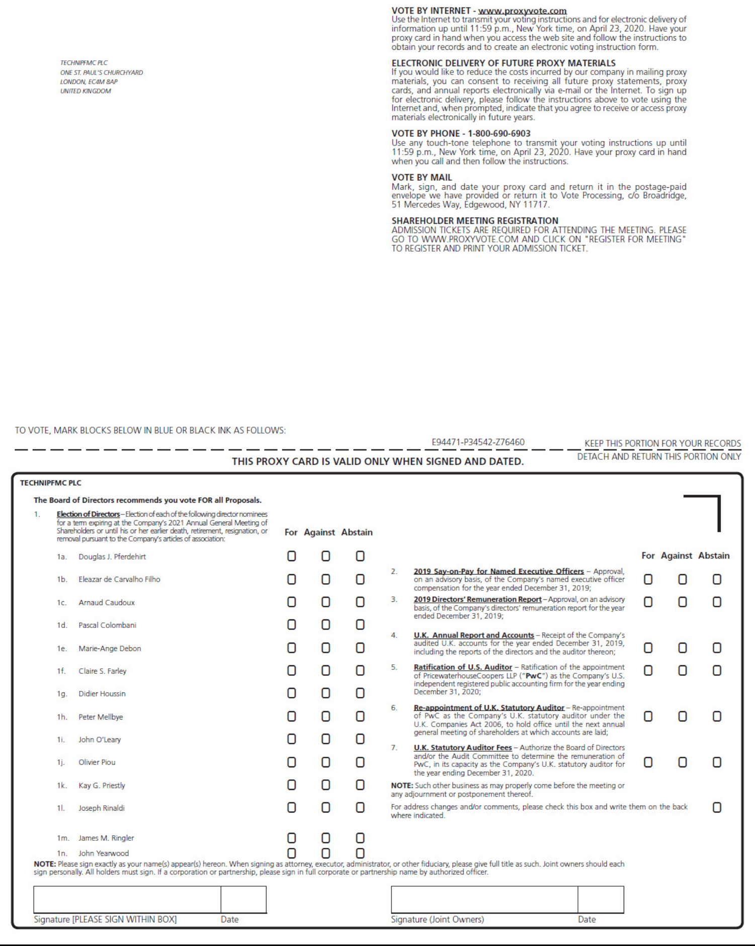

TechnipFMC Proxy Statement 2020


