As filed with the United States Securities and Exchange Commission on February 27, 2017

Registration No. 333-

UNITED STATES

SECURITIES AND EXCHANGE COMMISSION
Washington, D.C. 20549

FORM S-8

REGISTRATION STATEMENT
Under

THE SECURITIES ACT OF 1933

TechnipFMC plc

(Exact Name of Registrant as Specified in its Charter)

England and Wales | 3533 |  |  | 98-1283037
(State or other jurisdiction of |  | (Primary Standard Industrial |  | (I.R.S. Employer
incorporation or organization) |  | Classification Code Number) |  | Identification No.)
 |  | One St. Paul’s Churchyard
 |  | London, EC4M 8AP
 |  | United Kingdom
 | (Address, including zip code, of principal executive offices)
 | TechnipFMC plc Incentive Award Plan
 | 2010 Technip Incentive and Reward Plan
 | 2011 Technip Incentive and Reward Plan
 | 2012 Technip Incentive and Reward Plan
 | 2013 Technip Incentive and Reward Plan
 | 2014 Technip Incentive and Reward Plan
 | 2015 Technip Incentive and Reward Plan
 | 2016 Technip Incentive and Reward Plan
 |  | Technip Capital 2012 Plan
 |  | Technip Capital 2015 Plan
 | FMC Technologies, Inc. Incentive Compensation and Stock Plan
 |  | (Full title of the plans)
 |  | Dianne B. Ralston, Esq.
 | Executive Vice President, Chief Legal Officer and Secretary
 |  | TechnipFMC plc
 |  | 11740 Katy Freeway
 |  | Energy Tower 3
 |  | Houston, Texas 77079
 |  | United States
 |  | Telephone: (281) 591-4000
 | (Name, address and telephone number, including area code, of agent for service)

Copies to:

Ryan Maierson, Esq.

Latham & Watkins LLP

811 Main Street, Suite 3700

Houston, Texas 77002

United States

Telephone: (713) 546-7420

Indicate by check mark whether the Registrant is a large accelerated filer, an accelerated filer, a non-accelerated filer, or a smaller reporting company. See the definitions of “large accelerated filer,” “accelerated filer” and “smaller reporting company” in Rule 12b-2 of the Exchange Act.

Large accelerated filer | ☐ |  | Accelerated filer | ☐
Non-accelerated filer | ☑ (Do not check if a smaller reporting company) |  | Smaller reporting company | ☐

CALCULATION OF REGISTRATION FEE

 |  | Amount | Proposed | Proposed
 |  | Amount | Maximum | Maximum
 | Title of Each Class of Securities to be Registered | to be | Offering Price | Aggregate | Amount of
 | Title of Each Class of Securities to be Registered | Registered | Per Share (5) | Offering Price | Registration Fee
 | Ordinary Shares, nominal value $1 per share | 24,100,000 (1) | $32.18 | $775,538,000.00 | $89,884.85
Ordinary Shares, nominal value $1 per share |  | 6,989,196 (2) | $32.18 | $224,912,327.28 | $26,067.34
Ordinary Shares, nominal value $1 per share |  | 6,131,340 (3) | $32.18 | $197,306,521.20 | $22,867.83
Ordinary Shares, nominal value $1 per share |  | 213,127 (4) | $32.18 | $6,858,426.86 | $794.89
- Represents Ordinary Shares issuable upon exercise or settlement of awards that may be granted pursuant to the TechnipFMC plc Incentive Award Plan. Pursuant to Rule 416(a) promulgated under the Securities Act of 1933, as amended (the “Securities Act”), this Registration Statement shall also cover any additional ordinary shares of TechnipFMC plc, par value $1 per share (the “Ordinary Shares”), that become issuable under the TechnipFMC plc Incentive Award Plan by reason of any stock dividend, stock split, recapitalization or other similar transaction effected without receipt of consideration that increases the number of outstanding Ordinary Shares.

- Represents Ordinary Shares issuable upon settlement of outstanding awards under the 2010 Technip Incentive and Reward Plan, 2011 Technip Incentive and Reward Plan, 2012 Technip Incentive and Reward Plan, 2013 Technip Incentive and Reward Plan, 2014 Technip Incentive and Reward Plan, 2015 Technip Incentive and Reward Plan and 2016 Technip Incentive and Reward Plan (collectively, the “Legacy Technip Incentive and Reward Plans”). Pursuant to Rule 416(a) promulgated under the Securities Act this Registration Statement shall also cover any additional Ordinary Shares that become issuable under the Legacy Technip Incentive and Reward Plans by reason of any stock dividend, stock split, recapitalization or other similar transaction effected without receipt of consideration that increases the number of outstanding Ordinary Shares.

- Represents Ordinary Shares issuable upon settlement of outstanding awards under the Technip Capital 2012 Plan and the Technip Capital 2015 Plan. Pursuant to Rule 416(a) promulgated under the Securities Act this Registration Statement shall also cover any additional Ordinary Shares that become issuable under the Technip Capital 2012 Plan or the Technip Capital 2015 Plan by reason of any stock dividend, stock split, recapitalization or other similar transaction effected without receipt of consideration that increases the number of outstanding Ordinary Shares.

- Represents Ordinary Shares issuable upon settlement of outstanding awards under the FMC Technologies, Inc. Incentive Compensation and Stock Plan. Pursuant to Rule 416(a) promulgated under the Securities Act, this Registration Statement shall also cover any additional Ordinary Shares that become issuable under the FMC Technologies, Inc. Incentive Compensation and Stock Plan by reason of any stock dividend, stock split, recapitalization or other similar transaction effected without receipt of consideration that increases the number of outstanding Ordinary Shares.

- Estimated solely for the purpose of calculating the registration fee pursuant to Rule 457(c) and (h)(1) of the Securities Act. The proposed maximum offering price per share is based on the average of the high and low prices of the ordinary shares of TechnipFMC plc as reported on the New York Stock Exchange on February 17, 2017.

EXPLANATORY NOTE

On January 16, 2017 (the “Closing Date”), pursuant to the Business Combination Agreement, dated as of June 14, 2016 (as amended, the “Business Combination Agreement”), providing for a business combination among FMC Technologies, Inc., a Delaware corporation (“FMCTI”), Technip S.A., a French société anonyme (“Technip”), and TechnipFMC plc, a public limited company incorporated under the laws of England and Wales (the “Registrant”),
- Technip merged with and into the Registrant (the “Technip Merger”), with the Registrant surviving the Technip Merger, and immediately thereafter, (ii) a wholly owned indirect subsidiary of the Registrant (“Merger Sub”) merged with and into FMCTI (the “FMCTI Merger” and, together with the Technip Merger, the “Mergers”), with FMCTI surviving the FMCTI Merger as a wholly owned subsidiary of the Registrant.

Prior to the consummation of the Mergers, on January 11, 2017, the Registrant adopted the TechnipFMC plc Incentive Award Plan (together with a French and UK sub-plan thereunder, the “TechnipFMC Plan”). The TechnipFMC Plan became effective as of the Closing Date. Options, stock appreciation rights, restricted stock, restricted stock units, other share- and cash-based awards and dividend equivalents may be granted to non-employee directors, employees (including executive officers) and consultants of the Registrant and its subsidiaries under the terms of the TechnipFMC Plan. Unless the TechnipFMC Plan is sooner terminated by the board of directors of the Registrant, no awards may be granted under the TechnipFMC Plan after the tenth anniversary of its approval by the board of directors.

Additionally, effective as of the Closing Date, the Registrant assumed the FMC Technologies, Inc. Incentive Compensation and Stock Plan, 2010 Technip Incentive and Reward Plan, 2011 Technip Incentive and Reward Plan, 2012 Technip Incentive and Reward Plan, 2013 Technip Incentive and Reward Plan, 2014 Technip Incentive and Reward Plan, 2015 Technip Incentive and Reward Plan, 2016 Technip Incentive and Reward Plan, the Technip Capital 2012 Plan and the Technip Capital 2015 Plan (collectively, with the TechnipFMC Plan, the “Plans”).

PART I

INFORMATION REQUIRED IN THE SECTION 10(a) PROSPECTUS

Item 1. Plan Information.

The documents containing the information specified in Item 1 will be sent or given to participants in the Plans as specified by Rule 428(b)(1) of the U.S. Securities Act of 1933, as amended (the “Securities Act”). Such documents are not required to be and are not filed with the U.S. Securities and Exchange Commission (the “Commission”) either as part of this Registration Statement on Form S-8 (this “Registration Statement”) or as prospectuses or prospectus supplements pursuant to Rule 424. These documents and the documents incorporated by reference in this Registration Statement pursuant to Item 3 of Part II of this Form S-8, taken together, constitute a prospectus that meets the requirements of Section 10(a) of the Securities Act.

Item 2. Registrant Information and Employee Plan Annual Information.

Upon written or oral request, any of the documents incorporated by reference in Item 3 of Part II of this Registration Statement (which documents are incorporated by reference in a Section 10(a) Prospectus), other documents required to be delivered to eligible employees, non-employee directors and consultants, pursuant to Rule 428(b) or additional information about the Plans are available without charge by contacting:

TechnipFMC plc

Attn: Dianne B. Ralston

11740 Katy Freeway

Energy Tower 3

Houston, Texas 77079

United States

1

PART II

INFORMATION REQUIRED IN THE REGISTRATION STATEMENT

Item 3. Incorporation of Documents by Reference.

The following documents, which have been filed with the Commission pursuant to the U.S. Securities Exchange Act of 1934, as amended (the “Exchange Act”), are incorporated by reference in, and shall be deemed to be a part of, this Registration Statement:

(a) the Registrant’s final prospectus filed with the Commission pursuant to Rule 424(b) under the Securities Act on October 25, 2016 (the

“Prospectus”), except for the sections entitled “Opinion of Evercore as Financial Advisor to FMCTI” and “Opinions of Rothschild and Goldman Sachs

as Financial Advisors to Technip”;

- the Registrant’s Current Reports on Form 8-K filed with the Commission on December 14, 2016, December 21, 2016, January 17, 2017, and February 24, 2017;

- the Registrant’s Annual Report on Form 10-K for the fiscal year ended December 31, 2016, filed with the Commission on January 13, 2017;

- all other reports filed by the Registrant pursuant to Section 13(a) or 15(d) of the Exchange Act since the end of the fiscal year covered by the annual report referred to in (c) above; and

- the description of the ordinary shares of the Registrant, nominal value $1 per share (the “Ordinary Shares”) contained in the Prospectus under the heading “Description of Topco Shares.”

All reports and other documents filed by the Registrant with the Commission pursuant to Sections 13(a), 13(c), 14 and 15(d) of the Exchange Act since October 25, 2016 and prior to the filing of a post-effective amendment which indicates that all securities offered pursuant to this Registration Statement have been sold or which deregisters all securities then remaining unsold, shall be deemed to be incorporated by reference herein and to be a part hereof from the date of filing of such documents or reports, except as to any portion of any future annual or quarterly report to stockholders or document or current report furnished under Items 2.02 or 7.01 of Form 8-K that is not deemed filed under such provisions.

For purposes of this Registration Statement, any document or any statement contained in a document incorporated or deemed to be incorporated herein by reference shall be deemed to be modified or superseded to the extent that a subsequently filed document or a statement contained therein, or in any other subsequently filed document which also is or is deemed to be incorporated by reference, modifies or supersedes such document or such statement in such document. Any statement so modified or superseded shall not be deemed, except as so modified or superseded, to constitute a part of this Registration Statement.

Item 4. Description of Securities.

Not applicable.

Item 5. Interests of Named Experts and Counsel.

Not applicable.

Item 6. Indemnification of Directors and Officers.

The Registrant is currently a public limited company incorporated in England and Wales or under English law. Chapter 7 of Part 10 of the U.K.

Companies Act 2006 contains provisions relating to directors’ liability. All statutory references in this Item 20 are to the U.K. Companies Act 2006.

Section 232(1) makes void any provision that purports to exempt a director of a company from any liability that would otherwise attach to him in connection with any negligence, default, breach of duty or breach of trust in relation to the company.

2

Section 232(2) makes void any provision by which a company directly or indirectly provides an indemnity for a director of the company against any liability attaching to him or her in connection with any negligence, default, breach of duty or breach of trust in relation to the company, except if permitted as:

- liability insurance within Section 233;

- qualifying third-party indemnity provisions falling within Section 234; or

- qualifying pension scheme indemnity provision under Section 235.

Section 233 permits liability insurance, commonly known as directors’ and officers’ liability insurance, purchased and maintained by a company against liability for negligence, default, breach of duty or breach of trust in relation to the company.

Section 234 allows the Registrant to provide an indemnity against liability incurred by a director to someone other than the Registrant or an associated company of the Registrant. Such an indemnity does not permit indemnification against liability to pay criminal fines or civil penalties to a regulatory authority or the costs of an unsuccessful defense of criminal or civil proceedings or application for relief under Sections 661 (power of court to grant relief in case of acquisition of shares by innocent nominee) or 1157 (general power of court to grant relief in case of honest and reasonable conduct) of the U.K. Companies Act 2006.

Section 235 allows the Registrant to provide indemnification to a director that is a trustee of an occupational pension scheme if joint liability incurred in connection with the company’s activities as trustee of the scheme. Such provision does not permit indemnification against liability to pay criminal fines or civil penalties to a regulatory authority or the costs of an unsuccessful defense of criminal proceedings.

Any indemnity provided under Section 234 or Section 235 must be disclosed in the company’s annual report in accordance with Section 236 and copies of such indemnification provisions made available for inspection in accordance with Section 237 (and every member has a right to inspect and request such copies under Section 238).

Conduct of a director amounting to negligence, default, breach of duty or breach of trust in relation to the company can be ratified, in accordance with Section 239, by a resolution of the members of the company, disregarding the votes of the director (if a member) and any connected member.

The articles of association of the Registrant provide that, subject to the U.K. Companies Act 2006, the Registrant may indemnify (i) any person who is or was a director of the Registrant or any associated company against any loss, cost, charge or liability incurred by him as a director in the actual or purported execution and/or discharge of his duties or in relation to them whether in connection with any negligence, default, breach of duty or breach of trust by him or otherwise; and (ii) any person who is or was a director of an associated company that is a trustee of an occupational pension scheme, against any loss, cost, charge or liability incurred by him as a director in connection with the company’s activities as trustee of an occupational pension scheme.

The articles of association of the Registrant also provide that, subject to the U.K. Companies Act 2006, the Registrant may purchase and maintain insurance for or for the benefit of any person who is or was a director, officer or employee of the Registrant, or any corporate entity which is or was the holding company or subsidiary undertaking of the Registrant, or in which the Registrant or such holding company or subsidiary undertaking has or had any interest or with which the Registrant or such holding company or subsidiary undertaking is or was in any way allied or associated. This includes, without limitation, insurance against any loss or liability or any expenditure such director, officer or employee may incur, whether in connection with any proven or alleged act or omission in the actual or purported execution or discharge of his or her duties or in the exercise or purported exercise of his or her powers or otherwise in relation to his or her duties, powers or offices, whether comprising negligence, default, breach of duty, breach of trust or otherwise, in relation to the Registrant or the relevant body.

3

The Business Combination Agreement provides that, to the extent permitted by applicable law, for a period of six years from and after completion of the Mergers, the Registrant will indemnify and hold harmless and provide advancement of expenses to each past and present (as of completion of the Mergers) director, officer, and employee of FMCTI, Technip or any of their subsidiaries against all costs or expenses (including reasonable attorney’s fees and disbursements), judgments, inquiries, fines, losses, claims, damages or liabilities incurred by such individual in connection with any civil, criminal, administrative or investigative proceeding arising out of or pertaining to any act or omission of such director, officer or employee (i) in each case, to the same extent as such person is indemnified or has the right to advancement of expenses as of May 18, 2016 by FMCTI, Technip or their subsidiaries, as applicable, pursuant to the organizational documents and indemnification agreements thereof and (ii) with respect to directors and officers, to the fullest extent permitted by applicable law, in each case for acts or omissions occurring at or prior to the completion of the Mergers.

The Business Combination Agreement further provides that, for a period of not less than six years after completion of the Mergers, the organizational documents of the Registrant (and any successor thereto) will contain provisions providing for the elimination of liability of directors, indemnification of officers and directors and advancement of expenses to the fullest extent permitted by applicable law. Additionally, for the benefit of Technip’s and FMCTI’s directors and officers, the Registrant will cause to be maintained for a period of six years after completion of the Mergers the current policies of directors’ and officers’ liability insurance and fiduciary liability insurance maintained by Technip and FMCTI (provided that the Registrant (or its successor) may substitute another policy with at least the same coverage and amounts containing terms and conditions which are, in the aggregate, no less advantageous to the insured) with respect to claims arising from facts or events that occurred on or before completion of the Mergers; provided, however, that the Registrant is not required to spend more than 200% of the annual premiums currently paid by Technip or FMCTI, as applicable, for such insurance annually. Alternatively, the Registrant may purchase a six year “tail” prepaid policy; provided that the aggregate amount paid by the Registrant will not exceed 1200% of the annual premiums paid by Technip or FMCTI as of the date of the Business Combination Agreement, as applicable, for their current policies of directors’ and officers’ liability insurance and fiduciary liability insurance annually.

Item 7. Exemption from Registration Claimed.

Not applicable.

Item 8. Exhibits.

A list of exhibits included as part of this Registration Statement is set forth in the Index to Exhibits appearing elsewhere herein and is incorporated herein by reference.

Item 9. Undertakings.

- The undersigned Registrant hereby undertakes:

  - To file, during any period in which offers or sales are being made, a post-effective amendment to this Registration Statement:

    - To include any prospectus required by Section 10(a)(3) of the Securities Act;

    - To reflect in the prospectus any facts or events arising after the effective date of this Registration Statement (or the most recent post-effective amendment thereof) which, individually or in the aggregate, represent a fundamental change in the information set forth in this Registration Statement. Notwithstanding the foregoing, any increase or decrease in volume of securities offered (if the total dollar value of securities offered would not exceed that which was registered) and any deviation from the low or high end of the estimated maximum offering range may be reflected in the form of prospectus filed with the Commission pursuant to Rule 424(b) if, in the aggregate, the changes in volume and price represent no more than 20% change in the maximum aggregate offering price set forth in the “Calculation of Registration Fee” table in the effective registration statement;

4

- To include any material information with respect to the plan of distribution not previously disclosed in this Registration Statement or any material change to such information in this Registration Statement;

provided, however, that paragraphs (a)(1)(i) and (a)(1)(ii) shall not apply if the information required to be included on a post-effective amendment by those paragraphs is contained in periodic reports filed by or furnished to the Commission by the Registrant pursuant to Section 13 or Section 15(d) of the Exchange Act that are incorporated by reference in this Registration Statement.

  - That, for the purpose of determining any liability under the Securities Act, each such post-effective amendment shall be deemed to be a new registration statement relating to the securities offered therein, and the offering of such securities at that time shall be deemed to be the initial bona fide offering thereof.

  - To remove from registration by means of a post-effective amendment any of the securities being registered which remain unsold at the termination of the offering.

- The undersigned Registrant hereby undertakes that, for purposes of determining any liability under the Securities Act, each filing of the Registrant’s annual report pursuant to Section 13(a) or Section 15(d) of the Exchange Act that is incorporated by reference in this Registration Statement shall be deemed to be a new registration statement relating to the securities offered herein, and the offering of such securities at that time shall be deemed to be the initial bona fide offering thereof.

- Insofar as indemnification for liabilities arising under the Securities Act may be permitted to directors, officers and controlling persons of the Registrant pursuant to the foregoing provisions, or otherwise, the Registrant has been advised that in the opinion of the Commission such indemnification is against public policy as expressed in the Securities Act and is, therefore, unenforceable. In the event that a claim for indemnification against such liabilities (other than the payment by the Registrant of expenses incurred or paid by a director, officer or controlling person of the Registrant in the successful defense of any action, suit or proceeding) is asserted by such director, officer or controlling person in connection with the securities being registered, the Registrant will, unless in the opinion of its counsel the matter has been settled by controlling precedent, submit to a court of appropriate jurisdiction the question whether such indemnification by it is against public policy as expressed in the Securities Act and will be governed by the final adjudication of such issue.

5

SIGNATURES

Pursuant to the requirements of the Securities Act, the Registrant certifies that it has reasonable grounds to believe that it meets all of the requirements for filing on Form S-8 and has duly caused this Registration Statement to be signed on its behalf by the undersigned, thereunto duly authorized, in Houston, Texas on this 27th day of February, 2017.

TechnipFMC plc

/s/ Dianne B. Ralston (attorney-in-fact)

Name: Douglas J. Pferdehirt

Title: Director and Chief Executive Officer

(Principal Executive Officer)

/s/ Maryann T. Mannen

Name: Maryann T. Mannen

Title: Executive Vice President and Chief Financial Officer

(Principal Financial Officer and Principal Accounting Officer)

/s/ Dianne B. Ralston (attorney-in-fact)

Name: Thierry Pilenko

Title: Director and Executive Chairman

/s/ Dianne B. Ralston (attorney-in-fact)

Name: Arnaud Caudoux

Title: Director

/s/ Dianne B. Ralston (attorney-in-fact)

Name: Pascal Colombani

Title: Director

/s/ Dianne B. Ralston (attorney-in-fact)

Name: Marie-Ange Debon

Title: Director

/s/ Dianne B. Ralston (attorney-in-fact)

Name: Eleazar de Carvalho Filho

Title: Director

/s/ Dianne B. Ralston (attorney-in-fact)

Name: Claire S. Farley

Title: Director

/s/ Dianne B. Ralston (attorney-in-fact)

Name: Didier Houssin

Title: Director

/s/ Dianne B. Ralston (attorney-in-fact)

Name: Peter Mellbye

Title: Director

/s/ Dianne B. Ralston (attorney-in-fact)

Name: John O’Leary

Title: Director

/s/ Dianne B. Ralston (attorney-in-fact)

Name: Richard A. Pattarozzi

Title: Director

/s/ Dianne B. Ralston (attorney-in-fact)

Name: Kay G. Priestly

Title: Director

/s/ Dianne B. Ralston (attorney-in-fact)

Name: Joseph Rinaldi

Title: Director

/s/ Dianne B. Ralston (attorney-in-fact)

Name: James M. Ringler

Title: Director

/s/ Dianne B. Ralston

Name: Dianne B. Ralston

Title: Authorized Representative in the United States

 |  |  | INDEX TO EXHIBITS
Exhibit |  |  | Description of Exhibit
Number |  |  | Description of Exhibit
3.1* |  | Articles of Association of TechnipFMC plc (attached as Exhibit 3.1 to TechnipFMC plc’s Form 8-K filed on January 17, 2017 (Registration
 |  | File No. 333-213067))
4.1* |  | TechnipFMC plc Company Incentive Plan, adopted on January 11, 2017 (incorporated by reference from Exhibit 10.1 to TechnipFMC plc’s
 |  | Form 8-K filed on January 17, 2017 (Registration File No. 333-213067))
4.2* |  | Amended and Restated FMC Technologies, Inc. Incentive Compensation and Stock Plan, dated February 21, 2013 (incorporated by reference
 |  | from Exhibit 10.4 to the Annual Report on Form 10-K of FMC Technologies, Inc. filed on February 22, 2013 (File No. 001-16489))
4.2(a)* |  | First Amendment of the Amended and Restated FMC Technologies, Inc. Incentive Compensation and Stock Plan, dated October 3, 2013
 |  | (incorporated by reference from Exhibit 10.4.a to the Annual Report on Form 10-K of FMC Technologies, Inc. filed on February 21, 2014 (File
 |  | No. 001-16489))
4.3 |  | Technip Capital 2012 Plan
4.4 |  | Technip Capital 2015 Plan
5.1 |  | Opinion of Latham & Watkins LLP (London), as to the validity of the securities being registered
23.1 |  | Consent of PricewaterhouseCoopers Audit and Ernst & Young et Autres
23.2 |  | Consent of KPMG LLP
23.3 |  | Consent of Latham & Watkins LLP (London) (included in Exhibit 5.1)
24.1 |  | Power of Attorney
99.1 |  | 2010 | Technip Incentive and Reward Plan authorization of April 29, 2010
99.2 |  | 2011 Technip Incentive and Reward Plan authorization of April 28, 2011
99.3 |  | 2012 | Technip Incentive and Reward Plan authorization of April 26, 2012
99.4 |  | 2013 | Technip Incentive and Reward Plan authorization of June 14, 2013
99.5 |  | 2013 | Technip Incentive and Reward Plan authorization of June 14, 2013
99.6 |  | 2013 | Technip Incentive and Reward Plan authorization of January 10, 2014
99.7 |  | 2013 | Technip Incentive and Reward Plan authorization of January 10, 2014
99.8 |  | 2014 | Technip Incentive and Reward Plan authorization of December 10, 2014
99.9 |  | 2015 | Technip Incentive and Reward Plan authorization of September 7, 2015
99.10 |  | 2016 | Technip Incentive and Reward Plan authorization of July 1, 2016
99.11 |  | 2016 | Technip Incentive and Reward Plan authorization of July 1, 2016
99.12 |  | 2016 | Technip Incentive and Reward Plan authorization of December 6, 2016
- Previously filed.

Exhibit 4.3

TECHNIP – GROUP SAVINGS PLAN (P.E.G.) | 1 /18

Translation into English for informational purposes only

TECHNIP

GROUP SAVINGS PLAN (PLAN D’EPARGNE GROUPE – “PEG”)

PREAMBLE

Pursuant to Articles L3331-1 et seq. of the French Labor Code (hereinafter “Labor Code”), on November 13, 2003, Technip SA, whose registered offices are located at 89, avenue de la Grande Armée 75116 Paris, has instituted a Group Savings Plan.

This Group Savings Plan supersedes the Group Company Savings Plan (Plan d’Epargne d’Entreprise de Groupe, hereinafter “PEEG”) entered into on June 22, 2000, and its two amendments.

The purpose of the Group Savings Plan (Plan d’Epargne de Groupe, hereinafter “PEG”) is to allow current and former employees of Technip Group companies which are members of this plan to create a savings account with the help of their company. It gives current and former employees of Technip Group companies which are members of the PEG the opportunity to participate in the employee shareholding programs offered by TECHNIP.

The current plan has been amended on several occasions in order to improve its terms and conditions1.

1.
Rev. |  | Date |  | Subject |  | Prepared by |  | Verified by |  | Approved by
7 |  | 09/03/12 |  | Revision of PEG of February 10, 2011, |  | F. PICKERING |  | M. MARQUES |  | T. PARMENTIER
 |  |  |  | December 2009 and of its appendices
6 | 02/10/11 |  |  | Revision of PEG of December 23, 2009 and of its |  | F. PICKERING and | V. ESTRADA-NOHE |  |  | T. PARMENTIER
 |  |  |  | appendices |  | J. DE SOUSA
5 | 12/23/09 |  |  | Revision of PEG of April 25, 2008 and |  | F. PICKERING | V. ESTRADA-NOHE |  |  | T. PARMENTIER
 |  |  |  | of its appendices
4 | 04/25/08 |  |  | Revision of PEG of January 18, 2007 |  | F. PICKERING | P. CHANTECLAIR |  |  | A. DECRESSAC
 |  |  |  | and of its appendices
3 | 01/18/07 |  |  | Revision of PEG of January 7, 2005 and |  | C. HEID | P. CHANTECLAIR |  |  | A. DECRESSAC
 |  |  |  | of its appendices
2 | 01/07/05 |  |  | Revision of PEG of November 13, 2003 |  | A. GIRAULT | C. COLINEAU |  |  | A. DECRESSAC
 |  |  |  | and of its appendices
1 | 11/13/03 |  |  | General rewriting of PEG of June 22, |  | C. HEID | Ph. DAVIGNON |  |  | A. DECRESSAC
 |  |  |  | 2000 and of Riders 1 and 2

TECHNIP – GROUP SAVINGS PLAN (P.E.G.) |  |  | 2 /18
 |  | TABLE OF CONTENTS
I. GENERAL PROVISIONS |  |  | 3
A. SCOPE OF APPLICATION |  |  | 3
1. | Membership of new companies in the PEG |  | 3
2. | Withdrawal from the PEG by a company |  | 3
B. BENEFICIARIES |  |  | 3
C. ORIGIN OF FUNDS |  |  | 4
1. | PEG contributions |  | 4
2. | Terms of employee PEG contributions |  | 4
3. | Individual maximum contributions |  | 5
4. | Company contributions – matched funding |  | 5
D. USE OF FUNDS |  |  | 6
1. | Investment of savings |  | 6
2. | Arbitrage |  | 7
3. | Income |  | 7
E. BLOCKING PERIOD |  |  | 8
F. EMPLOYEE INFORMATION, MEMBER RIGHTS, AND SUPERVISORY BOARDS |  |  | 10
1. | Employee information |  | 10
2. | Member rights and Supervisory Board |  | 10
G. FORMER EMPLOYEES |  |  | 10
H. SAFEGUARD CLAUSE |  |  | 11
Any amendment to the mandatory provisions set out in any French regulations referred to in these rules shall be applicable automatically. |  |  | 11
I. ENTRY INTO FORCE – TERM – REVISION |  |  | 11
II. SPECIFIC PROVISIONS |  |  | 11
A. EMPLOYEE SHAREHOLDER OFFERS |  |  | 11
1. | Application of the PEG to companies in and outside of France |  | 11
2. | Specific terms applicable to employee shareholder offers made as part of the PEG |  | 12
B. SPECIFIC CONDITIONS APPLICABLE TO THE TECHNIP CAPITAL 2008 EMPLOYEE SHAREHOLDER OFFER |  |  | 13
C. SPECIFIC CONDITIONS APPLICABLE TO THE TECHNIP CAPITAL 2012 EMPLOYEE SHAREHOLDER OFFER |  |  | 15
III- REGISTRATION |  |  | 18
ANNEXES
ORGANISMES GESTIONNAIRES DES FONDS ET TENEUR DE COMPTES CONSERVATEUR DE PARTS
(TCCP)

APPENDICES

- List of PEG member companies as of March 9, 2012- List of companies participating in the Technip Capital 2008 and 2012 offers

- Major features of the funds

- Fund management institutions and custodian account holder (hereinafter “Custodian Account Holder”)

IV. Fund documentation

- Minutes of the Works Council consultation meetings

VI. Funds open during capital increases reserved for employees

TECHNIP – PLAN D’EPARGNE DE GROUPE (P.E.G.) | 3 /18
I. GENERAL PROVISIONS

A. SCOPE OF APPLICATION

This PEG is open to the French companies of Technip Group as defined by Article L3344-1 of the Labor Code. For information purposes, the list of French companies of Technip Group that are members of the PEG as of March 9, 2012 appears in Appendix I.

This PEG is also open to certain foreign companies of Technip Group as defined by Article L3344-1 of the Labor Code (insofar as those companies have decided to become members) during capital increases reserved for employees, offered by Technip in accordance with the provisions of the article “Employee shareholder offers” of Title II “Specific Provisions”.

- Membership of new companies in the PEG

Any French company that forms part of the Technip Group as defined by the second paragraph of Article L3344-1 of the Labor Code may offer the PEG to its employees, provided that it becomes a member.

Membership of a new company shall be formalized by a membership letter sent to Technip and signed by the executive of said company, after the plan has been implemented by the company in accordance with the provisions of Articles L3332-4 and L3332-5 of the Labor Code.

Whenever there is a change affecting the companies that form part of the group, the list of member companies shall be updated accordingly.

- Withdrawal from the PEG by a company

Any company that ceases to belong to Technip Group, as defined above, during the term of this plan shall immediately and automatically exit its scope of application. The employees of that company may no longer contribute to the PEG, but shall retain their savings therein, unless they are transferred to another savings plan, under the conditions of Article L3335-1 of the Labor Code.

The term “company” as used below in this plan shall be understood to refer to the current or former employer of the beneficiaries of this plan.

B. BENEFICIARIES

All employees of French companies of Technip Group, as defined in the above “Scope of application”, may become members of this PEG provided that, when they make their first contribution, they have been employees for at least three months. Periods of suspension from employment are not discounted when determining the period of employment. For the determination of the period of employment required, all employment contracts executed in the Technip Group during the membership year and the twelve months preceding it are counted.

TECHNIP – PLAN D’EPARGNE DE GROUPE (P.E.G.) | 4 /18
Employee membership in the PEG is effective upon the first payment into the plan, which implies acceptance of the terms thereof.

Payments may no longer be made on or after the date on which the employee ceases to be employed by the French companies of the Group, for any reason, except for:

    - payments made by pre-retirees or by retired individuals who have made at least one payment into the PEG before their departure and have not requested the liquidation of all of their savings,

    - the payment of amounts owed under profit-sharing and incentive plans and received by employees after the term of their employment contract has expired.

- ORIGIN OF FUNDS

  - PEG contributions

Payments into the PEG may be made in one or more of the following ways:

- voluntary employee contributions,

- payments by employees of all or part of the funds from their incentive plan,

- payments by employees of funds from profit-sharing plans,

- the transfer of funds from a Time Savings Account (Compte Epargne Temps, hereinafter “CET”), as provided for by the agreement governing the CET,

- the transfer of funds from another savings plan at the employees’ request,

- any matching contributions by the company as defined in Article 4.

  - Terms of employee PEG contributions

- Voluntary employee contributions

Voluntary employee contributions may be made directly to the custodian account holder (hereinafter“Custodian Account Holder”) to all funds, except those funds dedicated to capital increases, for which PEG beneficiaries shall be informed of the specific terms of contribution whenever such a capital increase occurs.

- Contribution of funds from incentive and profit-sharing plans

Contributions by employees to the PEG of all or part of their incentive payments and funds from profit-sharing plans shall be made, in accordance with the law, within a maximum of fifteen days following payment in order to be eligible for the resulting tax and social welfare credits.

TECHNIP – PLAN D’EPARGNE DE GROUPE (P.E.G.) | 5 /18
Such contributions shall be made upon prior instruction by the employee.

- Transfer of funds from a CET or other savings plans at the employee’s request

Beneficiaries may contribute funds from a CET to the PEG, as provided for by the agreement governing the CET.

Beneficiaries may also contribute funds from another savings plan, except for assets that they hold in a collective pension saving plan (PERCO).

- Individual maximum contributions

Pursuant to Article L3332-10 of the Labor Code, the total amount of the annual voluntary contributions by employees, incentive plans included, to the PEG and any other employee savings plan may not exceed one fourth of their gross annual compensation.

For retirees, this total may not exceed one fourth of the total annual amount of their retirement pensions.

For employees whose employment contract is suspended and who have not received any compensation for the previous year, contributions may not exceed one fourth of the annual maximum contribution set out in Article L. 241-3 of the French Social Security Code.

Compliance with these maximum limits is the sole responsibility of the beneficiaries.

  - Company contributions – matched funding (abondement)

- Management commissions

Fund management fees are paid by the company or by the fund.

The terms of payment for the PEG fund management fees are set out in the rules for those funds. They are stated in Appendix IV.

- Account management and registration fees for individual accounts

The fees for holding accounts and registering individual accounts are paid by the company.

TECHNIP – PLAN D’EPARGNE DE GROUPE (P.E.G.) | 6 /18
However, if an employee ceases to be employed by a Group company, the fees for custodian account holding shall cease to be paid by the company at the end of the calendar year underway.

- Matched funding

Contributions to a PEG are not entitled to matched funding, subject to the “Specific provisions” related to employee shareholder offers approved by Technip.

Matched funding is not paid for any transfers of PEG assets.

D. USE OF FUNDS

- Investment of savings

  - Choice of investment

The funds contributed to the PEG are invested, at the discretion of the employees, in one of the following investment vehicles:

- equity securities or securities giving access to TECHNIP share capital;

- units of diversified funds governed by Article L214-39 of the French Monetary and Financial Code;

- units of share ownership programs governed by Article L214-40 of the French Monetary and Financial Code, during capital increases;

- units of bridging funds (fonds de relais) that are intended to be transferred subsequently to a share ownership program,

- as part of the exercise of TECHNIP stock options granted under the conditions of Articles L225-177 et seq. of the French Commercial Code.

A detailed list of funds offered under the PEG and descriptions of these funds are located in Appendix II of this plan. Notices for the funds are located in Appendix IV.

- Managing bodies

Administrative record keeping for PEG accounts is performed by the body set out in Appendix III.

All contributions made to PEGs by employees are recorded in an administrative account opened in the name of each employee. This administrative account tracks all contributions made to the PEG, their allocation by investment vehicle and lists any remaining blocked periods. Once a year, the registrar shall prepare and send to all employees who are members of the PEG an individual account statement listing the shares or units belonging to them.

TECHNIP – PLAN D’EPARGNE DE GROUPE (P.E.G.) | 7 /18
Custodian account holding for PEG funds is performed by a single body whose contact information is listed in Appendix III.

The Custodian Account Holder is an institution approved by the Credit Institutions and Investment Firms Committee subject to the approval of the Autorité des Marchés Financiers (hereinafter “AMF”). It is responsible for holding the accounts for the funds held by the unitholder. The Custodian Account Holder receives and carries out unit subscriptions and redemption instructions and initiates the corresponding payments or settlements.

Every fund is created on the joint initiative of a portfolio management company responsible for its management and a corporate entity which acts as the fund depository. Contact information for the management companies and depositories for the various PEG funds is listed in Appendix III.

The portfolio management company is approved by the AMF and acts on behalf of the fund. It uses or reuses all contributions made, by subscribing, acquiring, selling, or exchanging all securities that comprise the fund portfolio. It acts on behalf of the unitholders and represents them with respect to third parties in all acts concerning the fund. It prepares accounting documents on a regular basis and sends periodic reports under the conditions set forth in the fund rules.

The depository is a corporate entity selected by the management company from a list prepared by the minister in charge of the economy and is responsible for holding the securities included in the Fund. It executes the subscription, purchase, sale, or exchange orders for the securities that comprise the portfolio and handles the receipts and disbursements generated by the management of the fund. It controls the inventory of fund assets prepared by the management company and certifies them at the end of the year.

- Arbitrage

Arbitrage of available and unavailable assets between funds are possible at any time. However, for arbitrage from the Actionnariat Technip and Technip France funds, only available assets may be transferred to other funds.

Arbitrage does not change the blocking period for the relevant amounts. It is not similar to a voluntary contribution.

No individual arbitrage from or to Technip International fund compartments is authorized.

- Income

Income or revenue from investments included in every sub-fund are always reinvested.

TECHNIP – PLAN D’EPARGNE DE GROUPE (P.E.G.) | 8 /18
However, income or revenue of all kinds from the assets of the “Technip Classic” compartment of the “Technip France” company mutual fund (FCPE) are:

- for “C” units: mandatorily reinvested. The amounts thus reused increase the total asset value and result in an issue of new units.

- for “D” Units: distributable income limited solely to income from Technip SA shares is paid annually and is subject to applicable tax and social security laws.

Beneficiaries choose whether they want to subscribe to “C” or “D” units when they subscribe to units of the “Technip Classic” compartment of the “Technip France” FCPE. During the lifespan of that compartment, unitholders may arbitrage “C” units into “D” units and vice versa.

E. BLOCKING PERIOD

Savings invested in a PEG by beneficiaries are available only after the expiration of a period of five years from the first day of the fifth month of the financial year during which such savings were invested.

However, assets registered into the fund account with a guarantee or leverage effect are available only upon the expiration of a period of five years starting from the date of the capital increase reserved to employees on which they were created.

The beneficiaries (or their beneficiaries, as the case may be), may, however, have their savings unblocked early in the cases authorized by the regulations which are in force at the time.As of the most recent version of these rules, such circumstances are as follows:

- Marriage of, or entry into a civil union (pacte civil de solidarité) by, the interested party;

- Birth or the arrival in the home of a child with the intent of adoption when the household already has at least two dependent children;

- Divorce, separation, or dissolution of a pacte civil de solidarité when there is a court order providing for sole or joint custody of at least one child in the domicile of the interested party;

- Incapacity of the employee, his or her children, spouse, or partner in a pacte civil de solidarité. Such incapacity is to be determined in accordance with the second and third paragraphs of Article L341-4 of the French Social Security Code or as recognized by a decision of the Commission for Rights and Autonomy of People with Disabilities, provided that the rate of incapacity is at least 80% and the interested party conducts no professional activities;

- Death of the employee or his or her spouse or partner in a pacte civil de solidarité;

TECHNIP – PLAN D’EPARGNE DE GROUPE (P.E.G.) | 9 /18

- Cessation of employment contract;

- Allocation of the saved funds to the creation or takeover, by the employee, his or her children, spouse, or partner in a pacte civil de solidarité, of an industrial, commercial, artisanal, or agricultural enterprise, either individually or in the form of a company, provided that he or she exercises effective control of the enterprise as defined by Article R5141-2 of the Labor Code; the establishment of an unsalaried profession; or the acquisition of units in a production cooperative;

- Allocation of the saved funds to the acquisition or enlargement of a primary residence that create a new habitable “surface” as defined in Article R111-2 of the French Construction and Residences Code, subject to the existence of a building permit or declaration prior to building work, or to the restoration of a primary residence damaged following a natural catastrophe which has been recognized by a ministerial order;

- Excessive debt incurred by the employee as defined in Article L331-2 of the French Consumer Code, upon a request sent to the fund management body or the employer by either the chairman of the Individual Over-indebtedness Commission, or by the judge when the release of rights appears to be necessary for the settlement of the interested party’s liabilities;

and in all other cases as provided for by subsequent regulations.

The employee’s request must be presented within a period of six months from the occurrence of the event, except in the event of a cessation of the employment contract, death of the employee’s spouse or partner in a pacte civil de solidarité, incapacity, or over-indebtedness, where it may occur at any time.

In the event of the beneficiary’s death, however, it is the responsibility of his or her beneficiaries to request the payment of his or her savings within six months of the death (the registration period for the declarations of inheritance is set out in Article 641 of the French General Tax Code, which may be longer in certain circumstances), in order to enjoy the tax exemptions set forth in Article 150-0-A of that Code as of the date of the most recent version of these rules.

Early unblocking of savings takes place in the form of a single payment per unblocking and affects, at the employee’s discretion, all or part of the savings that may be unblocked.

An early unblocking request shall be sent to the body that holds custody of the accounts or registered accounts.

The terms and conditions of redemption are set forth in the rules of each of the relevant funds.

TECHNIP – PLAN D’EPARGNE DE GROUPE (P.E.G.) | 10 /18
F. EMPLOYEE INFORMATION, MEMBER RIGHTS, AND SUPERVISORY BOARDS

- Employee information

A copy of this PEG, along with the principal information relating thereto, shall be posted and made available on the Group intranet site and/or the Human Resources Department of every member company. Moreover, employees shall be informed individually of the existence of the PEG.

At least once a year, beneficiaries shall receive a statement summarizing their situation, the date on which their savings become available, and the exceptional circumstances in which their savings become available.

- Member rights and Supervisory Board

The rights and obligations of unitholder beneficiaries, the management company, the depository, and the Supervisory Board are set by the fund rules established by the management companies for these funds and approved by the Autorité des Marchés Financiers (AMF).

The composition of the Supervisory Board for these funds is defined by the fund rules and repeated in the documentation for those funds, which is attached to these rules (see Appendix IV).

G. FORMER EMPLOYEES

With the exception of the cases mentioned in the article “Beneficiaries” of Title I “General Provisions” of these rules, the former employees of Group companies may no longer make contributions to the PEG. Their savings are kept in the Technip PEG unless they are transferred to another savings plan.

Fees for custodian account holding shall cease to be paid by the company at the end of the calendar year on which the employee’s contract ends.

Upon the cessation of their employment contract, all employees shall receive from the custodian account holder a summary statement of all contributions and securities saved under the employee savings schemes implemented within the Group.

Employees leaving the company are asked to specify the address to which the custodian account holder may contact them and to inform that body in the event of a change of address.

In accordance with Articles D3324-37 and R3332-30 of the Labor Code, whenever former employees cannot be reached at the most recent address that they have indicated, their savings will continue to be maintained by the body responsible for them, from which the interested party may claim them until the end of the period set forth in the seventh paragraph of Article L135-7 of the French Social Security Code (30 years from the signature date of the rules). Upon the expiration of this limitation period, the managing body shall liquidate the unclaimed savings and pay any amounts thus obtained into the Pension Reserve Fund.

TECHNIP – PLAN D’EPARGNE DE GROUPE (P.E.G.) | 11 /18
Employees ceasing to work for Group companies who wish to have the amounts they have contributed to the PEG transferred to a savings plan offered by their new employer shall contact the custodian account holder so that the transfer may be conducted. The terms of the transfer must comply with Articles D3335- 1, D3335-2, and D3335-3 of the Labor Code.

H. SAFEGUARD CLAUSE

Any amendment to the mandatory provisions set out in any French regulations referred to in these rules shall be applicable automatically.

I. ENTRY INTO FORCE – TERM – REVISION

The PEG was instituted in 2003 for a term of one year. It is renewable by tacit agreement. It may be revised at any time. Revisions enter into force on the day that they are filed.

II. SPECIFIC PROVISIONS

The “Specific Provisions” set out below supplement the “General Provisions” (Title I) of the PEG. These specific provisions are applicable on the occasion of employee shareholder offers (capital increase or sale of shares reserved to employees) approved by the Technip Board of Directors (or its Chairman and Chief Executive Officer as delegated) under the terms of the PEG.

A. EMPLOYEE SHAREHOLDER OFFERS

- Application of the PEG to companies in and outside of France

Employees of member companies of the PEG may participate in the employee shareholder offers (capital increase or sale of shares reserved to employees) approved by the Technip Board of Directors (or its Chairman and Chief Executive Officer as delegated) under the terms of the PEG.

On the occasion of an employee shareholder offer, the PEG is open to Technip Group companies as defined by the second paragraph of Article 3344-1 of the Labor Code located in France as well as to certain companies located outside of France (provided that these companies have decided to become members), insofar as local legislation allows. The list of Technip Group companies located in France and outside of France that are members of the PEG as of March 9, 2012 appears in Appendix I. This list is for information purposes only. Only the provisions of the PEG specific to the employee shareholder offers set out in Part II of the PEG are applicable to the Technip Group companies located outside of France and to their employees.

TECHNIP – PLAN D’EPARGNE DE GROUPE (P.E.G.) | 12 /18

- Specific terms applicable to employee shareholder offers made as part of the PEG

The employees of companies located both in France and outside of France set out in Appendix I may participate in the employee shareholder offers approved by Technip as part of this PEG and may benefit from the provisions of Part II of the PEG on such occasions.

Since the rules of this PEG are applicable when employee shareholder offers are made to both Group companies located in France and certain Group companies located outside of France, they may be subject to specific adjustments pursuant to certain legal, tax, and other restrictions applicable in each of these countries.

Employees who participate in the employee shareholder offers are subject to the following provisions:

- Beneficiary employees

All employees of PEG member companies who have completed at least three months service as of the last day of the subscription period may participate in the employee shareholder offer.

In certain companies, pursuant to applicable local laws or regulations, retired or pre-retired beneficiaries may not be able to continue making contributions to the PEG after their departure from the relevant company.

- Employee contributions

Employee contributions made as part of employee shareholder offers may occur only on the dates set by the Technip Board of Directors (or its Chairman and Chief Executive Officer as delegated).

- Financial participation by the company

Management fees for funds invested primarily in Technip stock are paid for by the company, with the exception of management fees for certain funds with a guarantee and/or leverage effect, which are paid for by the fund.

Employee shareholder offers may be entitled to additional matched funding paid by the company.

Former company employees are not entitled to any matched funding offered.

The total amount of employer matched funding may not exceed three times the employee’s contributions per calendar year and per beneficiary employee.

TECHNIP – PLAN D’EPARGNE DE GROUPE (P.E.G.) | 13 /18

- Terms of investment

In light of the restrictions inherent in applicable local regulations, some methods of acquiring Technip stock as part of employee shareholder offers (including FCPE units invested in Technip stock) may not be open to employees of companies whose headquarters are located in countries other than France or may be reserved to certain beneficiaries only.

Investments in registered accounts may be offered in such cases insofar as local laws permit.

- Arbitrage

No individual arbitrage from or to funds with a guarantee and/or leverage effect whose units are offered as part of an employee shareholder offer is authorized during the blocking period of the funds.

Amounts invested as part of an employee shareholder offer may be transferred individually as long as they are not available.

No individual arbitrage from or to Technip International FCPE compartments is authorized.

Arbitrage the purpose of which is subscription to an employee shareholder offer triggers another five-year blocking period.

- Early unblocking of funds

Savings invested in the PEG by the beneficiary are available only upon the expiration of a period of five years from the first day of the fifth month of the financial year during which such savings were invested.

On an exceptional basis, assets registered in the fund account with a guarantee or leverage effect are available only upon the expiration of a period of five years from the date of the capital increase reserved to employees on the occasion for which they were created.

The beneficiaries or their heirs and assigns, as the case may be, may, however, have their savings unblocked early in the cases authorized by the regulations in force at the time, which are, for the employees of French companies, as of the date of the most recent revision of these rules, those set out in paragraph I. E. In some countries, pursuant to local laws or restrictions imposed by the local authorities, some cases of early unblocking may not be available to beneficiaries. For these same reasons, the blocking period may be extended in some countries if necessary,

B. SPECIFIC CONDITIONS APPLICABLE TO THE TECHNIP CAPITAL 2008 EMPLOYEE SHAREHOLDER OFFER

As part of the Technip Capital 2008 employee shareholder offer, employees of the companies located in France and outside of France set out in Appendix I have subscribed for Technip shares directly, or through an FCPE if required on account of local legal, regulatory, and tax restrictions.

TECHNIP – PLAN D’EPARGNE DE GROUPE (P.E.G.) | 14 /18
The subscription price of the shares was equal to 80% of the average of the listed opening prices of the Technip share on the Eurolist Paris market for the twenty trading days preceding the decision of the Technip Board of Directors (or its Chairman and Chief Executive Officer as delegated) that set the price and subscription period (September 3, 2008).

Several options were offered: a “Classic” option, a “Secure” option, and a “Multiple” option. Due to local legal, regulatory, and tax restrictions, only one or two of these options could be offered in some countries.

The FCPEs whose units were offered for subscription as part of the Technip Capital 2008 offer are as follows:

- FCPE Technip Relais 2008, which was merged with FCPE Actionnariat Technip and whose units were offered for subscription to employees of the companies located in France set out in Appendix I;

- FCPE Technip Shares Relais 2008, which was merged with FCPE Technip Shares and whose units were offered for subscription to employees of the companies located outside of France set out in Appendix I;

- FCPE Technip Secure 2008;

- FCPE Technip Multiple 2008;

- FCPE Technip Secure Italia 2008, whose units were offered exclusively to employees of the companies located in Italy set out in Appendix I;

- FCPE Technip Multiple Italia 2008, whose units were offered exclusively to employees of the companies located in Italy set out in Appendix I.

The descriptions of these various FCPEs appear in their rules and notices.

The reservation/subscription period was from June 9 to 27, 2008 and the subscription/withdrawal period from September 4 to 12, 2008, subject to certain adaptations based on local legal, regulatory, and tax restrictions in some countries. At the end of this most recent period, beneficiaries of the offer were no longer able to subscribe TECHNIP shares directly or make contributions to the Technip Relais 2008, Technip Shares Relais 2008, Technip Multiple 2008, Technip Multiple Italia 2008, Technip Secure 2008, and Technip Secure Italia 2008 FCPEs, which were closed to subscription.

TECHNIP – PLAN D’EPARGNE DE GROUPE (P.E.G.) | 15 /18
As part of the “Technip Capital 2008” capital increase reserved to employees, all contributions (voluntary contributions, incentive payments previously allocated to the Technip Relais 2008 fund) were entitled to matched funding from the company under the following terms:

- 100% gross matched funding up to €200 in contributions;

- 50% gross matched funding from €200 up to €800 in contributions; and

- 25% gross matched funding from €800 up to €2,400 in contributions.

In the event that voluntary contributions were split between more than one of the options offered (“Classic”, “Secure”, and “Multiple” options), the amount of the gross matched funding from the company was distributed in proportion to the contribution in each option, in the following order of priority:

- “Multiple” option, with the understanding that the matched funding for this option is no more than €450 gross;

- “Secure” option;

- “Classic” option.

However, in companies located outside of France, the terms for matched funding from companies may have been different based on local legal and tax restrictions.

In the event of a contribution to the Technip Multiple 2008 and Technip Multiple Italia 2008 FCPEs, the employee’s personal contribution (comprised of employee contributions and asset transfers from the PEG) and the employer’s matched funding were taken into account ten times in order to determine whether the 25% gross annual compensation ceiling was achieved or not.

C. SPECIFIC CONDITIONS APPLICABLE TO THE TECHNIP CAPITAL 2012 EMPLOYEE SHAREHOLDER OFFER

As part of the projected Technip Capital 2012 employee shareholder offer (hereinafter “Offer”), employees of the companies located in France and outside of France set out in Appendix I may subscribe for Technip shares directly, or through an FCPE, if required on account of on local legal, regulatory, and tax restrictions.

The share subscription price shall be equal to 80% of the average of the listed opening prices of the Technip share on the NYSE Euronext Paris market for the twenty trading days preceding the decision of the Technip Board of Directors (or its Chairman and Chief Executive Officer as delegated) that set the price and subscription period, which is scheduled for June 6, 2012.

Several options shall be proposed: a “Classic” option, a “Secure” option, and a “Multiple” option. Due to local legal, regulatory, and tax restrictions, only one or two of these options may be offered in some countries.

TECHNIP – PLAN D’EPARGNE DE GROUPE (P.E.G.) | 16 /18
The FCPEs and the compartments whose units will be offered for subscription as part of the Offer will be as follows:

- FCPE Technip France, whose units will be offered for subscription to employees of the companies located in France set out in Appendix I:

  - Technip Classic compartment,

  - Technip Secure 2012 compartment,

  - Technip Multiple 2012 compartment.

- FCPE Technip International, whose units will be offered for subscription to employees of the companies located outside of France set out in Appendix I:

  - Technip Classic compartment,

  - Technip Secure 2012 compartment,

  - Technip Multiple NP 2012 compartment,

  - Technip Multiple 2012 compartment.

The characteristics of these various FCPEs and compartments appear in their rules.

The reservation/subscription period is scheduled for April 2 to 16, 2012 and the subscription/withdrawal period from June 7 to 11, 2012, subject to certain adaptations based on local legal, regulatory, and tax restrictions in some countries. At the end of the next period, beneficiaries of the Offer will no longer able to subscribe for Technip shares directly or make contributions to the Technip France Technip International FCPEs, which will be closed to subscription, as part of the Offer.

As part of the Offer, contributions may be made by voluntary contribution and allocation of incentive and profit-sharing payments as the case may be for beneficiaries from companies located in France and by voluntary contribution only for beneficiaries from companies located outside of France. Contributions will be entitled to employer matched funding on the following terms:

- 100% gross matched funding up to €200 in contributions;

- 50% gross matched funding from €200 up to €800 in contributions; and

- 25% gross matched funding from €800 up to €2,400 in contributions.

The maximum amount of matched funding is €900 gross.

In the event that voluntary contributions are split between more than one of the options offered (“Classic”, “Secure”, and “Multiple” options), the amount of the gross matched funding from the company shall be distributed in proportion to the contribution in each option, in the following order of priority:

- “Multiple” option, with the understanding that the matched funding for this option are no more than €450 gross,

- “Secure” option, then

- “Classic” option.

TECHNIP – PLAN D’EPARGNE DE GROUPE (P.E.G.) | 17 /18
The total amount of the investments made by beneficiaries during 2012 as part of all employee savings plans combined (PEE, PEG, and PERCO) may not exceed a total amount equal to one fourth (25%) of their gross annual compensation for 2012. Moreover, if beneficiaries participate in the Offer during the subscription/withdrawal period, which is scheduled for June 7 to 11, 2012 inclusive, their maximum subscription shall be an amount equal to 2.5% of their gross annual compensation for 2012, i.e. 10% of the applicable maximum if they reserve during the reservation period from April 2 to 16, 2012.

To determine if the contribution made as part of the Offer achieves either of these maximum limits, all beneficiaries from PEG member companies located in France must take into account (i) their personal contribution resulting from their voluntary contribution and their incentive payment (therefore excluding profit-sharing and matched funding) in the Technip Classic France and Technip Secure France 2012 compartment and (ii) ten times their personal allocation comprised of their voluntary contribution and their incentive payment and nine times their personal allocation comprised of their profit-sharing and matched funding in the Technip Multiple France 2012 compartment.

To determine if the contribution as part of the Offer achieves either of these maximum limits, all beneficiaries from PEG member companies located outside of France must take into account (i) their personal contribution resulting from their voluntary contribution (therefore excluding matched funding) in the Classic and Secure offers, as the case may be, and (ii) ten times their personal allocation comprised of their voluntary contribution and nine times the matched funding in a Multiple offer.

The amount of the beneficiary’s subscription to the Offer may be reduced if the total number of Technip SA shares subscribed for as part of the Offer is greater than the maximum number of Technip SA shares offered as part of the Offer. In this scenario, the total number of Technip SA shares offered shall be divided by the number of subscribers in order to obtain the “average subscription”. All subscriptions of a total equal to or less than the “average subscription” shall be met in full. All subscriptions for a number of shares greater than the “average subscription” shall be met in proportion to the number of shares requested and not yet honored. Reductions shall take place based on the source of the subscriber’s personal contribution, by reducing first voluntary contributions, then amounts from incentive payments, and finally amounts from profit-sharing, regardless of the option(s) chosen. If a subscriber has paid his or her subscription in part by bank transfer and in part by advance on salary, the subscription paid by bank transfer shall be reduced first.

In the event of the revocation or reduction of all or part of his or her payment, the amounts from the employees’ incentive or profit-sharing programs that are not subsequently invested in the Offer shall be transferred to the Technip Sérénité FCPE in the PEG.

The cases for early withdrawal applicable in each country as part of the Technip Capital 2012 Offer are set out in the legal and practical notices related to the Offer.

TECHNIP – PLAN D’EPARGNE DE GROUPE (P.E.G.) | 18 /18
III- REGISTRATION

These rules shall be registered by Technip SA in accordance with all applicable laws.

Concluded at Paris, March 9, 2012.

Thierry Parmentier

Group Director of Human Resources

THE TECHNIP SHARE INCENTIVE PLAN

Approved in principle by the Board on 20 February 2008

Adopted by the Chief Executive Officer, duly authorised by the Board, on 29 April 2008

Amended by an authorised signatory on 26 June 2015

HMRC Reference: A102715

 | CONTENTS
Clause |  | Page
 | PART 1 – GENERAL REQUIREMENTS
1. | Definitions | 1
2. | Purpose Of The Plan | 5
3. | Eligibility Of Individuals | 5
4. | Invitations | 6
5. | Participation On Same Terms | 6
6. | First Awards | 7
7. | Miscellaneous | 7
8. | General | 9
9. | Maximum Annual Award | 9
10. | Allocation Of Free Shares By Reference To Performance | 9
11. | Performance Allowances: Method 1 | 10
12. | Performance Allowances: Method 2 | 10
13. | Holding Period For Free Shares | 10
14. | General | 12
15. | Maximum Amount Of Deductions | 12
16. | Minimum Amount Of Deductions | 12
17. | Notice Of Possible Effect Of Deductions On Benefit Entitlement | 12
18. | Restriction Imposed On Number Of Shares Awarded | 12
19. | Payment Of Deductions To The Trustees | 13
20. | Plan with No Accumulation Period | 13
21. | Plan with Accumulation Period | 13
22. | Surplus Partnership Share Money | 14
23. | Scaling Down | 14
24. | Withdrawal From Partnership Share Agreement | 14
25. | Repayment of Partnership Share Money In Certain Circumstances | 14
26. | Stopping, Varying And Restarting Deductions | 15
27. | Access To Partnership Shares | 15
28. | General | 16
29. | General Requirements For Matching Shares | 16
30. | Ratio Of Matching Shares To Partnership Shares | 16
31. | Holding Period For Matching Shares | 16
32. | General | 18
33. | Reinvestment Of Cash Dividends | 18
34. | Certain Amounts Not Reinvested To Be Carried Forward | 18
35. | Holding Period For Dividend Shares | 19
36. | General | 20
37. | Rights Issues | 21
THE TECHNIP SHARE INCENTIVE PLAN

PART 1

GENERAL REQUIREMENTS

- DEFINITIONS

1.1 In this Plan, unless the context otherwise requires:

“Accumulation Period” means in relation to Partnership Shares, a period specified by the Board not exceeding twelve months during which the Trustees accumulate Partnership Share Money before acquiring Partnership Shares or repaying it to the employee;

“Acquisition Date” means:

- in relation to Partnership Shares, where there is no Accumulation Period, the date set by the Trustees in relation to the Award, being a date not later than 30 days after the last date on which the Partnership Share Money to be applied in acquiring the Partnership Shares was deducted;

- in relation to Partnership Shares, where there is an Accumulation Period, the date set by the Trustees in relation to the Award, being a date not later than 30 days after the end of the Accumulation Period which applies in relation to the Award; and

- in relation to Dividend Shares, the date set by the Trustees in relation to the acquisition of such Shares, being a date not later than 30 days after the dividend is received by them;

“Associated Company” has the same meaning as in paragraph 94 of the Schedule;

“Award Date” means in relation to Free Shares or Matching Shares, the date on which such Shares are awarded;

“Award” means:

- in relation to Free Shares and Matching Shares, the appropriation of Free Shares and Matching Shares in accordance with the Plan; and

- in relation to Partnership Shares, the acquisition of Partnership Shares on behalf of Qualifying Employees in accordance with the Plan. “the Board” means the board of directors of the Company or a committee appointed by them;
“Capital Receipt” has the same meaning as in section 502(2) of ITEPA;

“the Company” means Technip S.A. (registered in France with registered number 589 803 261);

  - 22 -

“Connected Company” has the same meaning as in paragraph 18(3) of the Schedule; “Control” has the same meaning as in section 719 of ITEPA;

“Dividend Shares” means Shares acquired on behalf of a Participant from reinvestment of dividends under Part 5 of the Plan and which are subject to the Plan;

“Forfeiture Period” means in relation to an Award of Free or Matching Shares, the period of three years (or such shorter period as the Board may determine when the Award is made) beginning with the Award Date;

“Free Share Agreement” means an agreement relating to Free Shares which complies with Part 5 of the Schedule and is entered into between a Qualifying Employee and the Company;

“Free Shares” means Shares awarded under Part 2 of the Plan which are subject to the Plan;

“HMRC” means HM Revenue & Customs;

“Holding Period” means:

- in relation to Free Shares, the period specified by the Board as mentioned in Rule 13.1;

- in relation to Matching Shares, the period specified by the Board as mentioned in Rule 31.1; and

- in relation to Dividend Shares, the period of three years from the Acquisition Date;

“Initial Market Value” means the Market Value of a Share on an Award Date and, where the Share is subject to a restriction or risk of forfeiture, the Market Value shall be determined without reference to that restriction or risk;

“ITEPA” means the Income Tax (Earnings and Pensions) Act 2003;

“Market Value” on any day:

- means, where all Shares to which an Award relates are admitted to trading on Eurolist of Euronext Paris S.A. and were purchased by the Trustees over five or fewer consecutive dealing days ending on (in the case of Free Shares) the Award Date and (in the case of Partnership Shares and Dividend Shares) the Acquisition Date, the price (in sterling) at which such Shares were purchased and, where Shares were purchased at different times and at different prices, the average of the prices (in sterling) paid by the Trustees in the purchase of those Shares (using for these purposes the actual sterling/euro exchange rate that applied to each purchase of shares); or

- means, if (a) does not apply and the Shares are admitted to trading on Eurolist of Euronext Paris S.A., the average of the closing prices of a Share on the three preceding dealing days or such other dealing day or days as may be agreed in advance with HMRC, converted into sterling at a spot rate selected by the Board on the day in question; or

  - 23 -

- means, if neither (a) nor (b) applies, the Market Value of a Share determined in accordance with the provisions of Part VIII of the Taxation of Chargeable Gains Act 1992 and agreed for the purposes of the Plan with HMRC Shares Valuation on or before that day; and

- is to be determined as if any restriction (as defined in paragraph 99(4) of the Schedule) to which Shares are subject does not apply.

“Matching Shares” means Shares awarded under Part 4 of the Plan and which are subject to the Plan; “NICs” means National Insurance Contributions;

“Participant” means an individual who has received under the Plan an Award of Free Shares, Matching Shares or Partnership Shares, or on whose behalf Dividend Shares have been acquired;

“Participating Company” means the Company and such of its Subsidiaries as have executed deeds of adherence to the Plan under clause 13 of the Trust Deed;

“Partnership Shares” means Shares awarded under Part 3 of the Plan and which are subject to the Plan;

“Partnership Share Agreement” means an agreement relating to Partnership Shares (and if appropriate Matching Shares) which complies with Part 6 of the Schedule and is entered into between a Qualifying Employee and the Company;

“Partnership Share Money” means money deducted from a Qualifying Employee’s Salary pursuant to a Partnership Share Agreement and held by the Trustees to acquire Partnership Shares or to be returned to such a person;

“PAYE” means the requirements of Pay As You Earn as prescribed by Part 11 of ITEPA or regulations under section 684 of ITEPA; “Performance Allowances” means the criteria for an Award of Free Shares where:

- whether Shares are awarded; or

- the number or value of Shares awarded is conditional on performance targets being met;
“the Plan” means the Technip Share Incentive Plan, as amended from time to time; “Plan Shares” means:

- Free Shares, Matching Shares or Partnership Shares awarded to Participants;

- Dividend Shares acquired on behalf of Participants; and

  - 24 -

- shares in relation to which paragraph 87 (consequences of company reconstructions) of the Schedule applies, in each case that remain subject to the Plan;
“Plan Termination Notice” means a notice issued under paragraph 89 of the Schedule; “Qualifying Company” means

- a company that is a Participating Company at the end of the Qualifying Period; or

- a company that when the individual was employed by it was a Participating Company; or

- a company that when the individual was employed by it was an Associated Company of

  - a company qualifying under paragraph (a) or (b); or

  - another company qualifying under paragraph 17 of the Schedule;

“Qualifying Corporate Bond” has the same meaning as in section 117 of the Taxation of Chargeable Gains Act 1992;

“Qualifying Employee” means an employee who must be invited to participate in an Award in accordance with Rule 4.1.1 and any employee who the Company has invited in accordance with Rule 4.1.2;

“Qualifying Period” means:

- in the case of Free Shares, a period of 18 months ending with the date on which the Award is made or such shorter period as the Board may determine in relation to the Award;

- in the case of Partnership Shares and Matching Shares where there is an Accumulation Period, a period of 6 months ending with the start of the Accumulation Period or such shorter period as the Board may determine in relation to the Award; and

- in the case of Partnership Shares and Matching Shares where there is no Accumulation Period, a period of 18 months ending with the deduction of Partnership Share Money relating to the Award or such shorter period as the Board may determine in relation to the Award;

“Redundancy” has the same meaning as in the Employment Rights Act 1996;

“Relevant Employment” means employment by the Company or an Associated Company of the Company;

“Salary” has the same meaning as in paragraph 43 of the Schedule;

- 25 -

“the Schedule” means Schedule 2 to ITEPA;

“Shares” means ordinary shares in the capital of the Company which comply with the conditions set out in paragraph 25 of the Schedule;

“Subsidiary” means a body corporate which is a subsidiary of the Company (within the meaning of section 736 of the Companies Act 1985) and of which the Company has Control;

“Tax Year” means a year beginning on 6 April and ending on the following 5 April; “the Trustees” means the trustees or trustee for the time being of the Trust Deed;

“the Trust Deed” means the trust deed made between the Company and the Trustees in connection with the Plan;

“the Trust Fund” means all assets transferred to the Trustees to be held on the terms of the Trust Deed and the assets from time to time representing such assets, including any accumulations of income;

“the Trust Period” means the period of 80 years beginning with the date of the Trust Deed;

and expressions not otherwise defined in the Plan have the same meanings as they have in the Schedule.

1.2 Any reference in the Plan to any enactment includes a reference to that enactment as from time to time modified, extended or re-enacted.

1.3 Words of the feminine gender shall include the masculine and vice versa and words in the singular shall include the plural and vice versa unless, in either case, the context otherwise requires or it is otherwise stated.

1.4 Expressions in italics are for guidance only and do not form part of the Plan.

- PURPOSE OF THE PLAN

The purpose of the Plan is to enable employees of Participating Companies to acquire Shares which give them a continuing stake in the Company.

- ELIGIBILITY OF INDIVIDUALS

3.1 Individuals may participate in an Award only if:

3.1.1 they are employees of a Participating Company;

3.1.2 they have been employees of a Qualifying Company at all times during any Qualifying Period;

3.1.3 they are eligible on the relevant date(s) as set out in Rule 3.5; and

3.1.4 they do not fail to be eligible under any or all of Rules 3.2 or 3.3.

- 26 -

3.2 Individuals are not eligible to participate in an Award of Free Shares in any Tax Year if in that Tax Year they are at the same time to participate in another plan established by the Company or a Connected Company and meets the requirements of the Schedule, or if they would have participated in such a plan but for their failure to meet the relevant Performance Allowances.

3.3 Individuals are not eligible to participate in an Award of Partnership Shares or Matching Shares in any Tax Year if in that Tax Year they are at the same time to participate in another plan established by the Company or a Connected Company and meets the requirements of the Schedule.

3.4 If an individual participates in an Award of Shares under the Plan in a Tax Year in which they have already participated in an Award of Shares under another plan established by the Company or a Connected Company and meets the requirements of the Schedule then Rule 9 (maximum annual award of free shares) and Rule 15 (maximum amount of partnership share money deductions) shall apply as if the Plan and the other plan or plans were a single plan.

3.5 The relevant dates mentioned in Rule 3.1.3 are:

3.5.1 in the case of an Award of Free Shares, the date on which the Award is made;

3.5.2 in the case of an Award of Partnership Shares or an Award of Matching Shares awarded in respect of such Partnership Shares where there is no Accumulation Period, the date on which the Partnership Share Money relating to the Award is deducted; and

3.5.3 in the case of an Award of Partnership Shares or an Award of Matching Shares awarded in respect of such Partnership Shares where there is an Accumulation Period, the date on which the Partnership Share Money relating to the Award is first deducted.

- INVITATIONS

4.1 Subject to Rule 7.5:

4.1.1 an individual shall be invited to participate in the Plan if he meets the requirements in Rule 3.1 and is a UK resident taxpayer (as defined in paragraph 8(2) of the Schedule); and

4.1.2 the Board may also invite any other employee who meets the requirements in Rule 3.1 to participate in the Plan.

- PARTICIPATION ON SAME TERMS

5.1 Subject to Rules 5.2, 10.1, 11 and 12, every Qualifying Employee who is invited to participate in the Plan shall be invited to participate on the same terms and those who do participate shall do so on the same terms.

5.2 The Company may make an Award of Free Shares to Qualifying Employees by reference to their remuneration, length of service or hours worked.

- 27 -

- FIRST AWARDS

No Awards can be made prior to the date on which the Plan is approved by HMRC under the Schedule.

- MISCELLANEOUS

7.1 The rights and obligations of any individual under the terms of his employment with a Qualifying Company shall not be affected by his participation in the Plan or any right which he may have to participate in it. An individual who participates in the Plan shall waive any and all rights to compensation or damages in consequence of the termination of his employment for any reason whatsoever (and regardless of whether such termination is lawful or unlawful) insofar as those rights arise or may arise from his ceasing to have rights under the Plan as a result of such termination. Participation in the Plan shall not confer a right to continued employment upon any individual who participates in it. The making of an Award does not imply that any further Awards will be made or that any individual has a right to receive an Award.

7.2 Except where required by law, no money or money’s worth received by any individual under the Plan shall form part of his remuneration for any purpose whatsoever.

7.3 In the event of any dispute or disagreement as to the interpretation of the Plan, or as to any question or right arising from or related to the Plan, the decision of the Board shall be final and binding upon all persons.

7.4 Any notice or other communication under or in connection with the Plan may be given in such manner as the Board consider to be appropriate which may include communication by email or intranet or by personal delivery or by sending the same by post, in the case of a company to its registered office, and in the case of an individual to his last known address, or, where he is an employee of the Qualifying Company, either to his last known address or to the address of the place of business at which he performs the whole or substantially the whole of the duties of his employment. Where any such notice or other communication is given by a Qualifying Employee or Participant to the Company or the Trustees, it shall be effective only on receipt by the Company or, as the case may be, the Trustees.

7.5 The Board shall determine when (if at all) Awards shall be made, the type of Awards that shall be made at that time, and subject to the Rules of the Plan, the terms of those Awards, and nothing in these Rules shall be interpreted as conferring any obligation on the Company to make Awards on a regular basis or replicate the terms of Awards previously made under the Plan.

7.6 All shares allotted under the Plan shall rank equally in all respects with shares of the same class then in issue except for any rights attaching to such shares by reference to a record date prior to the date of the allotment.

7.7 Where the Shares to be the subject of Awards of a particular type (that is to say Free Shares, Partnership Shares or Matching Shares) on any day do not all carry the same rights, the Trustees shall so far as possible ensure that the number of shares carrying any particular rights which are so awarded to any individual on that day bears to the number of shares so awarded to him on that date the same proportion as the total number of shares carrying those rights which are so appropriated on that day bears to the total number of shares so appropriated on that day.

- 28 -

7.8 If in the consequence of an error or omission it is ascertained following an Award Date that:

7.8.1 a Qualifying Employee has not been given the opportunity to participate in the Plan in respect of any type of Award to which he should have been entitled under the Plan; or

7.8.2 the number of Shares expressed to be awarded to any Qualifying Employee on any occasion is found to be incorrect

any Award expressed to have been made in respect of more than the correct number of Shares shall be void as to the excess, any Award expressed to have been made in respect of fewer than the correct number of Shares shall relate to the correct number of Shares if the Trustees holds unallocated Shares that could otherwise have been used to make that Award and the Company and the Trustees may do all acts and things as are necessary to rectify such error or omission notwithstanding that such actions may not otherwise be in accordance with the Rules of the Plan.

7.9 No third party has any right under the Contracts (Rights of Third Parties) Act 1999 to enforce any term of the Plan.

7.10 Each Participant consents to the collection, processing and transfer of his personal data for any purpose relating to the operation of the Plan. This includes:

7.10.1 providing personal data to the Company and any Associated Company and any third party such as trustees of any employee benefit trust, administrators of the Plan, registrars, brokers and any of their respective agents;

7.10.2 processing of personal data by the Company or any such Associated Company or third party;

7.10.3 transferring personal data to a country outside the European Economic Area (including a country which does not have data protection laws equivalent to those prevailing in the European Economic Area); and

7.10.4 providing personal data to potential purchasers of the Company, the Participant’s employer or the business in which the Participant works.

7.11 The Plan and all Awards shall be governed by and construed in accordance with the law of England and Wales and the parties hereto agree to submit to the exclusive jurisdiction of the Courts of England and Wales.

- 29 -

PART 2

FREE SHARES

- GENERAL

8.1 Every Qualifying Employee shall be invited to enter into a Free Share Agreement.

8.2 The Trustees, acting with the prior consent of the Board, may from time to time award Free Shares.

8.3 The number of Free Shares to be awarded to each Qualifying Employee on an Award Date shall be determined by the Board in accordance with this Part 2.

- MAXIMUM ANNUAL AWARD

9.1 The Initial Market Value of the Shares awarded to a Qualifying Employee in any Tax Year shall not exceed £3,600 or such other limit as may be permitted by paragraph 35 of the Schedule from time to time.

- ALLOCATION OF FREE SHARES BY REFERENCE TO PERFORMANCE

10.1 The Board may stipulate that the number of Free Shares (if any) to be awarded to each Qualifying Employee on a given Award Date shall be determined by reference to Performance Allowances.

10.2 If Performance Allowances are used, they shall apply to all Qualifying Employees.

10.3 Where Performance Allowances are used:

10.3.1 they shall be determined by reference to such fair and objective criteria (performance targets) relating to business results or such other objective criteria as the Board shall determine over such period as the Board shall specify; and

10.3.2 performance targets shall be set for performance units of one or more employees (provided that an employee shall not be a member of more than one performance unit).

10.4 Where the Board decides to use Performance Allowances it shall, as soon as reasonably practicable:

10.4.1 notify each employee participating in the Award of the performance targets and measures which, under the Plan, shall be used to determine the number or value of Free Shares awarded to him; and

10.4.2 notify all Qualifying Employees of any Participating Company, in general terms, of the performance targets and measures to be used to determine the number or value of Free Shares to be awarded to each Participant in the Award

- 30 -

provided that the Board may exclude from such notice any information as mentioned in Rule 10.4.2 the disclosure of which the Board reasonably considers would prejudice commercial confidentiality.

10.5 The Board shall determine the number of Free Shares (if any) to be awarded to each Qualifying Employee by reference to performance using Method 1 (Rule 11) or Method 2 (Rule 12). The same method shall be used for all Qualifying Employees for each Award.

- PERFORMANCE ALLOWANCES: METHOD 1

11.1 Subject to Rule 11.2, by this method:

11.1.1 at least 20% of Free Shares awarded in any performance period shall be awarded without reference to performance;

11.1.2 the remaining Free Shares shall be awarded by reference to performance; and

11.1.3 the highest Award made to an individual by reference to performance in any period shall be no more than four times the highest Award to an individual without reference to performance.

11.2 If this method is used:

11.2.1 the Free Shares awarded without reference to performance (Rule 11.1.1) shall be awarded on the same terms as mentioned in Rule 5; and

11.2.2 the Free Shares awarded by reference to performance (Rule 11.1.2) need not be allocated on the same terms as mentioned in Rule 5.

- PERFORMANCE ALLOWANCES: METHOD 2

12.1 By this method:

12.1.1 some or all Free Shares shall be awarded by reference to performance;

12.1.2 the Award of Free Shares to Qualifying Employees who are members of the same performance unit shall be made on the same terms as mentioned in Rule 5; and

12.1.3 Free Shares awarded for each performance unit shall be treated as separate Awards and there is no requirement for Awards of Free Shares made to members of difference performance units to be on the same terms.

- HOLDING PERIOD FOR FREE SHARES

13.1 The Board shall, in relation to each Award Date, specify a Holding Period throughout which a Participant shall be bound by the terms of the Free Share Agreement.

13.2 The Holding Period shall, in relation to each Award, be a specified period of not less than three years nor more than five years (or such other periods required by paragraph 36 of the Schedule from time to time), beginning with the Award Date and shall be the same for all Participants who receive an Award at the same time. The Holding Period shall not be increased in respect of Free Shares already awarded under the Plan.

- 31 -

13.3 A Participant may during the Holding Period direct the Trustees:

13.3.1 to accept an offer for any of his Free Shares if the acceptance or agreement shall result in a new holding being equated with those shares for the purposes of capital gains tax; or

13.3.2 to accept an offer of a Qualifying Corporate Bond (whether alone or with other assets or cash or both) for his Free Shares if the offer forms part of such a general offer as is mentioned in Rule 13.3.3; or

13.3.3 to accept an offer of cash, with or without other assets, for his Free Shares if the offer forms part of a general offer which is made to holders of shares of the same class as his shares, or to holders of shares in the same company and which is made in the first instance on a condition such that if it is satisfied the person making the offer shall have control of that company, within the meaning of paragraph 37(6) of the Schedule; or

13.3.4 to agree to a transaction affecting his Free Shares or such of them as are of a particular class, if the transaction would be entered into pursuant to a compromise, arrangement or scheme applicable to or affecting:

- all of the ordinary share capital of the Company or, as the case may be, all the shares of the class in question; or

- all the shares, or all the shares of the class in question, which are held by a class of shareholders identified otherwise than by reference to their employment or their participation in a plan (including the Plan) which meets the requirements of the Schedule.

13.4 The Board may in its absolute discretion award Free Shares subject to forfeiture if the Participant ceases to be in Relevant Employment at any time in the Forfeiture Period, provided that any provision for forfeiture shall apply equally to all Free Shares included in the same Award under the Plan but shall not apply if the Participant ceases Relevant Employment:

- because of injury or disability;

- on being dismissed by reason of Redundancy;

- by reason of a transfer to which the Transfer of Undertakings (Protection of Employment) Regulations 2006 apply;

- by reason of a change in control or other circumstances ending the Associated Company status of the company by which he is employed;

- by reason of retirement; or

- on his death.

13.5 Any Free Shares forfeited in accordance with Rule 13.4 shall be held by the Trustees subject to the Plan and be available for future awards of Free Shares or Matching Shares for other eligible individuals.

- 32 -

PART 3

PARTNERSHIP SHARES

- GENERAL

14.1 The Board may at any time invite every Qualifying Employee to enter into a Partnership Share Agreement.

14.2 Partnership Shares shall not be subject to any provision under which they may be forfeit.

- MAXIMUM AMOUNT OF DEDUCTIONS

15.1 The amount of Partnership Share Money deducted from a Participant’s Salary shall not exceed £1,800 in any Tax Year (or such other maximum amount as may for the time being be permitted by paragraph 46 of the Schedule).

15.2 Subject to Rule 15.3, the amount of Partnership Share Money deducted from a Participant’s Salary for any Tax Year shall not exceed 10% (or such other maximum amount as may for the time being be permitted by paragraph 46 of the Schedule) of the total of the payments of Salary made to the Participant for that Tax Year.

15.3 The Board may either determine a lower percentage than that specified in Rule 15.2 or, in relation to every Qualifying Employee, specify that a particular part of the Qualifying Employees’ earnings should be disregarded in calculating the Salary to which such limit shall apply.

15.4 Any amount deducted in excess of that allowed by Rule 15.1 or 15.2 shall be paid over to the relevant Participant, subject to both deduction of income tax under PAYE and NICs, as soon as practicable.

- MINIMUM AMOUNT OF DEDUCTIONS

16.1 The minimum amount to be deducted under the Partnership Share Agreement on any occasion shall be the same in relation to all Partnership Share Agreements entered into in response to invitations issued on the same occasion. It shall not be greater than £10 (or such other minimum amount as may for the time being be permitted by paragraph 47 of the Schedule).

- NOTICE OF POSSIBLE EFFECT OF DEDUCTIONS ON BENEFIT ENTITLEMENT

17.1 Every Partnership Share Agreement shall contain a notice under paragraph 48 of the Schedule.

- RESTRICTION IMPOSED ON NUMBER OF SHARES AWARDED

18.1 Subject to Rules 15.1 and 15.2, the Board may specify the maximum number of Shares to be included in, or the maximum amount of individual deductions relating to, an Award of Partnership Shares.

- 33 -

18.2 The Partnership Share Agreement shall contain an undertaking by the Company to notify each Qualifying Employee of any restriction on the number of Shares or the maximum amount of individual deductions to be included in an Award.

18.3 The notification in Rule 18.2 shall be given:

18.3.1 if there is no Accumulation Period, before the deduction of the Partnership Share Money relating to the Award; and

18.3.2 if there is an Accumulation Period, before the beginning of the Accumulation Period relating to the Award.

- PAYMENT OF DEDUCTIONS TO THE TRUSTEES

19.1 The Participating Companies shall, as soon as practicable after deduction from Salary, pass the Partnership Share Money to the Trustees.

- PLAN WITH NO ACCUMULATION PERIOD

20.1 If there is no Accumulation Period, the Trustees shall apply Partnership Share Money to acquire Shares on behalf of the Qualifying Employee on the Acquisition Date. The number of Shares awarded to each Qualifying Employee shall be determined in accordance with the Market Value of the Shares on that date.

- PLAN WITH ACCUMULATION PERIOD

21.1 If there is an Accumulation Period, the Trustees shall apply the Partnership Share Money to acquire Shares on behalf of the Qualifying Employee on the Acquisition Date.

21.2 The number of Shares acquired on behalf of each Qualifying Employee may be determined by reference to:

21.2.1 the Market Value of the Shares at the beginning of the Accumulation Period (i.e. on the first dealing day within the Accumulation Period); or

21.2.2 the Market Value of the Shares on the Acquisition Date; or

21.2.3 the lower of the two Market Values referred to in Rules 21.2.1 and 21.2.2 above.

For the purpose of this Rule 21.2, where there is an Accumulation Period, the Market Value of the Shares on any day will (unless the Board decides otherwise) be the average of the closing prices of a Share on the three preceding dealing days or such other dealing day or days as may be agreed in advance with HMRC converted into sterling at a spot rate selected by the Board on the day in question, as set out in paragraph (b) of the definition of Market Value in Rule 1.1.

21.3 The Partnership Share Agreement shall state whether the number of Shares to be acquired will be determined in accordance with Rule 21.2.1, 21.2.2 or 21.2.3.

21.4 If a transaction occurs during an Accumulation Period which results in a new holding of shares being equated for the purposes of capital gains tax with any of the Shares to be acquired under the Partnership Share Agreement, the Participant may agree that the Partnership Share Agreement shall have effect after the time of that transaction as if it were an agreement for the purchase of shares comprised in the new holding.

- 34 -

- SURPLUS PARTNERSHIP SHARE MONEY

22.1 Any surplus Partnership Share Money remaining after the acquisition of Shares by the Trustees:

22.1.1 may, with the agreement of the Participant, be carried forward to the next deduction (where there is no Accumulation Period) or to the next Accumulation Period (where there is an Accumulation Period); and

22.1.2 in any other case, shall be paid over to the Participant, subject to both deduction of income tax under PAYE and NICs, as soon as practicable.

- SCALING DOWN

23.1 If the Company receives applications for Partnership Shares exceeding the Award maximum determined in accordance with Rule 18.1 then the following steps shall be taken in sequence until the excess is eliminated.

Step 1. the excess of the deduction chosen by each applicant over the amount specified in accordance with Rule 16.1 shall be reduced pro rata;

Step 2. all deductions shall be reduced to the amount specified in accordance with Rule 16.1;

Step 3. no such Awards shall be made for that period.

Each application shall be deemed to have been modified or withdrawn in accordance with the foregoing provisions, and each employee who has applied for Partnership Shares shall be notified of the change.

- WITHDRAWAL FROM PARTNERSHIP SHARE AGREEMENT

24.1 A Qualifying Employee may withdraw from a Partnership Share Agreement at any time by notice in writing to the Company. Unless a later date is specified in the notice, such a notice shall take effect 30 days after the Company receives it. Any Partnership Share Money then held on behalf of a Qualifying Employee shall be paid over to that Qualifying Employee as soon as practicable, subject to deduction of income tax under PAYE and NICs.

- REPAYMENT OF PARTNERSHIP SHARE MONEY IN CERTAIN CIRCUMSTANCES

25.1 If the circumstances set out in paragraph 56 of the Schedule apply (Plan not meeting the requirements of the Schedule), any Partnership Share Money held on behalf of Qualifying Employees shall be repaid as soon as practicable after the relevant day (as defined in paragraph 56 of the Schedule), subject to deduction of income tax under PAYE and NICs.

25.2 If a Plan Termination Notice is issued in respect of the Plan, any Partnership Share Money held on behalf of Qualifying Employees shall be repaid to them as soon as practicable, after the Plan Termination Notice is notified to the Trustees, subject to deduction of income tax under PAYE and NICs.

- 35 -

- STOPPING, VARYING AND RESTARTING DEDUCTIONS

26.1 A Participant may at any time give notice to the Company to stop deductions under the Partnership Share Agreement. A Participant may vary his deductions under the Partnership Share Agreement with the agreement of the Company. Unless a later date is specified in the notice the Company will ensure within 30 days of receiving the notice that either no such further deductions are made by it or that such variation of deductions shall take effect.

26.2 A Participant who has stopped deductions may subsequently give notice in writing to the Company to restart deductions under the Partnership Share Agreement but the employee may not make up any deductions that have been missed. A Participant may not restart deductions more than such number of times in any Accumulation Period as the Board shall determine and notify to Participants before the beginning of that period. On receipt of a restart notice the Company will ensure that deductions are restarted under the Partnership Share Agreement not later than the re-start date within the meaning of paragraph 54(6) of the Schedule (the date of the first deduction due under the Partnership Share Agreement more than 30 days after receipt of the notice to restart deductions).

- ACCESS TO PARTNERSHIP SHARES

27.1 When Partnership Shares have been awarded to a Participant, the Participant may at any time withdraw any or all of the Partnership Shares from the Plan subject to the deduction of income tax under PAYE and NICs.

- 36 -

PART 4

MATCHING SHARES

- GENERAL

28.1 The Partnership Share Agreement sets out the basis on which a Participant is entitled to Matching Shares in accordance with this Part 4 of the Plan.

- GENERAL REQUIREMENTS FOR MATCHING SHARES

29.1 Matching Shares shall:

29.1.1 be Shares of the same class and carrying the same rights as the Partnership Shares to which they relate;

29.1.2 subject to Rule 30.2, be awarded on the same day as the Partnership Shares to which they relate are acquired on behalf of the Participant; and

29.1.3 be awarded to all Participants on exactly the same basis.

- RATIO OF MATCHING SHARES TO PARTNERSHIP SHARES

30.1 The Partnership Share Agreement shall specify the ratio of Matching Shares to Partnership Shares for the time being offered by the Company and that ratio shall not exceed 2:1 (or such other ratio as may for the time being be permitted by paragraph 60 of the Schedule). The Board may vary the ratio before Partnership Shares are acquired. Employees shall be notified of the terms of any such variation before the Partnership Shares are awarded under the Partnership Share Agreement.

30.2 If the number resulting from the application of the ratio referred to in Rule 30.1, when added (if relevant) to any fraction resulting from the last application of this Rule to Partnership Shares relating to the same Participant, does not produce a whole number, the resulting fraction shall be carried forward to be taken into account in determining the number of Matching Shares awarded on the next occasion on which Matching Shares are awarded to that Participant.

- HOLDING PERIOD FOR MATCHING SHARES

31.1 The Board shall, in relation to each Award Date, specify a Holding Period throughout which a Participant shall be bound by the terms of the Partnership Share Agreement.

31.2 The Holding Period shall, in relation to each Award, be a specified period of not less than three years nor more than five years (or such other periods required by paragraph 61 of the Schedule from time to time), beginning with the Award Date and shall be the same for all Participants who receive an Award at the same time. The Holding Period shall not be increased in respect of Matching Shares awarded under the Plan.

- 37 -

31.3 A Participant may during the Holding Period direct the Trustees:

31.3.1 to accept an offer for any of his Matching Shares if the acceptance or agreement shall result in a new holding being equated with those original Shares for the purposes of capital gains tax; or

31.3.2 to accept an offer of a Qualifying Corporate Bond (whether alone or with other assets or cash or both) for his Matching Shares if the offer forms part of such a general offer as is mentioned in Rule 31.3.3; or

31.3.3 to accept an offer of cash, with or without other assets, for his Matching Shares if the offer forms part of a general offer which is made to holders of shares of the same class as his Shares or to the holders of shares in the same company, and which is made in the first instance on a condition such that if it is satisfied the person making the offer shall have control of that company, within the meaning of paragraph 37(6) of the Schedule; or

31.3.4 to agree to a transaction affecting his Matching Shares or such of them as are of a particular class, if the transaction would be entered into pursuant to a compromise, arrangement or scheme applicable to or affecting;

- all of the ordinary share capital of the Company or, as the case may be, all the shares of the class in question; or

- all the shares, or all the shares of the class in question, which are held by a class of shareholders identified otherwise than by reference to their employment or their participation in a plan which meets the requirements of the Schedule.

31.4 The Board may in its absolute discretion award Matching Shares subject to forfeiture if the Participant withdraws from the Plan the Partnership Shares in respect of which the Matching Shares were awarded (other than following, and by reason of, an event referred to in Rule 31.3) or the Participant ceases to be in Relevant Employment at any time in the Forfeiture Period, provided that any provision for forfeiture shall apply equally to all Matching Shares included in the same Award under the Plan and shall not apply if the Participant ceases Relevant Employment:

- because of injury or disability;

- on being dismissed by reason of Redundancy;

- by reason of a transfer to which the Transfer of Undertaking (Prohibition of Employment) Regulations 2006 apply;

- by reason of a change in control or other circumstances ending the Associated Company status of the company by which he is employed;

- by reason of retirement; or

- on his death.

31.5 Any Matching Shares forfeited in accordance with Rule 31.4 shall be held by the Trustees subject to the Plan and be available for future awards of Free Shares or Matching Shares for other eligible individuals.

- 38 -

PART 5

DIVIDEND SHARES

- GENERAL

32.1 The Free Share Agreement or Partnership Share Agreement, as appropriate, shall set out the rights and obligations of Participants receiving Dividend Shares under the Plan.

- REINVESTMENT OF CASH DIVIDENDS

33.1 The Board may direct that some or all of any cash dividend in respect of Plan Shares held on behalf of Participants may be applied in acquiring further Plan Shares on their behalf.

33.2 Dividend Shares shall be Shares:

33.2.1 of the same class and carrying the same rights as the Shares in respect of which the dividend is paid; and

33.2.2 which are not subject to any provision for forfeiture.

33.3 The Board may decide to:

33.3.1 apply all Participants’ dividends (either in whole or in part), to acquire Dividend Shares;

33.3.2 to pay all or some dividends in cash to all Participants; or

33.3.3 to offer Participants the choice of either 33.3.1 or 33.3.2.

33.4 Any direction given by the Board to the Trustees regarding the reinvestment of cash dividends in respect of Plan Shares held on behalf of Participants shall set out the amount of the cash dividends to be so reinvested or how that amount is to be determined.

33.5 The Board may modify or revoke any direction for reinvestment of cash dividends.

33.6 The Trustees shall apply all the cash dividend to acquire Shares on behalf of the Participant on the Acquisition Date. The number of Dividend Shares acquired on behalf of each Participant shall be determined by the Market Value of the Shares on the Acquisition Date.

33.7 Any cash dividends which are not directed by the Board to be reinvested under the Plan in respect of Plan Shares held on behalf of a Participant must be paid over to a Participant as soon as practicable.

- CERTAIN AMOUNTS NOT REINVESTED TO BE CARRIED FORWARD

34.1 Any amount that is not reinvested:

34.1.1 because the amount of the cash dividend is insufficient to acquire a Share; or

34.1.2 because there is an amount remaining after acquiring the Dividend Shares;

may be retained by the Trustees and carried forward to be added to the amount of the next cash dividend to be reinvested.

- 39 -

34.2 Any amount that is not reinvested shall be repaid to the Participant as soon as practicable if:

34.2.1 the Participant ceases to be in Relevant Employment; or

34.2.2 a Plan Termination Notice is issued.

On making such a payment, the Participant shall be provided with the information specified in paragraph 80 of the Schedule.

- HOLDING PERIOD FOR DIVIDEND SHARES

35.1 The Holding Period shall be a period of three years, beginning with the Acquisition Date.

35.2 A Participant may during the Holding Period direct the Trustees:

35.2.1 to accept an offer for any of his Dividend Shares if the acceptance or agreement shall result in a new holding being equated with those shares for the purposes of capital gains tax; or

35.2.2 to accept an offer of a Qualifying Corporate Bond (whether alone or with other assets or cash or both) for his Dividend Shares if the offer forms part of such a general offer as is mentioned in paragraph 35.2.3; or

35.2.3 to accept an offer of cash, with our without other assets, for his Dividend Shares if the offer forms part of a general offer which is made to holders of shares of the same class as his shares or to holders of shares in the same company, and which is made in the first instance on a condition such that if it is satisfied the person making the offer shall have control of that company, within the meaning of paragraph 37(6) of the Schedule; or

35.2.4 to agree to a transaction affecting his Dividend Shares or such of them as are of a particular class, if the transaction would be entered into pursuant to a compromise, arrangement or scheme applicable to or affecting;

- all of the ordinary share capital of the Company or, as the case may be, all the shares of the class in question; or

- all the shares, or all the shares of the class in question, which are held by a class of shareholders identified otherwise than by reference to their employment or their participation in a plan (including the Plan) which meets the requirements of the Schedule.

35.3 Where a Participant is charged to tax in the event of their Dividend Shares ceasing to be subject to the Plan, they shall be provided with the information specified in paragraph 80 of the Schedule.

- 40 -

PART 6

COMPANY RECONSTRUCTIONS

- GENERAL

36.1 The following provisions of this Rule 36 apply if there occurs in relation to any of a Participant’s Plan Shares (referred to in this Rule 36 as “the

Original Holding”):

36.1.1 a transaction which results in a new holding (referred to in this Rule 36 as “the New Holding”) being equated with the Original Holding for the purposes of capital gains tax; or

36.1.2 a transaction which would have that result but for the fact that what would be the new holding consists of or includes a Qualifying Corporate Bond.

36.2 If an issue of Shares of any of the following description (in respect of which a charge to income tax arises) is made as part of a company reconstruction, those Shares shall be treated for the purposes of this Rule as not forming part of the New Holding:

36.2.1 redeemable shares or securities issued as mentioned in paragraph 86(4)(a) of the Schedule;

36.2.2 share capital issued in circumstances set out in paragraph 86(4)(b) of the Schedule applies; or

36.2.3 share capital to which paragraph 86(4)(c) of the Schedule applies.

36.3 In this Rule 36:

“Corresponding Shares” in relation to any New Shares, means the Shares in respect of which the New Shares are issued or which the New Shares otherwise represent;

“New Shares” means shares comprised in the New Holding which were issued in respect of, or otherwise represent, shares comprised in the Original Holding.

36.4 Subject to the following provisions of this Rule 36, references in the Plan to a Participant’s Plan Shares shall be respectively construed, after the time of the company reconstruction, as being or, as the case may be, as including references to any New Shares.

36.5 For the purposes of the Plan:

36.5.1 a company reconstruction shall be treated as not involving a disposal of Shares comprised in the Original Holding; and

36.5.2 the date on which any New Shares are to be treated as having been appropriated to or acquired on behalf of the Participant shall be that on which Corresponding Shares were so appropriated or acquired.

36.6 In the context of a New Holding, any reference in this Rule 36 to shares includes securities and rights of any description which form part of the New Holding for the purposes of Chapter II of Part IV of the Taxation of Chargeable Gains Act 1992.

- 41 -

- RIGHTS ISSUES

37.1 Any shares or securities allotted under clause 9 of the Trust Deed shall be treated as Plan Shares identical to the shares in respect of which the rights were conferred. They shall be treated as if they were awarded to or acquired on behalf of the Participant under the Plan in the same way and at the same time as those shares.

37.2 Rule 37.1 does not apply:

37.2.1 to shares and securities allotted as the result of taking up a rights issue where the funds to exercise those rights were obtained otherwise than by virtue of the Trustees disposing of rights in accordance with this rule; or

37.2.2 where the rights to a share issue attributed to Plan Shares are different from the rights attributed to other ordinary shares of the company.

CLIFFORD CHANCE LLP

10 Upper Bank Street

London

E14 5JJ

- 42 -

Exhibit 4.4

TECHNIP – GROUP SAVINGS PLAN (P.E.G.) | 1 /17

Translation into English for information purposes only

TECHNIP

GROUP SAVINGS PLAN (PLAN D’EPARGNE GROUPE – “PEG”)

PREAMBLE

Pursuant to Articles L3331-1 et seq. of the French Labor Code (hereinafter “Labor Code”), on November 13, 2003, Technip SA, the registration office of which is located at 89, avenue de la Grande Armée 75116 Paris, has instituted a Group Savings Plan.

This Group Savings Plan supersedes the Group Company Savings Plan (Plan d’Epargne d’Entreprise de Groupe, hereinafter “PEEG”) entered into on June 22, 2000, and its two amendments.

The purpose of the Group Savings Plan (Plan d’Epargne de Groupe, hereinafter “PEG”) is to allow current and former employees of Technip Group companies which are members of this plan to create a savings account with the help of their company. It gives current and former employees of Technip Group companies which are members of the PEG the opportunity to participate in the employee shareholding programs offered by TECHNIP

The current plan has been amended on several occasions in order to improve its terms and conditions1.

1

Rev. |  | Date |  | Subject |  | Prepared by |  | Verified by |  | Approved by
8 |  | 28/09/15 |  | Revision of PEG of March 9, 2012 and its appendices | F. PADOVAN |  |  | M. MARQUES |  | Y. BOUNI
7 |  | 09/03/12 |  | Revision of PEG of February 10, 2011, December 2009 | F. PICKERING |  |  | M. MARQUES |  | T. PARMENTIER
 |  |  |  | and of its appendices
6 |  | 02/10/11 |  | Revision of PEG of December 23, 2009 and of its | F. PICKERING and J. DE SOUSA |  |  | V. ESTRADA-NOHE |  | T. PARMENTIER
 |  |  |  | appendices
5 |  | 12/23/09 |  | Revision of PEG of April 25, 2008 and of its appendices | F. PICKERING |  |  | V. ESTRADA-NOHE |  | T. PARMENTIER
4 |  | 04/25/08 |  | Revision of PEG of January 18, 2007 and of its | F. PICKERING |  |  | P. CHANTECLAIR |  | A. DECRESSAC
 |  |  |  | appendices
3 |  | 01/18/07 |  | Revision of PEG of January 7, 2005 and of its appendices | C. HEID |  |  | P. CHANTECLAIR |  | A. DECRESSAC
2 |  | 01/07/05 |  | Revision of PEG of November 13, 2003 and of its | A. GIRAULT |  |  | C. COLINEAU |  | A. DECRESSAC
 |  |  |  | appendices
1 |  | 11/13/03 |  | General rewriting of PEG of June 22, 2000 and of Riders | C. HEID |  |  | Ph. DAVIGNON |  | A. DECRESSAC
 |  |  |  | 1 and 2

 |  |  | TABLE OF CONTENTS
I. | GENERAL PROVISIONS |  |  | 3
 | A. | SCOPE OF APPLICATION |  | 3
 |  | 1. | Membership of new companies in the PEG | 3
 |  | 2. | Withdrawal from the PEG by a company | 3
 | B. | BENEFICIARIES |  | 3
 | C. | ORIGIN OF FUNDS |  | 4
 |  | 1. | PEG contributions | 4
 |  | 2. | Terms of employee PEG contributions | 4
 |  | 3. | Individual maximum contributions | 5
 |  | 4. | Company contributions – matched funding (abondement) | 5
 | D. | USE OF FUNDS |  | 6
 |  | 1. | Investment of savings | 6
 |  | 2. | Income | 7
 | E. | BLOCKING PERIOD |  | 7
 | F. | EMPLOYEE INFORMATION, MEMBER RIGHTS, AND SUPERVISORY BOARDS |  | 9
 |  | 1. | Employee information | 9
 |  | 2. | Member rights and Supervisory Board | 9
 | G. | FORMER EMPLOYEES |  | 9
 | H. | SAFEGUARD CLAUSE |  | 10
 | I. | ENTRY INTO FORCE – TERM – REVISION |  | 10
II. | SPECIFIC PROVISIONS |  |  | 10
 | A. | EMPLOYEE SHAREHOLDER OFFERS |  | 11
 |  | 1. | Application of the PEG to companies in and outside of France | 11
 |  | 2. | Specific terms applicable to employee shareholder offers made as part of the PEG | 11
 | B. | SPECIFIC CONDITIONS APPLICABLE TO THE TECHNIP CAPITAL 2012 EMPLOYEE SHAREHOLDER OFFER |  | 13
 | C. | SPECIFIC CONDITIONS APPLICABLE TO THE TECHNIP CAPITAL 2015 EMPLOYEE SHAREHOLDER OFFER |  | 15
III. | REGISTRATION |  |  | 17

APPENDICES

- List of PEG member companies as of August 31, 2015 - List of companies participating in the Technip Capital 2012 and 2015 offers

- Major features of the funds

- Fund management institutions and custodian account holder (hereinafter “Custodian Account Holder”)

IV. Fund documentation

- Minutes of the Works Council consultation meetings

VI. Funds open during capital increases reserved for employees

TECHNIP – GROUP SAVINGS PLAN (P.E.G.) | 3 /17
Translation into English for information purposes only

- GENERAL PROVISIONS

- SCOPE OF APPLICATION

This PEG is open to the French companies of the Technip Group as defined by Article L3344-1 of the Labor Code. For information purposes, the French companies of the Technip Group that are members of the PEG as of August 31, 2015 are listed in Appendix I.

This PEG is also open to certain foreign companies of the Technip Group as defined by Article L3344-1 of the Labor Code (insofar as those companies have decided to become members) during capital increases reserved for employees, offered by Technip in accordance with the provisions of the article “Employee shareholder offers” of Title II “Specific Provisions”. The list of foreign companies of the Technip Group that are members of the PEG on August 31, 2015 are listed in Appendix I.

- Membership of new companies in the PEG

Any French company that forms part of the Technip Group as defined by the second paragraph of Article L3344-1 of the Labor Code may offer the PEG to its employees, provided that it becomes a member.

Membership of a new company shall be formalized by a membership letter sent to Technip and signed by the executive of said company, after the plan has been implemented by the company in accordance with the provisions of Articles L3332-4 and L3332-5 of the Labor Code.

Whenever there is a change affecting the companies that form part of the group, the list of member companies shall be updated accordingly.

- Withdrawal from the PEG by a company

Any company that ceases to belong to the Technip Group, as defined above, during the term of this plan shall immediately and automatically exit its scope of application. The employees of that company may no longer contribute to the PEG, but shall retain their savings therein, unless they are transferred to another savings plan, under the conditions of Article L3335-1 of the Labor Code.

The term “company” as used below in this plan shall be understood to refer to the current or former employer of the beneficiaries of this plan.

- BENEFICIARIES

All employees of French companies of Technip Group, as defined in the above “Scope of application”, may become members of this PEG provided that, when they make their first contribution, they have been employees for at least three months. Periods of suspension from employment are not discounted when determining the period of employment. For the determination of the period of employment required, all employment contracts executed in the Technip Group during the membership year and the twelve months preceding it are counted.

TECHNIP – GROUP SAVINGS PLAN (P.E.G.) | 4 /17
Translation into English for information purposes only

Employee membership in the PEG is effective upon the first payment into the plan, which implies acceptance of the present terms.

Payments may no longer be made on or after the date on which the employee ceases to be employed by the companies which are members of the PEG, for any reason whatsoever, with the exception of employees of French companies of the Group which are members of the PEG:

–payments made by pre-retirees or by retired individuals who have made at least one payment into the PEG before their departure and have not requested the liquidation of all of their savings,

–the payment of amounts owed under profit-sharing and incentive plans and received by employees after the term of their employment contract has expired.

- ORIGIN OF FUNDS

- PEG contributions

Payments into the PEG may be made in one or more of the following ways:

–voluntary employee contributions,

–payments by employees of all or part of the funds from their incentive plan,

–payments by employees of funds from profit-sharing plans,

–the transfer of funds from a Time Savings Account (Compte Epargne Temps, hereinafter “CET”), provided this is provided for by the agreement governing the CET,

–the transfer of funds from another savings plan at the employees’ request,

–any contributions by the company as defined in Article 4.

2. Terms of employee PEG contributions

- Voluntary employee contributions

Voluntary employee contributions may be made directly to the custodian account holder (hereinafter “Custodian Account Holder”) to all funds, except those funds dedicated to capital increases, for which PEG beneficiaries shall be informed of the specific terms of contribution whenever such a capital increase occurs.

- Contribution of funds from incentive and profit-sharing plans

Contributions by employees to the PEG of all or part of their incentive payments and funds from profit-sharing plans shall be made, in accordance with the law, within a maximum of fifteen days following payment in order to be eligible for the resulting tax and social welfare credits.

Such contributions shall be made upon prior instruction by the employee.

- Transfer of funds from a CET or other savings plans at the employee’s request

Beneficiaries may contribute funds from a CET to the PEG, provided this is provided for by the agreement governing the CET.

TECHNIP – GROUP SAVINGS PLAN (P.E.G.) | 5 /17
Translation into English for information purposes only

Beneficiaries may also contribute funds from another savings plan, except for assets that they hold in a collective pension saving plan (PERCO).

- Individual maximum contributions

Pursuant to Article L3332-10 of the Labor Code, the total amount of the annual voluntary contributions by employees, incentive plans included, to the PEG and any other employee savings plan may not exceed one fourth of their gross annual compensation.

For retirees, this total may not exceed one fourth of the total annual amount of their retirement pensions.

For employees whose employment contract is suspended and who have not received any compensation for the previous year, contributions may not exceed one fourth of the annual maximum contribution set out in Article L. 241-3 of the French Social Security Code.

Compliance with these maximum limits is the sole responsibility of the beneficiaries.

4. Company contributions – matched funding (abondement)

- Management commissions

Fund management fees are paid by the fund in accordance with the key investor documentation (DICI) and the fund regulations.

The terms of payment for the PEG fund management fees are set out in the rules for those funds. They are stated in Appendix IV.

- Account management and registration fees for individual accounts

The fees for holding accounts and registering individual accounts are paid by the company.

However, if an employee ceases to be employed by a Group company, the fees for custodian account holding shall cease to be paid by the company at the end of the calendar year underway.

- Potential matched funding

Contributions to a PEG are not entitled to matched funding, subject to the “Specific provisions” related to employee shareholder offers approved by Technip.

Matched funding is not paid for any transfers of PEG assets.

TECHNIP – GROUP SAVINGS PLAN (P.E.G.) | 6 /17
Translation into English for information purposes only

- USE OF FUNDS

1. Investment of savings

  - Choice of investment

The funds contributed to the PEG are invested, at the discretion of the employees, in one of the following investment vehicles:

–equity securities or securities giving access to TECHNIP share capital;

–units of diversified funds (fonds de diversifiés) governed by Article L214-164 of the French Monetary and Financial Code;

–units of share ownership funds (fonds d’actionnariat) governed by Article L214-165 of the French Monetary and Financial Code, during share capital increases;

–units of bridging funds (fonds de relais) that are intended to be transferred subsequently to a share ownership program;

–as part of the exercise of TECHNIP stock options granted under the conditions of Articles L225-177 et seq. of the French Commercial Code.

A detailed list of funds offered under the PEG and descriptions of these funds are located in Appendix II of this plan. Key investor documentation (DICI) is attached in Appendix IV.

- Managing bodies

Administrative record keeping for PEG accounts is performed by the body set out in Appendix III.

All contributions made to PEGs by employees are recorded in an administrative account opened in the name of each employee. This administrative account tracks all contributions made to the PEG, their allocation by investment vehicle and lists any remaining blocked periods. Once a year, the registrar shall prepare and send to all employees who are members of the PEG an individual account statement listing the shares or units belonging to them.

Custodian account holding for PEG funds is performed by a single body whose contact information is listed in Appendix III.

The Custodian Account Holder is an institution approved by the Credit Institutions and Investment Firms Committee subject to the approval of the Autorité des Marchés Financiers (hereinafter “AMF”). It is responsible for holding the accounts for the funds held by the unitholder. The Custodian Account Holder receives and carries out unit subscriptions and redemption instructions and initiates the corresponding payments or settlements.

Every fund is created on the joint initiative of a portfolio management company responsible for its management and a corporate entity which acts as the fund depository. Contact information for the management companies and depositories for the various PEG funds is listed in Appendix III.

The portfolio management company is approved by the AMF and acts on behalf of the fund. It uses or reuses all contributions made, by subscribing, acquiring, selling, or exchanging all securities that comprise the fund portfolio. It acts on behalf of the unitholders and represents them with respect to third parties in all acts concerning the fund. It prepares accounting documents on a regular basis and sends periodic reports under the conditions set forth in the fund rules.

TECHNIP – GROUP SAVINGS PLAN (P.E.G.) | 7 /17
Translation into English for information purposes only

The depository is a corporate entity selected by the management company from a list prepared by the minister in charge of the economy and is responsible for holding the securities included in the Fund. It executes the subscription, purchase, sale, or exchange orders for the securities that comprise the portfolio and handles the receipts and disbursements generated by the management of the fund. It controls the inventory of fund assets prepared by the management company and certifies them at the end of the year.

- Arbitrage

Arbitrage of available and unavailable assets between funds are possible at any time. However, for arbitrage from the Technip France funds, only available assets may be transferred to other funds.

Arbitrage does not change the blocking period for the relevant amounts. It is not similar to a voluntary contribution.

No individual arbitrage from or to Technip International fund compartments is authorized.

- Income

Income or revenue from investments included in every sub-fund are always reinvested.

However, income or revenue of all kinds from the assets of the “Technip Classic” compartment of the “Technip France” company mutual fund (FCPE) and of the “Technip Classic” compartment of the “Technip International” company mutual fund (FCPE) are:

–for “C” units: mandatorily reinvested. The amounts thus reused increase the total asset value and result in an issue of new units.

–for “D” Units: distributable income limited solely to income from Technip SA shares is paid annually and is subject to applicable tax and social security laws.

Beneficiaries choose whether they want “C” or “D” units and ask for an arbitrage of “C” units into “D” units and vice versa.

- BLOCKING PERIOD

Savings invested in a PEG by beneficiaries are available only after the expiration of a period of five years from the first day of the fifth month of the financial year during which such savings were invested.

By way of exception, assets registered into the fund account relating to the funds offered in the context of employee share capital increases, notably with guarantee or leverage effect, may only be available upon expiry of a five-year period starting from the date of the capital increase reserved to employees with respect to which they were created.

TECHNIP – GROUP SAVINGS PLAN (P.E.G.) | 8 /17
Translation into English for information purposes only

The beneficiaries (or their beneficiaries, as the case may be), may, however, have their savings unblocked early in the cases authorized by the regulations which are in force at the time. As of the most recent version of these rules, such circumstances are as follows:

- Marriage of, or entry into a civil union (pacte civil de solidarité) by, the interested party;

- Birth or the arrival in the home of a child with the intent of adoption when the household already has at least two dependent children;

- Divorce, separation, or dissolution of a pacte civil de solidarité when there is a court order providing for sole or joint custody of at least one child in the domicile of the interested party;

- Incapacity of the employee, his or her children, spouse, or partner in a pacte civil de solidarité. Such incapacity is to be determined in accordance with the second and third paragraphs of Article L341-4 of the French Social Security Code or as recognized by a decision of the Commission for Rights and Autonomy of People with Disabilities, provided that the rate of incapacity is at least 80% and the interested party conducts no professional activities;

- Death of the employee or his or her spouse or partner in a pacte civil de solidarité;

- Cessation of employment contract;

- Allocation of the saved funds to the creation or takeover, by the employee, his or her children, spouse, or partner in a pacte civil de solidarité, of an industrial, commercial, artisanal, or agricultural enterprise, either individually or in the form of a company, provided that he or she exercises effective control of the enterprise as defined by Article R5141-2 of the Labor Code; the establishment of an unsalaried profession; or the acquisition of units in a production cooperative;

- Allocation of the saved funds to the acquisition or enlargement of a primary residence that create a new habitable “surface” as defined in Article R111-2 of the French Construction and Residences Code, subject to the existence of a building permit or declaration prior to building work, or to the restoration of a primary residence damaged following a natural catastrophe which has been recognized by a ministerial order;

- Excessive debt incurred by the employee as defined in Article L331-2 of the French Consumer Code, upon a request sent to the fund management body or the employer by either the chairman of the Individual Over-indebtedness Commission, or by the judge when the release of rights appears to be necessary for the settlement of the interested party’s liabilities; and in all other cases as provided for by subsequent regulations.

TECHNIP – GROUP SAVINGS PLAN (P.E.G.) | 9 /17
Translation into English for information purposes only

The employee’s request must be presented within a period of six months from the occurrence of the event, except in the event of a cessation of the employment contract, death of the employee’s spouse or partner in a pacte civil de solidarité, incapacity, or over-indebtedness, where it may occur at any time.

In the event of the beneficiary’s death, however, it is the responsibility of his or her beneficiaries to request the payment of his or her savings within six months of the death (the registration period for the declarations of inheritance is set out in Article 641 of the French General Tax Code, which may be longer in certain circumstances), in order to enjoy the tax exemptions set forth in Article 150-0-A of that Code as of the date of the most recent version of these rules.

Early unblocking of savings takes place in the form of a single payment per unblocking and affects, at the employee’s discretion, all or part of the savings that may be unblocked.

An early unblocking request shall be sent to the body that holds custody of the accounts or registered accounts.

The terms and conditions of redemption are set forth in the rules of each of the relevant funds.

- EMPLOYEE INFORMATION, MEMBER RIGHTS, AND SUPERVISORY BOARDS

- Employee information

A copy of this PEG, along with the principal information relating thereto, shall be posted and made available on the Group intranet site and/or the Human Resources Department of every member company. Moreover, employees shall be informed individually of the existence of the PEG.

At least once a year, beneficiaries shall receive a statement summarizing their situation, the date on which their savings become available, and the exceptional circumstances in which their savings become available.

- Member rights and Supervisory Board

The rights and obligations of unitholder beneficiaries, the management company, the depository, and the Supervisory Board are set by the fund rules established by the management companies for these funds and approved by the Autorité des Marchés Financiers (AMF).

The composition of the Supervisory Board for these funds is defined by the fund rules and repeated in the key investor documentation (DICI) those funds, which is attached to these rules (see Appendix IV).

- FORMER EMPLOYEES

With the exception of the cases mentioned in the article “Beneficiaries” of Title I “General Provisions” of these rules, the former employees of Group companies may no longer make contributions to the PEG.

Their savings are kept in the Technip PEG, unless they are transferred to another savings plan.

TECHNIP – GROUP SAVINGS PLAN (P.E.G.) | 10 /17
Translation into English for information purposes only

Fees for custodian account holding shall cease to be paid by the company at the end of the calendar year on which the employee’s contract ends.

Upon the cessation of their employment contract, all employees shall receive from the custodian account holder a summary statement of all contributions and securities saved under the employee savings schemes implemented within the Group.

Employees leaving the company are asked to specify the address to which the custodian account holder may contact them and to inform that body in the event of a change of address.

In accordance with the provisions of Articles D3324-37 and R3332-30 of the Labor Code, whenever former employees cannot be reached at the most recent address that they have indicated, the amounts owed to them are made available to them by the company for a duration of one year as of the expiration period provided for, as the case may be, by either Article L3323-5 or L3324-10. Past that limit, these amounts will be handed to the Caisse des Dépôts et Consignations where each beneficiary can claim them until the end of the period set forth in the seventh paragraph of Article L135-7 of the French Social Security Code (thirty years from the signature date of the rules).

Employees ceasing to work for Group companies who wish to have the amounts they have contributed to the PEG transferred to a savings plan offered by their new employer shall contact the custodian account holder so that the transfer may be conducted. The terms of the transfer must comply with Articles D33351, D3335-2, and D3335-3 of the Labor Code.

- SAFEGUARD CLAUSE

Any amendment to the mandatory provisions set out in any French regulations referred to in these rules shall be applicable automatically.

- ENTRY INTO FORCE – TERM – REVISION

The PEG was instituted in 2003 for a term of one year. It is renewable by tacit agreement. It may be revised at any time. Revisions enter into force on the day that they are filed.

- SPECIFIC PROVISIONS

The “Specific Provisions” set out below supplement the “General Provisions” (Title I) of the PEG. These specific provisions are applicable on the occasion of employee shareholder offers (capital increase or sale of shares reserved to employees) approved by the Technip Board of Directors (or its Chairman and Chief Executive Officer as delegated) under the terms of the PEG.

TECHNIP – GROUP SAVINGS PLAN (P.E.G.) | 11 /17
Translation into English for information purposes only

- EMPLOYEE SHAREHOLDER OFFERS

- Application of the PEG to companies in and outside of France

Employees of member companies of the PEG may participate in the employee shareholder offers (capital increase or sale of shares reserved to employees) approved by the Technip Board of Directors (or its Chairman and Chief Executive Officer as delegated) under the terms of the PEG.

On the occasion of an employee shareholder offer, the PEG is open to Technip Group companies as defined by the second paragraph of Article 3344-1 of the Labor Code located in France as well as to certain companies located outside of France (provided that these companies have decided to become members), insofar as local legislation allows. The list of Technip Group companies located in France and outside of France that are members of the PEG as of August 31, 2015 appears in Appendix I. This list is for information purposes only. Only the provisions of the PEG specific to the employee shareholder offers set out in Part II of the PEG are applicable to the Technip Group companies located outside of France and to their employees.

- Specific terms applicable to employee shareholder offers made as part of the PEG

The employees of companies located both in France and outside of France set out in Appendix I may participate in the employee shareholder offers approved by Technip as part of this PEG and may benefit from the provisions of Part II of the PEG on such occasions.

Since the rules of this PEG are applicable when employee shareholder offers are made to both Group companies located in France and certain Group companies located outside of France, they may be subject to specific adjustments pursuant to certain legal, tax, and other restrictions applicable in each of these countries.

Employees who participate in the employee shareholder offers are subject to the following provisions:

- Beneficiary employees

All employees of PEG member companies who have completed at least three months service as of the last day of the subscription period may participate in the employee shareholder offer.

Only retirees and pre-retirees of Group companies which are members of the PEG located in France can partake in employees shareholdings offers, provided they have proceeded with at least one payment in the PEG before their departure and they have not asked for the liquidation of their entire savings.

- Employee contributions

Employee contributions made as part of employee shareholder offers may occur only on the dates set by the Technip Board of Directors (or its Chairman and Chief Executive Officer as delegated).

- Financial participation by the company

Management fees for funds invested primarily in Technip stock are paid for by the funds, as specified in the key investor documentation (DICI) and the fund rules.

TECHNIP – GROUP SAVINGS PLAN (P.E.G.) | 12 /17
Translation into English for information purposes only

Employee shareholder offers may be entitled to additional matched funding paid by the company.

Former company employees are not entitled to any matched funding offered.

The total amount of employer matched funding may not exceed three times the employee’s contributions per calendar year and per beneficiary employee.

- Terms of investment

In light of the restrictions inherent in applicable local regulations, some methods of acquiring Technip stock as part of employee shareholder offers (including FCPE units invested in Technip stock) may not be open to employees of companies whose headquarters are located in countries other than France or may be reserved to certain beneficiaries only.

Investments in registered accounts may be offered in such cases insofar as local laws permit.

- Arbitrage

No individual arbitrage from or to funds with a guarantee and/or leverage effect whose units are offered as part of an employee shareholder offer is authorized during the blocking period of the funds.

Amounts invested as part of an employee shareholder offer may be transferred individually as long as they are not available.

No individual arbitrage from or to Technip International FCPE compartments is authorized.

Arbitrage the purpose of which is subscription to an employee shareholder offer triggers another five-year blocking period.

- Early unblocking of funds

Savings invested in the PEG by the beneficiary are available only upon the expiration of a period of five years from the first day of the fifth month of the financial year during which such savings were invested.

By way of exception, assets in the formulas with a guarantee or leverage effect and, as the case may be, in the classic formulas, are available only upon the expiration of a period of five years from the date of the capital increase reserved to employees.

The beneficiaries or their heirs and assigns, as the case may be, may, however, have their savings unblocked early in the cases authorized by the regulations in force at the time, which are, for the employees of French companies, as of the date of the most recent revision of these rules, those set out in paragraph I. E. In some countries, pursuant to local laws or restrictions imposed by the local authorities, some cases of early unblocking may not be available to beneficiaries. For these same reasons, the blocking period may be extended in some countries if necessary.

TECHNIP – GROUP SAVINGS PLAN (P.E.G.) | 13 /17
Translation into English for information purposes only

- SPECIFIC CONDITIONS APPLICABLE TO THE TECHNIP CAPITAL 2012 EMPLOYEE SHAREHOLDER OFFER

As part of the Technip Capital 2012 employee shareholder contemplated offer (hereinafter the “Offer”), employees of the companies located in France and outside of France set out in Appendix I may subscribe for Technip shares, directly, or through an FCPE if required on account of local legal, regulatory, and tax restrictions.

The subscription price of the shares will be equal to 80% of the average of the listed opening prices of the Technip share on the NYSE Euronext Paris market for the twenty trading days preceding the decision of the Technip Board of Directors (or its Chairman and Chief Executive Officer as delegated) that set the price and subscription period (to occur on June 6, 2012).

Several options will be offered: a “Classic” option, a “Secure” option, and a “Multiple” option. Due to local legal, regulatory, and tax restrictions, only one or two of these options could be offered in some countries.

The FCPEs and the compartments, the units of which will be offered for subscription as part of the Offer, will be as follows:

–FCPE Technip France, the units of which were offered for subscription to employees of the companies located in France set out in Appendix I;

  - Technip Classic compartment,

  - Technip Secure France 2012 compartment,

  - Technip Secure Multiple France 2012 compartment;

–FCPE Technip International, the units of which were offered for subscription to employees of the companies located in France set out in Appendix I;

  - Technip Classic compartment,

  - Technip Secure 2012 compartment,

  - Technip Secure Multiple NP 2012 compartment,

  - Technip Secure Multiple 2012 compartment.

The features of these various FCPEs and compartments appear in their rules and notices.

The reservation/subscription period was from April 2 to 16, 2012 and the subscription/withdrawal period from June 7 to 11, 2012, subject to certain adaptations based on local legal, regulatory, and tax restrictions in some countries. At the end of this most recent period, beneficiaries of the offer were no longer able to subscribe TECHNIP shares directly or make contributions to the Technip France and Technip International FCPEs, which were closed to subscription.

As part of the Offer, contributions may be made by voluntary contribution and allocation of incentive and profit-sharing payments, as the case may be, for beneficiaries of companies located in France and solely by way of voluntary contribution only for beneficiaries from companies located outside of France. Contributions will be entitled to employer funding on the following terms:

TECHNIP – GROUP SAVINGS PLAN (P.E.G.) | 14 /17
Translation into English for information purposes only

–100% gross matched funding up to €200 (included) in contributions;

–50% gross matched funding from €200 up to €800 (included) in contributions; and

–25% gross matched funding from €800 up to €2,400 (included) in contributions.

The maximum matched funding amounts to gross €900.

In the event that voluntary contributions were split between more than one of the options offered (“Classic”, “Secure”, and “Multiple” options), the amount of the gross matched funding from the company was distributed in proportion to the contribution in each option, in the following order of priority:

- “Multiple” option, with the understanding that the matched funding for this option is no more than gross €450;

- “Secure” option;

- “Classic” option.

The total amount of the investments made by beneficiaries during 2012 as part of all employee savings plans combined (PEE, PEG, and PERCO) may not exceed a total amount equal to one fourth (25%) of their gross annual compensation for 2012. Moreover, if beneficiaries participate in the Offer during the subscription/withdrawal period, which is scheduled for June 7 to 11, 2012 inclusive, their maximum subscription shall be an amount equal to 2.5% of their gross annual compensation for 2012, i.e. 10 times below the applicable maximum if they reserve during the reservation period from April 2 to 16, 2012.

To determine if the contribution made as part of the Offer achieves either of these maximum limits, all beneficiaries from PEG member companies located in France must take into account (i) their personal contribution resulting from their voluntary contribution and their incentive payment (therefore excluding profit-sharing and matched funding) in the Technip Classic France and Technip Secure France 2012 compartment and (ii) ten times their personal allocation comprised of their voluntary contribution and their incentive payment and nine times their personal allocation comprised of their profit-sharing and matched funding in the Technip Multiple France 2012 compartment.

To determine if the contribution as part of the Offer achieves either of these maximum limits, all beneficiaries from PEG member companies located outside of France must take into account (i) their personal contribution resulting from their voluntary contribution (therefore excluding matched funding) in the Classic and Secure offers, as the case may be, and (ii) ten times their personal allocation comprised of their voluntary contribution and nine times the matched funding in a Multiple option.

The amount of the beneficiary’s subscription to the Offer may be reduced if the total number of Technip SA shares subscribed for as part of the Offer is greater than the maximum number of Technip SA shares offered as part of the Offer. In this scenario, the total number of Technip SA shares offered shall be divided by the number of subscribers in order to obtain the “average subscription”. All subscriptions of a

TECHNIP – GROUP SAVINGS PLAN (P.E.G.) | 15 /17
Translation into English for information purposes only

total equal to or less than the “average subscription” shall be met in full. All subscriptions for a number of shares greater than the “average subscription” shall be met in proportion to the number of shares requested and not yet honored. Reductions shall take place based on the source of the subscriber’s personal contribution, by reducing first voluntary contributions, then amounts from incentive payments, and finally amounts from profit-sharing, regardless of the option(s) chosen. If a subscriber has paid his or her subscription in part by bank transfer and in part by advance on salary, the subscription paid by bank transfer shall be reduced first.

In the event of the revocation or reduction of all or part of his or her payment, the amounts from the employees’ incentive or profit-sharing programs that are not subsequently invested in the Offer shall be transferred to the Technip Sérénité FCPE in the PEG.

The cases for early withdrawal applicable in each country as part of the Technip Capital 2012 Offer are set out in the legal and practical notices related to the Offer.

- SPECIFIC CONDITIONS APPLICABLE TO THE TECHNIP CAPITAL 2015 EMPLOYEE SHAREHOLDER OFFER

As part of the projected Technip Capital 2015 employee shareholder offer (hereinafter “Offer”), employees of the companies located in France and outside of France set out in Appendix I may subscribe for Technip shares directly, or through an FCPE, if required on account of on local legal, regulatory, and tax restrictions.

The share subscription price shall be equal to 80% of the average of the listed opening prices of the Technip share on the Euronext Paris market for the twenty trading days preceding the decision of the Technip Board of Directors (or its Chairman and Chief Executive Officer as delegated) that set the price and subscription period, which is scheduled for November 14, 2015.

Several options shall be proposed: a “Classic” option, a “Secure” option, and a “Multiple” option. Due to local legal, regulatory, and tax restrictions, only one or two of these options may be offered in some countries.

The FCPEs and the compartments whose units will be offered for subscription as part of the Offer will be as follows:

–FCPE Technip France, the units of which will be offered for subscription to employees of the companies located in France set out in Appendix I:

  - Technip Secure France 2015 compartment,

  - Technip Multiple France 2015 compartment.

–FCPE Technip International, whose units will be offered for subscription to employees of the companies located outside of France set out in Appendix I:

  - Technip Secure 2015 compartment,

  - Technip Multiple 2015 compartment

TECHNIP – GROUP SAVINGS PLAN (P.E.G.) | 16 /17
Translation into English for information purposes only

–FCPE Technip France Relais Classic 2015, intended to be merged with the “Technip Classic France” compartment of the Technip France FCPE;

–FCPE Technip International Relais Classic 2015, intended to be merged with the “Technip Classic Int.” of the Technip International FCPE.

The characteristics of these various FCPEs and compartments appear in their rules and key investor documentation (DICI).

The reservation/subscription period is scheduled for September 21 to October 9, 2015 and the subscription/withdrawal period from November 15 to 19, 2015 (included), subject to certain adaptations based on local legal, regulatory, and tax restrictions in some countries. At the end of the next period, beneficiaries of the Offer will no longer able to subscribe for Technip shares directly or make contributions to the Technip France Technip International FCPEs, which will be closed to subscription, as part of the Offer.

As part of the Offer, contributions may be made by voluntary contribution only. Contributions will be entitled to employer funding on the following terms:

–150% gross matched funding up to €400 (included) in contributions;

–20% gross matched funding from €400 up to €2,400 (included) in contributions; and

–no funding above €2,400 in contributions.

The maximum amount of matched funding is gross €1,000.

If the employee invests in two or three offer formulas, the paid funding amount is calculated with respect to the total personal contribution. The amount of funding is distributed in the following priority order:

- “Multiple” option, with the understanding that the matched funding for this option are no more than gross €600,

- “Secure” option, then

- “Classic” option.

The total amount of the investments made by beneficiaries during 2015 as part of all employee savings plans combined (PEE, PEG, and PERCO) may not exceed a total amount equal to one fourth (25%) of their gross annual compensation for 2015. Moreover, if beneficiaries participate in the Offer during the subscription/withdrawal period, which is scheduled for November 15 to 19, 2015 inclusive, their maximum subscription shall be an amount equal to 2.5% of their gross annual compensation for 2015, i.e. 10 times below the applicable maximum if they reserve during the reservation period from September 21 to October 9 (included).

To determine if the contribution made as part of the Offer achieves either of these maximum limits, all beneficiaries must take into account (i) their personal in the Classic option and (ii) ten times their personal contribution and nine times the multiple option.

TECHNIP – GROUP SAVINGS PLAN (P.E.G.) | 17 /17
Translation into English for information purposes only

The amount of the beneficiary’s subscription to the Offer may be reduced if the total number of Technip SA shares subscribed for as part of the Offer is greater than the maximum number of Technip SA shares offered as part of the Offer. In this scenario, the total number of Technip SA shares offered shall be divided by the number of subscribers in order to obtain the “average subscription”. All subscriptions of a total equal to or less than the “average subscription” shall be met in full. All subscriptions for a number of shares greater than the “average subscription” shall be met in proportion to the number of shares requested and not yet honored. Reductions shall take place based on the source of contribution. If a subscriber has paid his or her subscription in part by bank transfer and in part by advance on salary, the subscription paid by bank transfer shall be reduced first.

Assets invested through the Technip Capital 2015 Offer, whatever the option/formula, are not available for a five-year period as of the date of completion of the share capital increase. The cases for early withdrawal applicable in each country as part of the Technip Capital 2015 Offer are set out in the legal and practical notices related to the Offer.

- REGISTRATION

These rules shall be registered by Technip SA in accordance with all applicable laws.

Concluded in Paris, September 28, 2015.

Thierry Parmentier

Group Director of Human Resources

THE TECHNIP SHARE INCENTIVE PLAN

Approved in principle by the Board on 20 February 2008

Adopted by the Chief Executive Officer, duly authorised by the Board, on 29 April 2008

Amended by an authorised signatory on 26 June 2015

HMRC Reference: A102715

 | CONTENTS
Clause |  | Page
 | PART 1 – GENERAL REQUIREMENTS
1. | Definitions | 1
2. | Purpose Of The Plan | 5
3. | Eligibility Of Individuals | 5
4. | Invitations | 6
5. | Participation On Same Terms | 6
6. | First Awards | 7
7. | Miscellaneous | 7
8. | General | 9
9. | Maximum Annual Award | 9
10. | Allocation Of Free Shares By Reference To Performance | 9
11. | Performance Allowances: Method 1 | 10
12. | Performance Allowances: Method 2 | 10
13. | Holding Period For Free Shares | 10
14. | General | 12
15. | Maximum Amount Of Deductions | 12
16. | Minimum Amount Of Deductions | 12
17. | Notice Of Possible Effect Of Deductions On Benefit Entitlement | 12
18. | Restriction Imposed On Number Of Shares Awarded | 12
19. | Payment Of Deductions To The Trustees | 13
20. | Plan with No Accumulation Period | 13
21. | Plan with Accumulation Period | 13
22. | Surplus Partnership Share Money | 14
23. | Scaling Down | 14
24. | Withdrawal From Partnership Share Agreement | 14
25. | Repayment of Partnership Share Money In Certain Circumstances | 14
26. | Stopping, Varying And Restarting Deductions | 15
27. | Access To Partnership Shares | 15
28. | General | 16
29. | General Requirements For Matching Shares | 16
30. | Ratio Of Matching Shares To Partnership Shares | 16
31. | Holding Period For Matching Shares | 16
32. | General | 18
33. | Reinvestment Of Cash Dividends | 18
34. | Certain Amounts Not Reinvested To Be Carried Forward | 18
35. | Holding Period For Dividend Shares | 19
36. | General | 20
37. | Rights Issues | 21
THE TECHNIP SHARE INCENTIVE PLAN

PART 1

GENERAL REQUIREMENTS

- DEFINITIONS

1.1 In this Plan, unless the context otherwise requires:

“Accumulation Period” means in relation to Partnership Shares, a period specified by the Board not exceeding twelve months during which the Trustees accumulate Partnership Share Money before acquiring Partnership Shares or repaying it to the employee;

“Acquisition Date” means:

- in relation to Partnership Shares, where there is no Accumulation Period, the date set by the Trustees in relation to the Award, being a date not later than 30 days after the last date on which the Partnership Share Money to be applied in acquiring the Partnership Shares was deducted;

- in relation to Partnership Shares, where there is an Accumulation Period, the date set by the Trustees in relation to the Award, being a date not later than 30 days after the end of the Accumulation Period which applies in relation to the Award; and

- in relation to Dividend Shares, the date set by the Trustees in relation to the acquisition of such Shares, being a date not later than 30 days after the dividend is received by them;

“Associated Company” has the same meaning as in paragraph 94 of the Schedule;

“Award Date” means in relation to Free Shares or Matching Shares, the date on which such Shares are awarded;

“Award” means:

- in relation to Free Shares and Matching Shares, the appropriation of Free Shares and Matching Shares in accordance with the Plan; and

- in relation to Partnership Shares, the acquisition of Partnership Shares on behalf of Qualifying Employees in accordance with the Plan. “the Board” means the board of directors of the Company or a committee appointed by them;
“Capital Receipt” has the same meaning as in section 502(2) of ITEPA;

“the Company” means Technip S.A. (registered in France with registered number 589 803 261);

  - 21 -

“Connected Company” has the same meaning as in paragraph 18(3) of the Schedule; “Control” has the same meaning as in section 719 of ITEPA;

“Dividend Shares” means Shares acquired on behalf of a Participant from reinvestment of dividends under Part 5 of the Plan and which are subject to the Plan;

“Forfeiture Period” means in relation to an Award of Free or Matching Shares, the period of three years (or such shorter period as the Board may determine when the Award is made) beginning with the Award Date;

“Free Share Agreement” means an agreement relating to Free Shares which complies with Part 5 of the Schedule and is entered into between a Qualifying Employee and the Company;

“Free Shares” means Shares awarded under Part 2 of the Plan which are subject to the Plan;

“HMRC” means HM Revenue & Customs;

“Holding Period” means:

- in relation to Free Shares, the period specified by the Board as mentioned in Rule 13.1;

- in relation to Matching Shares, the period specified by the Board as mentioned in Rule 31.1; and

- in relation to Dividend Shares, the period of three years from the Acquisition Date;

“Initial Market Value” means the Market Value of a Share on an Award Date and, where the Share is subject to a restriction or risk of forfeiture, the Market Value shall be determined without reference to that restriction or risk;

“ITEPA” means the Income Tax (Earnings and Pensions) Act 2003;

“Market Value” on any day:

- means, where all Shares to which an Award relates are admitted to trading on Eurolist of Euronext Paris S.A. and were purchased by the Trustees over five or fewer consecutive dealing days ending on (in the case of Free Shares) the Award Date and (in the case of Partnership Shares and Dividend Shares) the Acquisition Date, the price (in sterling) at which such Shares were purchased and, where Shares were purchased at different times and at different prices, the average of the prices (in sterling) paid by the Trustees in the purchase of those Shares (using for these purposes the actual sterling/euro exchange rate that applied to each purchase of shares); or

- means, if (a) does not apply and the Shares are admitted to trading on Eurolist of Euronext Paris S.A., the average of the closing prices of a Share on the three preceding dealing days or such other dealing day or days as may be agreed in advance with HMRC, converted into sterling at a spot rate selected by the Board on the day in question; or

  - 22 -

- means, if neither (a) nor (b) applies, the Market Value of a Share determined in accordance with the provisions of Part VIII of the Taxation of Chargeable Gains Act 1992 and agreed for the purposes of the Plan with HMRC Shares Valuation on or before that day; and

- is to be determined as if any restriction (as defined in paragraph 99(4) of the Schedule) to which Shares are subject does not apply.

“Matching Shares” means Shares awarded under Part 4 of the Plan and which are subject to the Plan; “NICs” means National Insurance Contributions;

“Participant” means an individual who has received under the Plan an Award of Free Shares, Matching Shares or Partnership Shares, or on whose behalf Dividend Shares have been acquired;

“Participating Company” means the Company and such of its Subsidiaries as have executed deeds of adherence to the Plan under clause 13 of the Trust Deed;

“Partnership Shares” means Shares awarded under Part 3 of the Plan and which are subject to the Plan;

“Partnership Share Agreement” means an agreement relating to Partnership Shares (and if appropriate Matching Shares) which complies with Part 6 of the Schedule and is entered into between a Qualifying Employee and the Company;

“Partnership Share Money” means money deducted from a Qualifying Employee’s Salary pursuant to a Partnership Share Agreement and held by the Trustees to acquire Partnership Shares or to be returned to such a person;

“PAYE” means the requirements of Pay As You Earn as prescribed by Part 11 of ITEPA or regulations under section 684 of ITEPA; “Performance Allowances” means the criteria for an Award of Free Shares where:

- whether Shares are awarded; or

- the number or value of Shares awarded is conditional on performance targets being met;
“the Plan” means the Technip Share Incentive Plan, as amended from time to time; “Plan Shares” means:

- Free Shares, Matching Shares or Partnership Shares awarded to Participants;

- Dividend Shares acquired on behalf of Participants; and

  - 23 -

- shares in relation to which paragraph 87 (consequences of company reconstructions) of the Schedule applies, in each case that remain subject to the Plan;
“Plan Termination Notice” means a notice issued under paragraph 89 of the Schedule; “Qualifying Company” means

- a company that is a Participating Company at the end of the Qualifying Period; or

- a company that when the individual was employed by it was a Participating Company; or

- a company that when the individual was employed by it was an Associated Company of

  - a company qualifying under paragraph (a) or (b); or

  - another company qualifying under paragraph 17 of the Schedule;

“Qualifying Corporate Bond” has the same meaning as in section 117 of the Taxation of Chargeable Gains Act 1992;

“Qualifying Employee” means an employee who must be invited to participate in an Award in accordance with Rule 4.1.1 and any employee who the Company has invited in accordance with Rule 4.1.2;

“Qualifying Period” means:

- in the case of Free Shares, a period of 18 months ending with the date on which the Award is made or such shorter period as the Board may determine in relation to the Award;

- in the case of Partnership Shares and Matching Shares where there is an Accumulation Period, a period of 6 months ending with the start of the Accumulation Period or such shorter period as the Board may determine in relation to the Award; and

- in the case of Partnership Shares and Matching Shares where there is no Accumulation Period, a period of 18 months ending with the deduction of Partnership Share Money relating to the Award or such shorter period as the Board may determine in relation to the Award;

“Redundancy” has the same meaning as in the Employment Rights Act 1996;

“Relevant Employment” means employment by the Company or an Associated Company of the Company;

“Salary” has the same meaning as in paragraph 43 of the Schedule;

- 24 -

“the Schedule” means Schedule 2 to ITEPA;

“Shares” means ordinary shares in the capital of the Company which comply with the conditions set out in paragraph 25 of the Schedule;

“Subsidiary” means a body corporate which is a subsidiary of the Company (within the meaning of section 736 of the Companies Act 1985) and of which the Company has Control;

“Tax Year” means a year beginning on 6 April and ending on the following 5 April; “the Trustees” means the trustees or trustee for the time being of the Trust Deed;

“the Trust Deed” means the trust deed made between the Company and the Trustees in connection with the Plan;

“the Trust Fund” means all assets transferred to the Trustees to be held on the terms of the Trust Deed and the assets from time to time representing such assets, including any accumulations of income;

“the Trust Period” means the period of 80 years beginning with the date of the Trust Deed;

and expressions not otherwise defined in the Plan have the same meanings as they have in the Schedule.

1.2 Any reference in the Plan to any enactment includes a reference to that enactment as from time to time modified, extended or re-enacted.

1.3 Words of the feminine gender shall include the masculine and vice versa and words in the singular shall include the plural and vice versa unless, in either case, the context otherwise requires or it is otherwise stated.

1.4 Expressions in italics are for guidance only and do not form part of the Plan.

- PURPOSE OF THE PLAN

The purpose of the Plan is to enable employees of Participating Companies to acquire Shares which give them a continuing stake in the Company.

- ELIGIBILITY OF INDIVIDUALS

3.1 Individuals may participate in an Award only if:

3.1.1 they are employees of a Participating Company;

3.1.2 they have been employees of a Qualifying Company at all times during any Qualifying Period;

3.1.3 they are eligible on the relevant date(s) as set out in Rule 3.5; and

3.1.4 they do not fail to be eligible under any or all of Rules 3.2 or 3.3.

- 25 -

3.2 Individuals are not eligible to participate in an Award of Free Shares in any Tax Year if in that Tax Year they are at the same time to participate in another plan established by the Company or a Connected Company and meets the requirements of the Schedule, or if they would have participated in such a plan but for their failure to meet the relevant Performance Allowances.

3.3 Individuals are not eligible to participate in an Award of Partnership Shares or Matching Shares in any Tax Year if in that Tax Year they are at the same time to participate in another plan established by the Company or a Connected Company and meets the requirements of the Schedule.

3.4 If an individual participates in an Award of Shares under the Plan in a Tax Year in which they have already participated in an Award of Shares under another plan established by the Company or a Connected Company and meets the requirements of the Schedule then Rule 9 (maximum annual award of free shares) and Rule 15 (maximum amount of partnership share money deductions) shall apply as if the Plan and the other plan or plans were a single plan.

3.5 The relevant dates mentioned in Rule 3.1.3 are:

3.5.1 in the case of an Award of Free Shares, the date on which the Award is made;

3.5.2 in the case of an Award of Partnership Shares or an Award of Matching Shares awarded in respect of such Partnership Shares where there is no Accumulation Period, the date on which the Partnership Share Money relating to the Award is deducted; and

3.5.3 in the case of an Award of Partnership Shares or an Award of Matching Shares awarded in respect of such Partnership Shares where there is an Accumulation Period, the date on which the Partnership Share Money relating to the Award is first deducted.

- INVITATIONS

4.1 Subject to Rule 7.5:

4.1.1 an individual shall be invited to participate in the Plan if he meets the requirements in Rule 3.1 and is a UK resident taxpayer (as defined in paragraph 8(2) of the Schedule); and

4.1.2 the Board may also invite any other employee who meets the requirements in Rule 3.1 to participate in the Plan.

- PARTICIPATION ON SAME TERMS

5.1 Subject to Rules 5.2, 10.1, 11 and 12, every Qualifying Employee who is invited to participate in the Plan shall be invited to participate on the same terms and those who do participate shall do so on the same terms.

5.2 The Company may make an Award of Free Shares to Qualifying Employees by reference to their remuneration, length of service or hours worked.

- 26 -

- FIRST AWARDS

No Awards can be made prior to the date on which the Plan is approved by HMRC under the Schedule.

- MISCELLANEOUS

7.1 The rights and obligations of any individual under the terms of his employment with a Qualifying Company shall not be affected by his participation in the Plan or any right which he may have to participate in it. An individual who participates in the Plan shall waive any and all rights to compensation or damages in consequence of the termination of his employment for any reason whatsoever (and regardless of whether such termination is lawful or unlawful) insofar as those rights arise or may arise from his ceasing to have rights under the Plan as a result of such termination. Participation in the Plan shall not confer a right to continued employment upon any individual who participates in it. The making of an Award does not imply that any further Awards will be made or that any individual has a right to receive an Award.

7.2 Except where required by law, no money or money’s worth received by any individual under the Plan shall form part of his remuneration for any purpose whatsoever.

7.3 In the event of any dispute or disagreement as to the interpretation of the Plan, or as to any question or right arising from or related to the Plan, the decision of the Board shall be final and binding upon all persons.

7.4 Any notice or other communication under or in connection with the Plan may be given in such manner as the Board consider to be appropriate which may include communication by email or intranet or by personal delivery or by sending the same by post, in the case of a company to its registered office, and in the case of an individual to his last known address, or, where he is an employee of the Qualifying Company, either to his last known address or to the address of the place of business at which he performs the whole or substantially the whole of the duties of his employment. Where any such notice or other communication is given by a Qualifying Employee or Participant to the Company or the Trustees, it shall be effective only on receipt by the Company or, as the case may be, the Trustees.

7.5 The Board shall determine when (if at all) Awards shall be made, the type of Awards that shall be made at that time, and subject to the Rules of the Plan, the terms of those Awards, and nothing in these Rules shall be interpreted as conferring any obligation on the Company to make Awards on a regular basis or replicate the terms of Awards previously made under the Plan.

7.6 All shares allotted under the Plan shall rank equally in all respects with shares of the same class then in issue except for any rights attaching to such shares by reference to a record date prior to the date of the allotment.

7.7 Where the Shares to be the subject of Awards of a particular type (that is to say Free Shares, Partnership Shares or Matching Shares) on any day do not all carry the same rights, the Trustees shall so far as possible ensure that the number of shares carrying any particular rights which are so awarded to any individual on that day bears to the number of shares so awarded to him on that date the same proportion as the total number of shares carrying those rights which are so appropriated on that day bears to the total number of shares so appropriated on that day.

- 27 -

7.8 If in the consequence of an error or omission it is ascertained following an Award Date that:

7.8.1 a Qualifying Employee has not been given the opportunity to participate in the Plan in respect of any type of Award to which he should have been entitled under the Plan; or

7.8.2 the number of Shares expressed to be awarded to any Qualifying Employee on any occasion is found to be incorrect

any Award expressed to have been made in respect of more than the correct number of Shares shall be void as to the excess, any Award expressed to have been made in respect of fewer than the correct number of Shares shall relate to the correct number of Shares if the Trustees holds unallocated Shares that could otherwise have been used to make that Award and the Company and the Trustees may do all acts and things as are necessary to rectify such error or omission notwithstanding that such actions may not otherwise be in accordance with the Rules of the Plan.

7.9 No third party has any right under the Contracts (Rights of Third Parties) Act 1999 to enforce any term of the Plan.

7.10 Each Participant consents to the collection, processing and transfer of his personal data for any purpose relating to the operation of the Plan. This includes:

7.10.1 providing personal data to the Company and any Associated Company and any third party such as trustees of any employee benefit trust, administrators of the Plan, registrars, brokers and any of their respective agents;

7.10.2 processing of personal data by the Company or any such Associated Company or third party;

7.10.3 transferring personal data to a country outside the European Economic Area (including a country which does not have data protection laws equivalent to those prevailing in the European Economic Area); and

7.10.4 providing personal data to potential purchasers of the Company, the Participant’s employer or the business in which the Participant works.

7.11 The Plan and all Awards shall be governed by and construed in accordance with the law of England and Wales and the parties hereto agree to submit to the exclusive jurisdiction of the Courts of England and Wales.

- 28 -

PART 2

FREE SHARES

- GENERAL

8.1 Every Qualifying Employee shall be invited to enter into a Free Share Agreement.

8.2 The Trustees, acting with the prior consent of the Board, may from time to time award Free Shares.

8.3 The number of Free Shares to be awarded to each Qualifying Employee on an Award Date shall be determined by the Board in accordance with this Part 2.

- MAXIMUM ANNUAL AWARD

9.1 The Initial Market Value of the Shares awarded to a Qualifying Employee in any Tax Year shall not exceed £3,600 or such other limit as may be permitted by paragraph 35 of the Schedule from time to time.

- ALLOCATION OF FREE SHARES BY REFERENCE TO PERFORMANCE

10.1 The Board may stipulate that the number of Free Shares (if any) to be awarded to each Qualifying Employee on a given Award Date shall be determined by reference to Performance Allowances.

10.2 If Performance Allowances are used, they shall apply to all Qualifying Employees.

10.3 Where Performance Allowances are used:

10.3.1 they shall be determined by reference to such fair and objective criteria (performance targets) relating to business results or such other objective criteria as the Board shall determine over such period as the Board shall specify; and

10.3.2 performance targets shall be set for performance units of one or more employees (provided that an employee shall not be a member of more than one performance unit).

10.4 Where the Board decides to use Performance Allowances it shall, as soon as reasonably practicable:

10.4.1 notify each employee participating in the Award of the performance targets and measures which, under the Plan, shall be used to determine the number or value of Free Shares awarded to him; and

10.4.2 notify all Qualifying Employees of any Participating Company, in general terms, of the performance targets and measures to be used to determine the number or value of Free Shares to be awarded to each Participant in the Award

- 29 -

provided that the Board may exclude from such notice any information as mentioned in Rule 10.4.2 the disclosure of which the Board reasonably considers would prejudice commercial confidentiality.

10.5 The Board shall determine the number of Free Shares (if any) to be awarded to each Qualifying Employee by reference to performance using Method 1 (Rule 11) or Method 2 (Rule 12). The same method shall be used for all Qualifying Employees for each Award.

- PERFORMANCE ALLOWANCES: METHOD 1

11.1 Subject to Rule 11.2, by this method:

11.1.1 at least 20% of Free Shares awarded in any performance period shall be awarded without reference to performance;

11.1.2 the remaining Free Shares shall be awarded by reference to performance; and

11.1.3 the highest Award made to an individual by reference to performance in any period shall be no more than four times the highest Award to an individual without reference to performance.

11.2 If this method is used:

11.2.1 the Free Shares awarded without reference to performance (Rule 11.1.1) shall be awarded on the same terms as mentioned in Rule 5; and

11.2.2 the Free Shares awarded by reference to performance (Rule 11.1.2) need not be allocated on the same terms as mentioned in Rule 5.

- PERFORMANCE ALLOWANCES: METHOD 2

12.1 By this method:

12.1.1 some or all Free Shares shall be awarded by reference to performance;

12.1.2 the Award of Free Shares to Qualifying Employees who are members of the same performance unit shall be made on the same terms as mentioned in Rule 5; and

12.1.3 Free Shares awarded for each performance unit shall be treated as separate Awards and there is no requirement for Awards of Free Shares made to members of difference performance units to be on the same terms.

- HOLDING PERIOD FOR FREE SHARES

13.1 The Board shall, in relation to each Award Date, specify a Holding Period throughout which a Participant shall be bound by the terms of the Free Share Agreement.

13.2 The Holding Period shall, in relation to each Award, be a specified period of not less than three years nor more than five years (or such other periods required by paragraph 36 of the Schedule from time to time), beginning with the Award Date and shall be the same for all Participants who receive an Award at the same time. The Holding Period shall not be increased in respect of Free Shares already awarded under the Plan.

- 30 -

13.3 A Participant may during the Holding Period direct the Trustees:

13.3.1 to accept an offer for any of his Free Shares if the acceptance or agreement shall result in a new holding being equated with those shares for the purposes of capital gains tax; or

13.3.2 to accept an offer of a Qualifying Corporate Bond (whether alone or with other assets or cash or both) for his Free Shares if the offer forms part of such a general offer as is mentioned in Rule 13.3.3; or

13.3.3 to accept an offer of cash, with or without other assets, for his Free Shares if the offer forms part of a general offer which is made to holders of shares of the same class as his shares, or to holders of shares in the same company and which is made in the first instance on a condition such that if it is satisfied the person making the offer shall have control of that company, within the meaning of paragraph 37(6) of the Schedule; or

13.3.4 to agree to a transaction affecting his Free Shares or such of them as are of a particular class, if the transaction would be entered into pursuant to a compromise, arrangement or scheme applicable to or affecting:

- all of the ordinary share capital of the Company or, as the case may be, all the shares of the class in question; or

- all the shares, or all the shares of the class in question, which are held by a class of shareholders identified otherwise than by reference to their employment or their participation in a plan (including the Plan) which meets the requirements of the Schedule.

13.4 The Board may in its absolute discretion award Free Shares subject to forfeiture if the Participant ceases to be in Relevant Employment at any time in the Forfeiture Period, provided that any provision for forfeiture shall apply equally to all Free Shares included in the same Award under the Plan but shall not apply if the Participant ceases Relevant Employment:

- because of injury or disability;

- on being dismissed by reason of Redundancy;

- by reason of a transfer to which the Transfer of Undertakings (Protection of Employment) Regulations 2006 apply;

- by reason of a change in control or other circumstances ending the Associated Company status of the company by which he is employed;

- by reason of retirement; or

- on his death.

13.5 Any Free Shares forfeited in accordance with Rule 13.4 shall be held by the Trustees subject to the Plan and be available for future awards of Free Shares or Matching Shares for other eligible individuals.

- 31 -

PART 3

PARTNERSHIP SHARES

- GENERAL

14.1 The Board may at any time invite every Qualifying Employee to enter into a Partnership Share Agreement.

14.2 Partnership Shares shall not be subject to any provision under which they may be forfeit.

- MAXIMUM AMOUNT OF DEDUCTIONS

15.1 The amount of Partnership Share Money deducted from a Participant’s Salary shall not exceed £1,800 in any Tax Year (or such other maximum amount as may for the time being be permitted by paragraph 46 of the Schedule).

15.2 Subject to Rule 15.3, the amount of Partnership Share Money deducted from a Participant’s Salary for any Tax Year shall not exceed 10% (or such other maximum amount as may for the time being be permitted by paragraph 46 of the Schedule) of the total of the payments of Salary made to the Participant for that Tax Year.

15.3 The Board may either determine a lower percentage than that specified in Rule 15.2 or, in relation to every Qualifying Employee, specify that a particular part of the Qualifying Employees’ earnings should be disregarded in calculating the Salary to which such limit shall apply.

15.4 Any amount deducted in excess of that allowed by Rule 15.1 or 15.2 shall be paid over to the relevant Participant, subject to both deduction of income tax under PAYE and NICs, as soon as practicable.

- MINIMUM AMOUNT OF DEDUCTIONS

16.1 The minimum amount to be deducted under the Partnership Share Agreement on any occasion shall be the same in relation to all Partnership Share Agreements entered into in response to invitations issued on the same occasion. It shall not be greater than £10 (or such other minimum amount as may for the time being be permitted by paragraph 47 of the Schedule).

- NOTICE OF POSSIBLE EFFECT OF DEDUCTIONS ON BENEFIT ENTITLEMENT

17.1 Every Partnership Share Agreement shall contain a notice under paragraph 48 of the Schedule.

- RESTRICTION IMPOSED ON NUMBER OF SHARES AWARDED

18.1 Subject to Rules 15.1 and 15.2, the Board may specify the maximum number of Shares to be included in, or the maximum amount of individual deductions relating to, an Award of Partnership Shares.

- 32 -

18.2 The Partnership Share Agreement shall contain an undertaking by the Company to notify each Qualifying Employee of any restriction on the number of Shares or the maximum amount of individual deductions to be included in an Award.

18.3 The notification in Rule 18.2 shall be given:

18.3.1 if there is no Accumulation Period, before the deduction of the Partnership Share Money relating to the Award; and

18.3.2 if there is an Accumulation Period, before the beginning of the Accumulation Period relating to the Award.

- PAYMENT OF DEDUCTIONS TO THE TRUSTEES

19.1 The Participating Companies shall, as soon as practicable after deduction from Salary, pass the Partnership Share Money to the Trustees.

- PLAN WITH NO ACCUMULATION PERIOD

20.1 If there is no Accumulation Period, the Trustees shall apply Partnership Share Money to acquire Shares on behalf of the Qualifying Employee on the Acquisition Date. The number of Shares awarded to each Qualifying Employee shall be determined in accordance with the Market Value of the Shares on that date.

- PLAN WITH ACCUMULATION PERIOD

21.1 If there is an Accumulation Period, the Trustees shall apply the Partnership Share Money to acquire Shares on behalf of the Qualifying Employee on the Acquisition Date.

21.2 The number of Shares acquired on behalf of each Qualifying Employee may be determined by reference to:

21.2.1 the Market Value of the Shares at the beginning of the Accumulation Period (i.e. on the first dealing day within the Accumulation Period); or

21.2.2 the Market Value of the Shares on the Acquisition Date; or

21.2.3 the lower of the two Market Values referred to in Rules 21.2.1 and 21.2.2 above.

For the purpose of this Rule 21.2, where there is an Accumulation Period, the Market Value of the Shares on any day will (unless the Board decides otherwise) be the average of the closing prices of a Share on the three preceding dealing days or such other dealing day or days as may be agreed in advance with HMRC converted into sterling at a spot rate selected by the Board on the day in question, as set out in paragraph (b) of the definition of Market Value in Rule 1.1.

21.3 The Partnership Share Agreement shall state whether the number of Shares to be acquired will be determined in accordance with Rule 21.2.1, 21.2.2 or 21.2.3.

21.4 If a transaction occurs during an Accumulation Period which results in a new holding of shares being equated for the purposes of capital gains tax with any of the Shares to be acquired under the Partnership Share Agreement, the Participant may agree that the Partnership Share Agreement shall have effect after the time of that transaction as if it were an agreement for the purchase of shares comprised in the new holding.

- 33 -

- SURPLUS PARTNERSHIP SHARE MONEY

22.1 Any surplus Partnership Share Money remaining after the acquisition of Shares by the Trustees:

22.1.1 may, with the agreement of the Participant, be carried forward to the next deduction (where there is no Accumulation Period) or to the next Accumulation Period (where there is an Accumulation Period); and

22.1.2 in any other case, shall be paid over to the Participant, subject to both deduction of income tax under PAYE and NICs, as soon as practicable.

- SCALING DOWN

23.1 If the Company receives applications for Partnership Shares exceeding the Award maximum determined in accordance with Rule 18.1 then the following steps shall be taken in sequence until the excess is eliminated.

Step 1. the excess of the deduction chosen by each applicant over the amount specified in accordance with Rule 16.1 shall be reduced pro rata;

Step 2. all deductions shall be reduced to the amount specified in accordance with Rule 16.1;

Step 3. no such Awards shall be made for that period.

Each application shall be deemed to have been modified or withdrawn in accordance with the foregoing provisions, and each employee who has applied for Partnership Shares shall be notified of the change.

- WITHDRAWAL FROM PARTNERSHIP SHARE AGREEMENT

24.1 A Qualifying Employee may withdraw from a Partnership Share Agreement at any time by notice in writing to the Company. Unless a later date is specified in the notice, such a notice shall take effect 30 days after the Company receives it. Any Partnership Share Money then held on behalf of a Qualifying Employee shall be paid over to that Qualifying Employee as soon as practicable, subject to deduction of income tax under PAYE and NICs.

- REPAYMENT OF PARTNERSHIP SHARE MONEY IN CERTAIN CIRCUMSTANCES

25.1 If the circumstances set out in paragraph 56 of the Schedule apply (Plan not meeting the requirements of the Schedule), any Partnership Share Money held on behalf of Qualifying Employees shall be repaid as soon as practicable after the relevant day (as defined in paragraph 56 of the Schedule), subject to deduction of income tax under PAYE and NICs.

25.2 If a Plan Termination Notice is issued in respect of the Plan, any Partnership Share Money held on behalf of Qualifying Employees shall be repaid to them as soon as practicable, after the Plan Termination Notice is notified to the Trustees, subject to deduction of income tax under PAYE and NICs.

- 34 -

- STOPPING, VARYING AND RESTARTING DEDUCTIONS

26.1 A Participant may at any time give notice to the Company to stop deductions under the Partnership Share Agreement. A Participant may vary his deductions under the Partnership Share Agreement with the agreement of the Company. Unless a later date is specified in the notice the Company will ensure within 30 days of receiving the notice that either no such further deductions are made by it or that such variation of deductions shall take effect.

26.2 A Participant who has stopped deductions may subsequently give notice in writing to the Company to restart deductions under the Partnership Share Agreement but the employee may not make up any deductions that have been missed. A Participant may not restart deductions more than such number of times in any Accumulation Period as the Board shall determine and notify to Participants before the beginning of that period. On receipt of a restart notice the Company will ensure that deductions are restarted under the Partnership Share Agreement not later than the re-start date within the meaning of paragraph 54(6) of the Schedule (the date of the first deduction due under the Partnership Share Agreement more than 30 days after receipt of the notice to restart deductions).

- ACCESS TO PARTNERSHIP SHARES

27.1 When Partnership Shares have been awarded to a Participant, the Participant may at any time withdraw any or all of the Partnership Shares from the Plan subject to the deduction of income tax under PAYE and NICs.

- 35 -

PART 4

MATCHING SHARES

- GENERAL

28.1 The Partnership Share Agreement sets out the basis on which a Participant is entitled to Matching Shares in accordance with this Part 4 of the Plan.

- GENERAL REQUIREMENTS FOR MATCHING SHARES

29.1 Matching Shares shall:

29.1.1 be Shares of the same class and carrying the same rights as the Partnership Shares to which they relate;

29.1.2 subject to Rule 30.2, be awarded on the same day as the Partnership Shares to which they relate are acquired on behalf of the Participant; and

29.1.3 be awarded to all Participants on exactly the same basis.

- RATIO OF MATCHING SHARES TO PARTNERSHIP SHARES

30.1 The Partnership Share Agreement shall specify the ratio of Matching Shares to Partnership Shares for the time being offered by the Company and that ratio shall not exceed 2:1 (or such other ratio as may for the time being be permitted by paragraph 60 of the Schedule). The Board may vary the ratio before Partnership Shares are acquired. Employees shall be notified of the terms of any such variation before the Partnership Shares are awarded under the Partnership Share Agreement.

30.2 If the number resulting from the application of the ratio referred to in Rule 30.1, when added (if relevant) to any fraction resulting from the last application of this Rule to Partnership Shares relating to the same Participant, does not produce a whole number, the resulting fraction shall be carried forward to be taken into account in determining the number of Matching Shares awarded on the next occasion on which Matching Shares are awarded to that Participant.

- HOLDING PERIOD FOR MATCHING SHARES

31.1 The Board shall, in relation to each Award Date, specify a Holding Period throughout which a Participant shall be bound by the terms of the Partnership Share Agreement.

31.2 The Holding Period shall, in relation to each Award, be a specified period of not less than three years nor more than five years (or such other periods required by paragraph 61 of the Schedule from time to time), beginning with the Award Date and shall be the same for all Participants who receive an Award at the same time. The Holding Period shall not be increased in respect of Matching Shares awarded under the Plan.

- 36 -

31.3 A Participant may during the Holding Period direct the Trustees:

31.3.1 to accept an offer for any of his Matching Shares if the acceptance or agreement shall result in a new holding being equated with those original Shares for the purposes of capital gains tax; or

31.3.2 to accept an offer of a Qualifying Corporate Bond (whether alone or with other assets or cash or both) for his Matching Shares if the offer forms part of such a general offer as is mentioned in Rule 31.3.3; or

31.3.3 to accept an offer of cash, with or without other assets, for his Matching Shares if the offer forms part of a general offer which is made to holders of shares of the same class as his Shares or to the holders of shares in the same company, and which is made in the first instance on a condition such that if it is satisfied the person making the offer shall have control of that company, within the meaning of paragraph 37(6) of the Schedule; or

31.3.4 to agree to a transaction affecting his Matching Shares or such of them as are of a particular class, if the transaction would be entered into pursuant to a compromise, arrangement or scheme applicable to or affecting;

- all of the ordinary share capital of the Company or, as the case may be, all the shares of the class in question; or

- all the shares, or all the shares of the class in question, which are held by a class of shareholders identified otherwise than by reference to their employment or their participation in a plan which meets the requirements of the Schedule.

31.4 The Board may in its absolute discretion award Matching Shares subject to forfeiture if the Participant withdraws from the Plan the Partnership Shares in respect of which the Matching Shares were awarded (other than following, and by reason of, an event referred to in Rule 31.3) or the Participant ceases to be in Relevant Employment at any time in the Forfeiture Period, provided that any provision for forfeiture shall apply equally to all Matching Shares included in the same Award under the Plan and shall not apply if the Participant ceases Relevant Employment:

- because of injury or disability;

- on being dismissed by reason of Redundancy;

- by reason of a transfer to which the Transfer of Undertaking (Prohibition of Employment) Regulations 2006 apply;

- by reason of a change in control or other circumstances ending the Associated Company status of the company by which he is employed;

- by reason of retirement; or

- on his death.

31.5 Any Matching Shares forfeited in accordance with Rule 31.4 shall be held by the Trustees subject to the Plan and be available for future awards of Free Shares or Matching Shares for other eligible individuals.

- 37 -

PART 5

DIVIDEND SHARES

- GENERAL

32.1 The Free Share Agreement or Partnership Share Agreement, as appropriate, shall set out the rights and obligations of Participants receiving Dividend Shares under the Plan.

- REINVESTMENT OF CASH DIVIDENDS

33.1 The Board may direct that some or all of any cash dividend in respect of Plan Shares held on behalf of Participants may be applied in acquiring further Plan Shares on their behalf.

33.2 Dividend Shares shall be Shares:

33.2.1 of the same class and carrying the same rights as the Shares in respect of which the dividend is paid; and

33.2.2 which are not subject to any provision for forfeiture.

33.3 The Board may decide to:

33.3.1 apply all Participants’ dividends (either in whole or in part), to acquire Dividend Shares;

33.3.2 to pay all or some dividends in cash to all Participants; or

33.3.3 to offer Participants the choice of either 33.3.1 or 33.3.2.

33.4 Any direction given by the Board to the Trustees regarding the reinvestment of cash dividends in respect of Plan Shares held on behalf of Participants shall set out the amount of the cash dividends to be so reinvested or how that amount is to be determined.

33.5 The Board may modify or revoke any direction for reinvestment of cash dividends.

33.6 The Trustees shall apply all the cash dividend to acquire Shares on behalf of the Participant on the Acquisition Date. The number of Dividend Shares acquired on behalf of each Participant shall be determined by the Market Value of the Shares on the Acquisition Date.

33.7 Any cash dividends which are not directed by the Board to be reinvested under the Plan in respect of Plan Shares held on behalf of a Participant must be paid over to a Participant as soon as practicable.

- CERTAIN AMOUNTS NOT REINVESTED TO BE CARRIED FORWARD

34.1 Any amount that is not reinvested:

34.1.1 because the amount of the cash dividend is insufficient to acquire a Share; or

34.1.2 because there is an amount remaining after acquiring the Dividend Shares;

may be retained by the Trustees and carried forward to be added to the amount of the next cash dividend to be reinvested.

- 38 -

34.2 Any amount that is not reinvested shall be repaid to the Participant as soon as practicable if:

34.2.1 the Participant ceases to be in Relevant Employment; or

34.2.2 a Plan Termination Notice is issued.

On making such a payment, the Participant shall be provided with the information specified in paragraph 80 of the Schedule.

- HOLDING PERIOD FOR DIVIDEND SHARES

35.1 The Holding Period shall be a period of three years, beginning with the Acquisition Date.

35.2 A Participant may during the Holding Period direct the Trustees:

35.2.1 to accept an offer for any of his Dividend Shares if the acceptance or agreement shall result in a new holding being equated with those shares for the purposes of capital gains tax; or

35.2.2 to accept an offer of a Qualifying Corporate Bond (whether alone or with other assets or cash or both) for his Dividend Shares if the offer forms part of such a general offer as is mentioned in paragraph 35.2.3; or

35.2.3 to accept an offer of cash, with our without other assets, for his Dividend Shares if the offer forms part of a general offer which is made to holders of shares of the same class as his shares or to holders of shares in the same company, and which is made in the first instance on a condition such that if it is satisfied the person making the offer shall have control of that company, within the meaning of paragraph 37(6) of the Schedule; or

35.2.4 to agree to a transaction affecting his Dividend Shares or such of them as are of a particular class, if the transaction would be entered into pursuant to a compromise, arrangement or scheme applicable to or affecting;

- all of the ordinary share capital of the Company or, as the case may be, all the shares of the class in question; or

- all the shares, or all the shares of the class in question, which are held by a class of shareholders identified otherwise than by reference to their employment or their participation in a plan (including the Plan) which meets the requirements of the Schedule.

35.3 Where a Participant is charged to tax in the event of their Dividend Shares ceasing to be subject to the Plan, they shall be provided with the information specified in paragraph 80 of the Schedule.

- 39 -

PART 6

COMPANY RECONSTRUCTIONS

- GENERAL

36.1 The following provisions of this Rule 36 apply if there occurs in relation to any of a Participant’s Plan Shares (referred to in this Rule 36 as “the

Original Holding”):

36.1.1 a transaction which results in a new holding (referred to in this Rule 36 as “the New Holding”) being equated with the Original Holding for the purposes of capital gains tax; or

36.1.2 a transaction which would have that result but for the fact that what would be the new holding consists of or includes a Qualifying Corporate Bond.

36.2 If an issue of Shares of any of the following description (in respect of which a charge to income tax arises) is made as part of a company reconstruction, those Shares shall be treated for the purposes of this Rule as not forming part of the New Holding:

36.2.1 redeemable shares or securities issued as mentioned in paragraph 86(4)(a) of the Schedule;

36.2.2 share capital issued in circumstances set out in paragraph 86(4)(b) of the Schedule applies; or

36.2.3 share capital to which paragraph 86(4)(c) of the Schedule applies.

36.3 In this Rule 36:

“Corresponding Shares” in relation to any New Shares, means the Shares in respect of which the New Shares are issued or which the New Shares otherwise represent;

“New Shares” means shares comprised in the New Holding which were issued in respect of, or otherwise represent, shares comprised in the Original Holding.

36.4 Subject to the following provisions of this Rule 36, references in the Plan to a Participant’s Plan Shares shall be respectively construed, after the time of the company reconstruction, as being or, as the case may be, as including references to any New Shares.

36.5 For the purposes of the Plan:

36.5.1 a company reconstruction shall be treated as not involving a disposal of Shares comprised in the Original Holding; and

36.5.2 the date on which any New Shares are to be treated as having been appropriated to or acquired on behalf of the Participant shall be that on which Corresponding Shares were so appropriated or acquired.

36.6 In the context of a New Holding, any reference in this Rule 36 to shares includes securities and rights of any description which form part of the New Holding for the purposes of Chapter II of Part IV of the Taxation of Chargeable Gains Act 1992.

- 40 -

- RIGHTS ISSUES

37.1 Any shares or securities allotted under clause 9 of the Trust Deed shall be treated as Plan Shares identical to the shares in respect of which the rights were conferred. They shall be treated as if they were awarded to or acquired on behalf of the Participant under the Plan in the same way and at the same time as those shares.

37.2 Rule 37.1 does not apply:

37.2.1 to shares and securities allotted as the result of taking up a rights issue where the funds to exercise those rights were obtained otherwise than by virtue of the Trustees disposing of rights in accordance with this rule; or

37.2.2 where the rights to a share issue attributed to Plan Shares are different from the rights attributed to other ordinary shares of the company.

CLIFFORD CHANCE LLP

10 Upper Bank Street

London

E14 5JJ

- 41 -

Exhibit 5.1

99 Bishopsgate

London EC2M 3XF

United Kingdom

Tel: +44(0)20.7710.1000 Fax: +44(0)20.7374.4460

www.lw.com

 | FIRM / AFFILIATE OFFICES
 | Barcelona | Moscow
 | Beijing | Munich
 | Boston | New York
 | Brussels | Orange County
 | Century City | Paris
27 February 2017 | Chicago | Riyadh
 | Dubai | Rome
 | Düsseldorf | San Diego
 | Frankfurt | San Francisco
 | Hamburg | Seoul
 | Hong Kong | Shanghai
 | Houston | Silicon Valley
 | London | Singapore
 | Los Angeles | Tokyo
 | Madrid | Washington, D.C.
 | Milan

TechnipFMC plc

One St. Paul’s Churchyard

London EC4M 8AP

United Kingdom

Re: TechnipFMC plc – Registration Statements on Form S-8 Exhibit 5.1

Ladies and Gentlemen:

We have acted as English legal advisers to TechnipFMC plc, a public limited company incorporated in England and Wales (the “Company”) in connection with:

- the business combination effective as of 16 January 2017 among Technip S.A., a French société anonyme (“Technip”), FMC Technologies, Inc., a Delaware corporation (“FMCTI”) and the Company pursuant to a definitive business combination agreement dated 14 June 2016 between FMCTI, Technip and the Company (the “Business Combination Agreement”); and

- the preparation and filing of the registration statements on Form S-8 to which this opinion letter is attached as an exhibit (such registration statements, as amended, including the documents incorporated by reference therein, the “Registration Statements”) filed with the United States Securities and Exchange Commission (the “SEC”) pursuant to the United States Securities Act of 1933, as amended (the “Securities Act”).

As set out in the Registration Statements, it is proposed that up to 41,933,663 ordinary shares of the Company each having a nominal value of $1.00 (the “Shares”) will be issued upon the exercise or settlement of equity awards granted under:

- the TechnipFMC plc Incentive Award Plan (the “TechnipFMC Plan”);

- the 2010 Technip Incentive and Reward Plan;

- the 2011 Technip Incentive and Reward Plan;

- the 2012 Technip Incentive and Reward Plan;

Latham & Watkins is the business name of Latham & Watkins (London) LLP, a registered limited liability partnership organised under the laws of New York and authorised and regulated by the Solicitors Regulation Authority (SRA No. 203820). A list of the names of the partners of Latham & Watkins (London) LLP is open to inspection at its principal place of business, 99 Bishopsgate, London EC2M 3XF, and such persons are either solicitors, registered foreign lawyers or European lawyers. We are affiliated with the firm Latham & Watkins LLP, a limited liability partnership organised under the laws of Delaware.

27 February 2017

Page 2

- the 2013 Technip Incentive and Reward Plan;

- the 2014 Technip Incentive and Reward Plan;

- the 2015 Technip Incentive and Reward Plan;

- the 2016 Technip Incentive and Reward Plan;

- the Technip Capital 2012 Plan;

- the Technip Capital 2015 Plan;

- the FMC Technologies, Inc. Incentive Compensation and Stock Plan;

- the FMC Technologies, Inc. Savings and Investment Plan;

- the FMC Technologies, Inc. International Savings and Investment Plan;

- the FMC Puerto Rico Savings and Investment Plan; and

- the FMC Technologies, Inc. Non-Qualified Savings and Investment Plan,

(together, the “Equity Plans”), and each of which has been assumed or adopted by the Company pursuant to the Business Combination Agreement and/or a resolution of the board of directors of the Company on 11 January 2017.

- INTRODUCTION 1.1 Purpose

In connection with the Registration Statements, we have been asked to provide an opinion on certain matters, as set out below. We have taken instruction in this regard solely from the Company.

1.2 Defined terms and headings

In this letter:

- capitalised terms used without definition in this letter or the schedules hereto have the meanings assigned to them in the Registration Statements unless a contrary indication appears; and

- headings are for ease of reference only and shall not affect interpretation.

1.3 Legal review

For the purpose of issuing this letter, we have reviewed only the following documents and conducted only the following enquiries and searches:

- an online search at Companies House in respect of information available for inspection about the Company conducted on 27 February 2017; 2

27 February 2017

Page 3

- an enquiry by telephone at the Central Index of Winding Up Petitions, London on 27 February 2017 at 10:33 am (London time) ((a) and

(b) together, the “Searches”);

- a copy of the written resolutions of the board of directors of the Company dated 18 May 2016 approving the Business Combination Agreement;

- a copy of the written resolutions of the board of directors of the Company dated 11 January 2017 containing resolutions approving, inter alia, the TechnipFMC Plan;

- a copy of the written resolutions of the shareholders dated 11 January 2017 and 12 January 2017 authorising the directors to, inter alia, (i) allot shares up to an aggregate nominal amount of $500,000,000 in connection with the transactions contemplated by the Business Combination Agreement; (ii) adopt the TechnipFMC Plan; (iii) reserve an aggregate of up to 24,100,000 ordinary shares for purposes of issuances upon the grant, exercise or settlement of incentive awards under the TechnipFMC Plan; and (iv) assume the remaining Equity Plans pursuant to the terms of the Business Combination Agreement;

- a copy of the TechnipFMC Plan;

- a draft of the resolutions passed at a meeting of the compensation committee of the Company (the “Compensation Committee”) held on

20 February 2017, containing, among other things, resolutions delegating certain authorities of the Compensation Committee to grant awards to an equity plan committee (the “Equity Plan Committee”) (the “Compensation Committee Resolutions”);

- a copy of the certificate of incorporation of the Company dated 9 December 2015;

- a copy of the certificate of incorporation on change of name dated 4 August 2016;

- a copy of the certificate of incorporation on re-registration as a public limited company dated 11 January 2017;

- a copy of the current articles of association of the Company adopted pursuant to a special resolution of the shareholders passed on 12 January 2017 and effective from 16 January 2016; and

- a draft copy of the Registration Statements as at 25 February 2017 and to be filed with the SEC on 27 February 2017.

3

27 February 2017

Page 4

1.4 Applicable law

This letter, the opinions given in it, and any non-contractual obligations arising out of or in connection with this letter and/or the opinions given in it, are governed by, and to be construed in accordance with, English law and relate only to English law as applied by the English courts as at today’s date. In particular:

- we have not investigated the laws of any country other than England and we assume that no foreign law affects any of the opinions stated below; and

- we express no opinion in this letter on the laws of any jurisdiction other than England.

1.5 Assumptions and reservations

The opinions given in this letter are given on the basis of each of the assumptions set out in Schedule 1 (Assumptions) and are subject to each of the reservations set out in Schedule 2 (Reservations) to this letter. The opinions given in this letter are strictly limited to the matters stated in paragraph 2 (Opinions) below and do not extend, and should not be read as extending, by implication or otherwise, to any other matters.

- OPINION

Subject to paragraph 1 (Introduction) and the other matters set out in this letter and its Schedules, and subject further to the following:

  - the Registration Statements, as finally amended, having become effective under the Securities Act;

  - the shareholders of the Company in a general meeting or within the Company’s articles of association duly and validly having resolved: (i) as an ordinary resolution, or within the Company’s articles of association, to authorise the board of directors of the Company pursuant to section 551 of the Companies Act 2006 (the “Companies Act”) to allot Shares, or to grant rights to subscribe for Shares, pursuant to the Equity Plans, and
(ii) as may be required, as a special resolution, or within the Company’s articles of association, to empower the directors of the Company pursuant to section 570 of the Companies Act to allot such Shares, and grant such rights (as applicable), free of the restrictions in section 561 of the Companies Act, and such resolutions and authorities remaining in full force and effect and not having expired, been rescinded or amended;

  - the Compensation Committee Resolutions being validly passed and the delegation of authorities thereby to the Equity Plan Committee having been validly effected (among other things, in accordance with Article 12.6 of the TechnipFMC Plan);

  - the Equity Plan Committee having validly granted the awards in respect of the Shares;

4

27 February 2017

Page 5

- the receipt in full of payment for such Shares in an amount of “cash consideration” (as defined in section 583(3) of the Companies Act) of not less than the aggregate nominal value for such Shares, assuming in each case that the individual grants or awards under the relevant Equity Plan are duly authorised by all necessary corporate action (as described in (d) above) and duly granted or awarded and exercised in accordance with the requirements of law, the Company’s articles of association and the relevant Equity Plan (and the agreements and awards duly adopted thereunder and in accordance therewith); and

- valid entries having been made in relation to the allotment and issue of the Shares in the books and registers of the Company,

it is our opinion that the Shares, if and when allotted and issued, registered in the name of the recipient in the register of members of the Company and delivered in accordance with the terms of the Business Combination Agreement and the terms and conditions referred to above and/or in the Equity Plans, and as described in the Registration Statements, will be duly and validly authorised and issued, fully paid or credited as fully paid (subject to the receipt of valid consideration by the Company for the issue thereof) and will not be subject to any call for payment of further capital.

- EXTENT OF OPINIONS

We express no opinion as to any agreement, instrument or other document other than as specified in this letter or as to any liability to tax which may arise or be suffered as a result of or in connection with the transactions contemplated by the Business Combination Agreement or the Equity Plans.

This letter only applies to those facts and circumstances which exist as at today’s date and we assume no obligation or responsibility to update or supplement this letter to reflect any facts or circumstances which may subsequently come to our attention, any changes in laws which may occur after today, or to inform the addressee of any change in circumstances happening after the date of this letter which would alter our opinion.

- DISCLOSURE AND RELIANCE

This letter is addressed to you solely for your benefit in connection with the Registration Statements. We consent to the filing of this letter as an exhibit to the Registration Statements. In giving such consent, we do not thereby admit that we are in the category of persons whose consent is required under Section 7 of the Securities Act or the rules and regulations thereunder.

This letter may not be relied upon by you for any other purpose, and, other than as set out above, may not be furnished to, or assigned to or relied upon by any other person, firm or entity for any purpose without our prior written consent, which may be granted or withheld in our discretion.

Yours faithfully

/s/ LATHAM & WATKINS

5

27 February 2017

Page 6

SCHEDULE 1

ASSUMPTIONS

The opinions in this letter have been given on the basis of the following assumptions:

- the genuineness of all signatures, stamps and seals on all documents, the authenticity and completeness of all documents submitted to us as originals, and the conformity to original documents of all documents submitted to us as copies;

- that, where a document has been examined by us in draft or specimen form, it will be or has been duly executed in the form of that draft or specimen;

- that the articles of association of the Company referred to in paragraph 1.3 (k) of this letter remain in full force and effect, and no alteration has been made or will be made to such articles of association, in each case, prior to any date on which the Shares are allotted, issued or rights are granted to subscribe for Shares (each such date being an “Allotment Date”);

- that the TechnipFMC Plan remains in full force and effect and no alteration has been made or will be made to TechnipFMC Plan prior to an Allotment Date;

- that all documents, forms and notices which should have been delivered to the Companies Registration Office in respect of the Company have been so delivered, that the results of the Searches are complete and accurate, that the position has not changed since the times at which the Searches were made and that the results of the Searches will remain complete and accurate as at each Allotment Date;

- that (i) the resolutions described in the written resolutions of the board of directors of the Company and the resolutions of the Compensation Committee and the Equity Plan Committee provided to us in connection with the giving of this opinion or otherwise contemplated in connection with the matters referred to herein were and/or will be duly passed as written resolutions of the board of directors of the Company or the Compensation Committee or Equity Plan Committee, as applicable, all constitutional, statutory and other formalities were and/or will be observed and such resolutions have not been, and will not be, revoked or varied and remain in full force and effect and will remain so at each Allotment Date; and (ii) the proceedings and resolutions described in the minutes of the meetings of the board of directors, Compensation Committee and Equity Plan Committee referred to at paragraphs 2(c) and 2(d) of this letter or otherwise contemplated in connection with the matters referred to herein were and/or will be duly conducted as so described, and that each of the meetings referred to therein was and/or will be duly constituted, convened and conducted and all constitutional, statutory and other formalities were and/or will be duly observed (including, if applicable, those relating to the declaration of directors’ interests or the power of interested directors to vote), a quorum was and/or will be present throughout, the requisite majority of directors voted and/or will vote in favour of approving the resolutions and the resolutions passed thereat were and/or will be duly adopted, have not been and will not be revoked or varied and remain in full force and effect and will remain so as at each Allotment Date;

- that the resolutions of the shareholders of the Company provided to us in connection with the giving of this opinion and of the shareholders of the Company as referred to at paragraph 2 (b) of this letter or otherwise contemplated in connection with the matters referred to herein were and/or will be duly passed as written resolutions of the Company or at a general meeting of the Company, all constitutional, statutory and other formalities were and/or will be observed in relation to such written resolutions and/or general meeting and such resolutions have not been and/or will not be revoked or varied and will not be revoked or varied prior to each Allotment Date and remain in full force and effect and will remain in full force and effect as at each Allotment Date;

6

27 February 2017

Page 7

- that at the time of each allotment and issue of any Shares the Company shall have received in full “cash consideration” (as such term is defined in section 583(3) of the Companies Act) equal to the subscription price payable for such Shares and shall have entered the holder or holders thereof in the register of members of the Company showing that all such Shares shall have been fully paid up as to their nominal value and any premium thereon as at each Allotment Date;

- in relation to any allotment and issue of any Shares by the Company pursuant to the Equity Plans, that the recipient will have become entitled to such Shares under the terms of the relevant Equity Plan such Shares will, where applicable, be fully vested each in accordance with the terms of the relevant Equity Plan and such recipient has or will have complied with all other requirements of the relevant Equity Plan in connection with the allotment and issue of such Shares;

- that all awards have been made under the terms of the relevant Equity Plan, that the terms of all awards have not materially deviated from the terms set out in the relevant Equity Plan and that any Shares will be allotted and issued in accordance with the terms set out in the relevant Equity Plan and in accordance with the Company’s articles of association;

- that the Equity Plans have been validly adopted and no alteration has been or shall be made to the Equity Plans since the date of adoption;

- that immediately prior to each Allotment Date, the directors of the Company had or shall have sufficient authority and powers conferred upon them to allot and issue such Shares and grant such rights (as applicable) under section 551 of the Companies Act and under section 570 of the Companies Act as if section 561 of the Companies Act did not apply to such allotment and issue or grant, and the directors of the Company shall not allot or issue (or purport to allot or issue) Shares and shall not grant rights (or purport to grant rights) to acquire Shares in excess of such powers or in breach of any other limitation on their power to allot and issue Shares or grant rights to acquire Shares;

- that in relation to the allotment and issuance of Shares pursuant to the Equity Plans or otherwise to an employee benefit trust, that such Shares will be allotted and issued in accordance with the terms of the relevant Equity Plan, the Company’s articles of association and the requirements of all applicable laws;

- that no Shares shall be allotted or issued, or are or shall be committed to be allotted or issued, at a discount to their nominal value (whether in dollars or equivalent in any other currency);

- that no Shares or rights to subscribe for Shares have been or shall be offered to the public in the United Kingdom in breach of the Financial Services and Markets Act 2000 (“FSMA”) or of any other United Kingdom laws or regulations concerning offers of securities to the public, and no communication has been or shall be made in relation to the Shares in breach of section 21 of the FSMA or any other United Kingdom laws or regulations relating to offers or invitations to subscribe for, or to acquire rights to subscribe for or otherwise acquire, shares or other securities;

7

27 February 2017

Page 8

- that in issuing and allotting and granting rights to acquire Shares and administering the Equity Plans, the Company is not carrying on a regulated activity for the purposes of section 19 of FSMA;

- that the Company has complied and will comply with all applicable anti-terrorism, anti-money laundering, sanctions and human rights laws and regulations and that each allotment and issue of Shares and grant of rights to acquire Shares pursuant to the Equity Plans will be consistent with all such laws and regulations;

- that the Equity Plans have the same meaning and effect as if they were governed by English law;

- that the Business Combination Agreement, the Equity Plans and all obligations thereunder have been entered into and the Shares will be allotted and issued in good faith and on bona fide commercial terms and on arms’ length terms and for the purpose of carrying on the business of the Company and that there are reasonable grounds for believing that the entry into of the Business Combination Agreement and the Equity Plans and the allotment and issue of the Shares will promote the success of the Company for the benefit of its members as a whole; and

- that the Company has not taken any corporate or other action nor have any steps been taken or legal proceedings been started against the Company for the liquidation, winding up, dissolution, reorganisation or bankruptcy of, or for the appointment of a liquidator, receiver, trustee, administrator, administrative receiver or similar officer of, the Company or all or any of its assets (or any analogous proceedings in any jurisdiction) and the Company is not unable to pay its debts as they fall due within the meaning of section 123 of the Insolvency Act 1986 and will not become unable to pay its debts within the meaning of that section as a result of any of the transactions contemplated herein, is not insolvent and has not been dissolved or declared bankrupt (although the Searches gave no indication that any winding-up, dissolution or administration order or appointment of a receiver, administrator, administrative receiver or similar officer has been made with respect to the Company).

8

27 February 2017

Page 9

SCHEDULE 2

RESERVATIONS

The opinions in this letter are subject to the following reservations:

- the Searches are not capable of revealing conclusively whether or not a winding-up or administration petition or order has been presented or made, a receiver appointed, a company voluntary arrangement proposed or approved or any other insolvency proceeding commenced. We have not made enquiries of any District Registry or County Court;

- the opinions set out in this letter are subject to (i) any limitations arising from applicable laws relating to insolvency, bankruptcy, administration, reorganisation, liquidation, moratoria, schemes or analogous circumstances; and (ii) an English court exercising its discretion under section 426 of the Insolvency Act 1986 (co-operation between courts exercising jurisdiction in relation to insolvency) to assist the courts having the corresponding jurisdiction in any part of the United Kingdom or any relevant country or territory;

- we express no opinion as to matters of fact;

- we express no opinion on the compliance of the Equity Plans, or the compliance of any award made under the Equity Plans, with the rules or regulations of the NASDAQ Stock Market LLC, the rules of Euronext Paris or the rules or regulations of any other securities exchange that are applicable to the Company;

- we express no opinion in relation to the legality, enforceability or validity of the Equity Plans or any award agreement entered into pursuant to such Equity Plans. In particular, but without prejudice to the generality of the foregoing, we have assumed that the Shares to be allotted under the Equity Plans or any such award agreement will be paid up in full (as to their nominal value and any premium) in cash (within the meaning of section 583(1) of the Companies Act) and we express no opinion as to whether any consideration other than “cash consideration” (as such term is defined in section 583(3) of the Companies Act) which might be paid, or purport to be paid, for the Shares would result in such Shares being validly issued, fully paid and not subject to any call for payment of further capital;

- if any award of Restricted Stock Units under an Equity Plan does not constitute the award of a cash bonus, so as to create a liability for a liquidated sum, any Shares purported to be allotted and issued pursuant to any such award will not have been validly allotted and issued for cash in accordance with the requirements of the Companies Act and may not therefore be fully paid and not subject to any call for payment of further capital; and

- it should be understood that we have not been responsible for investigating or verifying the accuracy of the facts, including statements of foreign law, or the reasonableness of any statements of opinion, contained in the Registration Statements, or that no material facts have been omitted from it.

9

Exhibit 23.1

Consent of Independent auditors

We hereby consent to the incorporation by reference in this Registration Statement on Form S-8 of TechnipFMC plc dated February 27, 2017 pertaining to the TechnipFMC plc Incentive Award Plan, FMC Technologies, Inc. Incentive Compensation and Stock Plan, 2010 Technip Reward and Incentive Plan, 2011 Technip Reward and Incentive Plan, 2012 Technip Reward and Incentive Plan, 2013 Technip Reward and Incentive Plan, 2014 Technip Reward and Incentive Plan, 2015 Technip Reward and Incentive Plan, 2016 Technip Reward and Incentive Plan, Technip Capital 2012 Plan and Technip Capital 2015 Plan, of our reports (1) dated August 9, 2016 relating to the consolidated financial statements of Technip and its subsidiaries included in TechnipFMC plc’s S-4/A filed with the Commission on October 25, 2016 and (2) dated February 24, 2017 relating to the consolidated financial statements of Technip and its subsidiaries included in TechnipFMC plc’s Form 8-K/A filed with the Commission on February 24, 2017.

Neuilly-sur-Seine and Paris-La Défense, February 27, 2017

/s/ PricewaterhouseCoopers Audit /s/ ERNST & YOUNG et Autres

Exhibit 23.2

Consent of Independent Registered Public Accounting Firm

The Board of Directors

TechnipFMC plc:

We consent to the use of our reports (1) dated February 22, 2017, with respect to the consolidated balance sheets of FMC Technologies, Inc. as of

December 31, 2016 and 2015, and the related consolidated statements of income, comprehensive income, cash flows, and changes in stockholders’ equity for each of the years in the three-year period ended December 31, 2016, (2) dated January 13, 2017, with respect to the consolidated balance sheets of TechnipFMC plc as of December 31, 2016 and 2015, and the related consolidated statements of comprehensive income, changes in stockholder’s equity, and cash flows for the year ended December 31, 2016 and the period December 9, 2015 to December 31, 2015, and (3) dated February 24, 2016, with respect to the consolidated balance sheets of FMC Technologies, Inc. as of December 31, 2015 and 2014, and the related consolidated statements of income, comprehensive income, cash flows and changes in stockholders’ equity for each of the years in the three-year period ended December 31, 2015, and the related financial statement schedule II, and the effectiveness of internal control over financial reporting as of December 31, 2015, incorporated herein by reference.

(signed) KPMG LLP

Houston, Texas

February 27, 2017

Exhibit 24.1

TechnipFMC plc

Power of Attorney

The undersigned whose signature appears below constitutes and appoints Maryann Mannen and Dianne Ralston, and each of them (with full power to each of them to act alone), as the undersigned’s true and lawful attorneys-in-fact and agents, with full power of substitution, for the undersigned and in the undersigned’s name, place and stead, in any and all capacities, to sign and affix the undersigned’s name to TechnipFMC plc’s Registration Statements on Form S-8 and any and all amendments, including post-effective amendments thereto, in connection with the registration under the Securities Act of 1933, as amended, of ordinary shares of TechnipFMC plc pursuant to the FMC Technologies, Inc. Non-Qualified Savings and Investment Plan, FMC Technologies, Inc. Incentive Compensation and Stock Plan, TechnipFMC plc Incentive Award Plan, 2010 Technip Incentive and Reward Plan, 2011 Technip Incentive and Reward Plan, 2012 Technip Incentive and Reward Plan, 2013 Technip Incentive and Reward Plan, 2014 Technip Incentive and Reward Plan, 2015 Technip Incentive and Reward Plan, 2016 Technip Incentive and Reward Plan, Technip Capital 2015 Plan, Technip Capital 2012 Plan, FMC Technologies, Inc. Savings and Investment Plan, FMC Puerto Rico Savings and Investment Plan and FMC Technologies, Inc. International Savings and Investment Plan, and to file the same, with all exhibits thereto and other documents in connection therewith, with the Securities and Exchange Commission.

The undersigned also grants to said attorneys-in-fact and agents, and each of them, full power and authority to do and perform each and every act and thing requisite and necessary to be done in furtherance thereof, hereby ratifying and confirming all that such attorneys-in-fact and agents, or their substitute or substitutes, may lawfully do or cause to be done by virtue hereof.

[Signature Pages Follow]

IN WITNESS WHEREOF, the undersigned has executed this Power of Attorney as of this 27th day of February, 2017.

/s/ Douglas J. Pferdehirt

Name: Douglas J. Pferdehirt

Title: Director and Chief Executive Officer

/s/ Thierry Pilenko

Name: Thierry Pilenko

Title: Director and Executive Chairman

/s/ Arnaud Caudoux

Name: Arnaud Caudoux

Title: Director

/s/ Pascal Colombani

Name: Pascal Colombani

Title: Director

/s/ Marie-Ange Debon

Name: Marie-Ange Debon

Title: Director

/s/ Eleazar de Carvalho Filho

Name: Eleazar de Carvalho Filho

Title: Director

/s/ Claire S. Farley

Name: Claire S. Farley

Title: Director

/s/ Didier Houssin

Name: Didier Houssin

Title: Director

/s/ Peter Mellbye

Name: Peter Mellbye

Title: Director

/s/ John O’Leary

Name: John O’Leary

Title: Director

/s/ Richard A. Pattarozzi

Name: Richard A. Pattarozzi

Title: Director

/s/ Kay G. Priestly

Name: Kay G. Priestly

Title: Director

/s/ Joseph Rinaldi

Name: Joseph Rinaldi

Title: Director

/s/ James M. Ringler

Name: James M. Ringler

Title: Director

Exhibit 99.1

TECHNIP

STOCK OPTION PLAN RULES

Authorization of

the Extraordinary General Meeting

of April 29, 2010

TRANCHE 3

Board of Directors of March 4, 2011

Grant of Stock Options

1/9

This stock option plan (the “Plan”) to subscribe shares of Technip (the “Company”) is established pursuant to the provisions of the 15th and 16th resolutions of the April 29, 2010 General Shareholders’ Meeting authorizing the Board of Directors, for a period of 24 months, to grant Options giving the right to purchase existing shares or giving the right to subscribe to new shares issued by the Company by capital increase.

The purpose of the Plan is to strengthen the Group’s spirit and its cohesion. Stock Options are a vital tool for the motivation and loyalty of employees and for aligning the interests of employees and shareholders.

- BENEFICIARIES

The potential Beneficiaries of the Options are the employees and executive officers, eligible pursuant to article L. 225-185 of the French Code of Commerce, of the Company and its affiliates within the meaning of article L. 225-180 of the French Code of Commerce (the “Technip Group”), as at the date the Options are granted and not working out notice following dismissal or resignation on said date (work on notice in case of resignation followed by an employment contract with an affiliate of the Technip Group as an intra-Group move would not hinder such grant of Options).

The Board of Directors decides the Beneficiaries and the respective number of Options on the day of grant.

- NATURE OF OPTIONS

The exercise of granted Options will allow the Beneficiaries to subscribe new shares issued by the Company by capital increase.

The rights attached to the Options are non-transferable, except in the case of death, in which case the Beneficiary’s heirs may exercise the Options within six months from the date of death.

- EXERCICE PRICE

The exercise price of the Options is set by the Board of Directors on the day of grant. This price is without discount and equal to the average share price on the Euronext Paris market, during the twenty trading days preceding the day of grant.

Upon occurrence of decisions having an impact on the capital stock of the Company, the Board of Directors shall make the necessary adjustments in accordance with articles L. 225-181 and L. 228-99 of the French Commercial Code.

- VALIDITY OF THE OPTIONS

The Options granted under the present Plan are exercisable upon expiry of a four-years (4) period and shall have a maximum six-years (6) term starting from date of grant by the Board of Directors, which may nevertheless set a shorter period for all or part of the Options and/or of the Beneficiaries.

The Options not exercised within this six years term will become void and therefore will cease to be exercisable.

2/9

- CONDITIONS FOR EXERCISING THE OPTIONS

5.1 | General conditions
5.1.1 | The exercise of Options under this Plan is subject to the condition that the Beneficiary remains an employee or an Executive Officer until the
 | Date of exercise of the Options.
 | In this respect, the loss of the right to exercise of the Options arises on the date of receipt (or the first delivery attempt) of the notice of dismissal
 | or remittance of the resignation letter, notwithstanding any notice period, whether or not completed, or in the case of an Executive Officer, upon
 | expiration of this term, the date of his dismissal or notification of such dismissal (if the Beneficiary did not attend the Board Meeting having
 | made such decision). It is specified that the sole loss of the position as Executive Officer does not generate the loss of the right to exercise of the
 | Options in the case of a Beneficiary being an Executive Officer with an employment contract.
5.1.2 | However as an exception to the provisions of Article 5.1.1. hereabove, the right to exercise the Options is maintained in the following situations:
5.1.2.1 | Retirement leave once satisfying the legal minimum period of contributions to the National Insurance in France (or corresponding rules in other
 | countries).
5.1.2.2 | Disability classified in categories two or three provided in article L.431-4 of the French Social Security Code or corresponding rules in other
 | countries. In such a case the exercise of options by the Beneficiary shall occur prior to the end of the four years period referred to in Article 4
5.1.2.3 | Redundancy or dismissal for any reasons other than gross or willful misconduct or negotiated leave.
5.1.2.4 | Departure from the Group in the context of a sale of assets.
5.1.2.5 | Waiver of the condition mentionned in Article 5.1.1 above if granted by the Board of Directors.
5.1.3 | Case of death
 | In the event of death of the Beneficiary prior to the date of exercise of the Options, his heirs may request, within six months of the dated of death,
 | the Options according to the provisions of Article 5.2 2 hereunder.
5.2 | Conditions relating to the number of Options
5.2.1 | Principle
 | The number of Options to be exercised is determined by the level of achievement of the Performance Conditions at that date, in accordance with
 | Annex I of these Rules.
5.2.2 | Exceptions
5.2.2.1 | Death – Disability
 | As an exception to the provisions of article 5.2.1, the number of options to be delivered in the cases of disability (article 5.1.2.2) or death (article
 | 5.1.3) of the Beneficiary, shall be the whole of the options granted to him by the Board of Directors disregarding the Performance Conditions
 | referred to in article 5.2.1.
 | 3/9

5.2.2.2 Take over bid or exchange offer on the shares of the Company

As an exception to the above provisions, Beneficiaries may exercise their Options before the expiration of the four-years period referred in Article 4 should the Company be subject to a public take-over bid or an exchange offering. In this case, the Beneficiaries may exercise their Options upon the effective opening of such offer pursuant to the conditions in article L.231-32 of the general rules of the French Autorité des Marchés Financiers.

The early exercise of the Options pursuant to the provisions of the above paragraph, shall apply to the whole of the Options granted to the Beneficiaries whose situation is in compliance with Article 5.1 hereabove, disregarding the Performance Conditions referred to in Article 5.2.1.

5.3 Suspension of the right to exercise Options

The Board of Directors may temporarily suspend the right to exercise Options, for a maximum period of three months, in the event of an issuance of new equity securities or securities giving access to share capital as well as in the event of a merger of de-merger of the Company. The Beneficiaries involved shall in this case be individually informed of the duration of this suspension period.

5.4 Disposal and hedging of shares are prohibited

The grant of options is personal in essence and the rights attached cannot be sold or transferred during the four-years period. No pledge or surety can be instituted on the options. Any hedging, forward sales and put or call options on the same, which have an adverse effect on the economic rationale of this Plan, are also prohibited.

- MODE OF EXERCICE OF OPTIONS

Exercise of Options should apply at least to a minimum of 100 Options or to the balance of Options should it be lower than 100.

As a condition of the validity of the exercise of Options, each Beneficiary must send his exercise request to the Managing Bank, which consists of:

  - A completed and signed Options exercise form,

  - Except in the case of a cash-less exercise, payment made to the Managing Bank amounting to the global exercise price of the exercised Options.

After receiving the Company’s approval on such exercise (which requires the clearance by th Group Chief Financial Officer in the case of insiders listed in accordance with article L 621-18-4 al. 1 of the French Monetary and Financial Code), the Managing Bank checks that the number of exercised Options does not exceed the number to the Options exercisable pursuant to the level of achievement of the performance condition applicable to the said Options. The Managing Bank processes the request of the Beneficiary within the limits of the number of exercisable Options defined herein and delivers the corresponding number of shares of the Beneficiary or, upon instruction of the latter, carries out the resale of such shares and transfers the net sales proceeds thereof to the Beneficiary.

By returning the acknowledgement of receipt of the rules of the Plan, the Beneficiaries having tax residence outside of France authorize the Managing Bank to retain, as long as needed, the amount of all costs and taxes or similar expenses, the payment of which will be due following the exercise of the Options or the transfer of the shares and shall be carried out to the relevant entities by the employer.

Specific conditions will be applied in the case of the exercise of Options pursuant to the Group Company Savings Plan (PEG).

4/9

- NATURE AND RIGHTS OF ENTITLEMENT OF SHARES

The shares subscribed by exercise of Options shall be kept as registered shares in an individual account opened in the books held by the Managing Bank.

These shares shall benefit from all shareholders’ rights as of the first day of the Company’s fiscal year on which the Options have been exercised. With regards to the distribution of dividends, the shares issued upon exercise of Options shall entitle the Beneficiary to paid dividends from the year during which said Options have been exercised. On the contrary, said shares shall not entitle the Beneficiary to paid dividends from the previous year irrespective of the date on which the Options were exercised. These shares shall be subject to all the statutory provisions and decisions of the General Meetings with regard to the rights to which they give access.

Each Beneficiary may deposit its shares created by the exercise of Options in the Group Company Savings Plan (PEG) in accordance with article L-3332-25 of the French Labour Code, or in any other type of Fund selected by the Company. Shares deposited on the PEG shall remain unavailable for sale for a period of 5 years from the date of deposit.

- INFORMATION OF THE BENEFICIARIES

Notification of the Allocation of Options to the Beneficiaries is made in the form of a letter by the Chief Executive Officer of the Company, or any other person chosen by him or by the Board of Directors, sent by mail or hand-delivered, along with a copy of these Rules, and specifying the number of Options granted to the Beneficiary, the Performance Conditions, the period of exercise of the Options, as well as, as the case may be, the specific provisions applicable to the relevant Beneficiary.

Each Beneficiary shall acknowledge receipt (i) of these Rules, (ii) of the letter of notification and (iii) acceptance of the grant of options, by returning within one month from the date of grant a signed and dated copy of said letter. Failing to do so he will loose his rights to the Options.

- AMENDMENTS TO THE PLAN AND NOTIFICATIONS

9.1 | This Plan may be amended by the Board of Directors.
 | However, no amendment may be made to this Plan without the Beneficiary’s consent if it would be unfavorable to the Beneficiary, unless such
 | modification would result from a new law or regulatory enactment or any other enforceable provision applicable to the Company.
9.2 | Notifications may be made by any means, including by internal mail, regular mail, or mail with acknowledgement of receipt, by fax or by
 | electronic mail to the address or fax number indicated by the Beneficiary.
 | 5/9

- BENEFICIARIES NON RESIDING IN FRANCE

10.1 | As concern Beneficiary subject to taxations in the United States of America, the Plan shall be construed and enforced so that the exercises of
 | Options and the delivery of shares shall not result in a differed compensation under Section 409 A of the US Internal Revenue Code of 1986, as
 | modified.
10.2 | The Beneficiary’s eligibility to participate in the Plan, the exercise of Options and the delivery of Shares are contingent on the Company and/or
 | the companies in its Group obtaining the necessary or desirable local authorizations, settlements or formality, in the relevant countries. As for the
 | United States, while the grant of Options and the acquisition of shares by an American resident is possible in accordance with current American
 | tax and securities regulations, if there is a change to such regulations or the interpretations thereof, or their interpretation by the Company,
 | making it impossible or inopportune the delivery of Shares to an American resident, the ability to exercise the Options or the delivery of Shares
 | resulting from such exercise may be suspended by the Company without prior notice.
10.3 | More generally, if the legislation of the country in which the Beneficiary is located makes the delivery of the Shares to such Beneficiary
 | impossible or inopportune, the exercise of the Options or the delivery of the Shares may be suspended without any prior notice by the Company.
 | In the event that the ability to exercise the Options is suspended due to local regulations, the Company may require Beneficiaries to exercise their
 | Options using a procedure under which Shares are simultaneously sold back to the Company or the Company may pay the affected Beneficiaries
 | an amount equivalent to the net capital gain in euros or in local currency they could have incurred in exercising the Options.
10.4 | Neither the Options, not the resulting shares were of will be registered with the US Securities and Exchange Commission or any other US
 | Authority. Shares subscribed for under this Plan may not be sold in the United States. Such Shares may be sold only through Euronext Paris.
10.5 | Each Beneficiary is responsible for being informed to the tax consequences (including social charges) as a result of the Options granted to him or
 | her, the Shares and the gains received through the exercise of Options and/or the sale of the Shares. All such taxes and social chares imposed on
the Beneficiary shall be his or her sole responsibility. If upon grant of any Options, the delivery or sale of Shares in connection therewith, the Beneficiary’s employer or any member of the Group is responsible for withholding tax or social charges for the amount of the Beneficiary, he or she immediately accepts that the Company suspends the exercise of the Option and/or delay the delivery of Shares resulting from exercise or prohibit the sale of Shares until the Beneficiary has made or arranged for payment of the required amount. Alternatively, the Company has the right to sell all or a portion the Shares in order to reimburse the amounts owed with the proceeds of such sales.

6/9

- APPLICABLE LAW

11.1 | The present Plan is governed by French Law.
11.2 | In case of conflict regarding its interpretation, validity or implementation, the parties will attempt to find an amicable settlement; if not, the
 | dispute will be brought before the competent French Court.
11.3 | Provision invalid
 | Should a provision be deemed invalid for any reason, the enforcement of the Plan will not be affected therefrom and will be construed as closely
 | as possible in accordance with the initial intent.
 | 7/9

ANNEX I

METHOD OF DETERMINATION OF THE PERFORMANCE CONDITIONS

The exercise by the Beneficiaries of the stock Options granted by the Board of Directors on March 4, 2011 will be subject to a performance achieved by the “Company” over the 2011/2014 period (the “Period”).

Such performance will be measured by the evolution of the Group’s Consolidated Operating Income compared to a representative sample of the Group’s competitors based on the following scale:

- If the evolution of the Group’s Consolidated Operating Income is greater than or equal to that of the sample, then all of the Options will be exercisable pursuant to the conditions provided for in the plan’s rules.

- If the evolution of the Group’s Consolidated Operating Income is higher or equal to 80% and lower than 100% of that of the sample, then the fraction of Options that will be exercisable will be set by the linear interpolation between 50% and 100% and pursuant to the conditions provided for in the plan’s rules.

- If the evolution of the Group’s Consolidated Operating Income is less than 80% of that of the sample, then 50% of the Options will be exercisable pursuant to the conditions provided for in the plan’s rules.

The reference sample will include the following companies: Saipem, Subsea 7, Fluor, JGC, Chiyoda and Mac Dermott. The Board of Directors, upon consultation of the Nominations and Remunerations Committee, may make any necessary adjustments in order to preserve the representativeness of the sample and, in particular, decide to replace any of the companies in the sample which may disappear or the financial statements of which would cease to be available or relevant.

The reference financial year for the Company as well as for the companies included in the reference sample will be the last closed financial year as known on the day of this grant of Options, i.e., the 2010 financial year.

It should be noted that the financial year ends on (i) December 31 for Saipem, Subsea 7, Fluor and Mac Dermott, and (ii) March 31 for JGC and Chiyoda (for these last two companies the reference financial year will be 2010/2011 closing on 31st March 2011).

An independent expert appointed by the Board of Directors, upon consultation of the Nominations and Remunerations Committee will carry out the above-mentioned comparison as follows:

- The expert will calculate, for the Company and for each company included in the reference sample, the 2010 Consolidated Operating Income as expressed in their currency of account. This 2010 Consolidated Operating Income will constitute the individual 100 index for each company concerned.

- The unweighted arithmetic average of the individual 2010 Consolidated Operating Incomes, or 100 expressed in index 100, of the companies included in the reference sample will be the 2010 Reference Index.

8/9

- For the Company and for each of the companies included in the reference sample, the expert will calculate for every financial year of the Period, the Consolidated Operating Income expressed by comparison to the individual 100 index mentioned in 1 above. The expert will then calculate, for every financial year of the Period, the unweighted arithmetic average of the Consolidated Operating Income of the companies included in the reference sample expressed in index 100 (the “2011 Reference Index”, “2012 Reference Index”, “2013 Reference Index” and “2014 Reference Index”). To avoid any misinterpretation, it is underlined that intermediate Reference Index (2010 to 2012) will only be used in case of early exercise of the options.

- Finally, in order to determine the number of Options which can be exercised by the Beneficiaries, the expert will compare the 2014 Consolidated Operating Income expressed in index 100 of the Company to the 2014 Reference Index.

- The expert will proceed with the aforementioned calculations within one month, based on the financial statements published on each anniversary of the present date of grant for the companies included in the reference sample and will notify the number of exercisable Options to the Managing Bank and to the Company.

- At each request for the exercise of Options, the Managing Bank will apply the last calculations notified by the expert.

The Options which cannot be exercised due to the lack of performance will be definitively lost.

The determination of the number of Options to be exercised, in case of early exercise, shall be calculated by the Expert who will substitute the 2014 Reference Index with the most recently calculated Reference index.

The basis of an early exercise will be calculated as follows: (i) the basis of an early exercise calculated pursuant to the 2011 Reference Index will be 25% of the number of Options initially granted, (ii) the basis of an early exercise calculated pursuant to the 2012 Reference Index will be 50% of the number of Options initially granted and (iii) the basis of an early exercise calculated pursuant to the 2013 Reference Index will be 75% of the number of Options initially granted.

Moreover, should an early exercise of Options occur at the time when the 2011 Reference Index cannot yet be calculated for the determination of the level of achievement of the performance conditions, the basis of such early exercise will be equal to 15% of the number of Options initially granted.

In the case of fractional rights, the number of Options which can be exercised will be rounded off to the nearest inferior number.

9/9

Exhibit 99.2

TECHNIP

STOCK OPTION PLAN RULES

Authorization of

the Extraordinary General Meeting

of April 28, 2011

Board of Directors of June 17, 2011

Grant of Stock Options

(Translation for information purpose)

1/9

This stock option plan (the “Plan”) to subscribe shares of Technip (the “Company”) is established pursuant to the provisions of the 18th and 19th resolutions of the April 28, 2011 General Shareholders’ Meeting authorizing the Board of Directors, for a period of 24 months, to grant Options giving the right to purchase existing shares or giving the right to subscribe to new shares issued by the Company by capital increase.

The purpose of the Plan is to strengthen the Group’s spirit and its cohesion. Stock Options are a vital tool for the motivation and loyalty of employees and for aligning the interests of employees and shareholders.

- BENEFICIARIES

The potential Beneficiaries of the Options are the employees and executive officers, eligible pursuant to article L. 225-185 of the French Code of Commerce, of the Company and its affiliates within the meaning of article L. 225-180 of the French Commercial Code (the “Technip Group”), as at the date the Options are granted and not working out notice following dismissal or resignation on said date (work on notice in case of resignation followed by an employment contract with an affiliate of the Technip Group as an intra-Group move would not hinder such grant of Options).

The Board of Directors decides the Beneficiaries and the respective number of Options on the day of grant.

- NATURE OF OPTIONS

The exercise of granted Options will allow the Beneficiaries to subscribe new shares issued by the Company by capital increase.

The rights attached to the Options are non-transferable, except in the case of death, in which case the Beneficiary’s heirs may exercise the Options within six months from the date of death.

- EXERCISE PRICE

The exercise price of the Options is set by the Board of Directors on the day of grant. This price is without discount and equal to the average share price on the Euronext Paris market, during the twenty trading days preceding the day of grant.

Upon occurrence of decisions having an impact on the capital stock of the Company, the Board of Directors shall make the necessary adjustments in accordance with articles L. 225-181 and L. 225-99 of the French Commercial Code.

- VALIDITY OF THE OPTIONS

The Options granted under the present Plan are exercisable upon expiry of a four-year (4) period and shall have a maximum seven-year (7) term starting from date of grant by the Board of Directors which may nevertheless set a shorter period for all or part of the Options and/or of the Beneficiaries.

The Options not exercised within this seven-year term will become void and therefore will cease to be exercisable.

2/9

- CONDITIONS FOR EXERCISING THE OPTIONS

5.1 | General conditions
5.1.1 | The exercise of Options under this Plan is subject to the condition that the Beneficiary remains an employee or an Executive Officer until the
 | Date of exercise of the Options.
 | In this respect, the loss of the right to exercise the Options arises on the date of receipt (or the first delivery attempt) of the notice of dismissal or
 | remittance of the resignation letter, notwithstanding any notice period, whether or not completed, or in the case of an Executive Officer, upon
 | expiration of his term or on the date of his dismissal (or notification of such dismissal if the Beneficiary did not attend the Board Meeting having
 | made such decision). It is specified that the sole loss of the position as Executive Officer does not generate the loss of the right to exercise the
 | Options in the case of a Beneficiary being an Executive Officer with an employment contract.
5.1.2 | Notwithstanding the condition provided for in provisions of Article 5.1.1. hereabove, the right to exercise the Options is maintained in the
 | following situations:
5.1.2.1 | Retirement leave once satisfying the legal minimum period of contributions to the National Insurance in France (or corresponding rules in other
 | countries).
5.1.2.2 | Full disability impairing any employment contract as classified in categories two or three under article L.341-4 of the French Social Security
 | Code (or corresponding rules in other countries). In such a case the exercise of options by the Beneficiary shall occur prior to the end of the four
 | years period referred to in Article 4.
5.1.2.3 | Redundancy or dismissal for any reasons other than gross or willful misconduct or negotiated leave.
5.1.2.4 | Departure from the Group in the context of a sale of assets.
5.1.2.5 | Waiver of the condition mentioned in Article 5.1.1 above if granted by the Chairman and Chief Executive Officer.
5.1.3 | Case of death
 | In the event of death of the Beneficiary prior to the date of exercise of the Options, his heirs may request, within six months of the date of death,
 | the Options according to the provisions of Article 5.2 2 hereunder.
5.2 | Conditions relating to the number of Options
5.2.1 | Principle
 | The number of Options to be exercised is determined by the level of achievement of the Performance Conditions at that date, in accordance with
 | Annex I of these Rules.
5.2.2 | Exceptions
5.2.2.1 | Death – Disability
 | As an exception to the provisions of article 5.2.1, the number of options to be delivered in the cases of disability (article 5.1.2.2) or death (article
5.1.3) of the Beneficiary, shall be the whole of the options granted by the Board of Directors disregarding the Performance Conditions referred to in article 5.2.1.

3/9

5.2.2.2 Take-over bid or exchange offer on the shares of the Company

As an exception to the above provisions, Beneficiaries may exercise their Options before the expiration of the four-year period referred in Article 4 should the Company be subject to a public take-over bid or an exchange offering. In this case, the Beneficiaries may exercise their Options upon the effective opening of such offer pursuant to the conditions in article L.231-32 of the General Regulations of the French Autorité des Marchés Financiers.

The early exercise of the Options pursuant to the provisions of the above paragraph, shall apply to the whole of the Options granted to the Beneficiaries whose situation is in compliance with Article 5.1 hereabove, disregarding the Performance Conditions referred to in Article 5.2.1.

5.3 Suspension of the right to exercise Options

The Board of Directors may temporarily suspend the right to exercise Options, for a maximum period of three months, in the event of an issuance of new equity securities or securities giving access to the share capital as well as in the event of a merger or de-merger of the Company. The Beneficiaries involved shall in this case be individually informed of the duration of this suspension period.

5.4 Disposal and hedging of shares are prohibited

The grant of options is personal in essence and the rights attached cannot be sold or transferred during the four-year period. No pledge or surety can be instituted on the options.

- MODE OF EXERCISE OF OPTIONS

Exercise of Options should apply at least to a minimum of 500 Options or to the balance of Options should it be lower than 500.

As a condition of the validity of the exercise of Options, each Beneficiary must send to the Managing Bank his/her exercise request, which consists of:

  - A completed and signed Options exercise form,

  - Except in the case of a cash-less exercise, payment made to the Managing Bank amounting to the global exercise price of the exercised Options.

After receiving the Company’s approval on such exercise which requires the clearance by the Group Chief Financial Officer in the case of insiders listed in accordance with article L.621-18-4 al. 1 of the French Monetary and Financial Code, the Managing Bank checks that the number of exercised Options does not exceed the number of Options exercisable pursuant to the level of achievement of the applicable Reference Performance as defined in Annex 1. The Managing Bank processes the request of the Beneficiary within the limits of the number of exercisable Options defined herein and delivers the corresponding number of shares to the Beneficiary or, upon instruction of the latter, carries out the resale of such shares and transfers the net sales proceeds thereof to the said Beneficiary.

By returning the acknowledgement of receipt of the rules of the Plan, the Beneficiaries having tax residence outside of France authorize the Managing Bank to retain, if needed, the amount of all costs and taxes or similar expenses, the payment of which will be due following the exercise of the Options or the transfer of the shares and shall be carried out by the employer of the Beneficiary.

Specific conditions will be applied in the case of the exercise of Options pursuant to the Group Company Savings Plan (PEG).

4/9

- TEMPORARY PROHIBITION TO SALE THE SHARES

No Beneficiary may transfer or convert into bearer form any share resulting from the exercise of the option before the expiry of a four-year period as from the date of allocation of the options, subject to provisions of Article 5.

- NATURE AND RIGHTS OF ENTITLEMENT OF SHARES

The shares subscribed by exercise of Options shall be kept as registered shares in an individual account opened in the books held by the Managing Bank.

These shares shall benefit from all shareholders’ rights as of the first day of the Company’s fiscal year on which the Options have been exercised. With regards to the distribution of dividends, the shares issued upon exercise of Options shall entitle the Beneficiary to paid dividends from the year during which said Options have been exercised. On the contrary, said shares shall not entitle the Beneficiary to paid dividends from the previous year irrespective of the date on which the Options were exercised. These shares shall be subject to all the statutory provisions and decisions of the General Meetings with regard to the rights to which they give access.

Each Beneficiary may deposit its shares created by the exercise of Options in the Group Company Savings Plan (PEG) in accordance with Article L.3332-25 of the French Labour Code, or in any other type of Fund selected by the Company. Shares deposited on the PEG shall remain unavailable for sale for a period of 5 years from the date of deposit.

- INFORMATION OF THE BENEFICIARIES

Notification of the Allocation of Options to the Beneficiaries is made in the form of a letter by the Chairman and Chief Executive Officer of the Company, or any other person chosen by him or by the Board of Directors, sent by mail or hand-delivered, along with a copy of these Rules, and specifying the number of Options granted to the Beneficiary, the Performance Conditions, the period of exercise of the Options, the temporary prohibition to sale the shares, as well as, as the case may be, the specific provisions applicable to the relevant Beneficiary.

Each Beneficiary shall acknowledge receipt (i) of these Rules, (ii) of the letter of notification and (iii) receipt and acceptance of the Options, by returning within one month from the date of grant of the Options a signed and dated copy of said letter. Failing to do so he will loose automatically his rights to the Options.

- AMENDMENTS TO THE PLAN AND NOTIFICATIONS

10.1 | This Plan may be amended by the Board of Directors.
 | However, no amendment may be made to this Plan without the Beneficiaries’ consent if it would be unfavourable to them, unless such
 | modification would result from a new law or regulatory enactment or any other enforceable provision applicable to the Company.
10.2 | Notifications may be made by any means, including by internal mail, regular mail, or mail with acknowledgement of receipt, by fax or by
 | electronic mail to the address or fax number indicated by the Beneficiary.
 | 5/9

- BENEFICIARIES NON RESIDING IN FRANCE

11.1 | As concern Beneficiary subject to taxations in the United States of America, the Plan shall be construed and enforced so that the exercise of
 | Options and the delivery of shares shall not result in a deferred compensation under Section 409 A of the US Internal Revenue Code of 1986, as
 | modified.
11.2 | The Beneficiary’s eligibility to participate in the Plan, the exercise of Options and the delivery of Shares are contingent upon the Company and/or
 | the companies in its Group obtaining the necessary or desirable local authorizations, settlements or formality, in the relevant countries. As for the
 | United States, while the grant of Options and the acquisition of shares by an American resident is possible in accordance with current American
 | tax and securities regulations, if there is a change to such regulations or the interpretations thereof, or their interpretation by the Company,
 | making it impossible or inopportune the delivery of Shares to an American resident, the ability to exercise the Options or the delivery of Shares
 | resulting from such exercise may be suspended by the Company without prior notice.
11.3 | More generally, if the legislation of the country in which the Beneficiary is located makes the delivery of the Shares to such Beneficiary
 | impossible or inopportune, the exercise of the Options or the delivery of the Shares may be suspended without any prior notice by the Company.
 | In the event that the ability to exercise the Options is suspended due to local regulations, the Company may require Beneficiaries to exercise their
 | Options using a procedure under which Shares are simultaneously sold back to the Company or the Company may pay the affected Beneficiaries
 | an amount equivalent to the net capital gain in euros or in local currency they could have incurred in exercising the Options.
11.4 | Neither the Options, not the resulting shares were of will be registered with the US Securities and Exchange Commission or any other US
 | Authority. Shares subscribed for under this Plan may not be sold in the United States. Such Shares may be sold only through Euronext Paris.
11.5 | Each Beneficiary is responsible for being informed to the tax consequences (including social charges) as a result of the Options granted to him or
 | her, the Shares and the gains received through the exercise of Options and/or the sale of the Shares. All such taxes and social chares imposed on
 | the Beneficiary shall be his or her sole responsibility. If upon grant of any Options, the delivery or sale of Shares in connection therewith, the
Beneficiary’s employer or any member of the Group is responsible for withholding tax or social charges for the amount of the Beneficiary, he or she immediately accepts that the Company suspends the exercise of the Option and/or delay the delivery of Shares resulting from exercise or prohibit the sale of Shares until the Beneficiary has made or arranged for payment of the required amount. Alternatively, the Company has the right to sell all or a portion the Shares in order to reimburse the amounts owed with the proceeds of such sales.

6/9

- APPLICABLE LAW

12.1 | The present Plan is governed by French Law.
12.2 | In case of conflict regarding its interpretation, validity or implementation, the parties will attempt to find an amicable settlement; if not, the
 | dispute will be brought before the competent French Court.
12.3 | Should a provision be deemed invalid for any reason, the enforcement of the Plan will not be affected therefrom and will be construed as closely
 | as possible in accordance with the initial intent.
 | 7/9

STOCK OPTION PLAN RULES

ANNEX I

METHOD OF DETERMINATION OF THE REFERENCE PERFORMANCE

The exercise by the Beneficiaries of the stock Options granted by the Board of Directors on June 17, 2011 shall be conditional upon the achievement of a performance to be measured by the results of the Group over three consecutive years in terms of Total Shareholder Return (TSR), Operating Income From Recurring Activities (OIFRA) and Return on Capital Employed (ROCE), considering that:

- The TSR metric is calculated as the rate of return of a share over a year, taking into account the payment of a dividend during the period. The dividend is assumed to be reinvested at the dividend record date closing share price (definition used by Bloomberg);

- The OIFRA metric is the operating income from recurring activities, as reported in Technip’s Annual Report;

- The ROCE metric (Return on Capital Employed)

ROCE = Net Operating Income/ employed capital

where Employed Capital = Non current assets (excluding Available-for-Sale Financial Assets) + Working Capital needs + Other non-current liabilities.

The performance obtained shall be measured, as a percentage for the TSR metric, from the comparison of the yearly average of Technip’s TSR performance with the corresponding average performance of a sample of competitors (1), for the OIFRA and the ROCE metrics, from targets decided by the Board of Directors and determined in absolute value (2).

The stated performances will determine the Reference Performance as the arithmetical average of the percentages of the three abovementioned performances.

An independent expert appointed by the Board of Directors, upon consultation of the Nominations and Remunerations Committee, will carry out the abovementioned Reference Performance calculation, according to the provisions of the Plan.

The “At Risk Portion of the Plan” is made of the Options which might be lost by the Beneficiaries according to the level of performance achieved and corresponding to (i) 100% of the Options allocated to the Excom Members (the “Comex At Risk Portion”) and, (ii) 50% of the Options allocated to the other Beneficiaries (the “Other Beneficiaries At Risk Portion”).

The Reference Performance shall determine the definitive proportion of options to be exercised based on the following scale:

- if the Reference Performance is below 25%, the At Risk Portion of the Plan will be lost; 8/9

- if the Reference Performance is at least equal to 25%, the percentage of the options that will be exercisable in the At Risk Portion of the Plan will be defined on a straight line basis against the Reference Performance:

  - from 0 to 100% for the Comex At Risk Portion,

  - from 0 to 50% for the Other Beneficiaries At Risk Portion.

The Options which cannot be exercised due to the lack of performance will be definitively lost.

- The list of competitors to be retained for the comparison of the TSR competitors is the following: Subsea7, Amec, Petrofac, Tecnicas Reunidas, Saipem, KBR, Chiyoda, SBM Offshore, Aker Solutions, JGC, Oceaneering and McDermott. The Board of Directors, upon consultation of the Nominations and Remunerations Committee, may make any necessary adjustments in order to preserve the representativeness of the sample and, in particular, decide to replace any of the companies in the sample which may disappear or the financial statements of which would cease to be available or relevant.

It is to be noted that, as far as the calculation performance is concerned, the TSR performance will be defined as follow:

- The TSR of the two competitors with the lowest and the highest TSR will be eliminated

- The TSR performance will be:

  - 100% if Technip’s TSR performance is above of or equal to that of the two remaining best competitors

  - 80% if Technip’s TSR performance is above of or equal to that of the 3rd and 4th remaining best competitors

  - 60% if Technip’s TSR performance is above of or equal to that of the 5th and 6th remaining best competitors

  - 40% if Technip’s TSR performance is above of or equal to that of the 7th and 8th remaining best competitors

  - 20% if Technip’s TSR performance is above of or equal to that of the 9th and 10th remaining best competitors

  - 0% if Technip’s TSR performance is below that of the 10th remaining best competitor.

- The target values for the OIFRA and ROCE metrics are confidential data likely to have an influence of the share price which prohibits any ex ante disclosure even to the Beneficiaries. Conversely the calculation of the Reference Performance ex post, shall be fully disclosed based on actual reported figures.

9/9

Exhibit 99.3

TECHNIP

STOCK OPTION PLAN RULES

Authorization of

the Extraordinary General Meeting

of April 26, 2012

Board of Directors of June 15, 2012

Grant of Stock Options

(Translation for information purpose)

1/8

This stock option plan (the “Plan”) to subscribe shares of Technip (the “Company”) is established pursuant to the provisions of the 13th and 14th resolutions of the April 26, 2012 General Shareholders’ Meeting authorizing the Board of Directors, for a period of 24 months, to grant Options giving the right to purchase existing shares or giving the right to subscribe to new shares issued by the Company by capital increase.

The purpose of the Plan is to strengthen the Group’s spirit and its cohesion. Stock Options are a vital tool for the motivation and loyalty of employees and for aligning the interests of employees and shareholders.

- BENEFICIARIES

The potential Beneficiaries of the Options are the employees and executive officers, eligible pursuant to article L. 225-185 of the French Commercial Code, of the Company and its affiliates within the meaning of article L. 225-180 of the French Commercial Code (the “Technip Group”), as at the date the Options are granted and not working on notice following dismissal or resignation on said date (work on notice in case of resignation followed by an employment contract with an affiliate of the Technip Group as an intra-Group move would not hinder such grant of Options).

The Board of Directors decides the Beneficiaries and the respective number of Options on the day of grant.

- NATURE OF OPTIONS

The exercise of granted Options will allow the Beneficiaries to subscribe new shares issued by the Company by capital increase.

The rights attached to the Options are non-transferable, except in the case of death, in which case the Beneficiary’s heirs may exercise the Options within six months from the date of death.

- EXERCISE PRICE

The exercise price of the Options is set by the Board of Directors on the day of grant. This price is without discount and equal to the average share price on the Euronext Paris market, at the opening of the twenty trading days preceding the day of grant.

Upon occurrence of decisions having an impact on the capital stock of the Company, the Board of Directors shall make the necessary adjustments in accordance with articles L. 225-181 and L. 225-99 of the French Commercial Code.

- VALIDITY OF OPTIONS

The Options granted under this Plan are exercisable upon expiry of a four-year (4) period and shall have a maximum seven-year (7) term starting from date of grant by the Board of Directors which may nevertheless set a shorter period for all or part of the Options and/or of the Beneficiaries. The Options not exercised within this seven-year term will become null and void and therefore will cease to be exercisable.

2/8

- CONDITIONS FOR EXERCISING THE OPTIONS

5.1 | General conditions
5.1.1 | The exercise of Options under this Plan is subject to the condition that the Beneficiary remains an employee or an Executive Officer until the
 | Date of exercise of the Options.
 | In this respect, the loss of the right to exercise arises on the date of the end of the employment contract or of the position as Executive Officer. It
 | is specified that the sole loss of the position as Executive Officer does not generate the loss of the right to exercise the Options in the case of a
 | Beneficiary being an Executive Officer with an employment contract within the Group.
5.1.2 | Notwithstanding the condition provided for in provisions of Article 5.1.1. hereabove, the right to exercise the Options is maintained in the
 | following situations:
5.1.2.1 | Retirement leave once satisfying the legal minimum period of contributions to the National Insurance in France (or corresponding rules in other
 | countries).
5.1.2.2 | Full disability impairing any employment contract as classified in categories two or three under article L.341-4 of the French Social Security
 | Code (or corresponding rules in other countries). In such a case the exercise of options by the Beneficiary shall occur prior to the end of the four
 | years period referred to in Article 4.
5.1.2.3 | Departure from the Group in the context of a sale of assets, notably in case of sale of shares, sale of a business activity or partial sale of assets.
5.1.2.4 | Waiver of the condition mentioned in Article 5.1.1 above if granted by the Chairman and Chief Executive Officer.
5.1.3 | Case of death
 | In the event of death of the Beneficiary prior to the date of exercise of the Options, his heirs may request, within six months of the date of death,
 | the exercise of the Options according to the provisions of Article 5.2 2 hereunder.
5.2 | Conditions relating to the number of Options
5.2.1 | Principle
 | The number of Options to be exercised is determined by the level of achievement of the Performance Conditions, in accordance with the Annex
 | to these Rules.
5.2.2 | Exceptions
5.2.2.1 | Death – Disability
 | As an exception to the provisions of article 5.2.1, the number of Options to be delivered in the cases of disability (article 5.1.2.2) or death (article
 | 5.1.3) of the Beneficiary, shall be the whole of the Options granted by the Board of Directors disregarding the Performance Conditions referred
 | to in article 5.2.1.
5.2.2.2 | Take-over bid or exchange offer on the shares of the Company
 | As an exception to the above provisions of article 5.2.1, Beneficiaries may exercise their Options before the expiration of the four-year period
 | referred in Article 4 should the Company be subject to a public take-over bid or an exchange offering. In this case, the Beneficiaries may exercise
their Options at the end of such offer pursuant to the conditions in article L.231-32 of the General Regulations of the French Autorité des Marchés Financiers.

3/8

The early exercise of the Options pursuant to the provisions of the above paragraph, shall apply to the whole of the Options granted to the Beneficiaries whose situation is in compliance with Article 5.1 hereabove, disregarding the Performance Conditions referred to in Article 5.2.1.

It is specified that the exercise of the provisions of this article will be subject to prior assessment of the effectiveness of the change in control resulting from the above mentioned public offering.

5.3 Suspension of the right to exercise Options

The Board of Directors may temporarily suspend the right to exercise Options, for maximum periods of three months, in the event of an issuance of new equity securities or securities giving access to the share capital as well as in the event of a merger or de-merger of the Company. The Beneficiaries involved shall in this case be individually informed of the duration of this suspension period.

5.4 Disposal and hedging of shares are prohibited

The grant of options is personal in essence and such options cannot be sold or transferred. No pledge or surety can be instituted on the options.

- MODE OF EXERCISE OF OPTIONS

Exercise of Options should apply to a minimum of 500 Options or to the balance of Options should it be lower than 500.

As a condition of the validity of the exercise of Options, each Beneficiary must send to the Managing Bank of the Plan his/her exercise request, which consists of:

  - A completed and signed Options exercise form,

  - Except in the case of a cash-less exercise, payment made to the Managing Bank amounting to the global exercise price of the exercised Options.

After receiving the Company’s approval on such exercise which requires the clearance by the Group Chief Financial Officer in the case of insiders listed in accordance with article L.621-18-4 al. 1 of the French Monetary and Financial Code, the Managing Bank checks that the number of exercised Options does not exceed the number of Options exercisable pursuant to the level of achievement of the applicable Reference Performance as defined in Annex 1. The Managing Bank processes the request of the Beneficiary within the limits of the number of exercisable Options defined herein and delivers the corresponding number of shares to the Beneficiary or, upon instruction of the latter, carries out the resale of such shares and transfers the net sales proceeds thereof to the said Beneficiary.

It is specified that the Company set up the “Rules of good conduct” available on the internal website of the Group (TPNET>Technip Group) and for which the mode of exercise of options, notably regarding restriction period, are subject including in case of setting up of the provisions of Article 5.1.2 for a period of 6 months after the occurrence of one of the events considered in such article.

By returning the acknowledgement of receipt of the rules of the Plan, the Beneficiaries having tax residence outside of France authorize the Managing Bank to retain, if needed, the amount of all costs and taxes or similar expenses, the payment of which will be due following the exercise of the Options or the transfer of the shares and shall be carried out by the employer of the Beneficiary.

4/8

Specific conditions will be applied in the case of the exercise of Options pursuant to the Group Company Savings Plan (PEG).

- TEMPORARY PROHIBITION TO SELL THE SHARES

No Beneficiary may transfer or convert into bearer form any share resulting from the exercise of the Options before the expiry of a four-year period from the date of allocation of the Options, subject to provisions of Article 5.

- NATURE AND RIGHTS OF ENTITLEMENT OF SHARES

The shares subscribed by exercise of Options shall be kept as registered shares in an individual account opened in the books held by the Managing Bank.

These shares will be issued with current dividend eligibility and will entitle to any dividend paid after the issuance of said shares.

Each Beneficiary may deposit its shares created by the exercise of Options in the Group Company Savings Plan (PEG) in accordance with Article L.3332-25 of the French Labour Code, or in any other type of Fund selected by the Company. Shares deposited on the PEG shall remain unavailable for sale for a period of 5 years from the date of deposit.

- INFORMATION OF THE BENEFICIARIES

Notification of the Allocation of Options to the Beneficiaries is made in the form of a letter by the Chairman and Chief Executive Officer of the Company, or any other person chosen by him or by the Board of Directors, sent by mail or hand-delivered, along with a copy of these Rules, and specifying the number of Options granted to the Beneficiary, the Performance Conditions, the period of exercise of the Options, the temporary prohibition to sell the shares, as well as, as the case may be, the specific provisions applicable to the relevant Beneficiary.

Each Beneficiary shall acknowledge receipt (i) of these Rules, (ii) of the letter of notification and (iii) receipt and acceptance of the Options, by returning within one month from the date of grant of the Options a signed and dated copy of said letter. Failing to do so he will loose automatically his rights to the Options.

- AMENDMENTS TO THE PLAN AND NOTIFICATIONS

10.1 | This Plan may be amended by the Board of Directors.
 | However, no amendment may be made to this Plan without the Beneficiaries’ consent if it would be unfavourable to them, unless such
 | modification would result from a new law or regulatory enactment or any other enforceable provision applicable to the Company.
10.2 | Notifications may be made by any means, including by internal mail, regular mail, or mail with acknowledgement of receipt, by fax or by
 | electronic mail to the address or fax number indicated by the Beneficiary.

- BENEFICIARIES NON RESIDING IN FRANCE

11.1 | As concern Beneficiary subject to taxations in the United States of America, the Plan shall be construed and enforced so that the exercise of
 | Options and the delivery of shares shall not result in a deferred compensation under Section 409 A of the US Internal Revenue Code of 1986, as
 | modified.
 | 5/8

11.2 | The Beneficiary’s eligibility to participate in the Plan, the exercise of Options and the delivery of Shares are contingent upon the Company and/or
 | the companies in its Group obtaining the necessary or desirable local authorizations, settlements or formality, in the relevant countries. As for the
 | United States, while the grant of Options and the acquisition of shares by an American resident is possible in accordance with current American
 | tax and securities regulations, if there is a change to such regulations or the interpretations thereof, or their interpretation by the Company,
 | making it impossible or inopportune the delivery of Shares to an American resident, the ability to exercise the Options or the delivery of Shares
 | resulting from such exercise may be suspended by the Company without prior notice.
11.3 | More generally, if the legislation of the country in which the Beneficiary is located makes the delivery of the Shares to such Beneficiary
 | impossible or inopportune, the exercise of the Options or the delivery of the Shares may be suspended without any prior notice by the Company.
 | In the event that the ability to exercise the Options is suspended due to local regulations, the Company may require Beneficiaries to exercise their
 | Options using a procedure under which Shares are simultaneously sold back to the Company or the Company may pay the affected Beneficiaries
 | an amount equivalent to the net capital gain in euros or in local currency they could have incurred in exercising the Options.
11.4 | Neither the Options, not the resulting shares were of will be registered with the US Securities and Exchange Commission or any other US
 | Authority. Shares subscribed for under this Plan may not be sold in the United States. Such Shares may be sold only through Euronext Paris.
11.5 | Each Beneficiary is responsible for being informed to the tax consequences (including social charges) as a result of the Options granted to him or
 | her, the Shares and the gains received through the exercise of Options and/or the sale of the Shares. All such taxes and social chares imposed on
 | the Beneficiary shall be his or her sole responsibility. If upon grant of any Options, the delivery or sale of Shares in connection therewith, the
 | Beneficiary’s employer or any member of the Group is responsible for withholding tax or social charges for the amount of the Beneficiary, he or
 | she immediately accepts that the Company suspends the exercise of the Option and/or delay the delivery of Shares resulting from exercise or
 | prohibit the sale of Shares until the Beneficiary has made or arranged for payment of the required amount. Alternatively, the Company has the
 | right to sell all or a portion the Shares in order to reimburse the amounts owed with the proceeds of such sales.
12. | APPLICABLE LAW
12.1 | This Plan is governed by French Law.
12.2 | In case of conflict regarding its interpretation, validity or implementation, the parties will attempt to find an amicable settlement; if not, the
 | dispute will be brought before the competent French Court.
12.3 | Should a provision be deemed invalid for any reason, the enforcement of the Plan will not be affected therefrom and will be construed as closely
 | as possible in accordance with the initial intent.
 | 6/8

STOCK OPTION PLAN RULES

ANNEX

METHOD OF DETERMINATION OF THE REFERENCE PERFORMANCE

The exercise by the Beneficiaries of the Stock Options granted by the Board of Directors on June 15, 2012 shall be conditional upon the achievement of a performance to be measured by the results of the Group over the fiscal years 2012, 2013 and 2014 in terms of Total Shareholder Return (TSR), Operating Income From Recurring Activities (OIFRA) and Return on Capital Employed (ROCE), considering that:

- The TSR metric is calculated as the rate of return of a share over the period, taking into account the payment of the dividend. The dividend is assumed to be reinvested at the share price of the dividend date of payment (definition used by Bloomberg);

- The OIFRA metric is the operating income from recurring activities, as reported in Technip’s Annual Report;

- The ROCE metric (Return on Capital Employed)

ROCE = Net Operating Income/ Employed Capital

where Employed Capital = Non Current Assets (excluding Available-for-Sale Financial Assets) + Working Capital needs + Other non-current liabilities.

The performance obtained shall be measured, as a percentage for the TSR metric, from the comparison of the yearly average of Technip’s TSR performance with the corresponding average performance of a sample of competitors (1), for the OIFRA and the ROCE metrics, from targets decided by the Board of Directors and determined in absolute value (2).

The stated performances will determine the Reference Performance as the arithmetical average of the percentages of the three abovementioned performances.

An independent expert appointed by the Board of Directors, upon consultation of the Nominations and Remunerations Committee, will carry out the abovementioned Reference Performance calculation, according to the provisions of this Plan.

The “At Risk Portion of the Plan” is made of the Options which might be lost by the Beneficiaries according to the level of performance achieved and corresponding to (i) 100% of the Options allocated to the Excom Members (the “Comex At Risk Portion”) and, (ii) 50% of the Options allocated to the other Beneficiaries (the “Other Beneficiaries At Risk Portion”).

The Reference Performance shall determine the definitive proportion of Options to be exercised based on the following scale:

- if the Reference Performance is below 25%, the At Risk Portion of the Plan will be lost; 7/8

- if the Reference Performance is at least equal to 25%, the percentage of the Options that will be exercisable in the At Risk Portion of the Plan will be defined on a straight line basis against the Reference Performance:

  - from 0 to 100% for the Comex At Risk Portion,

  - from 0 to 50% for the Other Beneficiaries At Risk Portion.

The Options which cannot be exercised due to the lack of performance will be definitively lost.

- The list of competitors to be retained for the comparison of the TSR competitors is the following: Subsea7, Amec, Petrofac, Tecnicas Reunidas, Saipem, KBR, SBM Offshore, Aker Solutions, JGC, Oceaneering and McDermott. The Board of Directors, upon consultation of the Nominations and Remunerations Committee, may make any necessary adjustments in accordance with article 10 of these Rules, in order to preserve the representativeness of the sample and, in particular, decide to replace any of the companies in the sample which may disappear or the financial statements of which would cease to be available or relevant.

It is to be noted that, as far as the calculation performance is concerned, the TSR performance will be defined as follow:

- The TSR of the two competitors with the lowest and the highest TSR will be eliminated

- The TSR performance will be:

  - 100% if Technip’s TSR performance is above of or equal to that of the two remaining best competitors

  - 80% if Technip’s TSR performance is above of or equal to that of the 3rd and 4th remaining best competitors

  - 60% if Technip’s TSR performance is above of or equal to that of the 5th and 6th remaining best competitors

  - 40% if Technip’s TSR performance is above of or equal to that of the 7th and 8th remaining best competitors

  - 20% if Technip’s TSR performance is above of or equal to that of the 9th remaining best competitors

  - 0% if Technip’s TSR performance is below that of the 9th remaining best competitor.

- The target values for the OIFRA and ROCE metrics are confidential data likely to have an influence on the share price which prohibits any ex ante disclosure even to the Beneficiaries. Conversely the calculation of the Reference Performance ex post, shall be fully disclosed based on actual reported figures.

8/8

Exhibit 99.4
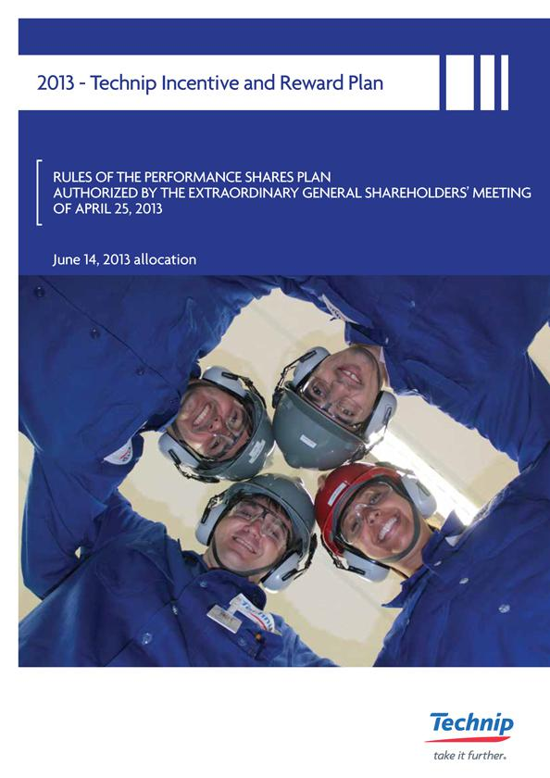

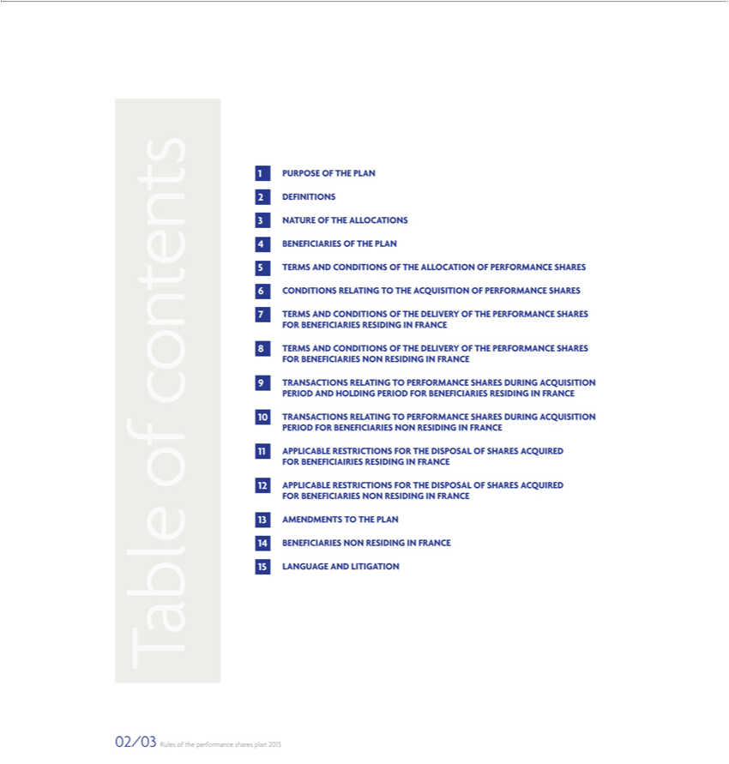

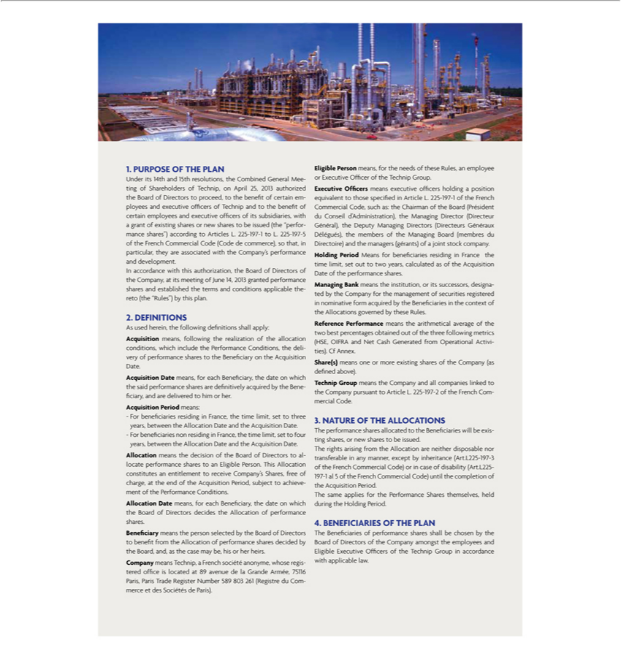

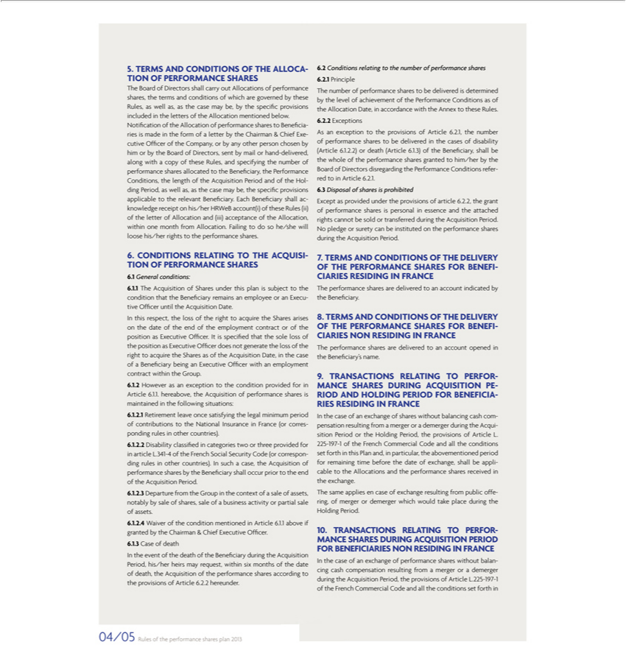

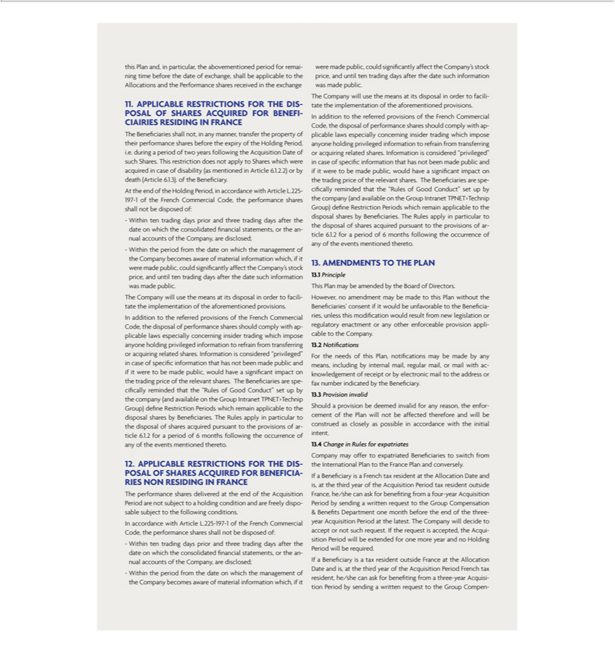

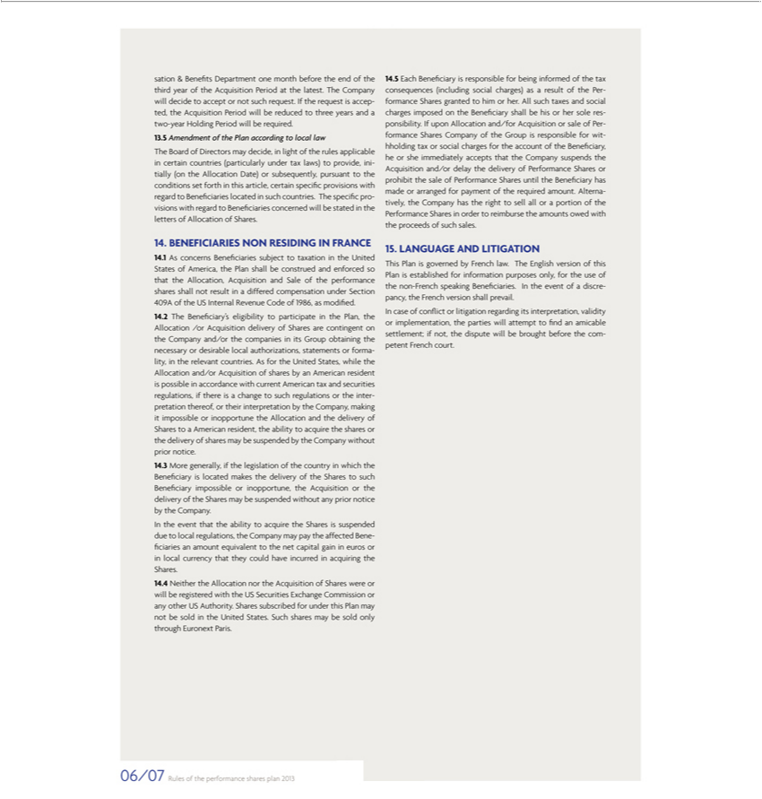

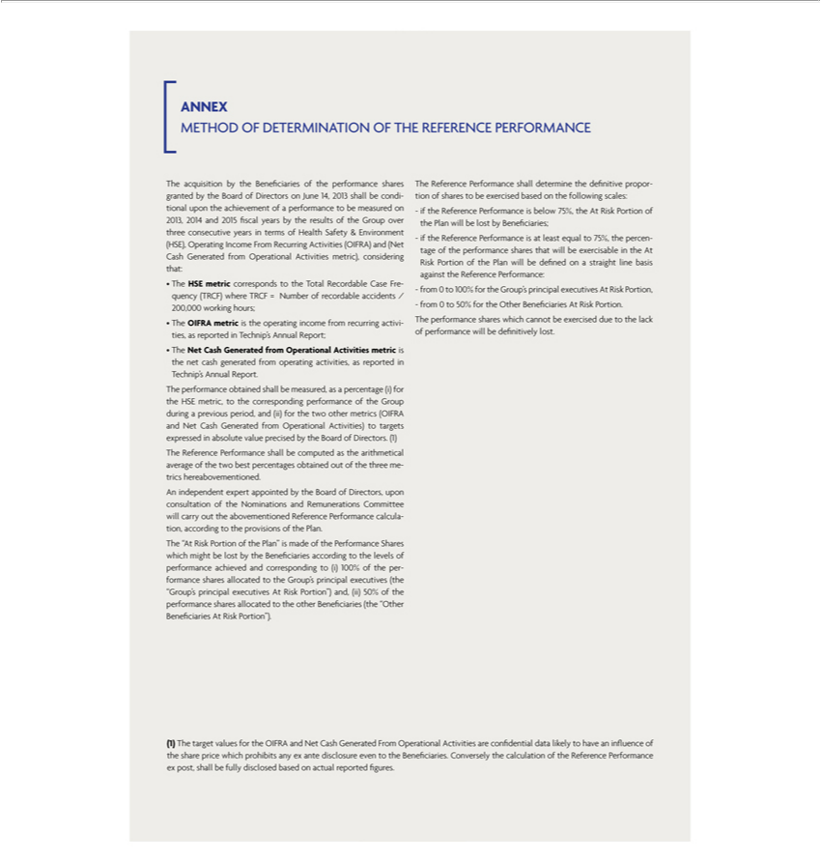



Exhibit 99.5

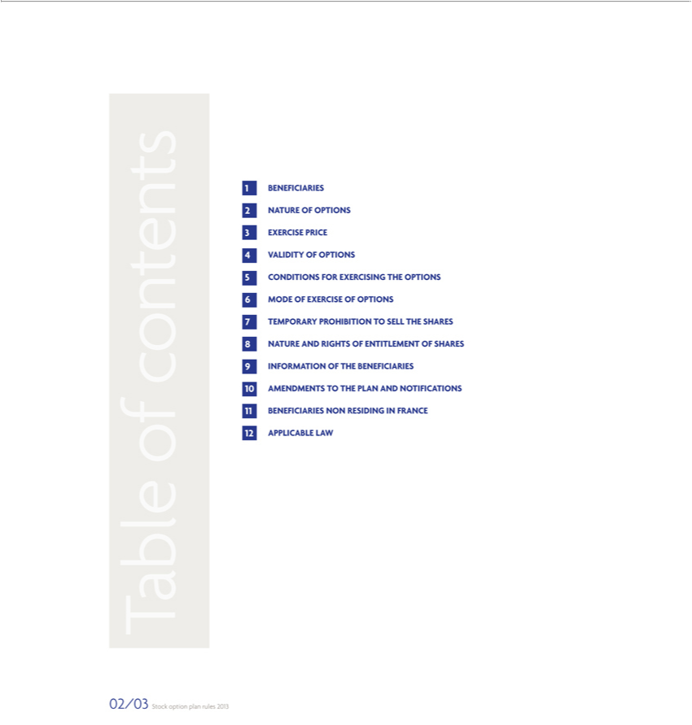

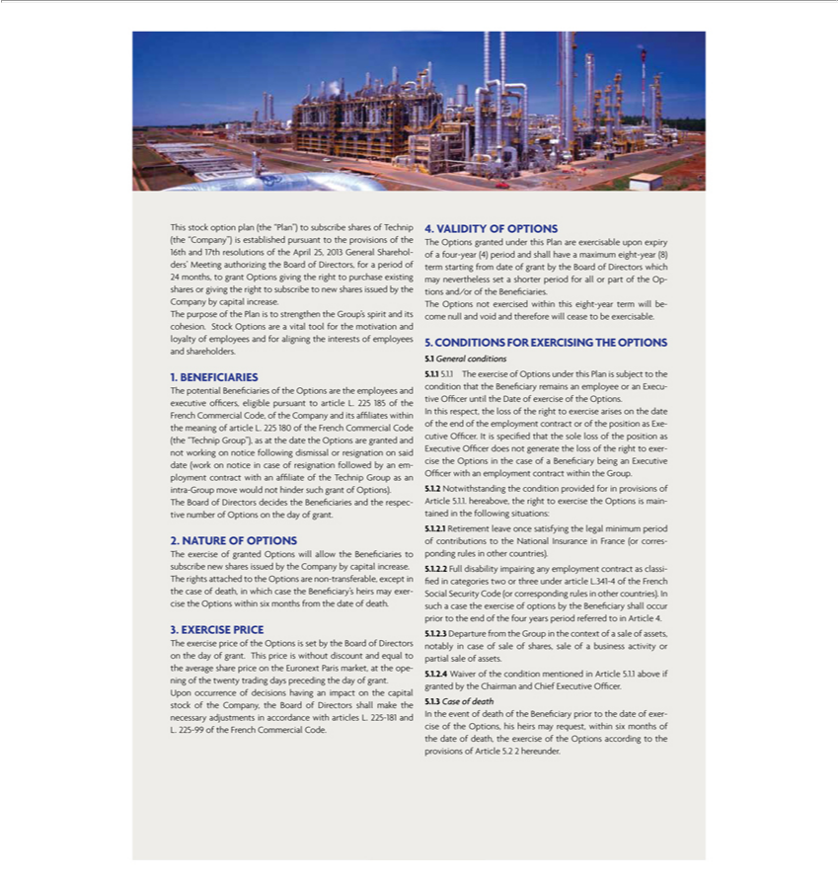

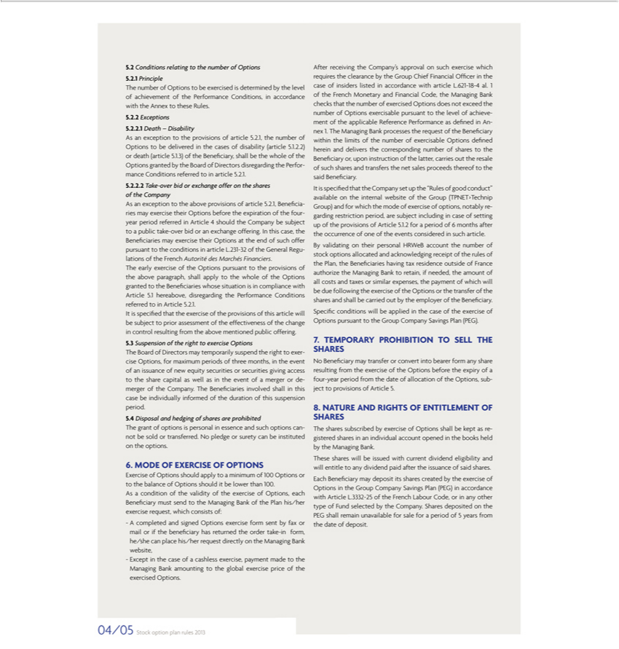

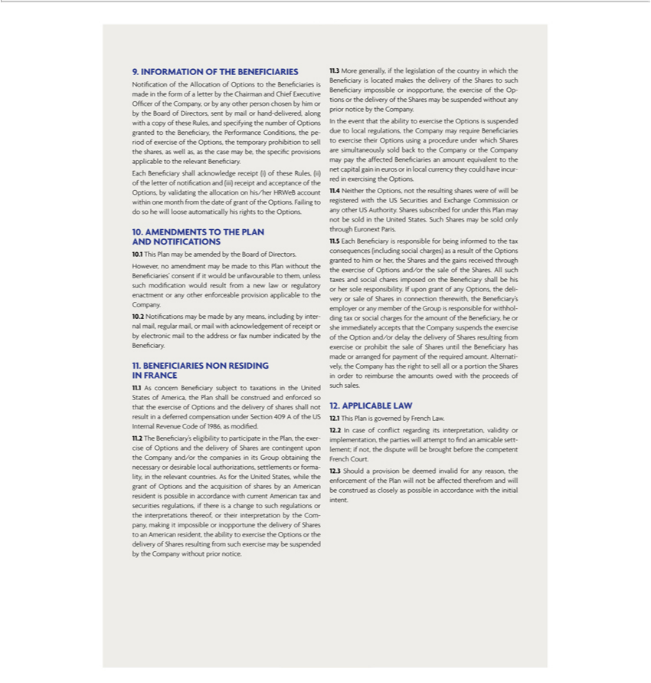

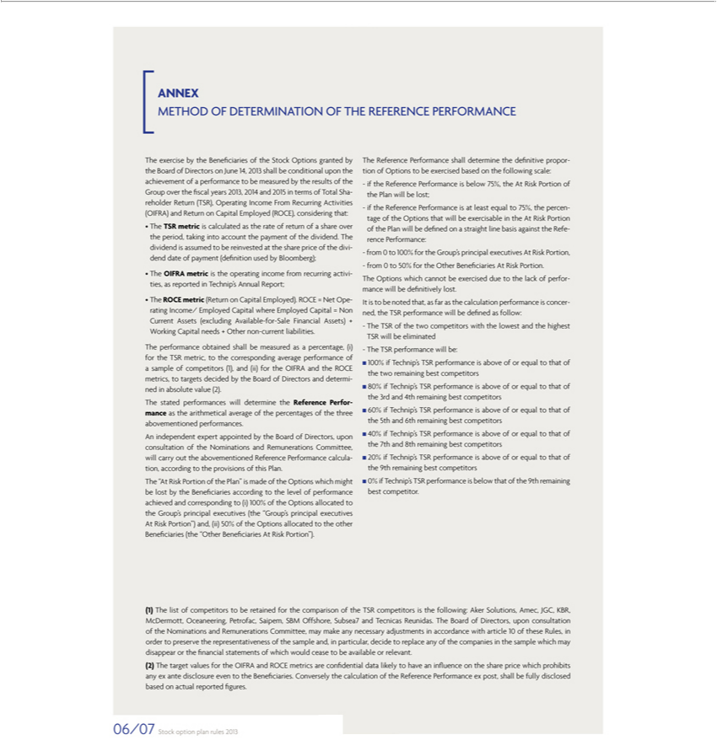





Exhibit 99.6
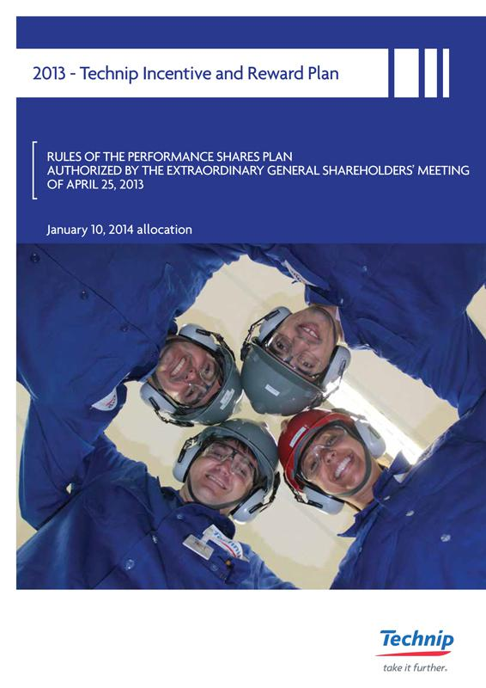

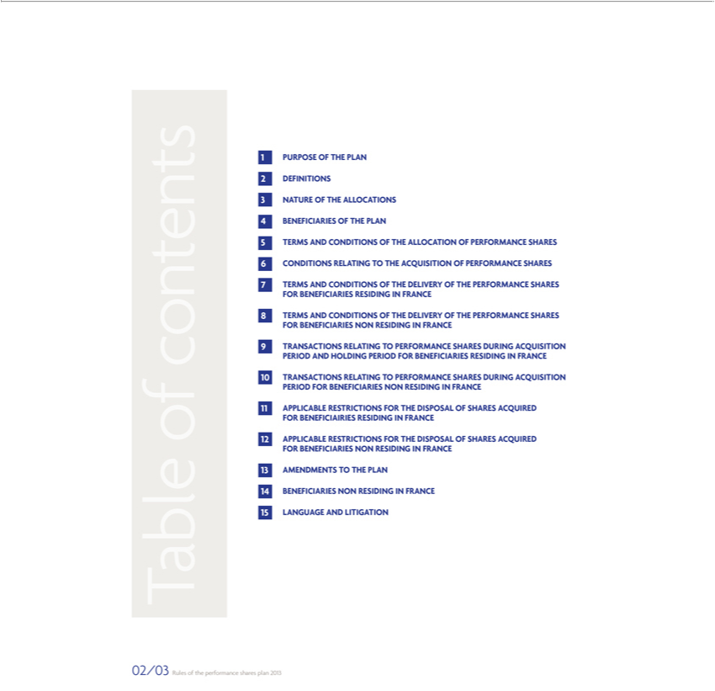

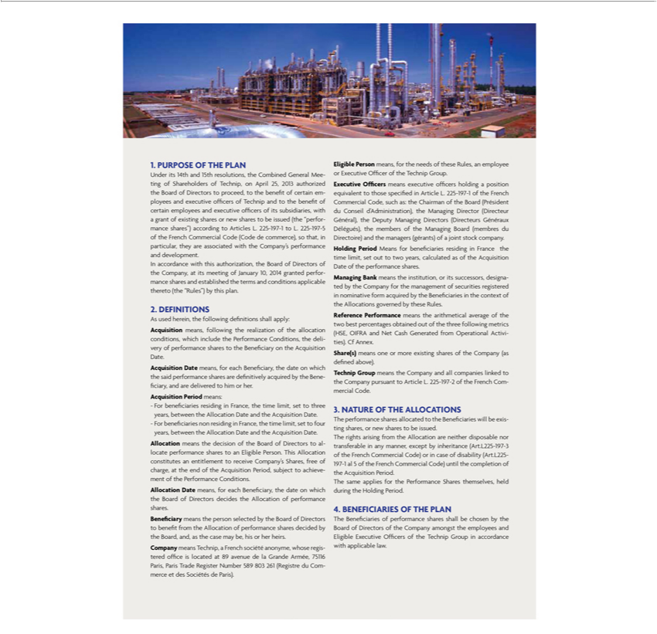

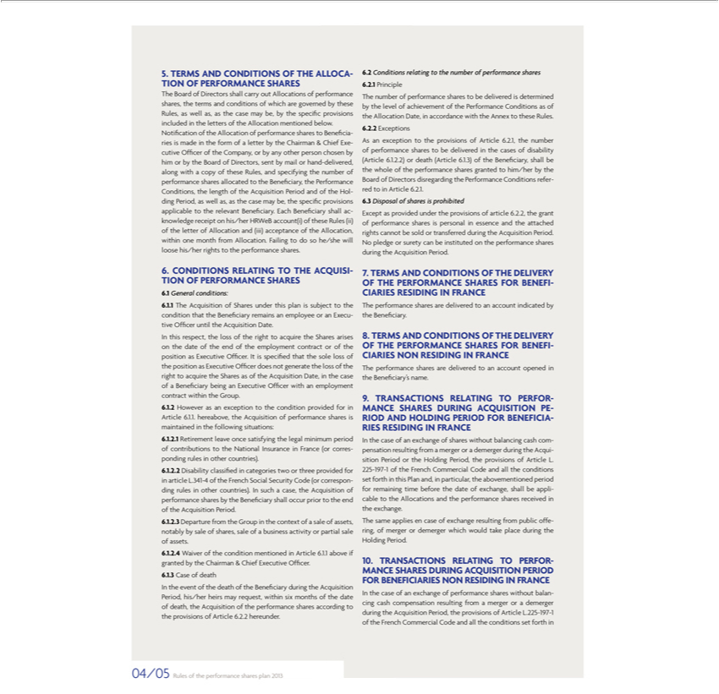

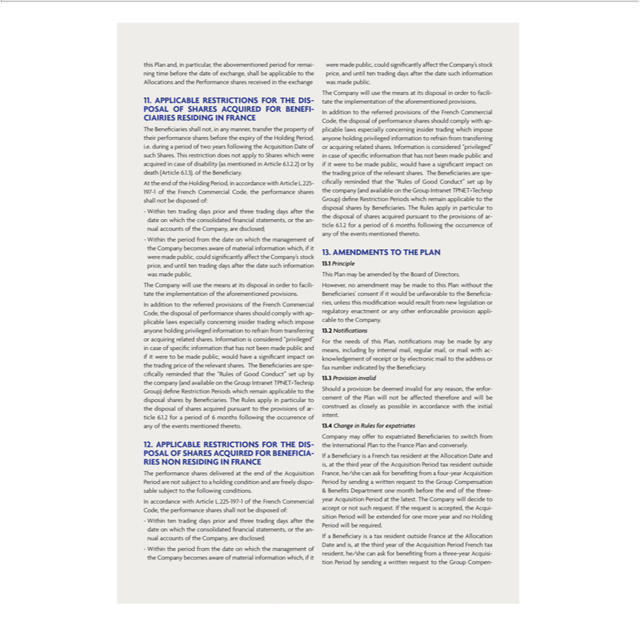

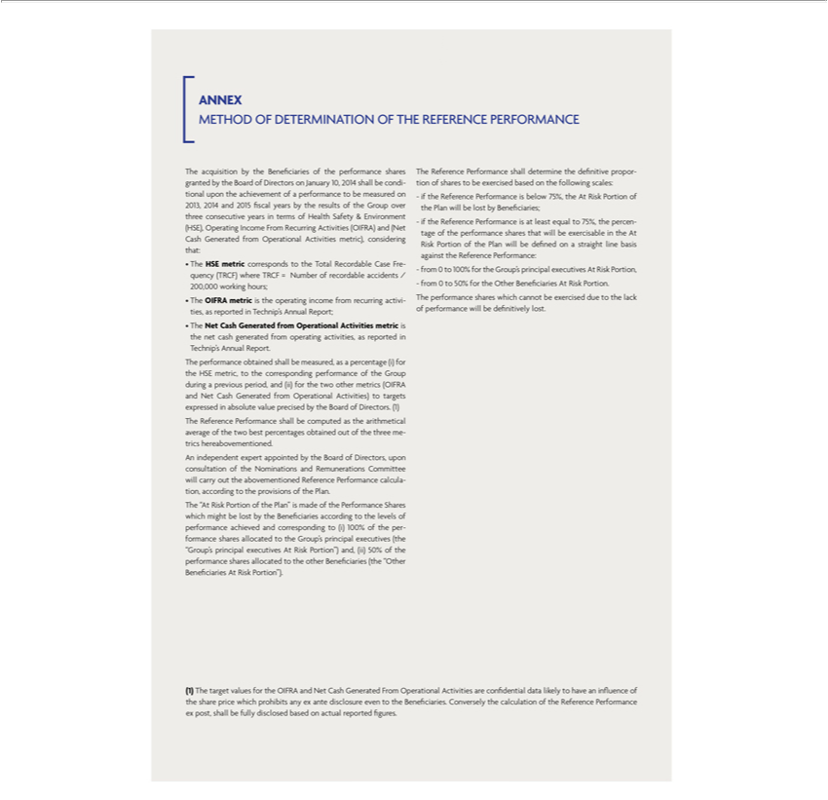



Exhibit 99.7
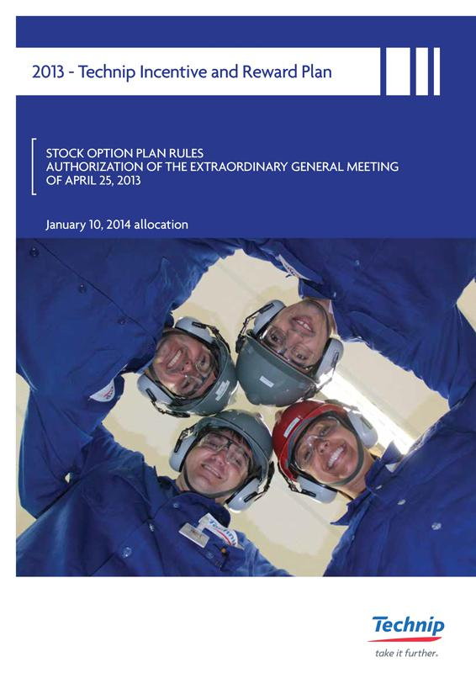

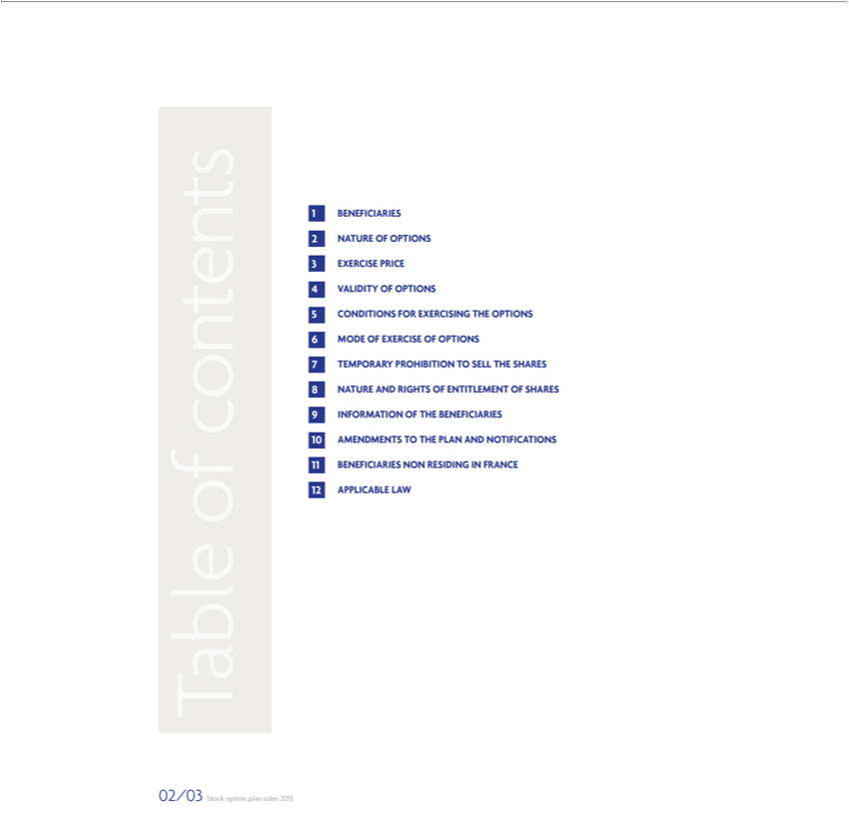

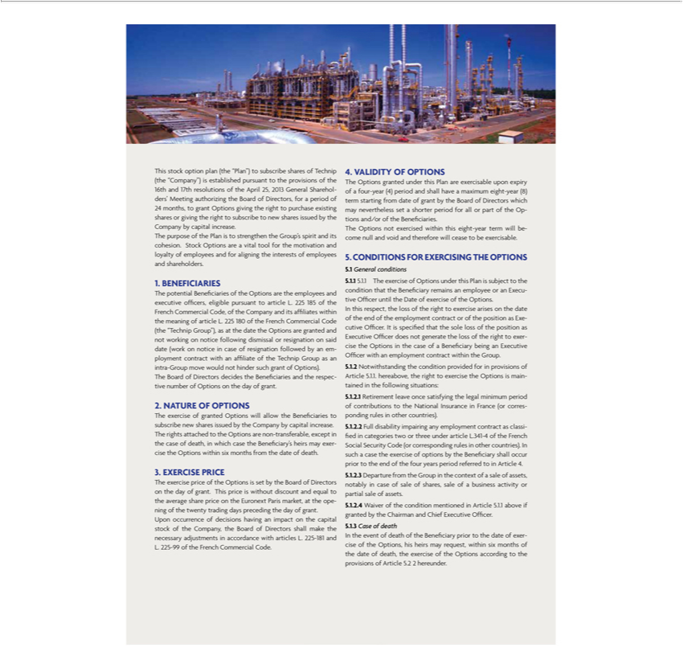

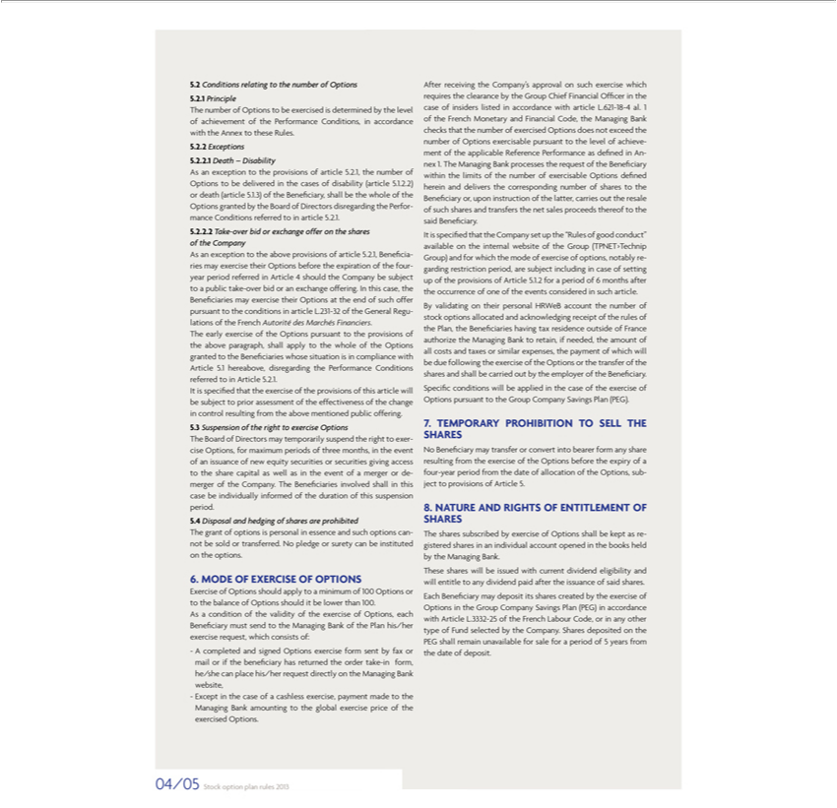

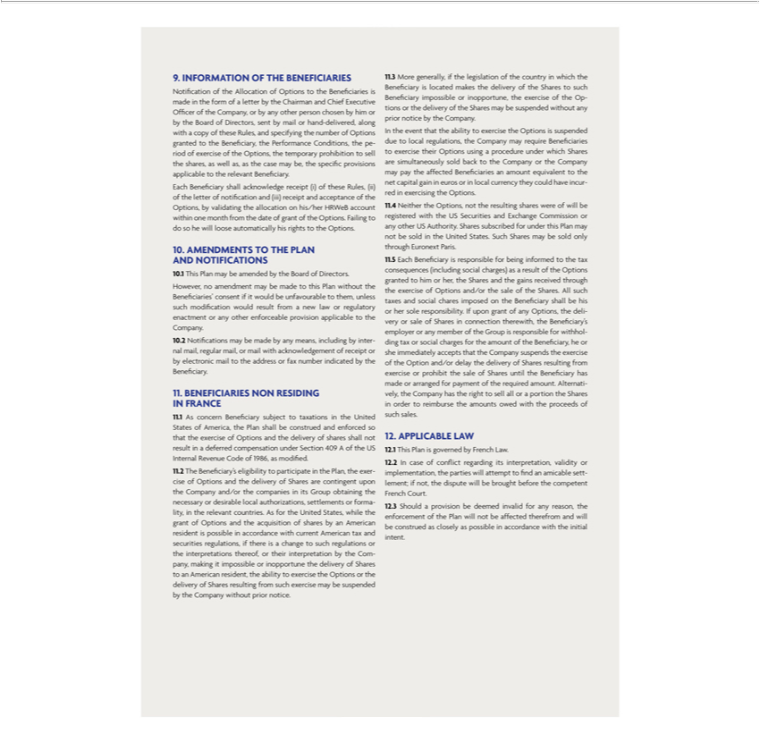

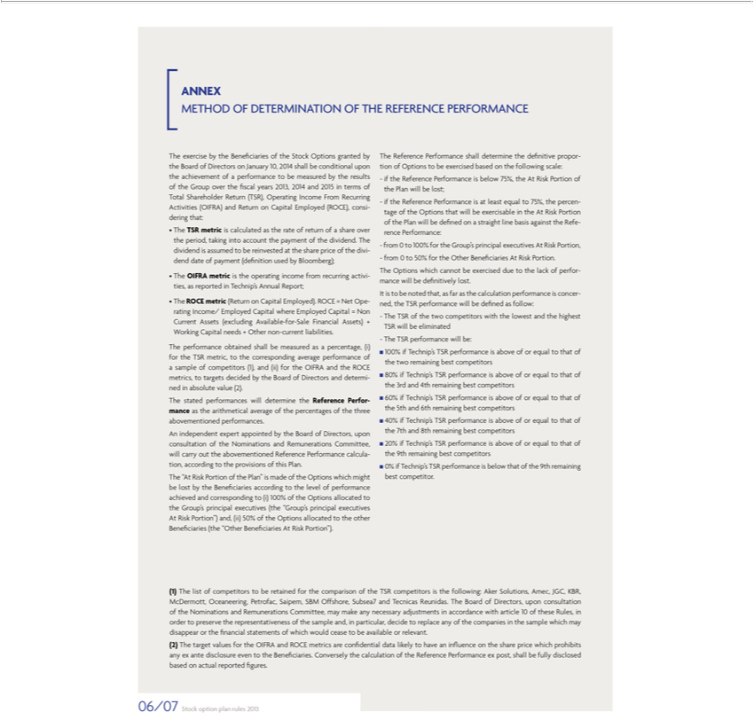





Exhibit 99.8
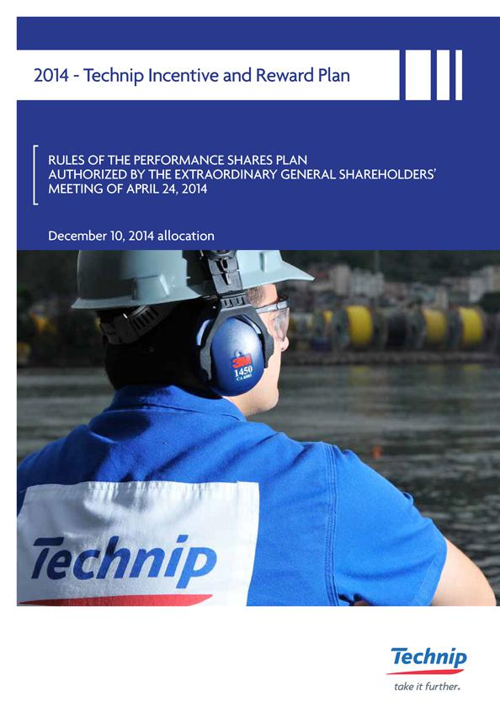

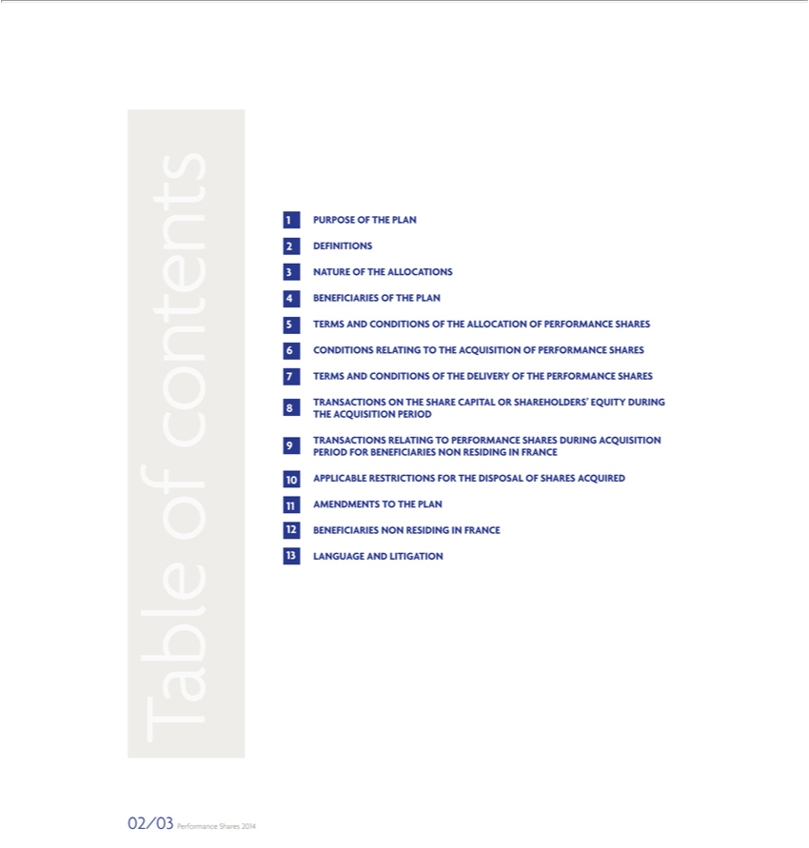

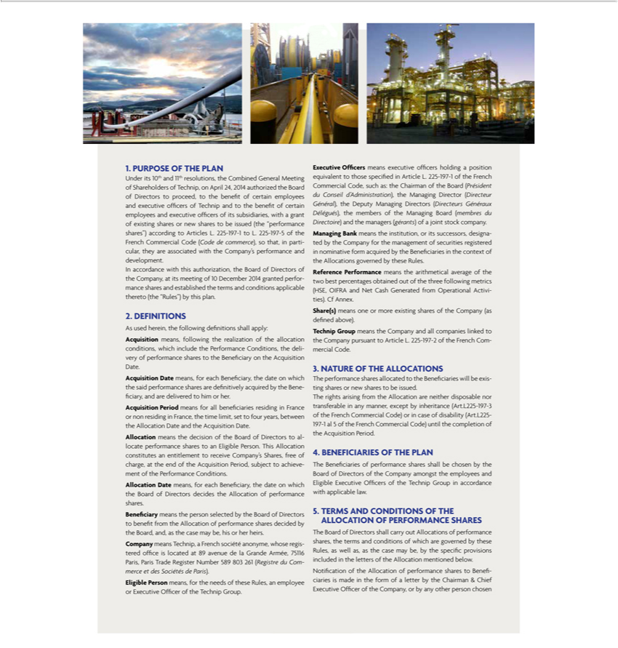

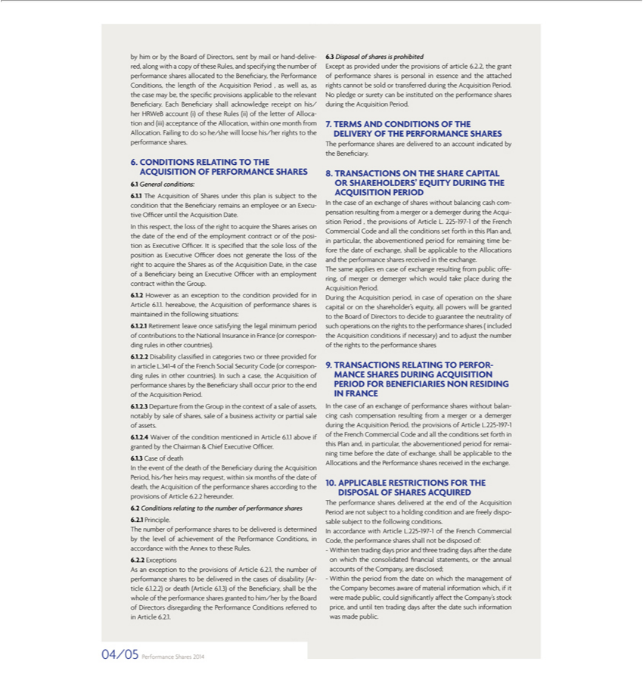

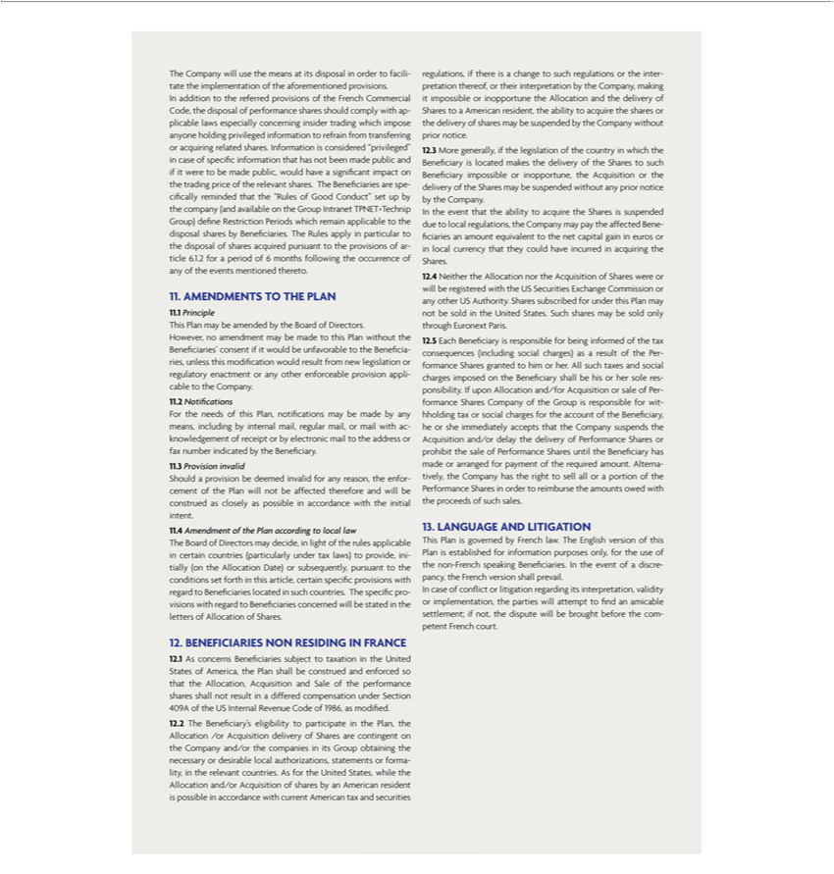

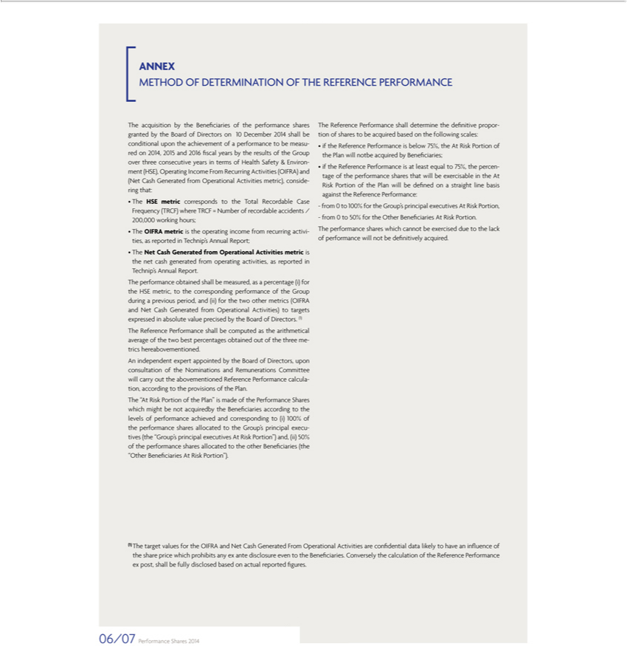





Exhibit 99.9


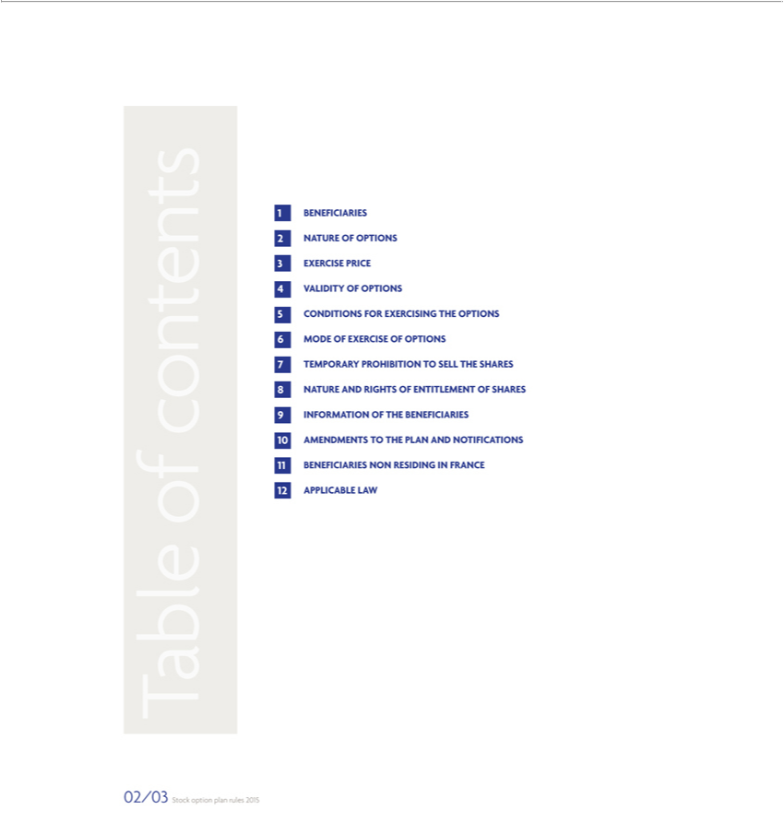

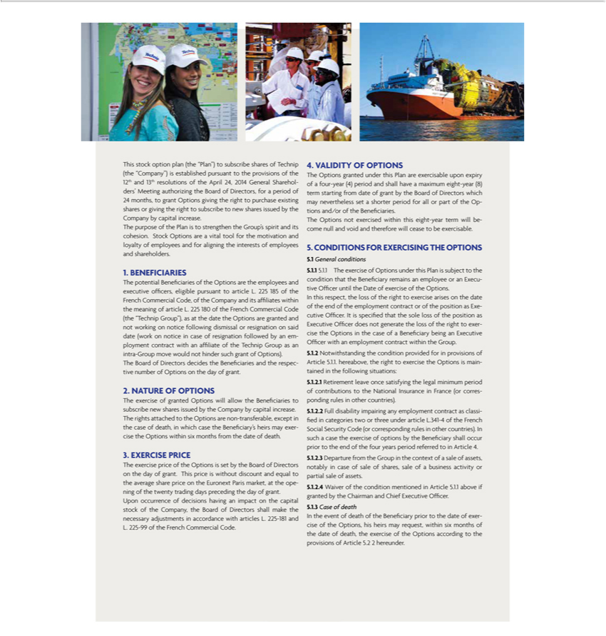

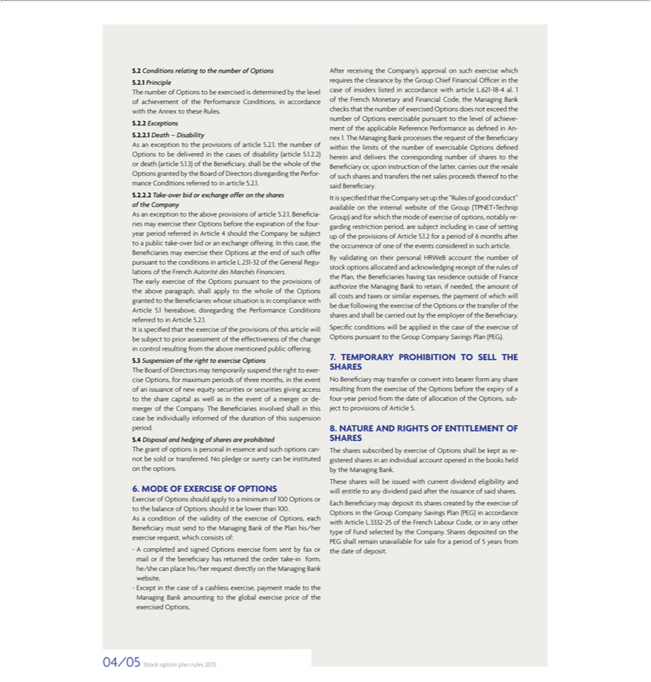

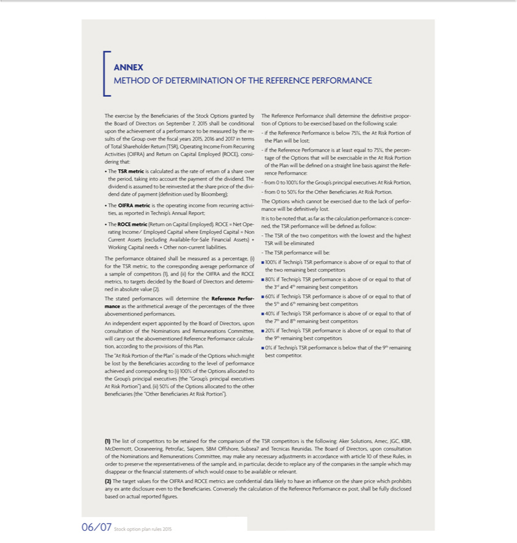





Exhibit 99.10
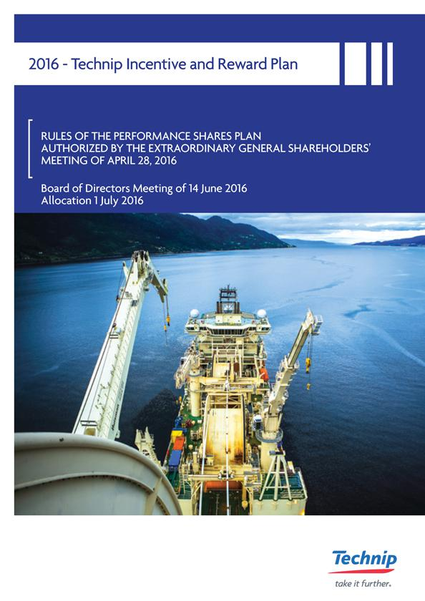

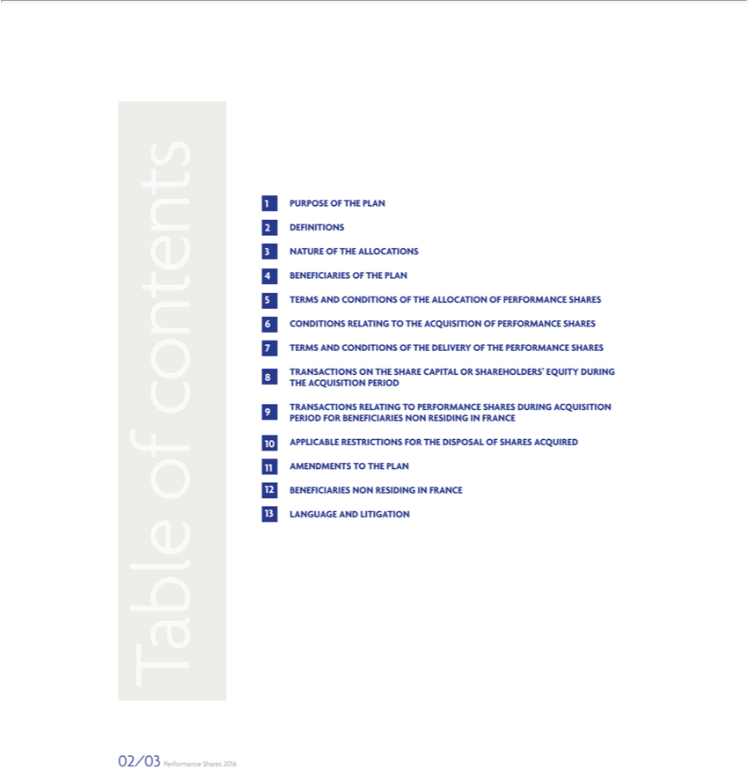

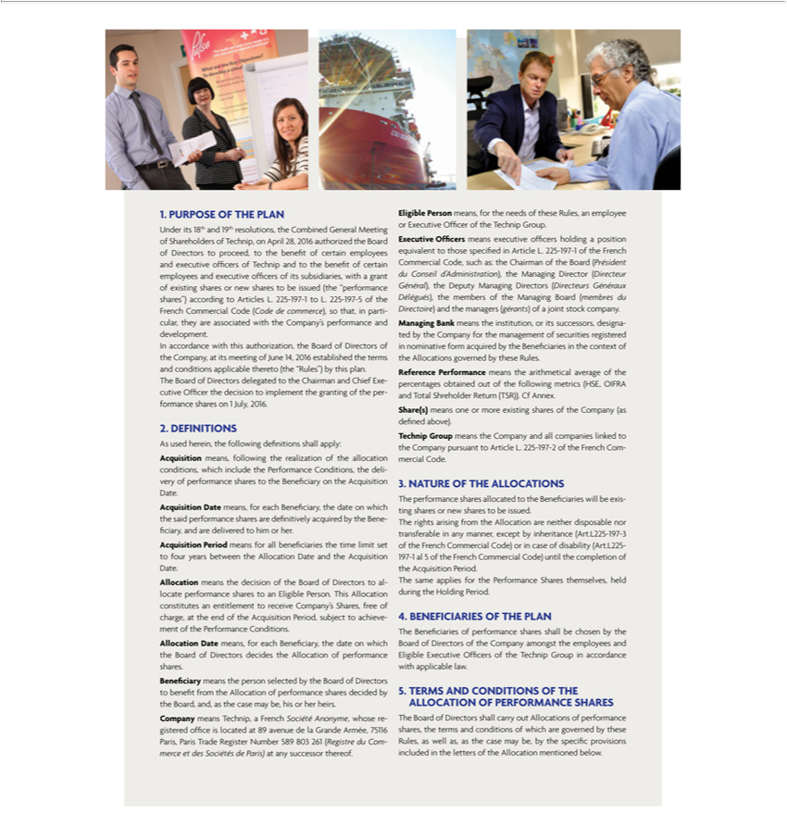

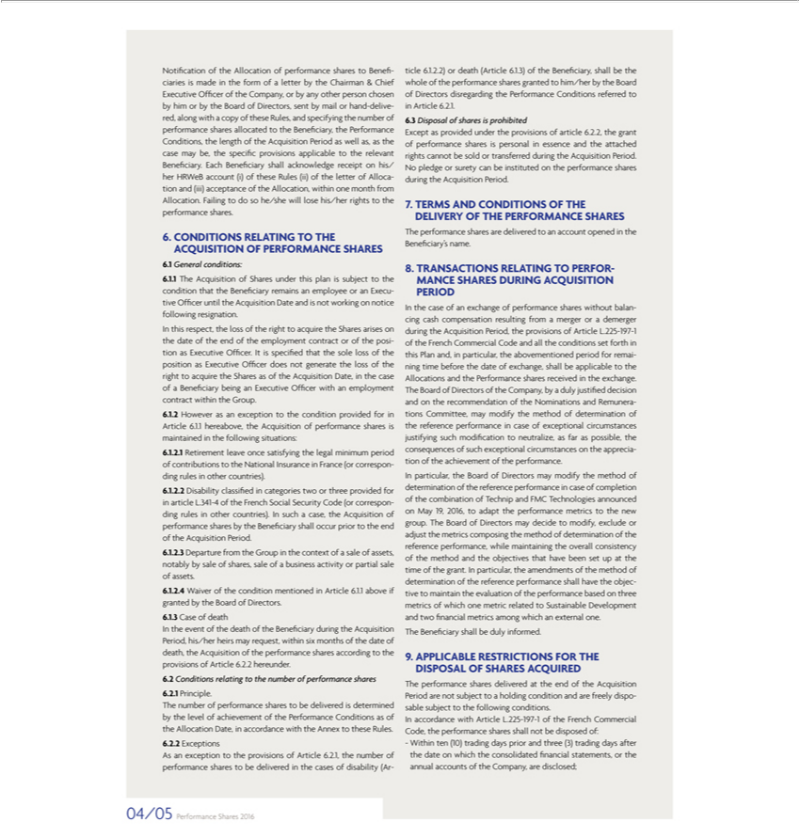

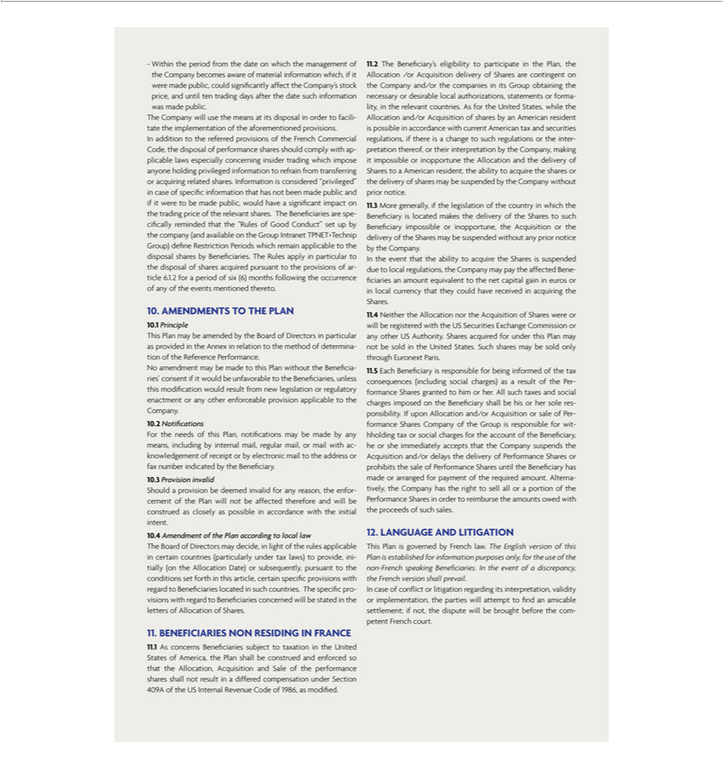

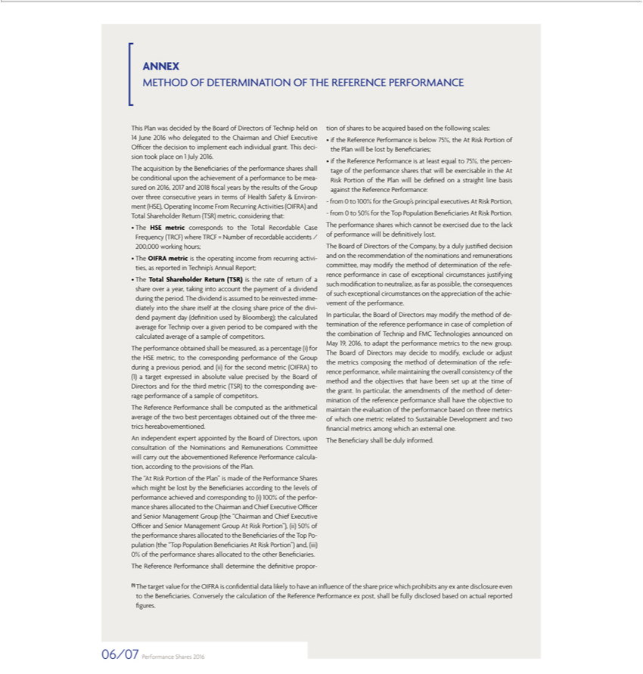





Exhibit 99.11
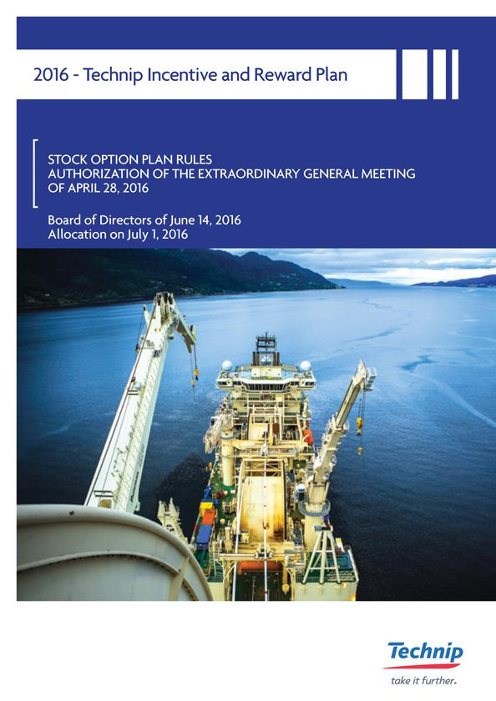

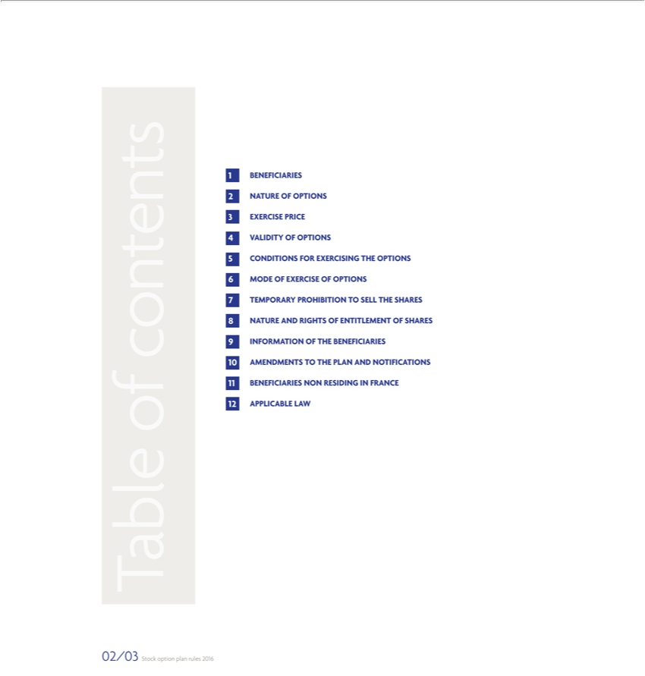



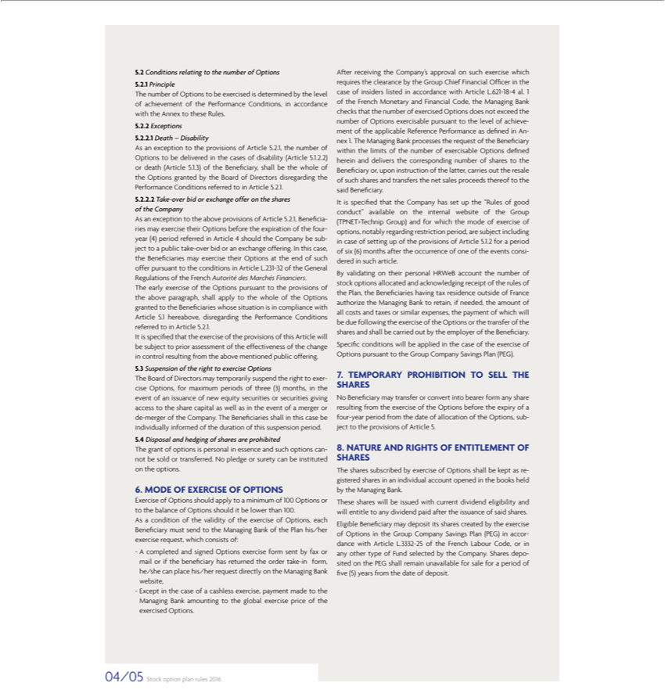

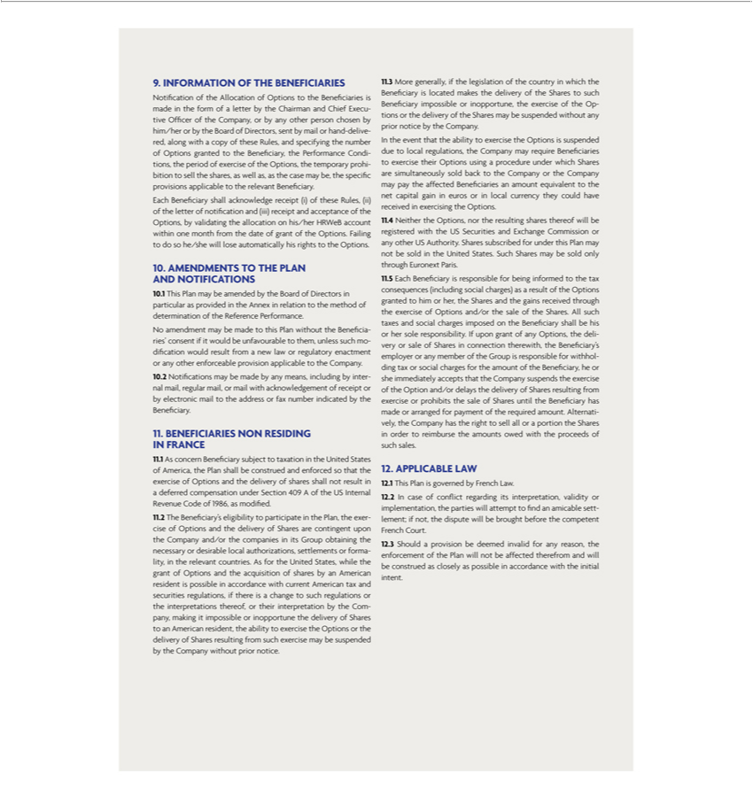

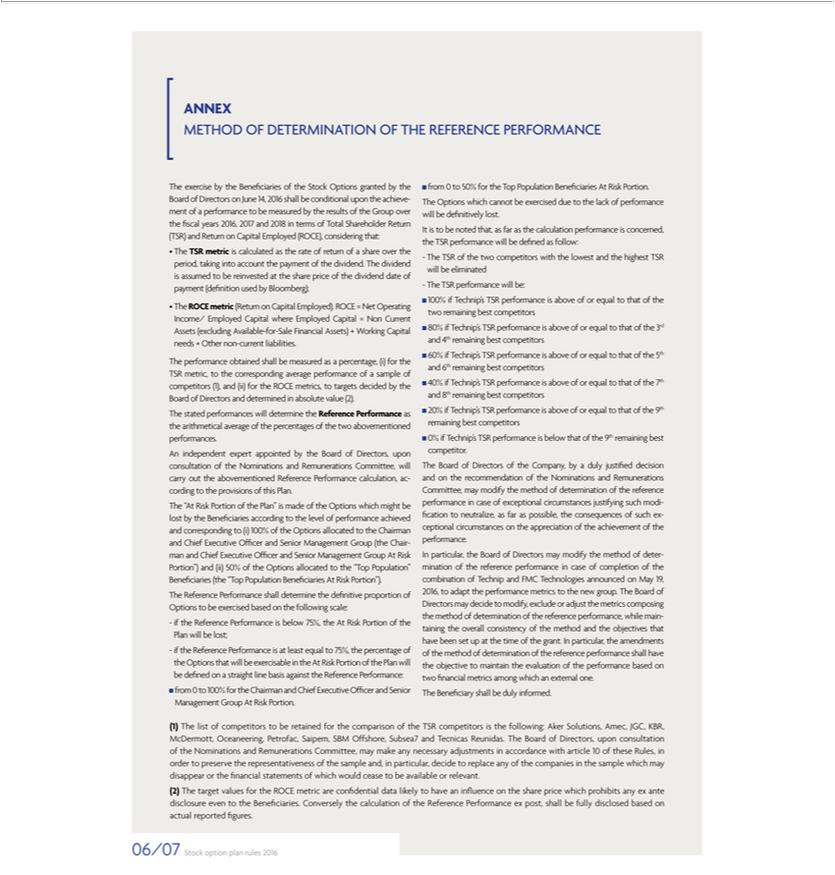





Exhibit 99.12






